-- QUERY TO CREATE DATABASE AND USE DATABASE

CREATE DATABASE UNIVERSITY;

USE UNIVERSITY;

-- QUERY TO CREATE TABLE WITH PRIMARY KEY

CREATE TABLE DEPARTMENT(

ID INTEGER PRIMARY KEY IDENTITY(1,1),

DEPT_NAME VARCHAR(50) NOT NULL

);

-- QUERY TO RENAME TABLE

EXEC sp_rename 'DEPARTMENT', 'DEPARTMENTS';

-- QUERY TO CREATE TABLE WITH PRIMARY KEY AND FOREIGN KEY

CREATE TABLE STUDENTS(

REG_NUMBER VARCHAR(10) PRIMARY KEY,

FULL_NAME VARCHAR(50),

AGE INTEGER,

DEPT_ID INTEGER FOREIGN KEY REFERENCES DEPARTMENTS(ID) ON DELETE CASCADE

);

CREATE TABLE TEMP(

ID INTEGER,

VAL VARCHAR(10)

);

-- QUERY TO SHOW COLUMN NAMES OF TABLE

SELECT COLUMN_NAME FROM INFORMATION_SCHEMA.COLUMNS WHERE TABLE_NAME = 'STUDENTS';

Output:

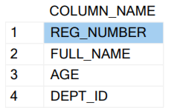

-- QUERY TO ALTER TABLE

ALTER TABLE STUDENTS

ADD SGPA DECIMAL(5, 2);

SELECT COLUMN_NAME FROM INFORMATION_SCHEMA.COLUMNS WHERE TABLE_NAME = 'STUDENTS';

Output:

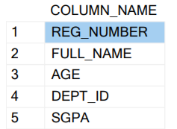

-- QUERY TO SHOW ALL TABLES IN DATABASE

SELECT* FROM UNIVERSITY.INFORMATION_SCHEMA.TABLES;

Output:

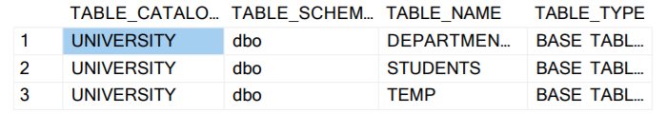

-- QUERY TO DROP THE TABLE

DROP TABLE TEMP;

SELECT* FROM UNIVERSITY.INFORMATION_SCHEMA.TABLES;

Output:

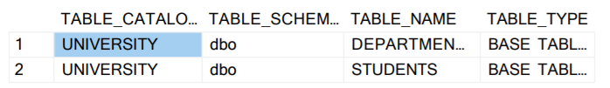

-- QUERY TO INSERT DATA INTO TABLE

INSERT INTO DEPARTMENTS(DEPT_NAME) VALUES('MATHEMATICS');

INSERT INTO DEPARTMENTS(DEPT_NAME) VALUES('COMPUTER SCIENCE');

INSERT INTO STUDENTS(REG_NUMBER, FULL_NAME, AGE, DEPT_ID, SGPA) VALUES('2020BCS512', 'SHINDE CHAITANYA ADINATH', 20, 2, 92.5);

INSERT INTO STUDENTS(REG_NUMBER, FULL_NAME, AGE, DEPT_ID, SGPA) VALUES('2020BCS513', 'CHAUDHARI AKASH DATTA', 19, 1, 94.5);

-- QUERY TO SHOW DATA FROM TABLE

SELECT * FROM DEPARTMENTS;

Output:

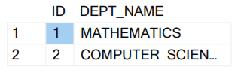

SELECT * FROM STUDENTS;

Output:

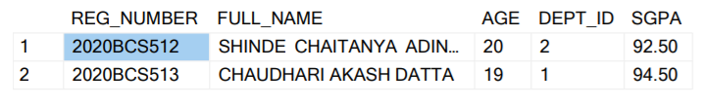

-- QUERY TO TRUNCATE DATA FROM TABLE

TRUNCATE TABLE STUDENTS;

SELECT * FROM STUDENTS;

-- QUERY TO DROP DATABASE

USE master;

ALTER DATABASE UNIVERSITY SET SINGLE_USER WITH ROLLBACK IMMEDIATE;

DROP DATABASE UNIVERSITY ;