R.NO CB.EN.U4CSE19156

LAB-1

SET-B

**Server.py:**

import pandas as pd

import socket

df=pd.read_csv('stationary.csv')

print(df)

s=socket.socket(socket.AF_INET,socket.SOCK_STREAM)

port=6000

host=socket.gethostname()

s.bind((host,port))

s.listen()

print('Server is listening ..')

while True:

con,addr=s.accept()

print('connection established')

c=True

while c:

data=con.recv(1024)

f=repr(data.decode())

print(f)

f=f[1:]

f=f[:len(f)-1]

f=f.split('_')

print(f)

if f[0]=="I":

p=f[1:]

df2=pd.DataFrame.from_records([{'date':p[0],'product_id':int(p[1]),'quantity':int(p[2]),'cost':int(p[3])}])

print(df2)

df=df.append(df2)

print(df)

df.to_csv('stationary.csv')

if f[0]=="M":

df['total_cost']=df['quantity']*df['cost']

df.to_csv('stationary.csv')

if f[0]=="V":

df.to_csv('k.csv')

f_n='k.csv'

fl = open(f_n,'rb')

l = fl.read(1024)

while (l):

con.send(l)

l = fl.read(1024)

fl.close()

if f[0]=='U':

for i in range(len(df)):

if df.loc[i,'total_cost']>1000:

df.loc[i,'category']='B'

else:

df.loc[i,'category']='A'

df.to_csv('stationary.csv')

if f[0]=='F':

p=f[1:]

df2=df[df['date']==p[0]]

k1=str(df2).encode()

con.send(k1)

if f[0]=="S":

con.close()

break

**client.py:**

import socket

import pandas as pd

import csv

s=socket.socket(socket.AF_INET,socket.SOCK_STREAM)

host=socket.gethostname()

port=6000

s.connect((host,port))

print("connected")

s1=0

while s1!='S':

print("Select the actions below")

print('I-insertion')

print('M-modify')

print('V-view')

print('U-update')

print('F-view based on pname')

print('S-stop')

s1=input()

if s1=='I':

date=input('enter date:')

product_id=input('enter product_id:')

quantity=input('enter quantity:')

cost=input('enter pcost:')

p=str(s1)+'_'+str(date)+'_'+str(product_id)+'_'+str(quantity)+'_'+str(cost)

s.send(p.encode())

print('sent')

if s1=='M':

p=str(s1)

p=str(p)

s.send(p.encode())

print('modified')

if s1=='V':

p=str(s1)

p=str(p)

s.send(p.encode())

print('sent')

data=s.recv(1024)

f1=open('m.csv','w')

f1.write(str(data.decode()))

f1.close()

df1=pd.read_csv('m.csv')

print(df1.loc[:,'date':])

f2=open('m.csv','r+')

f2.truncate(0)

f2.close()

if s1=='U':

p=str(s1)

p=str(p)

s.send(p.encode())

print('updated')

if s1=='F':

date=input('enter date')

p=str(s1)+'_'+str(date)

p=str(p)

s.send(p.encode())

print('querying ..')

m1=s.recv(1024)

dt=m1.decode()

print(dt)

if s1==4:

break

INSERT OPERATION:

Server side output:

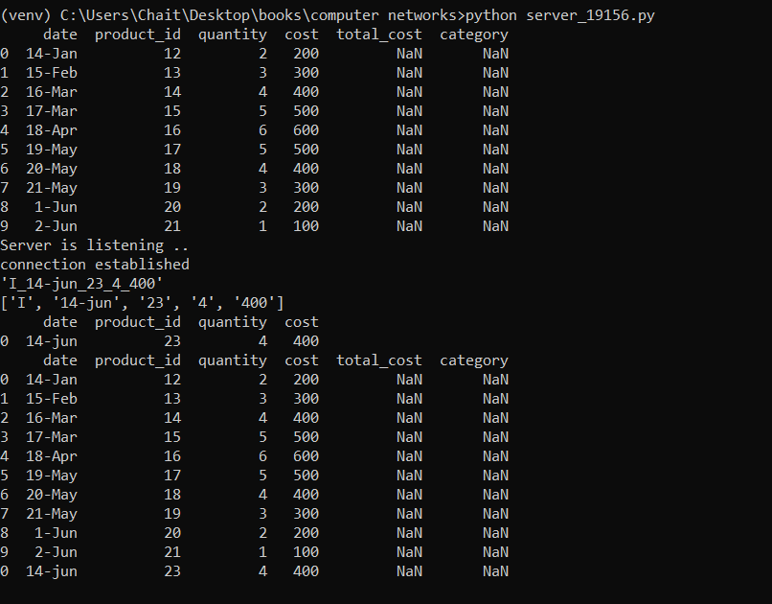

Clientside output:

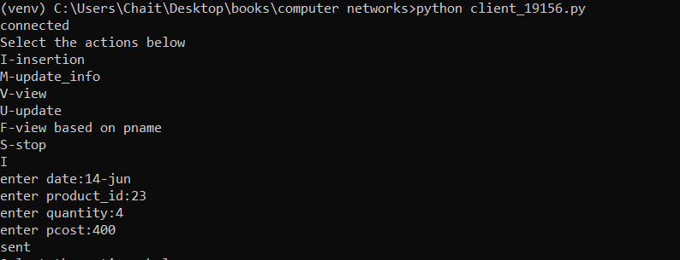

MODIFICATION and VIEW:

Server side output:

(Data frame before modification)

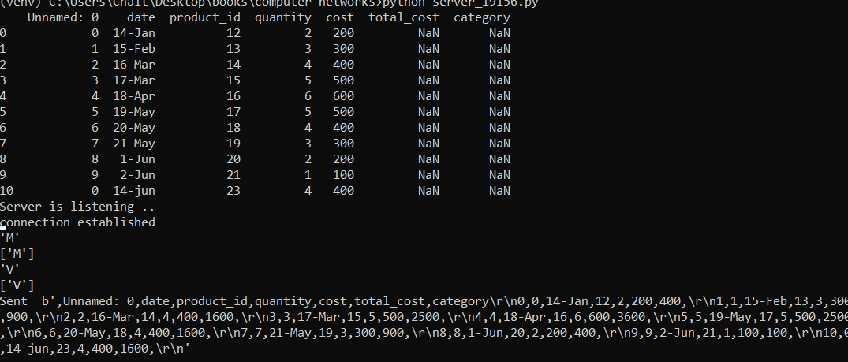

Client side output:

Modification and view operations

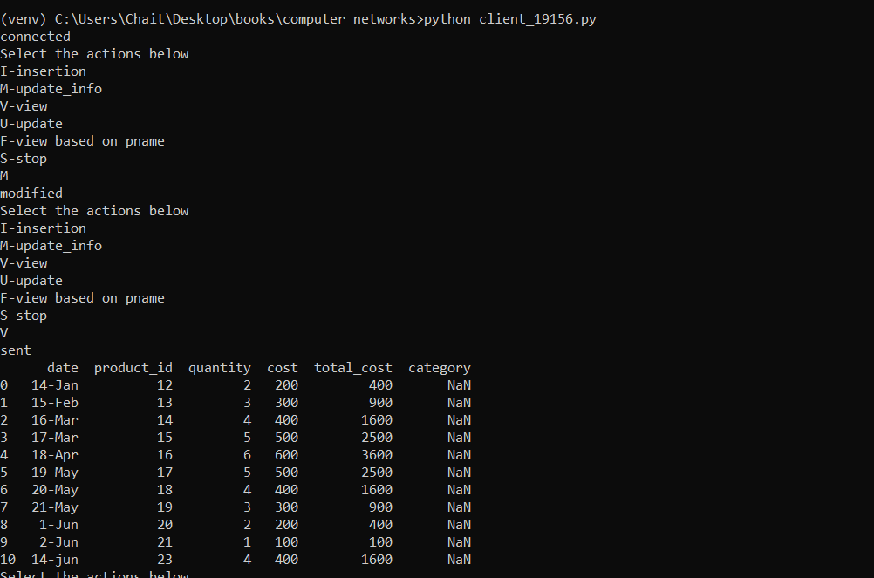

UPDATE AND VIEW:

SERVER SIDE:

EXCEL FILE DATA BEFORE:

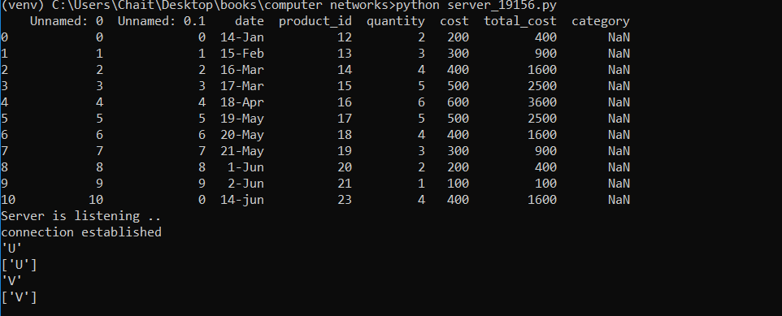

CLIIENT SIDE OUTPUT:

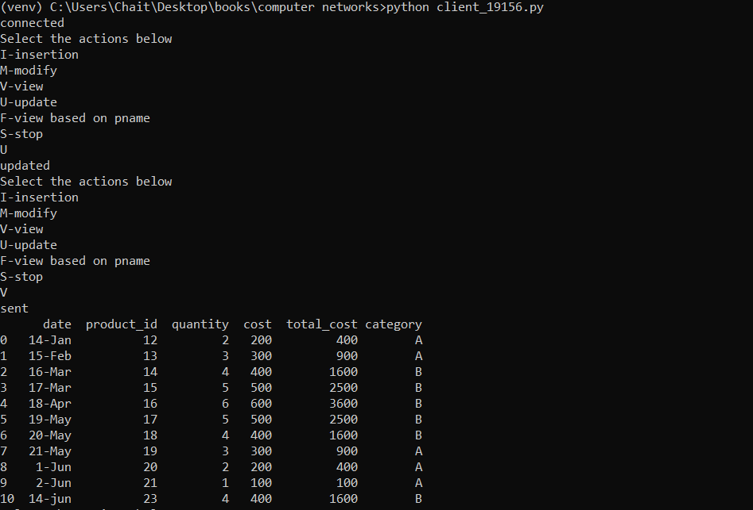

F-get values based on date:

Server side:

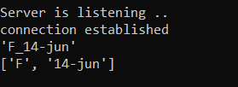

Client side:

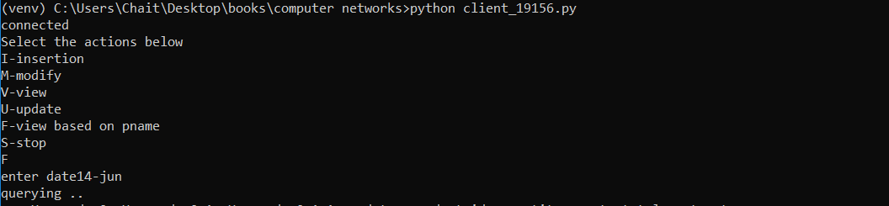

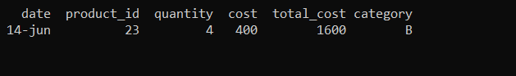

EXCEL SHEET AFTER ALL OPERATIONS:

