**19CSE301-COMPUTER NETWORKS**

**Case Study**

**R.NO:CB.EN.U4CSE19156**

**V S S K CHAITANYA**

#### Title: Railway Zone Management

|  |  |  |
| --- | --- | --- |
| **Department Name** | **Purpose** | **Network Details**  **(No of nodes,servers,Protocols)** |
| Tourism And Catering Department | Catering Department is used to serve food in trains. | 35 nodes, 4 servers,RIP,OSPF,FTP |
| Railway Hospital Department | Railway Hospital is used for emergency surgeries and for Railway employees treatment. | 22 nodes, 4 servers,RIP,OSPF,FTP |
| Railway Reservation Department | Railway Reservation Department manages ticket bookings and special bookings like tatkal. | 30 nodes, 4 servers,RIP,OSPF,FTP |
| Accounts Department | Manages employee salary and bills. | 20 nodes, 4 servers,RIP,OSPF,FTP |

|  |  |  |
| --- | --- | --- |
| **ROLL Number** | **Name** | **Contribution in Case Study** |
| CB.EN.U4CSE19153 | T. Krishna Chaitanya | Tourism And Catering Department |
| CB.EN.U4CSE19155 | U. Yeshwanth | Railway Hospital Department |
| CB.EN.U4CSE19156 | V. S. S. K. Chaitanya | Railway Reservation Department |
| CB.EN.U4CSE19165 | P. Prem Sai | Accounts Department |

|  |  |  |
| --- | --- | --- |
| **Topic** | **Page No in the document** | **Supporting file name** |
| Problem Statement | **3** |  |
| Objective of the case study | **3** |  |
| Network Architecture Diagram | **23** |  |
| Performance Parameters | **9** |  |
| Department Details in the case study with description | **3** |  |
| Subnet ip scheme followed  [Solving the IP address allocation process for each subnetwork ] | **23** |  |
| Socket programming | **13** | Res_server.py,res_client.py,res_client_2.py |
| Cisco packet tracer – Application layer protocols | **25** |  |
| Cisco packet tracer – Virtual Local Area Network | **26** |  |
| Cisco packet tracer – OSPF | **25** |  |
| Cisco packet tracer – RIP | **25** |  |
| GoBack N and Selective Repeat protocol | **28** |  |
| Cloud concepts | **29** |  |
| Cloud and Networking | **29** |  |
| How is cloud related to your application? | **30** |  |

Name: V.S.S.K.Chaitanya

Roll Number : CB.EN.U4CSE19156

**Problem Staement:**

To design a computer network that organize and manage various railway departments within a railway zone.

Objective of the case study:

To design a network architecture for Railway Zone Management

**Description of the case study:**

Railway zones play a very crucial part in maintenance of Indian Railway system

various data that need to be managed between the stations coming under a particular zone such as maintaining the record of passenger data, health system, amount sanctioned to the station for development etc. All this data must be collected from various stations falling under a particular zone must be managed by the zone headquarters

So In order to operate effectively exchange of data among railway stations located in various place is crucial and needs a proper architecture. Our case study is aimed to demonstrate how different detpartments within a railway zone headquarter mange this effectively.

**Railway Reservation Department:**

In this department railway bookings, cancellation and many other services that are provided to the customers are managed.

In the network along with sub networks connection with same department across other branch is also shown.

##### Railway Zone Network NETWORKS

Tourism And Catering Department – Wide Area Network Railway Reservation – Wide Area Network

Railway Hospital – Local Area Network Accounts Department – Virtual Private Network

|  |  |
| --- | --- |
| **Client configuration** | **Server Configuration** |
| Intel(R) Core 4005U Series Processor | 2 Intel(R) Itanium 2 9100 Series Processors |
| 8 GB RAM | 23.98 GB RAM |
| 8 MB Cache | 12 MB Cache |
| 1 TB | 4.5 TB Storage (EMC Box) |
| Dual External Storage Connectivity | Dual External Storage Connectivity |
| DVD ROM Drive | DVD ROM Drive |

##### SERVERS

Database Server Proxy Server Mail Server

Application Server Client Server **CABLES**

Coaxial Fibre Twisted Fibre Optical Fibre **TOPOLOGY**

Reservation, Accounts - Star Topology Medical - Bus Topology

Tourism And Catering Department -

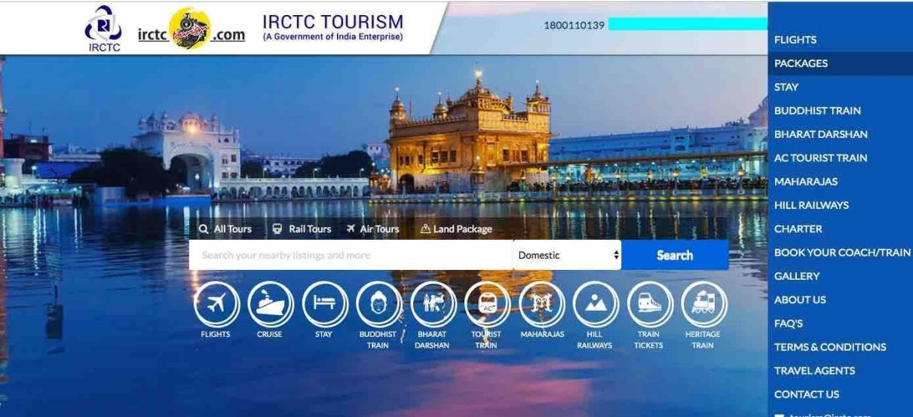

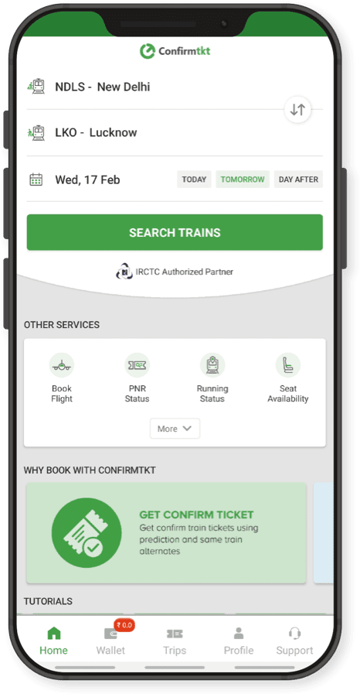

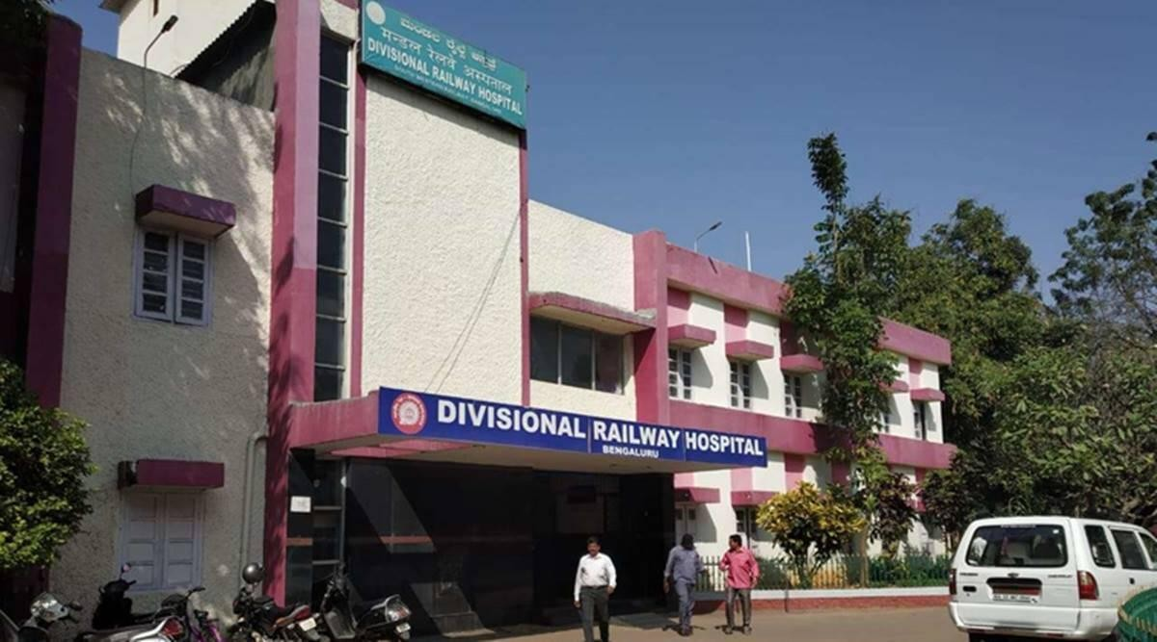

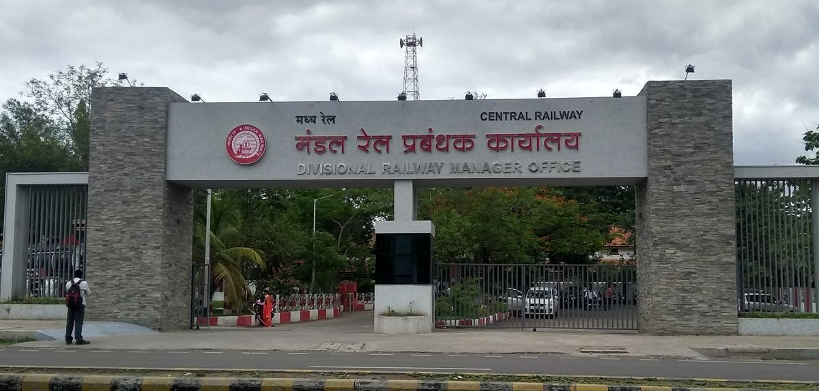

##### Why is Networking required?

As we saw before railway zone headquarters needs to collect and send info to various railway stations and should be able to manage the passenger data. So computer network plays a vital role to establish a proper connection between various departments. A proper architecture is needed because various devices like printer, ip phone, pcs are to be connected. So that a zone headquarter can manage all the railway stations effectively.

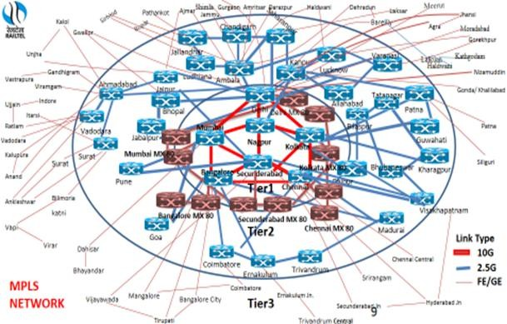

List of Network performance parameters:

**Bandwidth:**

**bandwidth** is defined as the maximum number of bits that can flow through a network connection in a given period of time. The fundamental unit of network bandwidth is bits per second.

Formula:

Expressed as bits per second ( bps ), modern network links have greater capacity, which is typically measured in millions of bits per second

( megabits per second , or Mbps) or billions of bits per second ( gigabits per second ,or Gbps).

### Possible Value In General Scenario.

normally speeds ranging from 10–1,000 Mbps

**Throughput:**

The purpose of throughput is measuring the number of messages successfully transmitted per unit time.

#### Formula:

F = Frames per minute

A = Average of bits each frame carries Through Put = ((F x A)/Unit Time)

### Possible Value In General Scenario:

16.2 mbps

#### Latency (Delay):

Latency meaning in networking is best thought of as the amount of time it takes for a packet of data to be captured, transmitted, processed through multiple devices, then received at its destination and decoded.

#### Formula:

Propagation time = Distance/Propagation speed Transmission time=Message size / Bandwidth

Queuing Time = Directly Proportional to the congestion in the network

Processing Delay = Directly proportional to processing speed of the routers.

Latency = Propagation Time + Transmission Time + Queuing Time + Processing Delay

### Possible Value In General Scenario:

1ms to 20ms

# Bandwidth-Delay Product:

Bandwidth and delay are two performance measurements of a link. However, what is significant in data communications is the product of the two, the bandwidth- delay product.

**Formula:**

Bandwidth x Delay

**Possible Value In General Scenario:**

500kb

Example is Residential Cable internet

# Jitter:

JItter is used to describe the amount of inconsistency in latency across the network, while latency measures the time it takes for data to reach its destination and ultimately make a round trip

**Formula:**

To measure Jitter, we take the difference between samples,then divide by the number of samples (minus-1)

**Possible Value In General Scenario:**

below 30ms

Railway reservation department manages the passenger reservation count of trains based on different classes like sleeper class, 3A class, 2A class.

Description of CSV file:

It consists of five columns

Train_id: Train Id is an unique id which is given to each train to avoid confusion with trains having same names.

Train name: Name of the Train.

Sleeper/3a/2a : Passenger count of respective classes on a particular day.

b. List of operations completed with the File 1.Adding new train details.

2.updating existing train details. 3.Retrieving the particular train details.

4.Viewing all train details on a particular Day.

CODE:

SERVER.PY

import socket import threading import pandas as pd

df=pd.read_csv('train_list.csv') df=df.set_index('train_id') print(df)

s=socket.socket(socket.AF_INET,socket.SOCK_STREAM) port=6000

host=socket.gethostname() s.bind((host,port)) s.listen()

print('Server is listening ...Passenger_Reservation__Department')

def add_info(p,

data=con.recv(1024) f=repr(data.decode()) print(f)

f=f[1:]

f=f[:len(f)-1]

f=f.split('_') print(f)

if f[0]=="1": p=f[1:]

df2=pd.DataFrame.from_records([{'train_id':p[0],'train':p[1],'sleeper':int(p[2]),'3a':int(p[3]),'2a':int(p[4])}],index='train_id ')

print(df2) df=df.append(df2) print(df) df.to_csv('train_list.csv')

if f[0]=="2": p=f[1:]

df.at[int(p[0]),p[1]]=p[2]

if f[0]=="3":

d=get_info(f[1:],df) print(d) con.send(str(d).encode())

if f[0]=="4":

c=False if f[0]=="5":

dfi=str(df) con.send(dfi.encode())

def get_info(p,df): id=df.index

if (p[1] not in df): return 'Not exist'

return df.at[int(p[0]),p[1]] while True:

con,addr=s.accept()

print('Connection established from ',addr) thread=threading.Thread(target=handle_client,args=(con,df,addr)) thread.start()

# CLIENT.PY

import socket s=socket.socket(socket.AF_INET,socket.SOCK_STREAM) host=socket.gethostname()

port=6000 s.connect((host,port))

print("WELCOME TO RAILWAY PASSNGER RESERVATION DEPARTMENT") s1=0

while s1!=4:

print("Select the actions below") print('1-add_info')

print('2-update_info') print('3-get_info') print('4-stop') s1=int(input())

if s1==1:

train_id=input('enter train id:') train=input('enter train name:')

sleeper=input('enter number of passengers in sleeper:') ac3=input('enter no of passengers in 3A:') ac2=input('enter no of passengers in 2A:')

p=str(s1)+'_'+str(train_id)+'_'+str(train)+'_'+str(sleeper)+'_'+str(ac3)+'_'+str(ac2)

s.send(p.encode()) print('sent')

if s1==2:

train_id=input('enter train id:') sleeper=input('enter class(sleeper/3a/2a:') num=input('enter no of passengers to update:')

p=str(s1)+'_'+str(train_id)+'_'+str(sleeper)+'_'+str(num)

p=str(p) s.send(p.encode()) print('updated')

if s1==3:

train=input('enter train id:') sleeper=input('enter class(sleeper/3a/2a:')

p=str(s1)+'_'+str(train)+'_'+str(sleeper) p=str(p)

s.send(p.encode()) print('sent') data=s.recv(1024)

print('no of pasengers are',data.decode()) if s1==4:

break

## Client 3.py:

import socket import pandas as pd s=socket.socket()

host=socket.gethostname() port=6000 s.connect((host,port))

print("WELCOME TO RAILWAY PASSNGER RESERVATION DEPARTMENT") s1=0

while s1!=4:

print("Select the actions below") print('5-view data')

print('4-stop') s1=int(input()) if s1==5:

p=str(s1)

s.send(p.encode()) print('sent') data=s.recv(1024) l=data.decode() d=""

for i in l:

if i!="\n" and i!="\r": if i==",":

d+=" "

else:

d+=i elif i=="\n":

print(d) d=""

if s1==4:

break

## Output screen shorts: SERVER:

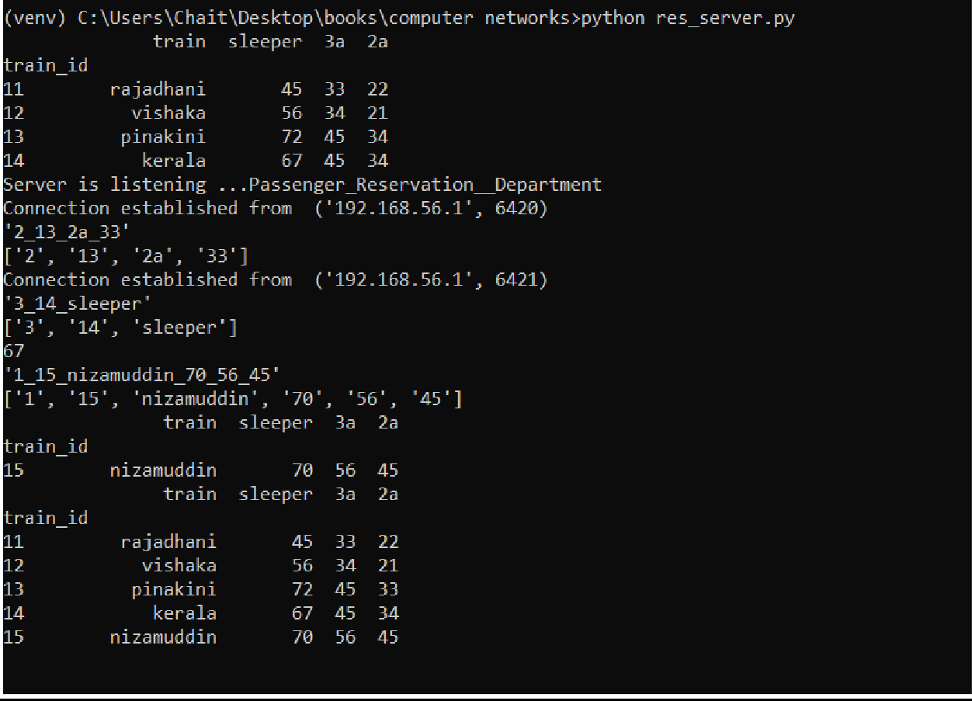

CLIENT 1:

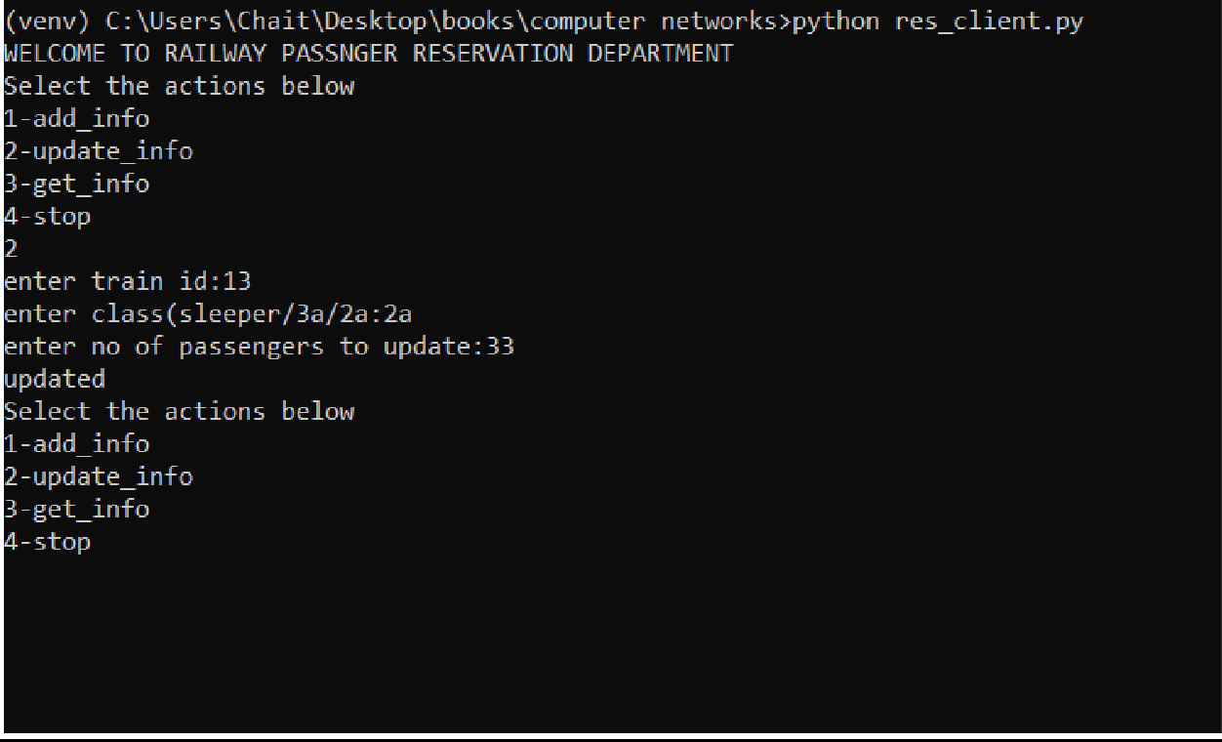

## CLIENT 2:

Client 3:

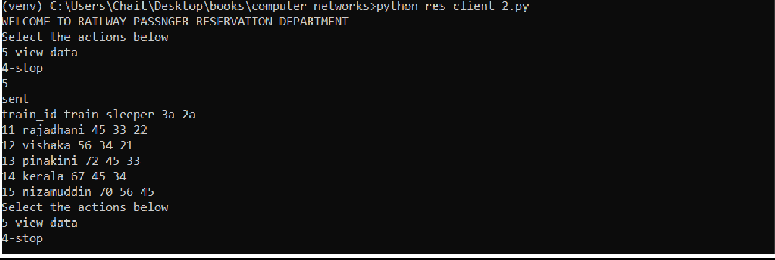

Cisco Packet Tracer Design(RAILWAY RESERVATION):

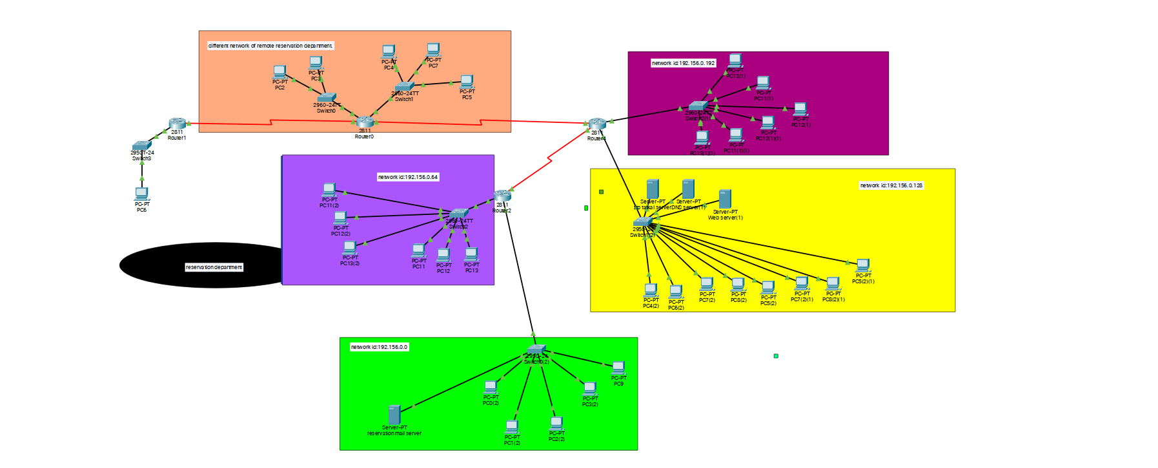

Subnet Allocation:

Subnetting with range of IP addresses possible of 64 and starting from subnet address as 196.156.0.0 for first subnet and following for other three mentioned in table.

|  |  |  |  |
| --- | --- | --- | --- |
| Reservation Department Local Office | Reservation | Range of IP address:  192.156.0.1-192.156.0.63  Subnet address: 192.156.0.0  Subnet mask :255.255.255.192  Protocols configured:ospf | Organizing reservation info. |
|  | Tatkal | Range of IP address:  192.156.0.65-192.156.0.127  Subnet  address: 192.156.0.64  Subnet mask :255.255.255.192  Protocols configured:ospf | Managing Tatkal operations |
|  | Management | Range of IP address:  192.156.0.129-192.156.0.191  Subnet address: 192.156.0.128  Subnet mask :255.255.255.192  Protocols configured:ospf | Updating reservation info about any changes |
|  | Subnetwork name | Range of IP address:  192.156.0.193-192.156.0.255  Subnet address: 192.156.0.192  Subnet mask :255.255.255.192  Protocols configured:ospf | Back office management |
| Remote Reservation Offices |  | Showing how remote networks are connected. |  |
|  | FTP server | Category:  FTP |  |
|  | Email server | Category:  Email |  |
|  | Application server | Category:  Web |  |
|  | OSPF | Routing protocol | Between subnets and outer network |
|  | RIP | Routing protocol | Between remote office and local office. |

Mail Server:

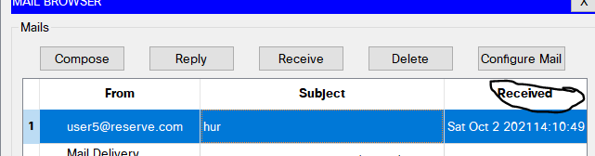

Web Server:

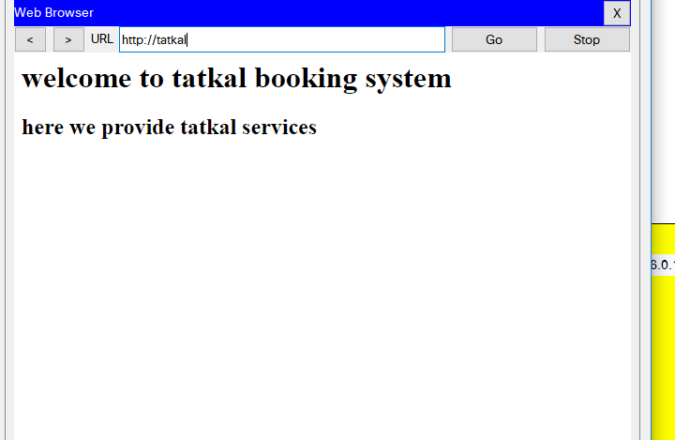

RIP:

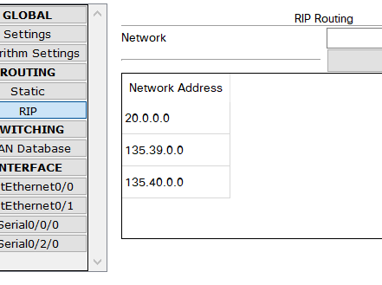

OSPF:

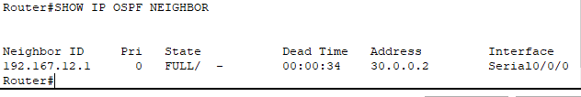

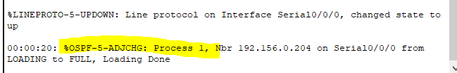

VLAN:

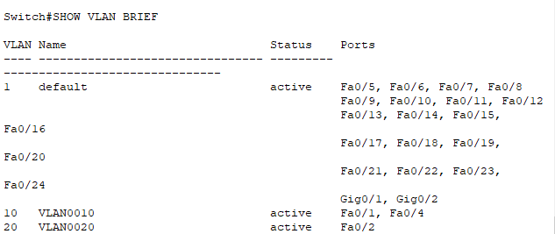

Inter vlan:

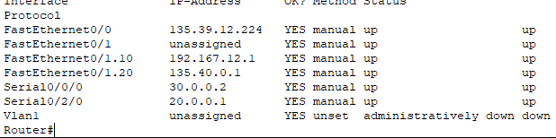

package snippet;

import java.io.DataInputStream;

import java.io.DataOutputStream;

import java.io.IOException;

import java.net.ServerSocket;

import java.net.Socket;

import java.net.SocketException;

public class go_back {

static ServerSocket Serversocket;

static DataInputStream dis;

static DataOutputStream dos;

public static void main(String[] args) throws SocketException {

try {

int a[] = { 100,30, 40, 50, 60, 70, 80, 90, 100, 110,40 };

Serversocket = new ServerSocket(8011);

System.out.println("waiting for connection");

Socket client = Serversocket.accept();

dis = new DataInputStream(client.getInputStream());

dos = new DataOutputStream(client.getOutputStream());

System.out.println("The number of packets sent is:" + a.length);

int y = a.length;

dos.write(y);

dos.flush();

for (int i = 0; i < a.length; i++) {

dos.write(a[i]);

dos.flush();

}

int k = dis.read();

dos.write(a[k]);

dos.flush();

} catch (IOException e) {

System.out.println(e);

} finally {

try {

dis.close();

dos.close();

} **catch** (IOException e) {

e.printStackTrace(); }

}}}

Go back N and Selective Repeat:

Server side:

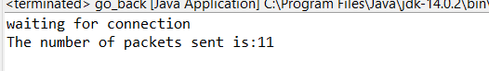

package snippet;

import java.lang.System;

import java.net.*;

import java.io.*;

public class client {

static Socket connection;

public static void main(String a[]) throws SocketException {

try {

int v[] = new int[11];

//int g[] = new int[8];

int n = 0;

InetAddress addr = InetAddress.getByName("Localhost");

System.out.println(addr);

connection = new Socket(addr, 8011);

DataOutputStream out = new DataOutputStream(

connection.getOutputStream());

DataInputStream in = new DataInputStream(

connection.getInputStream());

int p = in.read();

System.out.println("No of frame is:" + p);

for (int i = 0; i < p; i++) {

v[i] = in.read();

System.out.println(v[i]);

//g[i] = v[i];

}

v[3] = -1;

for (int i = 0; i < p; i++)

{

System.out.println("Received frame is: " + v[i]);

}

for (int i = 0; i < p; i++)

if (v[i] == -1) {

System.out.println("Request to retransmit packet no "

+ (i+1) + " again!!");

n = i;

out.write(n);

out.flush();

}

System.out.println();

v[n] = in.read();

System.out.println("Received frame is: " + v[n]);

System.out.println("quiting");

} catch (Exception e) {

System.out.println(e);

}

}

}

Client Side:

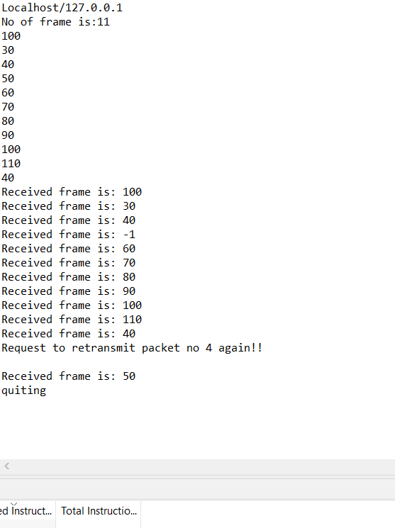

Cloud Virtualization:

Now a days it is very difficult to bring every employee around the world to work at same place where all the data centers of a company are located or it will be very costly for a small organization to purchase heavy hardware material for limited amount of work.

To answer all these problems , CLOUD concept comes into play where you can virtually use hardware or software present in some other parts of the world right from your home.

Having physical devices or copies of these things can be difficult to move or copy when you need to move something. A virtual server or desktop can be easily moved and accessed from a different location.

In addition, physical devices are limited by the specific set of hardware they’re installed on, while virtual devices can easily be allocated resources as necessary. Physical hardware can be consolidated, and a virtual machine could access resources from multiple pieces of hardware.

Cloud and Networking:

Normally with the help of internet you can login to your cloud provider. After that within the cloud you can create your virtual private cloud and access the storage and software facilities so that your data is protected from accessing by some other clients.Cloud providers will provide separate network ids and subnets to work on.

Cloud is not different from normal network but a part of network where the hardware ot software that needed to be installed in different geographical locations are offered as a remote service that can be accessed by people belonging to different areas.

Cloud In Railway Zone Management:

Railway requires huge software support in order to provide services relentlessly . So software that is being used can be a part of cloud and data that is needed to be accessed within departments also uses cloud.

Mostly in Railway Department cloud is an important means of storage and crucial part of network. A private cloud is used for official purpose and is accessed by employees from various geographical locations who are connected to the railway computer network.

In this way virtualization is possible along with proper security and effective management.