**19CSE301-Computer Networks**

**CO#1**

**Practice Lab**

**(Set -1)**

A browsing center has a log maintained for users for every date. The fields and purpose are as below:

|  |  |
| --- | --- |
| Date | Date of entry to browsing center |
| User | The user name |
| Bandwidth | Bandwidth consumed by user |
| Time | Time of utilization |

A sample log is attached (centerlog.xls)

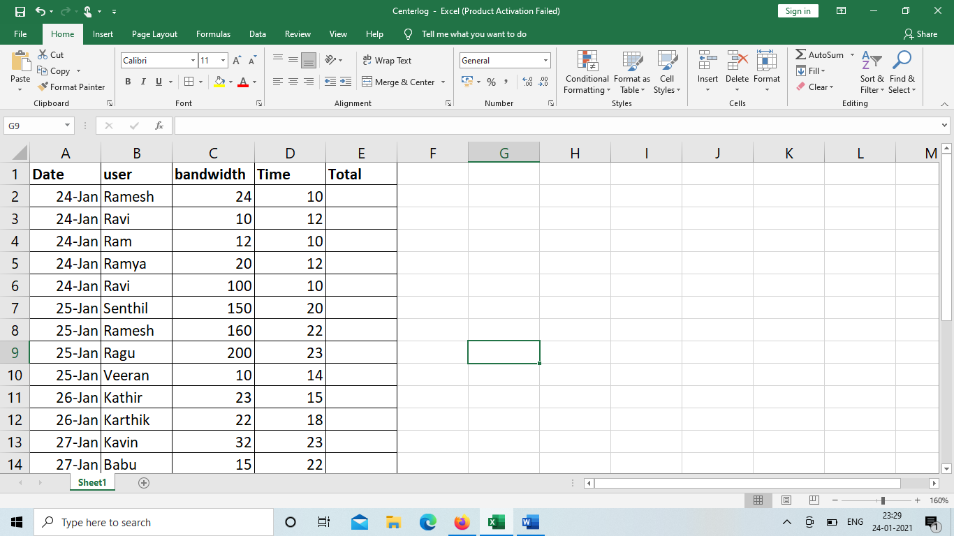

Create a client server program with multiple clients. The program should have the following functionality:

1. The client program should have the facility to update the sample log with values for Date,user,bandwidth,Time.
2. Upon entering it should calculate the Total as Bandwidth*Time . For example for 24-jan,user as Ramesh it should provide Total as 24*10 I,e 240 in Total column.
3. The server program will provide the following features:
4. On entering the date it should display the Date,user,bandwidth,Time.Total

For ex: if the date entered is 24-jan the output should be

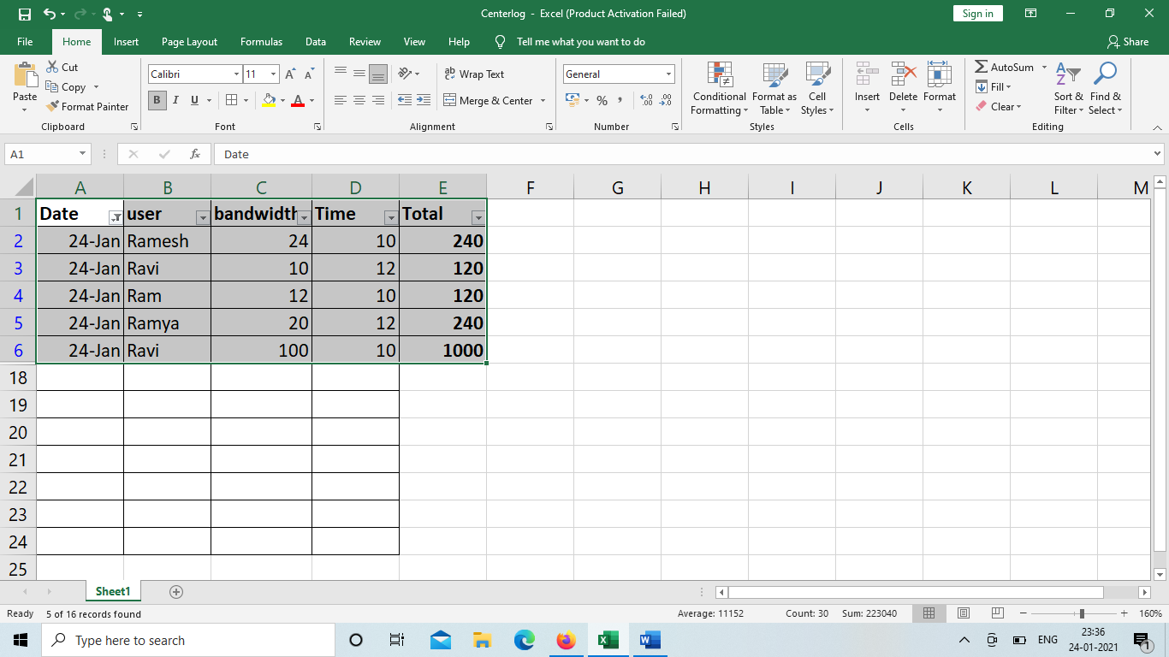

1. Given the user name it should display their dates of access. For ex: if the user name is Ravi it should display as :

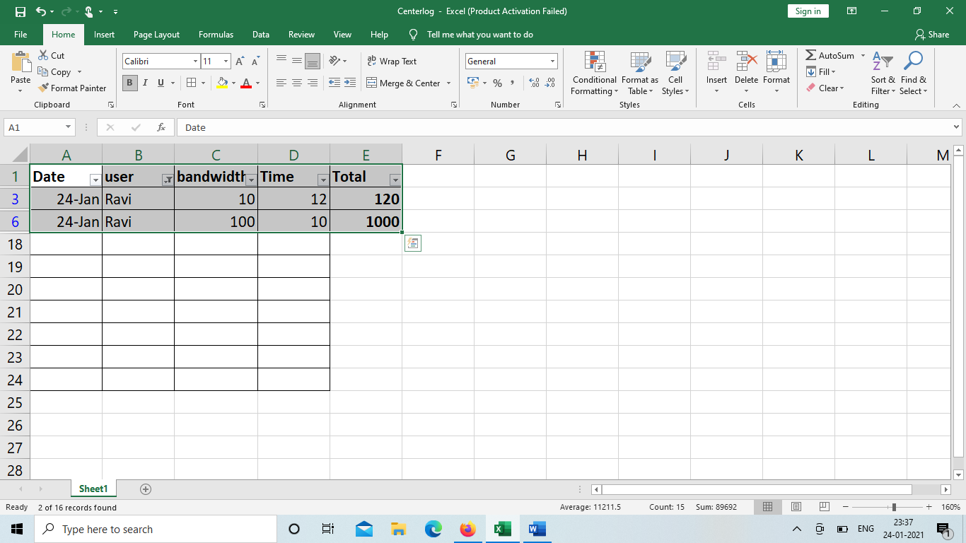

1. On entering a option “Total sales” it should sum and say the total sales datewise:

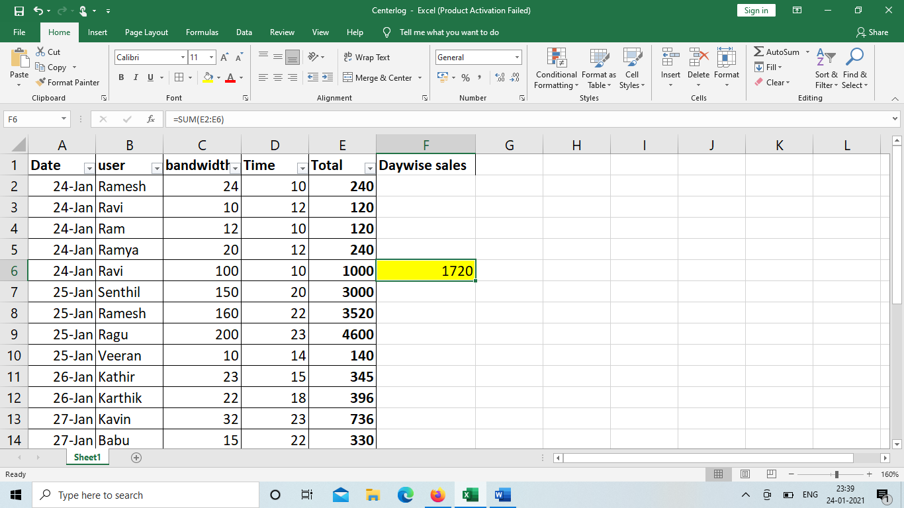

Demonstrate the same for multiple client.

d.Include the ipaddress as a parameter in **centerlog.xls** and provide values for the same from the client. Demonstrate operations under a,b,c.

e.There can be option named “splitfiles” in server side. Upon selecting the option it can create individual files for each date and store their logs. For ex: 24-Jan.xls will have data related to Date as 24-jan.

**Evaluation procedure**

a. If they have completed option a,b,c,d they can be given full marks

b.If they have not completed any options minimum mark can be awarded

c.If they have completed option e also kindly mention in excel sheet. This we shall take it forward for awarding the top grade during grading process

**Evaluation Split-up**

|  |  |  |
| --- | --- | --- |
| Program | 10 Marks | Minimum mark-2 |
| Design | 5 Marks | Minimum mark-1 |
| Output | 10 Marks | Minimum mark-2 |
| Viva | 5 Marks |  |

Note : Option e in question is not compulsory. It can be completed and will be considered towards best performance during grading process.