PROJECT REPORT

AI DATA ANALYTICS PROJECT
Cover Page
1. Introduction
2. Project Objective
3. Dataset Description
4. Technologies Used
5. Data Loading
6. Data Cleaning
7. Exploratory Data Analysis
7.1 Monthly Revenue + Screenshot
7.2 Revenue by Category + Screenshot
7.3 Customer Segments + Screenshot
7.4 Regional Revenue + Screenshot
7.5 Top 10 Products by Profit + Screenshot
8. 5 Observations
9. 5 Insights
10. 3 Hypotheses
11. 3 Recommendations
12. Conclusion
13. References

1. Introduction
This project focuses on analyzing an e-commerce transaction dataset using exploratory data analysis techniques. The project uses Python, Pandas, Matplotlib, Excel, and Google Colab to explore sales performance, customer behaviour, regional revenue, and product profitability. The analysis converts raw transaction data into meaningful observations, insights, hypotheses, and business recommendations.
2. Project Objective
The main objective of this project is to explore the e-commerce dataset and identify important business patterns. The analysis aims to understand monthly revenue trends, category performance, customer segmentation, regional revenue distribution, and product profitability. The project also aims to convert analytical findings into useful business insights and practical recommendations.
3. Dataset Description
The dataset contains e-commerce transaction records. Each record provides information about an order, customer, product, category, region, quantity, revenue, and profit.
The main fields used in the analysis are:
• Order_ID – Unique identifier for each order.
• Order_Date – Date on which the order was placed.
• Customer_ID – Identifier of the customer.
• Product – Name of the purchased product.
• Category – Category of the product.
• Region – Region associated with the transaction.
• Quantity – Number of units purchased.
• Revenue – Revenue generated from the transaction.
• Profit – Profit generated from the transaction.

4. Technologies Used
Python:
Used as the primary programming language for data analysis.
Pandas:
Used for loading, cleaning, grouping, and analyzing the dataset.
Matplotlib:
Used to create the required visualizations.
Microsoft Excel:
Used for reviewing and preparing the dataset.
Google Colab:
Used as the environment for running the Python analysis and generating charts.
Gemini:
Used as an AI assistant for analysis guidance, code generation, and validation of analytical findings.
5. Data Loading
The dataset was loaded into Python using the Pandas library. The Excel workbook was read into a Pandas DataFrame, which was then used for further data exploration and analysis. The first few records were displayed using df.head() to verify that the dataset was loaded correctly.
import pandas as pd
df = pd.read_excel('/content/Raw_Data.xlsx', sheet_name='Cleaned_Data')
df.head()

6. Data Cleaning
Data cleaning was performed before the exploratory analysis to improve the consistency and reliability of the data. Category and region names were standardized so that different capitalization formats represented the same category or region. Revenue and profit values were converted into numeric values for analysis. Date values were processed so that monthly revenue could be calculated. Customer segments were determined using Customer_ID so that customers appearing once were treated as new customers and customers appearing more than once were treated as repeat customers.
7. Exploratory Data Analysis
7.1 Monthly Revenue
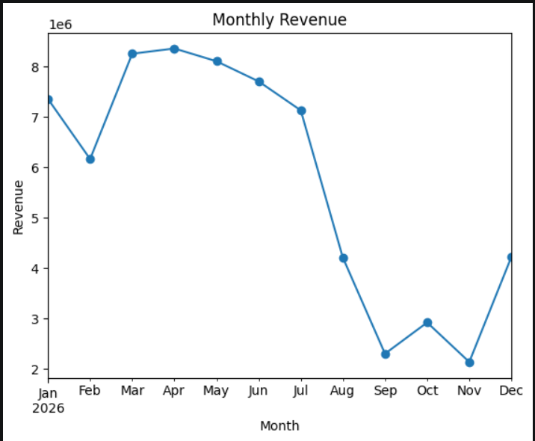

Figure 1: Monthly Revenue Analysis
7.2 Revenue by Category

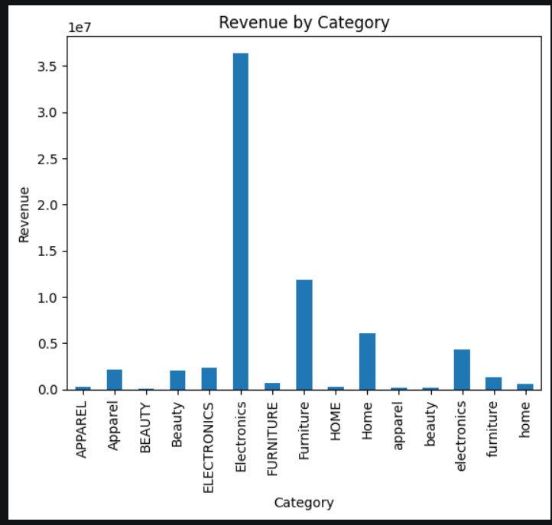

Figure 2: Revenue by Category

7.3 Customer Segments(Figure 3: Customer Segment Analysis)
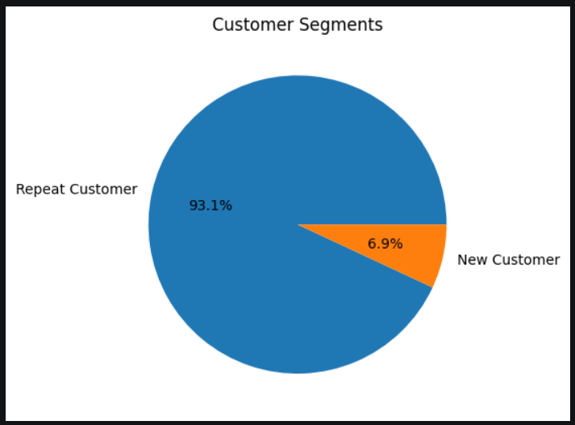
7.4 Regional Revenue (Figure 4: Regional Revenue Analysis)
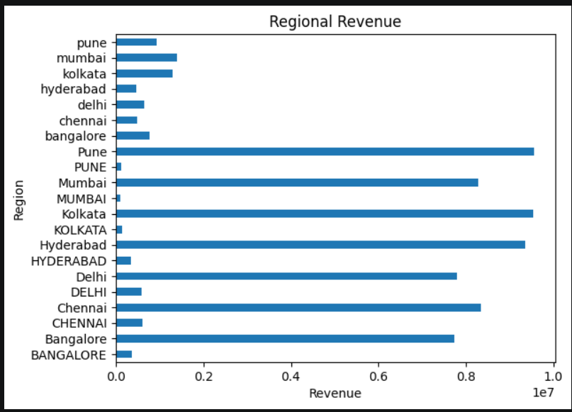
7.5 Top 10 Products by Profit
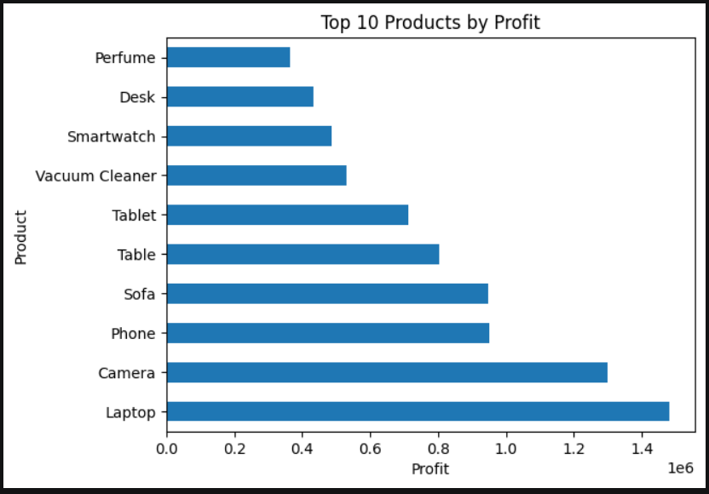

8. 5 Observations
1. Monthly Revenue:
Revenue peaked in April 2026 and showed a significant decline in the later months.
2. Category Breakdown:
Electronics generated the highest total revenue, while Beauty generated the lowest revenue.
3. Customer Segment Split:
Repeat customers make up the larger share of customers compared with New Customers.
4. Regional Distribution:
Pune generated the highest revenue among the regions, while Bangalore had the lowest among the known regions.
5. Product Profitability:
Phone was the highest-profit named product.
9. 5 Insights
1. Extreme Revenue Seasonality:
The large difference between the highest- and lowest-revenue months indicates strong variation in monthly revenue.
2. Core Category Dependency:
Electronics contributes a very large share of total revenue compared with the other categories.
3. Customer Retention vs. Acquisition:
The customer base contains a much larger proportion of repeat customers than new customers.
4. Regional Revenue Distribution:
Revenue is spread across the regions, with noticeable differences between the highest- and lowest-revenue regions.
5. Data Quality Risk:
Blank or unlabeled product entries account for a large amount of profit, which can make product-level profitability analysis less reliable.
10. 3 Hypotheses
1. Promotional Lulls:
The large drop in revenue in the later months might be related to changes or pauses in promotional and marketing activities.
2. Supply Chain Disruption:
The sharp decline in revenue might be caused by stockouts or inventory shortages in important product categories.
3. Product Catalog Changes:
Changes in product launches, product availability, or discount structures might have contributed to the large variation in monthly revenue.
11. 3 Recommendations
1. Revenue Stability:
Investigate the reasons for large month-to-month revenue changes and review marketing, inventory, and product availability around low-revenue periods.
2. Customer Growth:
Develop initiatives to increase the number of new customers while maintaining engagement with existing repeat customers.
3. Product Data Quality:
Complete and standardize missing or blank product information so that product-level profit analysis is reliable.
12. Conclusion
The project successfully applied exploratory data analysis to an e-commerce dataset using Python, Pandas, Matplotlib, Excel, Google Colab, and Gemini. The analysis examined monthly revenue, category performance, customer segments, regional revenue, and product profitability. Five visualizations were created to identify important patterns in the data. These findings were then converted into five observations, five insights, three hypotheses, and three practical recommendations. The project demonstrates how data analysis can support better understanding of business performance and guide further investigation.

13. References
1. IBM SkillsBuild – Data Analytics with AI Internship Materials
2. IBM SkillsBuild Masterclass 2 – AI Discovers the Story
3. Google Colab
4. Python Documentation
5. Pandas Documentation
6. Matplotlib Documentation
7. E-commerce Dataset used for the project

Student Name: Kage KrishnaChaitanya Kumar
Branch: B.Tech – CSE(Data Science)
Internship: AICTE | IBM SkillsBuild Data Analytics with AI Internship 2026 | BharatCares
Project Title: AI Data Analytics Project

