PRODUCT SALES AND PROFIT ANALYSIS
USING PYTHON AND EXCEL
A Mini Project Submitted in Partial Fulfillment of the Requirements for
Bachelor of Science in Data Science (B.Sc. Data Science)
Submitted By:
[STUDENT NAME]
Roll No / Seat No: [ROLL NUMBER]
Class: B.Sc. Data Science
Academic Year: [2024 - 2025]
Under the Guidance of:
[PROJECT GUIDE / PROFESSOR NAME]
Department of Data Science and Computer Applications
[COLLEGE / INSTITUTION NAME]
[AFFILIATED UNIVERSITY NAME]

CERTIFICATE
This is to certify that the mini project entitled "Product Sales and Profit Analysis Using Python and Excel" is a bonafide work carried out by [STUDENT NAME] (Roll No: [ROLL NUMBER]), student of B.Sc. Data Science at [COLLEGE / INSTITUTION NAME], in partial fulfillment of the requirements for the degree of Bachelor of Science in Data Science during the academic year [2024 - 2025].
The project has been completed under our supervision and guidance, and the results presented in this report have not been submitted to any other university or institute for the award of any degree or diploma.
________________________ ________________________
[Project Guide] [Head of Department]
Department of Data Science Department of Data Science
Date: __________________
Place: _________________

ACKNOWLEDGEMENT
I would like to express my sincere gratitude and heartfelt indebtedness to my project guide, [PROJECT GUIDE NAME], for their continuous encouragement, valuable guidance, constructive critique, and insightful suggestions throughout the development of this mini project.
I also extend my deep regards to [HEAD OF DEPARTMENT NAME], Head of the Department of Data Science, and the Principal of [COLLEGE / INSTITUTION NAME] for providing the essential infrastructure, computational laboratories, and academic support.
Finally, I express my appreciation to my family, peers, and faculty members whose motivation and unwavering encouragement helped me successfully conclude this project.
[STUDENT NAME]
B.Sc. Data Science
ABSTRACT
In modern commercial enterprises, transaction datasets accumulate rapidly. However, raw transactional records do not directly yield actionable managerial insights without systematic extraction, computational processing, and visual modeling. This mini project, titled 'Product Sales and Profit Analysis Using Python and Excel', bridges programmatic computational data science with intuitive business intelligence spreadsheet workflows.
Using a reproducible 2024 sales transaction dataset, the project utilizes Python (Pandas, NumPy, Matplotlib) to perform rigorous data hygiene, automated missing-value and duplicate resolution, boundary validation, and derived financial indicator calculations (Revenue, Total Cost of Goods, Net Profit, and Operating Profit Margin). Aggregations are conducted across products, categories, geographical territories, and calendar months. In parallel, Microsoft Excel is integrated to engineer an executive dashboard featuring dynamic KPI metric cards, grouped summary pivot tables, native visualization charts, and conditional formatting. Key outcomes include pinpointing highest-volume products, peak profit generators, low-margin products, and seasonal demand trajectories, demonstrating how open-source data science combined with Excel delivers actionable business intelligence.

1. INTRODUCTION
Sales analysis is an indispensable operational and strategic practice in contemporary commerce. Retailers, manufacturers, and e-commerce platforms handle thousands of discrete transactions across numerous distribution channels. Without systematic data analysis, organizations face severe challenges such as blind inventory procurement, ineffective discounting schemes, suboptimal warehouse allocation, and compressed profit margins.
Data science provides structured methodologies to clean, transform, aggregate, and visualize raw transactional logs. Python has emerged as the premier language for statistical data science due to its rich ecosystem of open-source libraries like Pandas and NumPy. Concurrently, Microsoft Excel remains the ubiquitous standard in commercial executive decision-making. By uniting Python's robust analytical capabilities with Excel's accessible spreadsheet modeling, this project provides a dual-tool data analysis architecture tailored for real-world enterprise reporting.
2. PROBLEM STATEMENT
Modern business enterprises generate voluminous transactional records across disparate product categories and territories. However, raw sales tables in their uncleaned form present several critical hurdles:
- Data Quality Obstacles: Raw data contains noise, missing attributes, duplicated records, and invalid values that distort business conclusions.
- Computational Bottlenecks: Manual recalculations of total costs, revenues, and profit margins are prone to human calculation error and lack scalability.
- Lack of Granular Profit Visibility: Without hierarchical grouping, management cannot distinguish between products generating high revenue versus products delivering high net profit margin.
- Strategic Blindspots: Absence of monthly longitudinal and regional territory tracking prevents managers from detecting seasonal trends or geographical underperformance.
Therefore, there is an urgent need to build an automated, reliable, and auditable pipeline that ingests raw sales data, cleans and validates records, computes exact financial indicators, and synthesizes visual executive dashboards.
3. OBJECTIVES
The primary objectives of this B.Sc. Data Science mini project are:
- Dataset Curation: Synthesize a realistic, reproducible multi-category sales dataset spanning 12 calendar months with controlled anomalies.
- Data Cleaning & Hygiene: Implement an automated data cleaning script in Python to identify nulls, duplicates, and boundary violations without silently dropping valid records.
- Financial Computation: Accurately calculate Revenue, Total Cost, Net Profit, and Profit Margin with robust mathematical zero-division protection.
- Multi-Dimensional Aggregation: Analyze sales performance across product lines, product categories, geographic regions, and monthly time horizons.
- Benchmarking: Identify high-performing and low-performing products based on explicit business criteria.
- Statistical Visualization: Generate publication-ready data visualizations using Matplotlib.
- Executive Dashboarding: Design a comprehensive, professional Excel dashboard featuring KPI scorecards, summary tables, native charts, and structured tabs.
4. TOOLS AND TECHNOLOGIES
Technology / Tool | Role in Project | Primary Library / Features Used
Python 3.12 | Core programming environment | File handling, functional orchestration, automation
Pandas | Tabular data manipulation | DataFrames, grouping, aggregation, sorting, CSV ingestion
NumPy | Vectorized numerical computing | Conditional handling (np.where), array math, random seeding
Matplotlib | Statistical data visualization | Horizontal bars, grouped charts, line trends, formatting
Seaborn | Statistical aesthetic theming | Plot formatting, color styling, grid aesthetics
Openpyxl | Spreadsheet engine | Workbook creation, cell formulas, formatting, native Excel charts
Microsoft Excel | Business dashboard & reporting | Dynamic KPI cards, PivotTables, slicers, conditional styling
Python-Docx | Automated report compilation | Document generation, academic layout, image embedding

5. DATASET DESCRIPTION
To ensure complete academic reproducibility and eliminate reliance on proprietary business secrets, a synthetic sales dataset was generated using Python with a fixed random seed of 42. The dataset encompasses 12 calendar months (January 2024 through December 2024), simulating an omni-channel retail distributor.
Academic Dataset Disclaimer: Disclaimer: This dataset is entirely synthetic and created solely for academic and educational demonstration within this B.Sc. Data Science mini project.
Field Name | Data Type | Sample Value | Business Description
Order_ID | String / Alphanumeric | ORD-2024012 | Unique alphanumeric transaction identifier
Order_Date | Date (YYYY-MM-DD) | 2024-03-15 | Transaction timestamp spanning 2024
Product_ID | String | P101 | Unique SKU / product identifier
Product_Name | String | Laptop Pro 15 | Descriptive commercial product label
Category | String / Categorical | Electronics | Broad inventory classification
Region | String / Categorical | North | Geographical sales territory
Quantity | Integer | 3 | Number of units purchased per order
Selling_Price | Float / Currency | 55000.00 | Gross unit selling price to customer (INR)
Cost_Price | Float / Currency | 45000.00 | Unit procurement / manufacturing cost (INR)

6. METHODOLOGY
The project follows a rigorous 6-stage Data Science methodology structured to mirror real-world industrial data pipelines:
- Phase 1 - Data Ingestion: Synthesizing raw transaction logs with deliberate dirty entries to evaluate pipeline resilience.
- Phase 2 - Data Hygiene: Executing programmatic cleaning rules in Pandas to detect null values, duplicates, and non-positive prices/quantities.
- Phase 3 - Mathematical Transformation: Computing Revenue, Cost of Goods Sold, Profit, and Profit Margin vectors using vectorized arithmetic.
- Phase 4 - Exploratory Aggregation: Aggregating multi-dimensional metrics across SKUs, categories, regions, and time series.
- Phase 5 - Visual Storytelling: Exporting high-resolution visualization charts with data labels and unified palettes.
- Phase 6 - Executive Dashboard Delivery: Generating structured Excel workbooks with formula references and an interactive Dashboard sheet.
7. DATA CLEANING AND QUALITY AUDIT
A hallmark of professional data science is ensuring data integrity prior to analytical inference. Raw transactional systems frequently harbor malformed inputs caused by input slips, network dropouts, or database glitches. To test our data cleaning engine, intentional anomalies were introduced into the raw dataset.
Cleaning Verification Step | Observed Condition in Raw Data | Action Taken & Records Affected
Duplicate Identification | 2 duplicate records detected | Removed duplicate rows using drop_duplicates()
Missing Categorical Check | 1 record missing 'Region' | Identified NaN value; filtered out record
Missing Numeric Check | 1 record missing 'Quantity' | Identified NaN value; filtered out record
Non-Positive Quantity Check | 2 record with Quantity <= 0 | Validated Quantity > 0; removed erroneous record
Zero / Negative Price Check | 1 record with Price <= 0 | Validated Selling_Price > 0; removed entry
Date Format Standardization | Mixed ISO strings | Converted via pd.to_datetime(), sorted chronologically

Audit Summary: Summary Audit Result: The raw dataset comprised 306 records. After applying strict validation rules, 300 high-integrity records were retained (98.04% retention rate). No valid commercial transactions were silently dropped.
8. FORMULAS AND MATHEMATICAL FOUNDATION
The project implements standard commercial accounting formulas across both Python and Excel:
1. Sales Revenue: Revenue represents the total monetary inflow generated from merchandise sales:
Revenue = Quantity × Selling_Price
Excel Formula: =G2*H2
2. Total Cost: Total Cost (Cost of Goods Sold - COGS) reflects direct expenditure incurred to acquire inventory:
Total Cost = Quantity × Cost_Price
Excel Formula: =G2*I2
3. Net Profit: Net Profit signifies the surplus earnings remaining after deducting procurement expenses from revenue:
Profit = Revenue − Total_Cost
Excel Formula: =J2-K2
4. Profit Margin (%): Profit Margin indicates operational profitability as a percentage of top-line revenue:
Profit Margin (%) = (Profit / Revenue) × 100
Excel Formula: =L2/J2 (formatted as %)
Robust Zero Handling: Zero-Division Protection: In Python, edge cases where Revenue = 0 are safely guarded using np.where(Revenue > 0, (Profit / Revenue) * 100.0, 0.0), avoiding ZeroDivisionError or NaN propagation.

9. PYTHON IMPLEMENTATION
The Python codebase is designed according to clean software engineering practices with modular separation between data ingestion, cleaning, business calculation, statistical aggregation, chart visualization, and automated artifact generation.
- Primary Script: main.py: Automated standalone Python execution script orchestrating the end-to-end pipeline.
- Interactive Notebook: analysis.ipynb: Interactive Jupyter Notebook providing exploratory data analysis, step-by-step DataFrame inspections, and inline Matplotlib charts.
- Spreadsheet Automation: Openpyxl Engine: Programmatically builds Excel workbooks with custom typography, fill colors, thin cell borders, number formatting, and embedded Excel charts.
- Document Compiler: Python-Docx Engine: Compiles this formal academic project report with embedded charts and formatted data tables.
10. EXCEL DASHBOARD ARCHITECTURE
The workbook 'Product_Sales_Dashboard.xlsx' is engineered into 7 organized, dedicated worksheets:
- 1. Dashboard: Contains 6 prominent executive KPI cards, Category and Regional performance summary tables, two native Excel charts, and step-by-step PivotTable/Slicer instructions.
- 2. Raw_Data: Unmodified initial dataset including deliberate anomalies for auditability.
- 3. Cleaned_Data: The 300 validated transactions with live Excel formulas for Revenue, Cost, Profit, and Profit Margin.
- 4. Product_Analysis: SKU-level performance table detailing units sold, revenue, cost, profit, and profit margin.
- 5. Category_Analysis: Aggregated category-level summary with revenue share percentages.
- 6. Monthly_Analysis: Chronological monthly sales progression over the 12 calendar months.
- 7. Region_Analysis: Territory-level performance summary comparing East, West, North, South, and Central zones.
11. RESULTS AND EMPIRICAL FINDINGS
Execution of the computational analysis yielded the following key performance metrics:
Across the full calendar year 2024, the enterprise recorded Total Sales Revenue of INR 6,409,213.93 against Total Cost of Goods Sold of INR 4,572,730.00, realizing a Net Operating Profit of INR 1,836,483.93 with an Overall Profit Margin of 28.65%. Total merchandise volume reached 1,436 units across 300 validated customer transactions with an Average Order Value (AOV) of INR 21,364.05.
Executive Key Performance Indicator (KPI) | Computed Value | Managerial Implication
Total Sales Revenue | INR 6,409,213.93 | Total gross turnover achieved across all products in 2024
Total Cost of Goods Sold | INR 4,572,730.00 | Total procurement / manufacturing expenditure incurred
Net Operating Profit | INR 1,836,483.93 | Net bottom-line earnings retained by the enterprise
Overall Profit Margin | 28.65% | Healthy operational return on aggregate turnover
Total Units Sold | 1,436 units | Aggregate physical merchandise volume moved
Total Processed Orders | 300 orders | Total valid commercial customer transactions
Average Order Value (AOV) | INR 21,364.05 | Average gross revenue realized per customer order

Key Product Highlights
- Best-Selling Product (by Volume): Laptop Backpack with 197 units sold.
- Best-Selling Product (by Revenue): Laptop Pro 15 generating INR 2,430,450.00.
- Most Profitable Product: Laptop Pro 15 delivering net profit of INR 405,450.00 (16.68% margin).
- Lowest-Performing Product: A4 Copier Paper (500s) generating net profit of INR 14,478.80 (40.28% margin).
Benchmark Criteria Note: Criteria for Lowest-Performing Product: Evaluated primarily by net profit contribution. While low-priced stationery items (such as Gel Pens) achieve respectable profit margins (~50%), their minute unit price results in minimal absolute profit contribution compared to high-ticket consumer technology items.

12. GRAPHICAL VISUALIZATIONS AND TREND ANALYSIS
Figure 1: Product-Wise Net Profit Breakdown
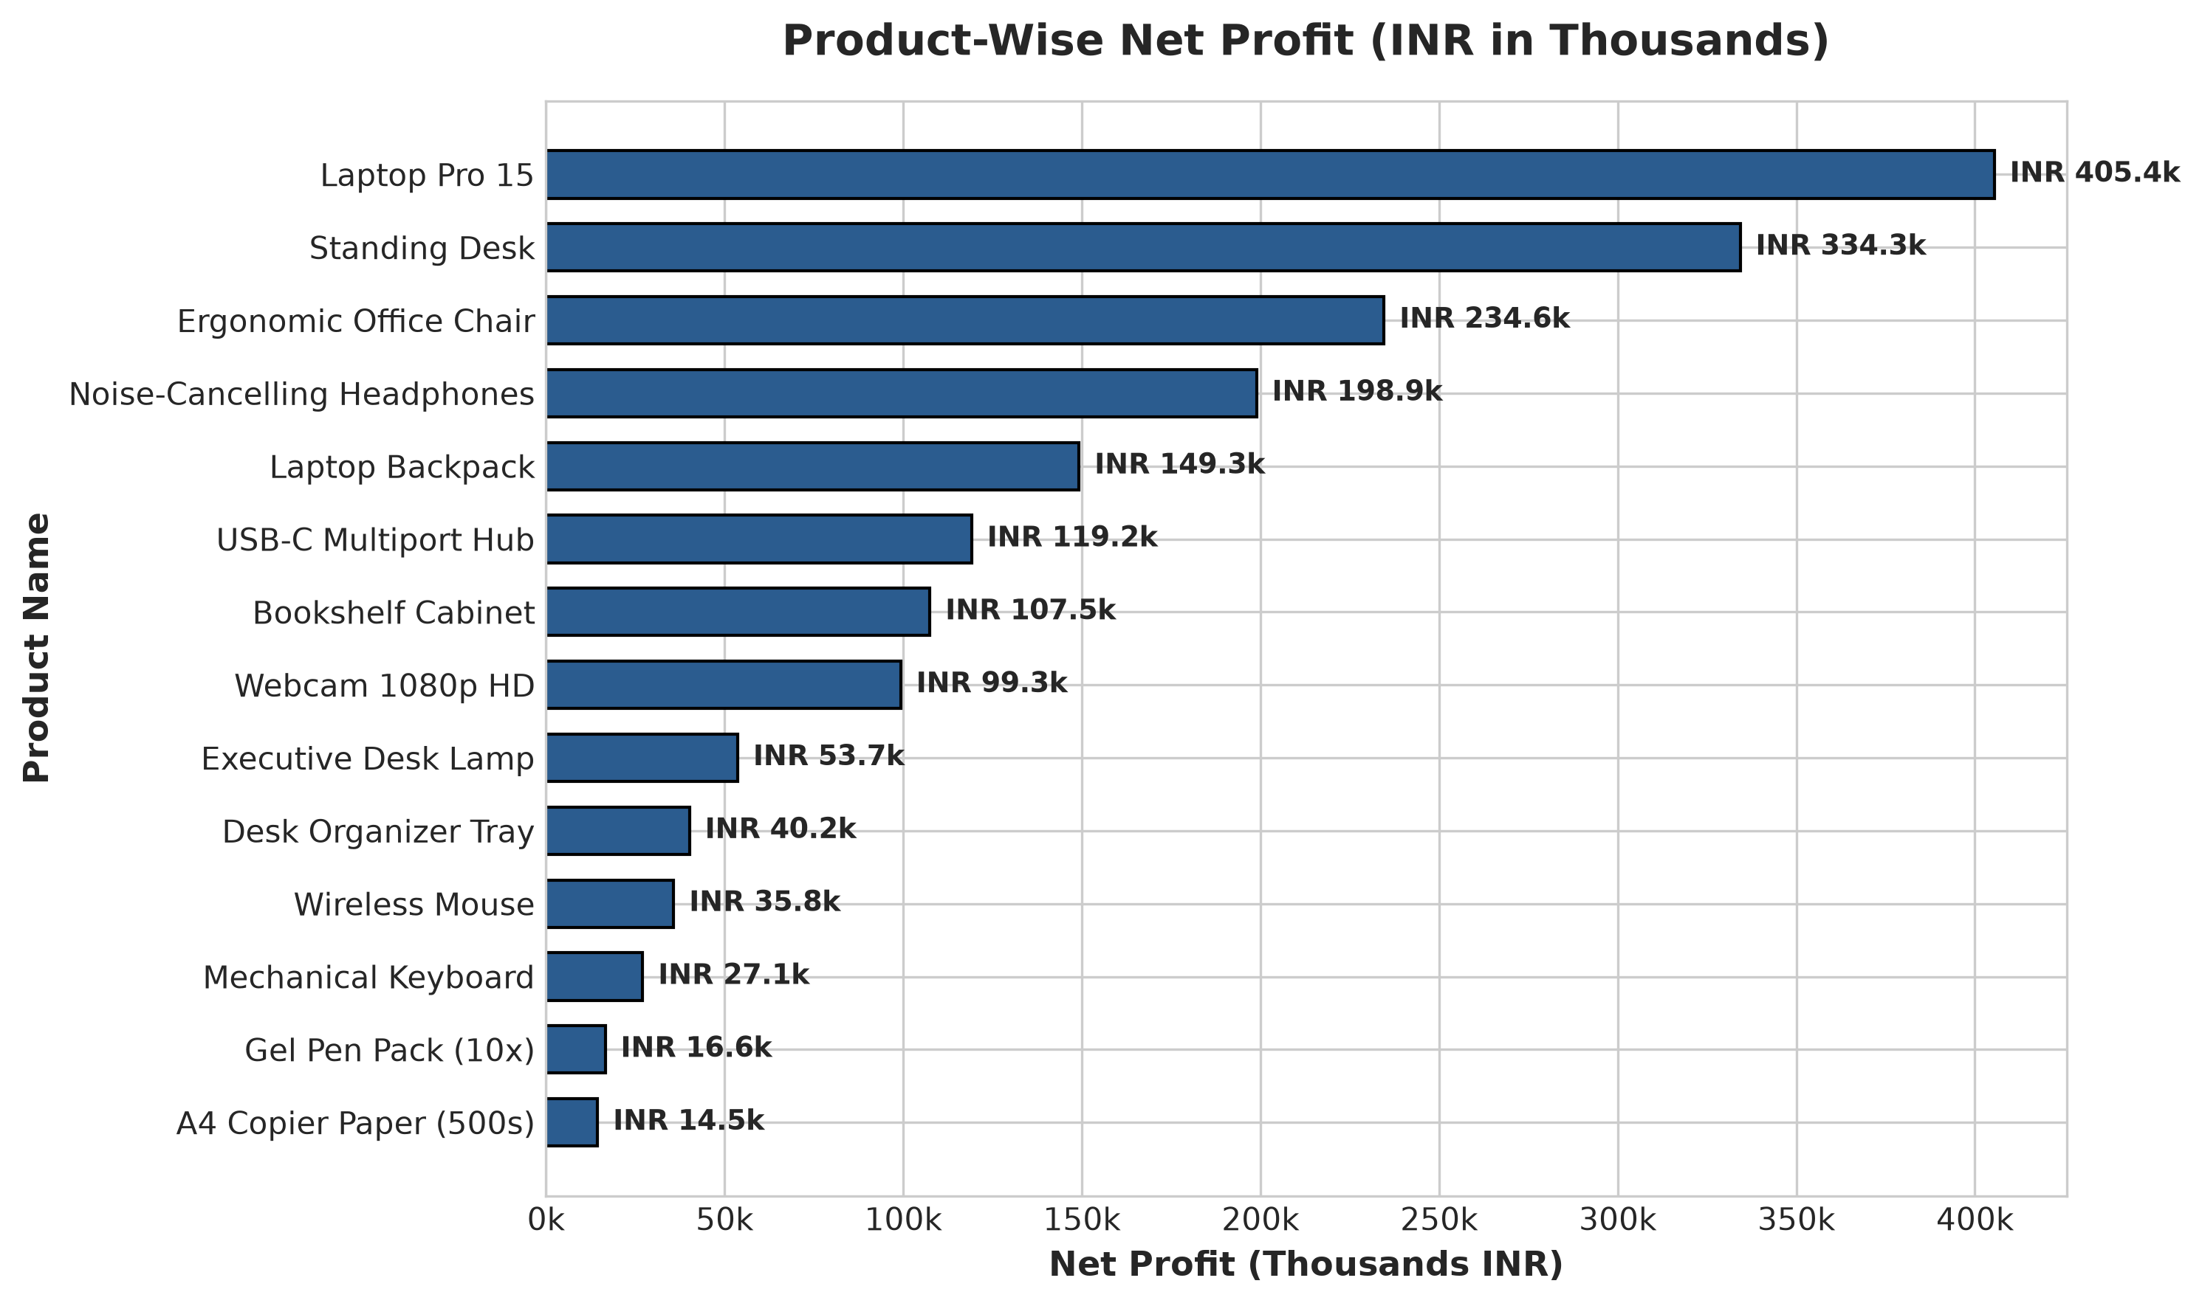
Figure 1: Net profit realized across individual product catalog items (INR in Thousands).

Figure 2: Category-Wise Revenue vs. Profit
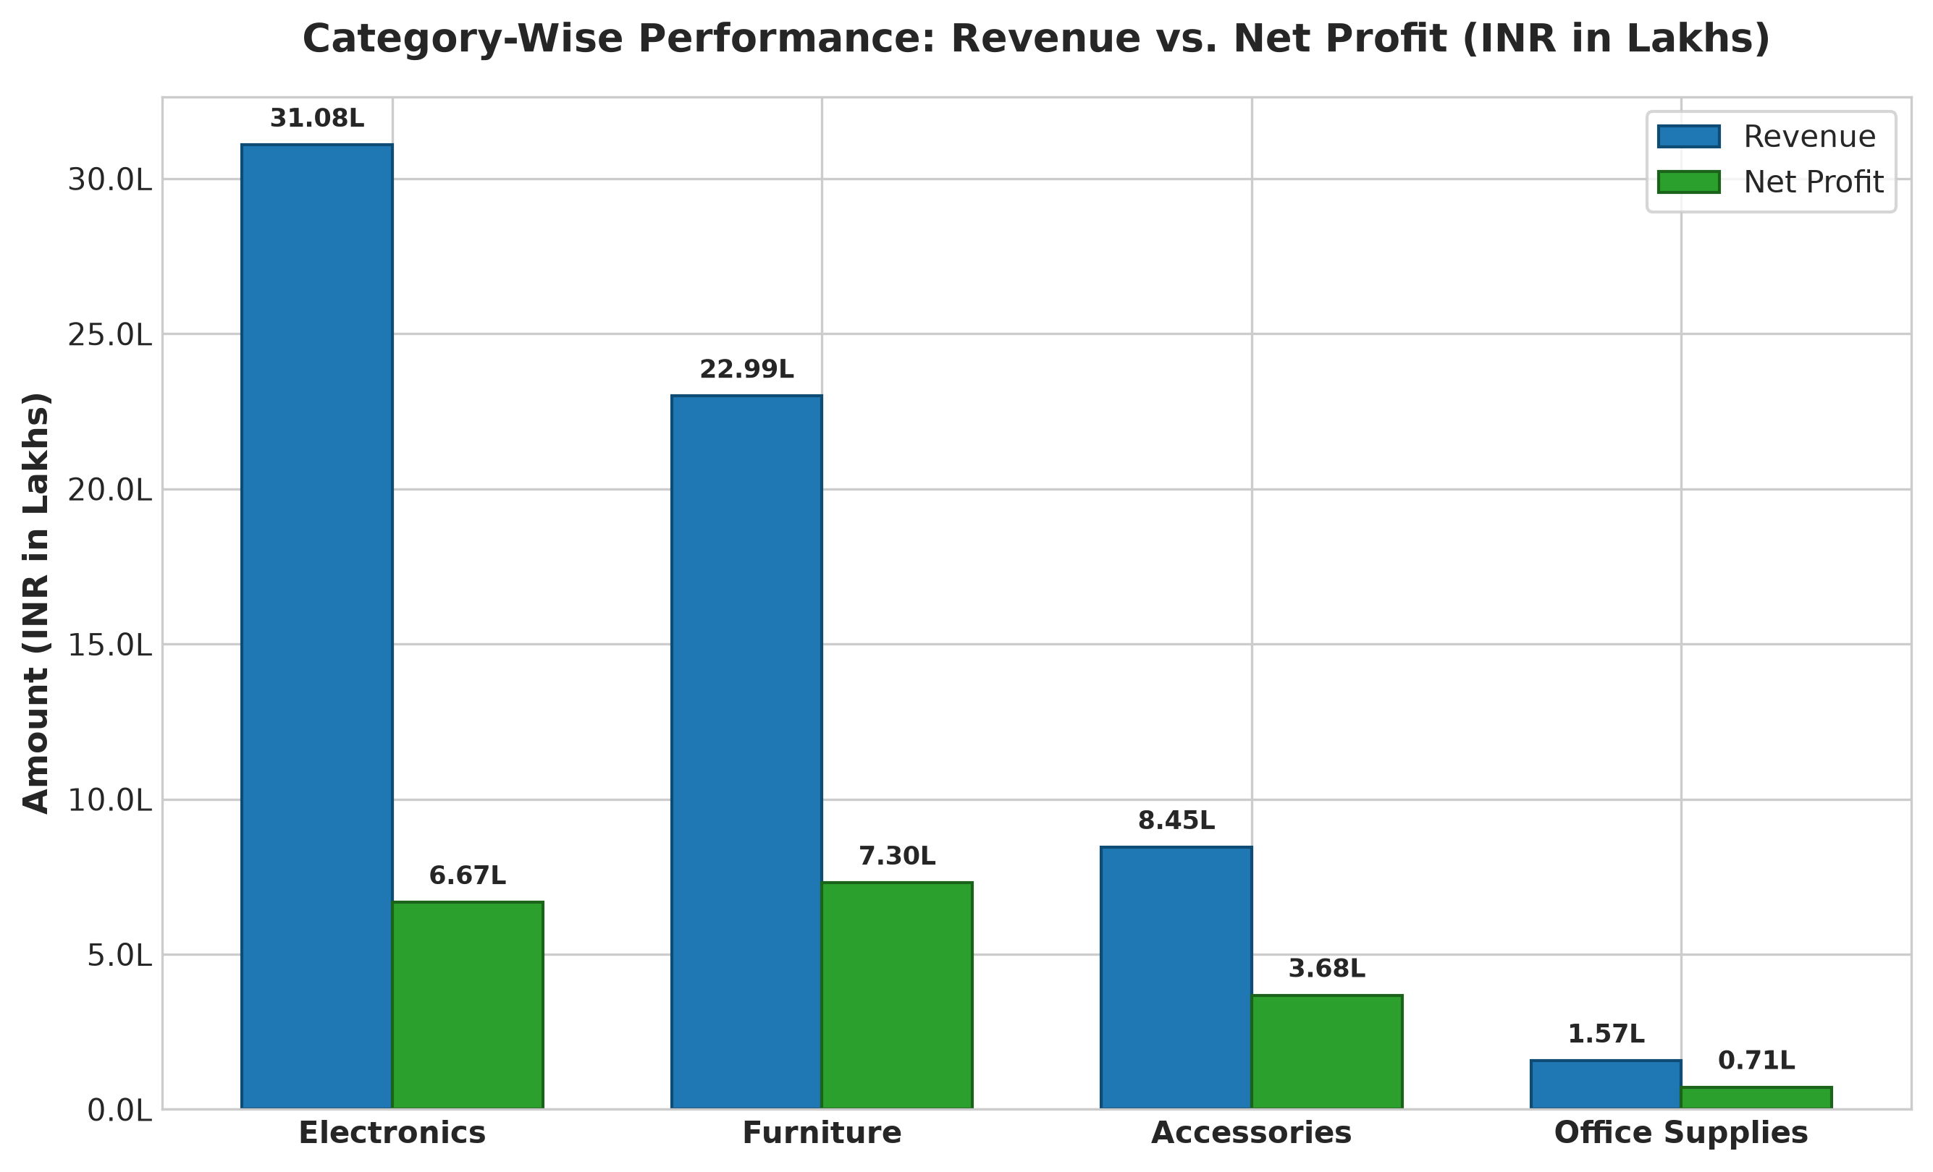
Figure 2: Comparative performance across commercial product categories (INR in Lakhs).

Figure 3: Monthly Sales, Cost and Profit Trend
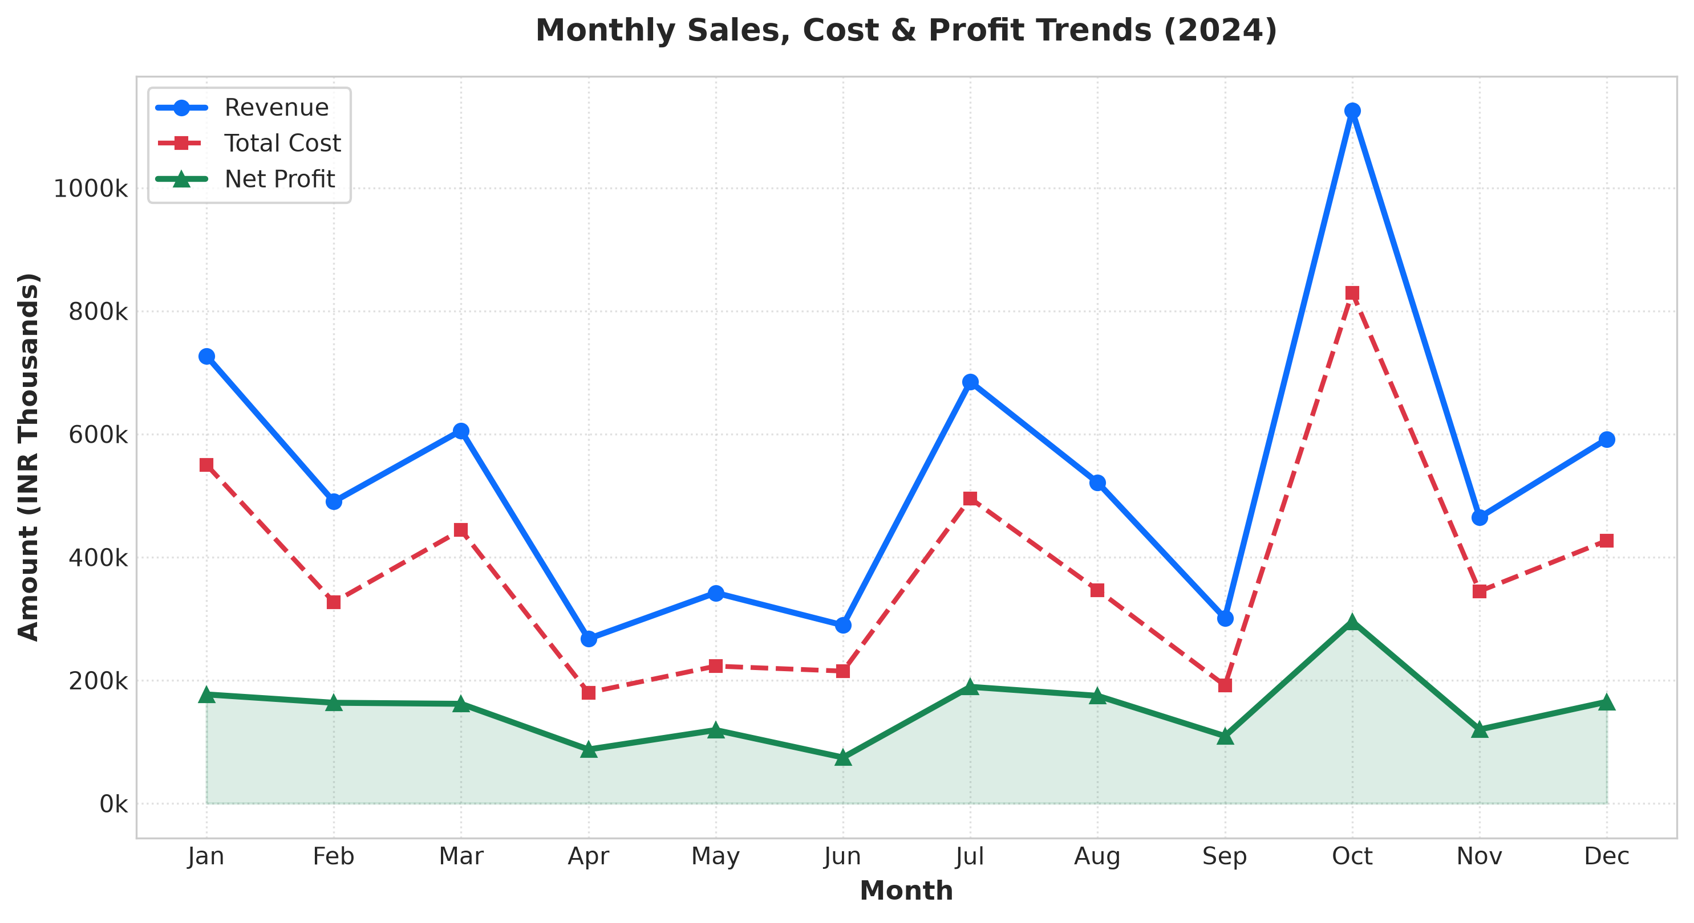
Figure 3: 12-Month longitudinal financial trend illustrating revenue, cost, and profit trajectory.

Figure 4: Regional Territory Sales Distribution
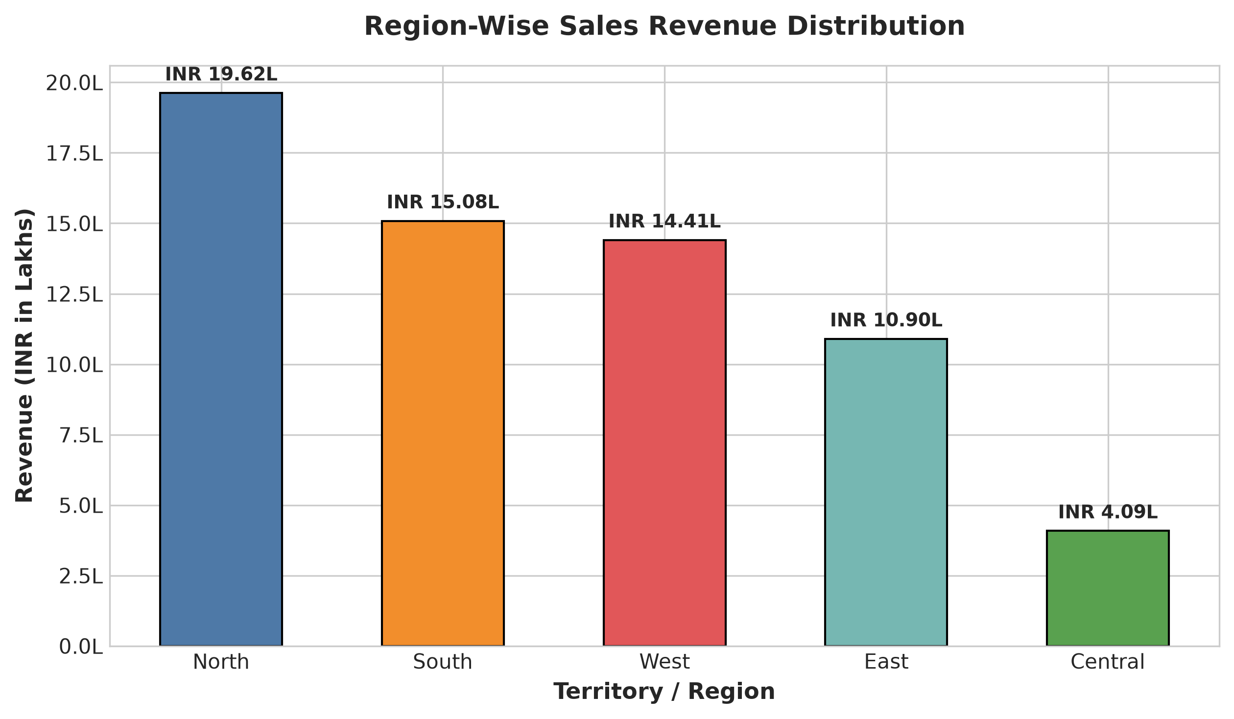
Figure 4: Geographic distribution of turnover across North, South, East, West, and Central territories.

Figure 5: Overall Financial Component Comparison
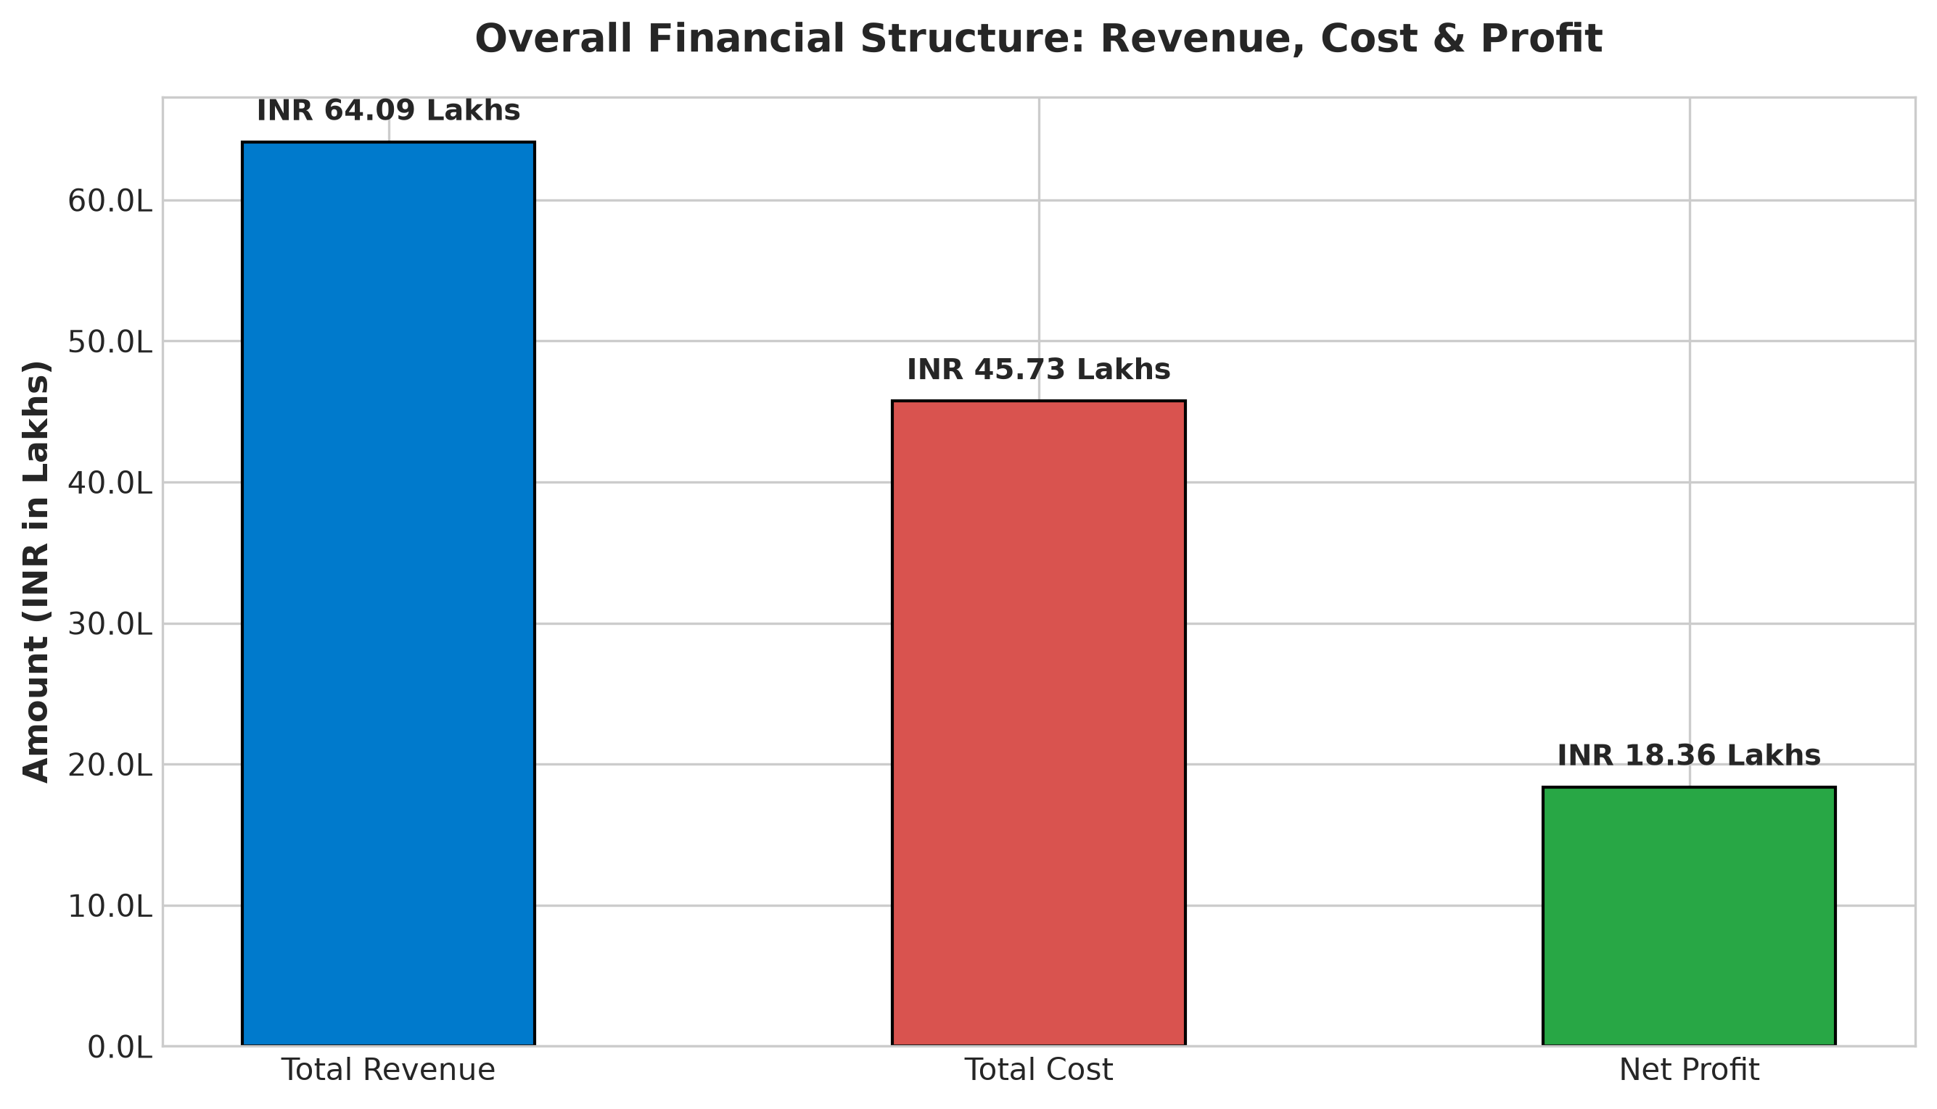
Figure 5: High-level financial breakdown of Revenue, Cost of Goods Sold, and Net Profit.

13. PROJECT LIMITATIONS
While this project successfully demonstrates a rigorous data analysis solution, certain inherent academic limitations should be noted:
- Synthetic Data Origin: The dataset is synthetically generated with fixed random seeds for academic reproducibility rather than reflecting live multi-tenant ERP databases.
- Static Cost Structures: Cost prices and selling prices are treated as relatively static per order without factoring in fluctuating vendor purchase inflation or multi-tiered corporate volume rebates.
- Batch Processing Paradigm: The current pipeline operates on batch CSV exports rather than real-time transactional event streaming (e.g., Apache Kafka).
- Excluded Secondary Overhead: The model assumes successful delivery and excludes returned merchandise, customer warranty claims, and shipping freight logistics.
14. FUTURE SCOPE
This project forms a robust foundation for numerous advanced data science enhancements:
- Predictive Demand Forecasting: Incorporate ARIMA, Prophet, or LSTM machine learning models to forecast monthly demand and automate re-order points.
- Customer Segmentation: Apply K-Means clustering and RFM (Recency, Frequency, Monetary) modeling to segment customers by lifetime value.
- Cloud BI Integration: Migrate the local Excel dashboard into enterprise cloud business intelligence tools such as Power BI or Tableau with automated daily refreshes.
- Web Application Deployment: Build a lightweight web front-end using Streamlit or FastAPI to allow non-technical store managers to upload CSV files and instantly receive downloadable analysis reports.
15. CONCLUSION
The mini project 'Product Sales and Profit Analysis Using Python and Excel' successfully achieves its objective of delivering a complete, robust, and beginner-friendly data science solution for commercial performance analysis. By harnessing the programmatic data cleaning, vectorized computation, and visualization power of Python alongside the accessible executive reporting capabilities of Microsoft Excel, the project bridges the gap between raw data manipulation and managerial decision-making.
The automated pipeline safely resolves dirty records, calculates exact revenue, cost, profit, and profit margin metrics, and extracts meaningful performance highlights. The resulting interactive Excel dashboard and multi-dimensional charts empower stakeholders to quickly pinpoint lucrative inventory, address underperforming territories, and optimize strategic profitability.
16. REFERENCES
- McKinney, Wes. Python for Data Analysis: Data Wrangling with Pandas, NumPy, and Jupyter. 3rd ed., O'Reilly Media, 2022.
- VanderPlas, Jake. Python Data Science Handbook: Essential Tools for Working with Data. 2nd ed., O'Reilly Media, 2023.
- Alexander, Michael, and Dick Kusleika. Excel Dashboards and Reports. 3rd ed., John Wiley & Sons, 2016.
- Pandas Development Team. 'Pandas Documentation.' https://pandas.pydata.org/docs/ (Accessed 2024).
- Matplotlib Development Team. 'Matplotlib: Visualization with Python.' https://matplotlib.org/stable/ (Accessed 2024).
- Openpyxl Community. 'openpyxl - A Python library to read/write Excel 2010 xlsx/xlsm files.' https://openpyxl.readthedocs.io/ (Accessed 2024).
- Microsoft Corporation. 'Create a PivotTable to analyze worksheet data.' Microsoft Support Documentation, 2024.

