**2nd Day(30-09-2024)**

**Specificity :**

We have 5 positions in this:

1. Absolute.
2. Relative
3. Fixed
4. Sticky
5. Static

**Absolute:**

* **Moving child element with respect to the parent element.**

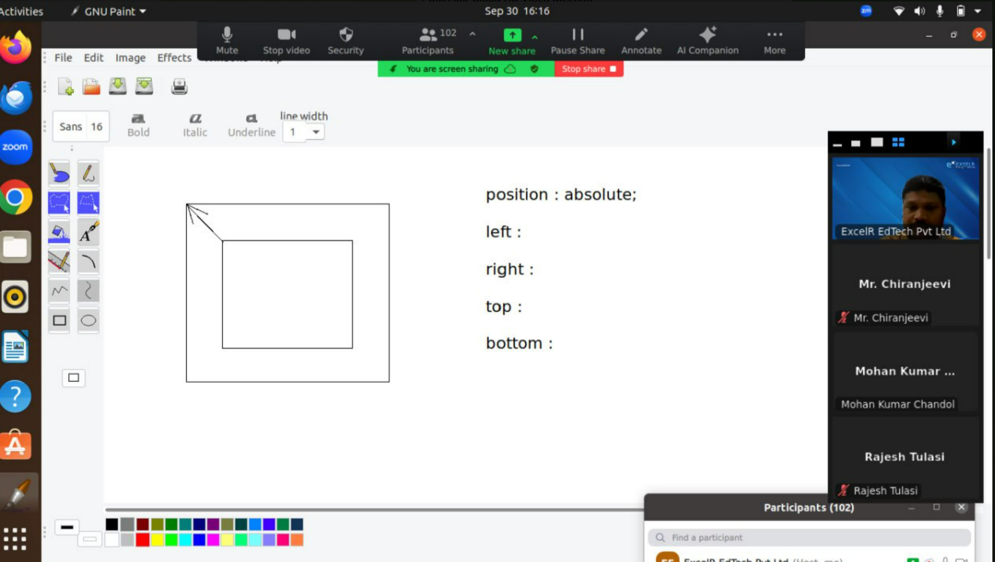

**Animation code - transform: translate (-50%,-50%)**

**Sample code:**

<!DOCTYPE html>

<html>

    <head>

        <style>

            img{

                position: absolute;

                left:50%;

                top:50%;

                transform: translate(-50%,-50%);

            }

        </style>

    </head>

    <body>

        <img src="./logo.png" alt="Error">

    </body>

</html>

**4.Sticky:**

**While scrolling the element will stick on top or bottom on the page.**

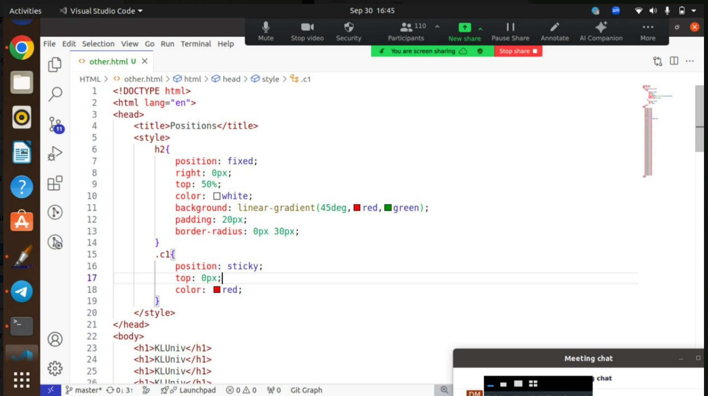

**Source code:**

<!DOCTYPE html>

<html>

    <head>

        <style>

           h2{

            position: fixed;

            right: 0px;

            top: 50%;

            color: white;

            background:linear-gradient(270deg,red,green);

            padding: 20px;

            border-radius: 0px 30px;

           }

           .c1{

            position: sticky;

            top:0px;

            color:red;

           }

        </style>

    </head>

    <body>

        <h1 class="c1"> KLUNIVERSITY</h1>

        <h1> KLUNIVERSITY</h1>

       <h1> KLUNIVERSITY</h1>

       <h1> KLUNIVERSITY</h1>

       <h1> KLUNIVERSITY</h1>

       <h1> KLUNIVERSITY</h1>

       <h1> KLUNIVERSITY</h1>

       <h1> KLUNIVERSITY</h1>

       <h2>Chaitu</h2>

       <h1> KLUNIVERSITY</h1>

       <h1> KLUNIVERSITY</h1>

       <h1> KLUNIVERSITY</h1>

       <h1> KLUNIVERSITY</h1>

       <h1> KLUNIVERSITY</h1>

       <h1> KLUNIVERSITY</h1>

       <h1> KLUNIVERSITY</h1>

       <h1> KLUNIVERSITY</h1>

       <h1> KLUNIVERSITY</h1>

       <h1> KLUNIVERSITY</h1>

       <h1> KLUNIVERSITY</h1><h1> KLUNIVERSITY</h1><h1> KLUNIVERSITY</h1><h1> KLUNIVERSITY</h1><h1> KLUNIVERSITY</h1><h1> KLUNIVERSITY</h1><h1> KLUNIVERSITY</h1><h1> KLUNIVERSITY</h1><h1> KLUNIVERSITY</h1><h1> KLUNIVERSITY</h1><h1> KLUNIVERSITY</h1><h1> KLUNIVERSITY</h1><h1> KLUNIVERSITY</h1>

    </body>

</html>

**Dimesions:**

1.rem(relative em)

2.em

3.%(percentage)

4.vw&vh(view pot width & view port height)

5 px (pixel)

**Rem:** All elements are depending on the root element dimensions.

**Source code:**

<!DOCTYPE html>

<html>

    <head>

        <style>

            html{

                font-size: 16px;

            }

            h1{

                font-size: 2rem;

            }

            p{

                font-size: 1.5rem;

            }

        </style>

    </head>

    <body>

      <h1>KLUNIVERSITY</h1>

      <p>CHAITU</p>

    </body>

</html>

**Em:** Depending on the nearest parent element**.**

**Source code:**

Em.html

<!DOCTYPE html>

<html>

    <head>

        <link rel="stylesheet" href=".\dimesions.css">

    </head>

    <body>

      <div>

        <p>KLUNIVERSITY</p>

        <p>CHAITU</p>

      </div>

    </body>

</html>

Dimesions.css

----------------

html{

    font-size: 16px;

}

div{

    font-size: 2rem;

}

p{

    font-size: 3em;

}

Em is never recommended for web apps

* Dis advantage: global consistency

**% Dimension class**

Depending on the nearest ancestor.

**Source code:**

<!DOCTYPE html>

<html>

    <head>

        <link rel="stylesheet" href=".\dimesions.css">

    </head>

    <body>

      <div class="parent_cls">

        <p class="c4" > KLU</p>

      </div>

    </body>

</html>

CSS CODE

------------

html{

    font-size: 16px;

}

div{

    font-size: 2rem;

}

p{

    font-size: 3em;

}

.parent_cls{

    width: 400px;

    height: 250px;

    border: 1px solid red;

}

.c4{

    width: 50%;

    background-color: green;

}

**VW&VH Dimension :** Depending on the screen view

Responsive web design

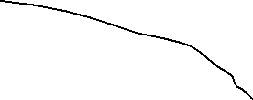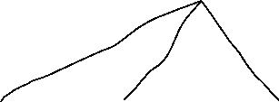

Mobile tablet laptop desktop

---------------------------

<!DOCTYPE html>

<html>

    <head>

        <link rel="stylesheet" href=".\dimesions.css">

    </head>

    <body>

      <div class="parent_cls">

        <p class="c4" > KLU</p>

        <p class="c5">chaitu</p>

      </div>

    </body>

</html>

html{

    font-size: 16px;

}

div{

    font-size: 2rem;

}

p{

    font-size: 3em;

}

.parent_cls{

    width: 400px;

    height: 250px;

    border: 1px solid red;

}

.c4{

    width: 50%;

    background-color: green;

}

.c5{

    width:50vw;

    background-color: brown;

}

**5.px (pixel);** every point in the screen is treated as a pixel.

**Floating property**

**Larem500 :** to print the para.

**Float:right** – to move the para from the logo right

**Float:left** – to move the para from the logo left

**ALt+Z** – line by line para

**Source code:**

<!DOCTYPE html>

<html>

    <head>

        <link rel="stylesheet" href=".\dimesions.css">

        <title>Floating property</title>

    </head>

    <body>

      <p>

        <img src="./logo.png"  alt="error"> Lorem ipsum dolor sit amet consectetur adipisicing elit. Amet voluptatem maxime laudantium accusamus. Accusamus officiis, quo eligendi dicta eaque quis molestiae tenetur est ex aliquid nesciunt rerum consequatur! Provident esse excepturi vitae eaque ipsum blanditiis ipsa iure. Ducimus molestiae fugit maiores nihil odio. Quam in, officiis blanditiis iusto iure, ipsum veniam voluptatum quo exercitationem nemo aspernatur ab quas distinctio deserunt doloremque dignissimos rem ducimus aperiam ipsa porro? Officiis eaque esse reiciendis perspiciatis praesentium ipsam velit sunt et repudiandae minima deserunt id voluptatum, rerum molestias. Autem quas commodi blanditiis, fugit consequatur, illo sit reprehenderit explicabo ducimus minus sunt mollitia accusantium aliquid nobis maxime voluptatem error eos! Ducimus accusamus, minus iure vitae dolorem quia nostrum porro ipsa voluptatem eos. Suscipit nobis aliquam dolorem porro adipisci aspernatur, omnis deleniti enim, iure illum expedita ipsam, repellendus fuga distinctio eos ab provident totam alias ipsum quis doloribus soluta illo nam officia. Quod, temporibus! Nam, veritatis nulla? Ipsa quae quibusdam ex voluptas rerum quasi odit perferendis explicabo quaerat, atque doloribus sequi ad perspiciatis voluptates, maxime, laborum maiores ullam possimus. Vitae quos blanditiis maiores in dolorum aut ducimus veritatis, excepturi dicta alias corporis, aliquam dolore cum ut? Tempora expedita nobis rerum delectus temporibus saepe eveniet, maxime possimus adipisci recusandae nulla similique ex assumenda eum, debitis vel excepturi modi omnis. Dolorum ut molestias, neque numquam culpa dolorem praesentium error nisi delectus, ipsam blanditiis natus excepturi placeat eius tempore deserunt quidem velit! Consequatur error minus, nesciunt sequi ab id repudiandae, labore dicta asperiores perspiciatis excepturi. Quos itaque iste, dolorum consequuntur quod eos impedit consectetur quibusdam ab suscipit alias labore voluptatem rerum hic nesciunt? Iusto voluptate, dolorum esse iste nihil consectetur tempore quasi error ducimus consequatur inventore quidem amet adipisci sit dolor numquam accusamus quaerat labore voluptatem quas! Dolorem aspernatur illo vel perferendis ipsa voluptas necessitatibus harum dicta a temporibus, repellat dolor! Magni illo dolores sunt amet, dicta delectus et expedita ratione veritatis tempora autem quod, sit, natus nemo dolorum labore consequuntur commodi eligendi odit libero! Dolorem quibusdam maiores vitae suscipit rerum itaque, architecto a est, enim mollitia illo voluptate aspernatur minima explicabo soluta consequuntur nostrum! Vel ipsa esse ex laborum odio commodi totam, id voluptatibus repudiandae. Porro deserunt ullam sapiente ipsum delectus rem iusto fuga? Assumenda cum animi voluptas facilis debitis. Minus officiis, dicta facilis repellendus assumenda suscipit unde fuga nesciunt itaque, tempore hic aliquid, quam neque quisquam in quidem! Harum ipsum distinctio voluptate quod placeat. Repellendus mollitia incidunt architecto corrupti consequatur sapiente id commodi, officiis veniam, ad perspiciatis. Perferendis repudiandae natus dicta non voluptas! Reprehenderit obcaecati voluptas totam, facilis suscipit blanditiis, eligendi error incidunt, labore quasi harum modi? Qui eos sunt reprehenderit at possimus dignissimos inventore non, officiis consequuntur voluptatum quibusdam natus eligendi tempora! Labore quam aspernatur distinctio provident quaerat eius ipsam temporibus ut voluptas quia ratione ab earum voluptatum, rerum, ad eveniet culpa architecto. Eveniet, soluta. Explicabo illo suscipit facere nihil veritatis soluta labore vero minus est. Fugit, aliquid autem ea a hic accusamus earum impedit at cum. Porro perspiciatis corporis nesciunt libero blanditiis. Similique, error rerum.

        In common usage, data is a collection of discrete or continuous values that convey information, describing the quantity, quality, fact, statistics, other basic units of meaning, or simply sequences of symbols that may be further interpreted formally. A datum is an individual value in a collection of data. Wikipedia

      </p>

    </body>

</html>

Css code:

.img{

    float:right;

    margin:20px;

}

