**4th day (2-10-2024)**

**Grid:**

Flex is one dimensional

Grid is two-dimensional

Explained with a use-case code saved in

Ex: one.html

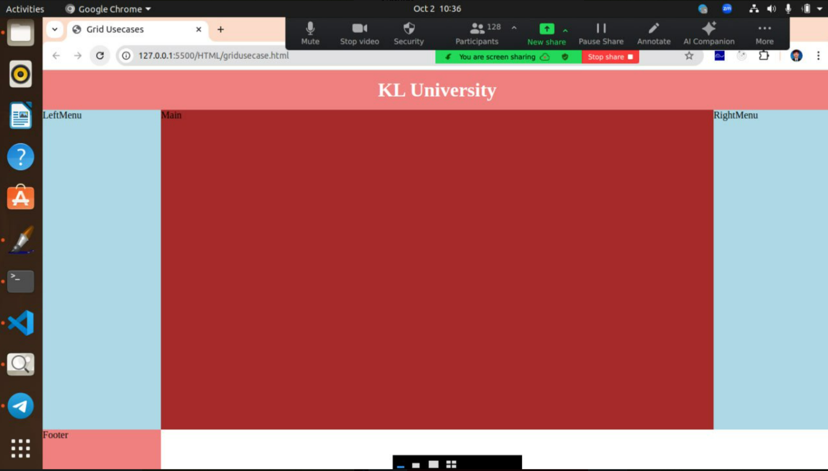

**Source code:**

<!DOCTYPE html>

<html>

    <head>

        <title>Grid USes Cases</title>

        <style>

            body{

                padding:0px;

                margin: 0px;

            }

            .parent{

                height: 100vh;

                display: grid;

                grid-template-rows: 10% 80% 10%;

                grid-template-columns: 15% 75% 15%;

            }

            .header{

                background-color: lightcoral;

                grid-column: 1/4;

                grid-row: 1/2;

                display: flex;

                justify-content: center;

                align-items: center;

                color: white;

            }

            .leftmenu{

                background-color: lightblue;

                grid-row: 2/3;

                grid-column: 1/2;

            }

            .main{

                background-color: brown;

                grid-row: 2/3;

            }

            .rightmenu{

                background-color: lightblue;

                grid-row: 2/3;

                grid-column: 3/4;

            }

            .footer{

            background-color: lightcoral;

            grid-row: 3/4;

            grid-column:1/4;

            }

        </style>

    </head>

    <body>

        <!--parent  -->

        <div class="parent">

            <!--grid item1  -->

            <div class="header">

               <h1>KL UNIVERSITY</h1>

            </div>

            <!--grid item2  -->

            <div class="leftmenu">LeftMenu</div>

            <!--grid item3  -->

            <div class="main">Main</div>

            <!--grid item4  -->

            <div class="rightmenu">RIghtMenu</div>

            <!--grid item5  -->

            <div class="footer">Footer</div>

        </div>

    </body>

</html>

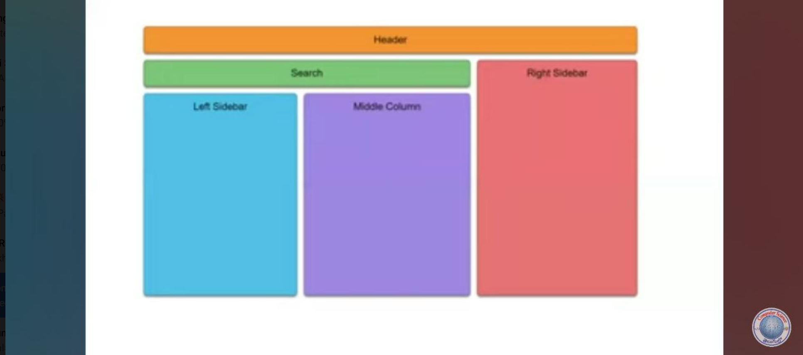

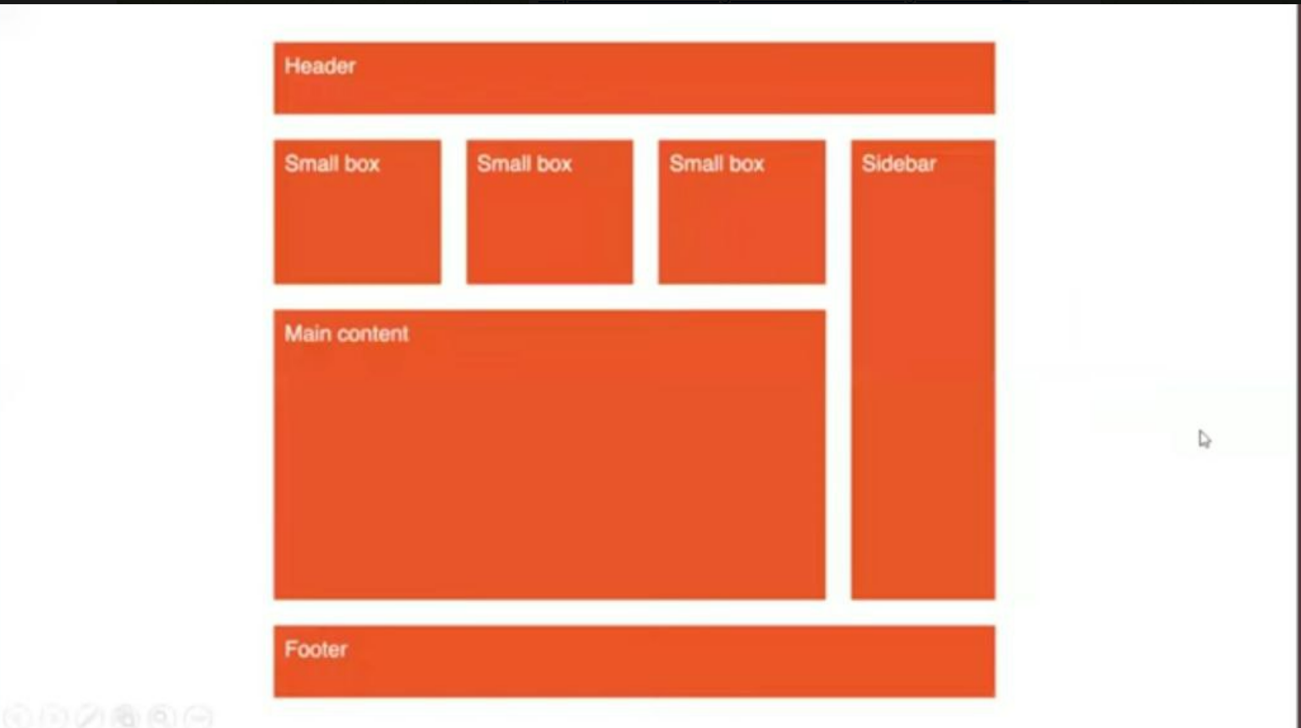

**Box sizing:** The original width changes because of the padding and border. To overcome this problem the below box sizing is introduced in css3.x

**Box- sizing :border-box: (never change the original value).**

**Source code:**

<!DOCTYPE html>

<html>

    <head>

<style>

    .c1{

        width: 500px;

        height: 500px;

        border: 2px solid red;

        padding: 20px;

**box-sizing: border-box;**

    }

</style>

    </head>

    <body>

        <div class="c1">KLuniversity</div>

    </body>

</html>

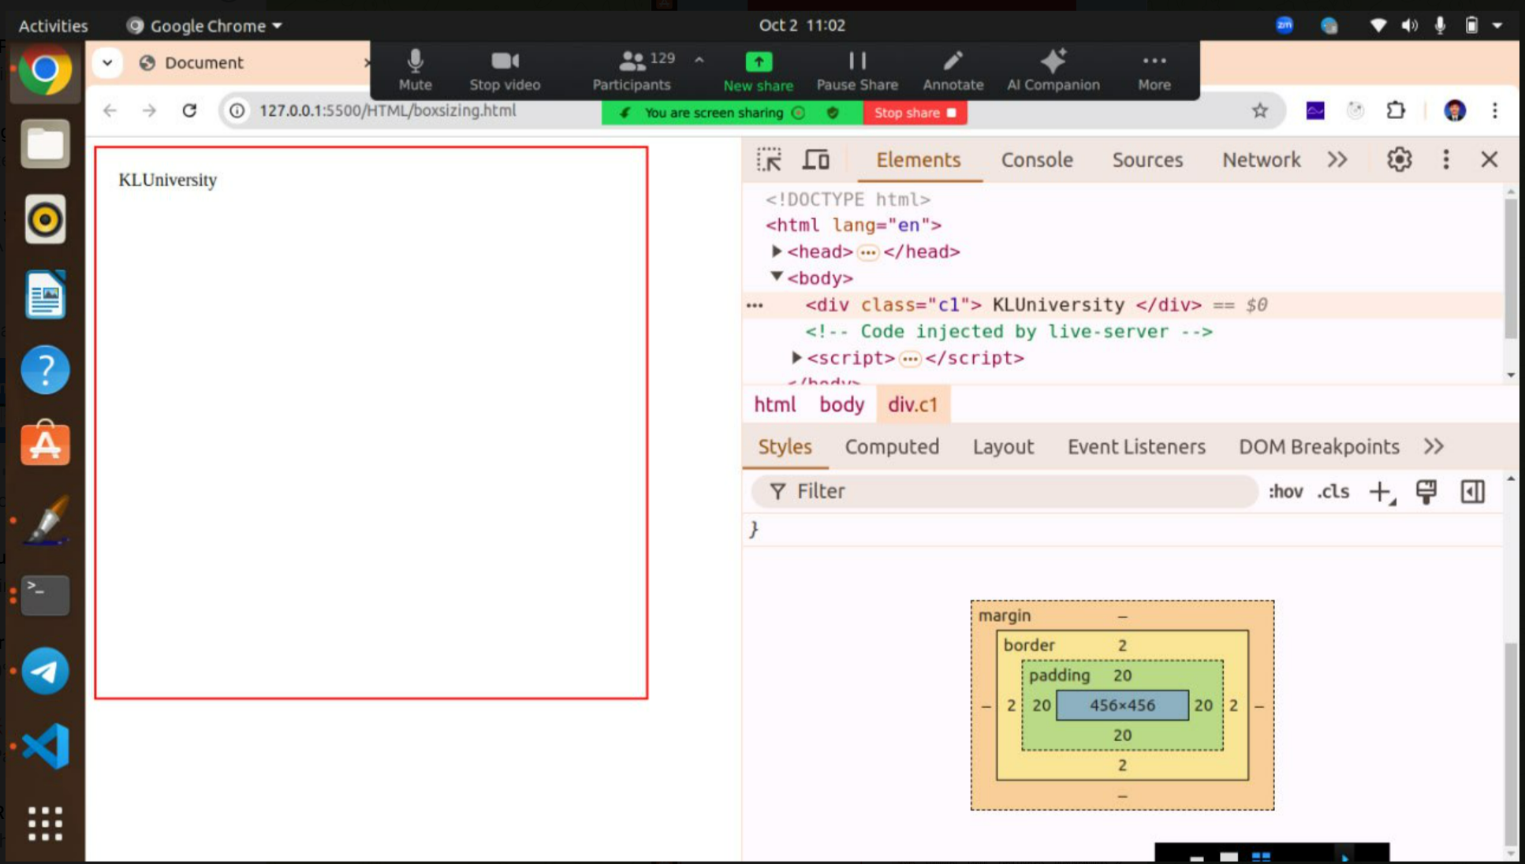

**Media Queries (RWD)**

Execution of same web pages in multiple devices**.**

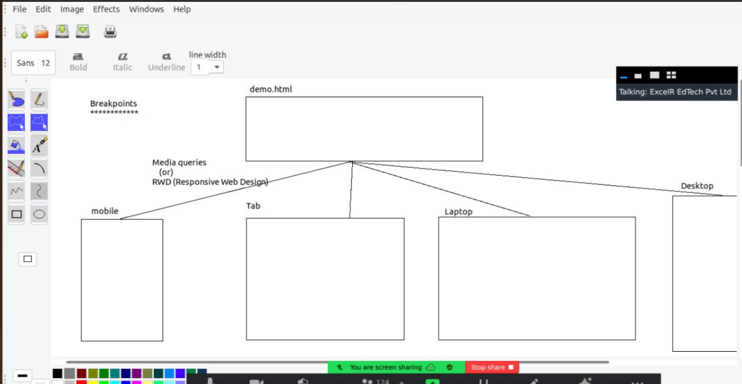

**Break point dimensions:**

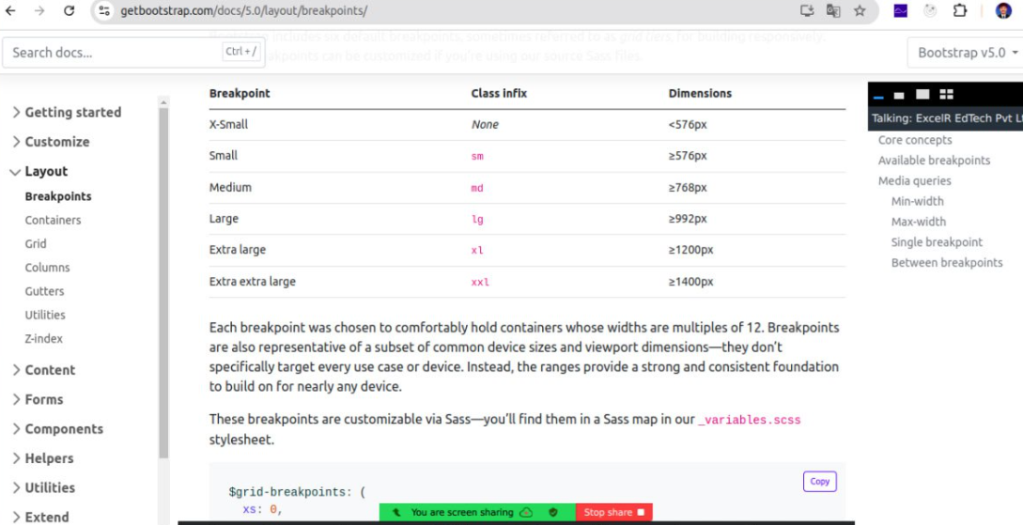

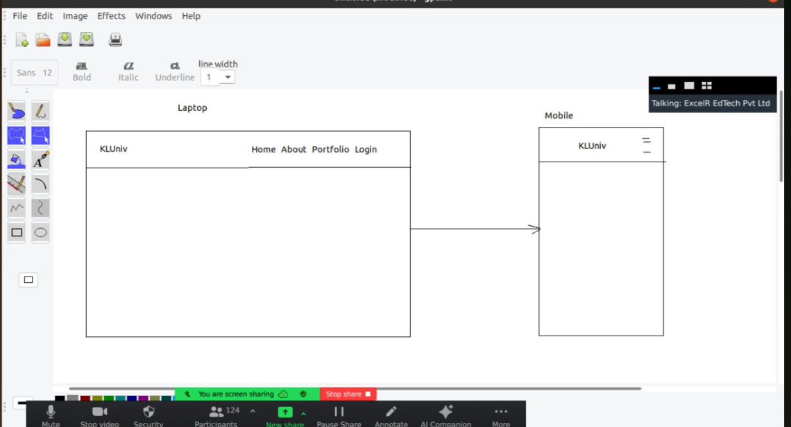

**Source code: rwd.html**

<!DOCTYPE html>  
<html lang="en">  
<head>  
    <meta charset="UTF-8">  
    <meta name="viewport" content="width=device-width, initial-scale=1.0">  
    <link rel="stylesheet" href="rwd.css">  
    <title>Document</title>  
</head>  
<body>  
      
    <!-- CONTAINER SECTION -->  
    <div class="container">  
          
        <!-- HEADER-->  
        <div class="container__header">  
            <!-- FLEX ITEM1-->  
            <div class="container__header__logo">  
                <h1 class="container__header__logo__brand">KLUniv</h1>  
            </div>  
            <!-- FLEX ITEM2-->  
            <div class="container__header__menu">  
                <a href="#">Home</a>  
                <a href="#">About</a>  
                <a href="#">Portfolio</a>  
                <a href="#">Signin</a>  
            </div>  
        
        </div>  
         
         
         
         
        <!-- MAIN -->  
        <div class="container__main"></div>  
          
        <!-- FOOTER -->  
        <div class="container__footer"></div>  
    </div>  
  
  
</body>  
</html>

**Rwd.scss file:**

* $mobile : 576px;  
  *{  
     margin: 0;  
     padding: 0;  
     box-sizing: border-box;   
  }  
  .container{  
      height: 100%;  
      &__header{  
          height: 10vh;  
          display: flex;  
          justify-content: space-between;  
          align-items: center;  
            
          &__logo{  
              margin-left: 10px;  
              &__brand{  
    
              }  
          }  
          &__menu{  
              margin-right: 10px;  
              display: flex;  
              gap: 2rem;  
          }  
      }  
      &__main{  
          height: 80vh;  
          background-color: yellowgreen;  
      }  
      &__footer{  
          height: 10vh;  
          background-color: goldenrod;  
      }  
  }  
    
    
  @media(max-width:$mobile){  
      .container{  
         &__header{  
              justify-content: center;  
              align-items: center;  
              color: olivedrab;  
              /* flex item1*/  
              &__logo{  
                  &__brand{  
                  }  
                
              }  
    
              /* flexitem2 */  
              &__menu{  
                  display: none;  
              }  
          }  
      }
* SAS instead of CSS
* SAS means preprocessor of CSS.
* For the execution goto extensions and install the live SAS compiler.