Day-7

Docker

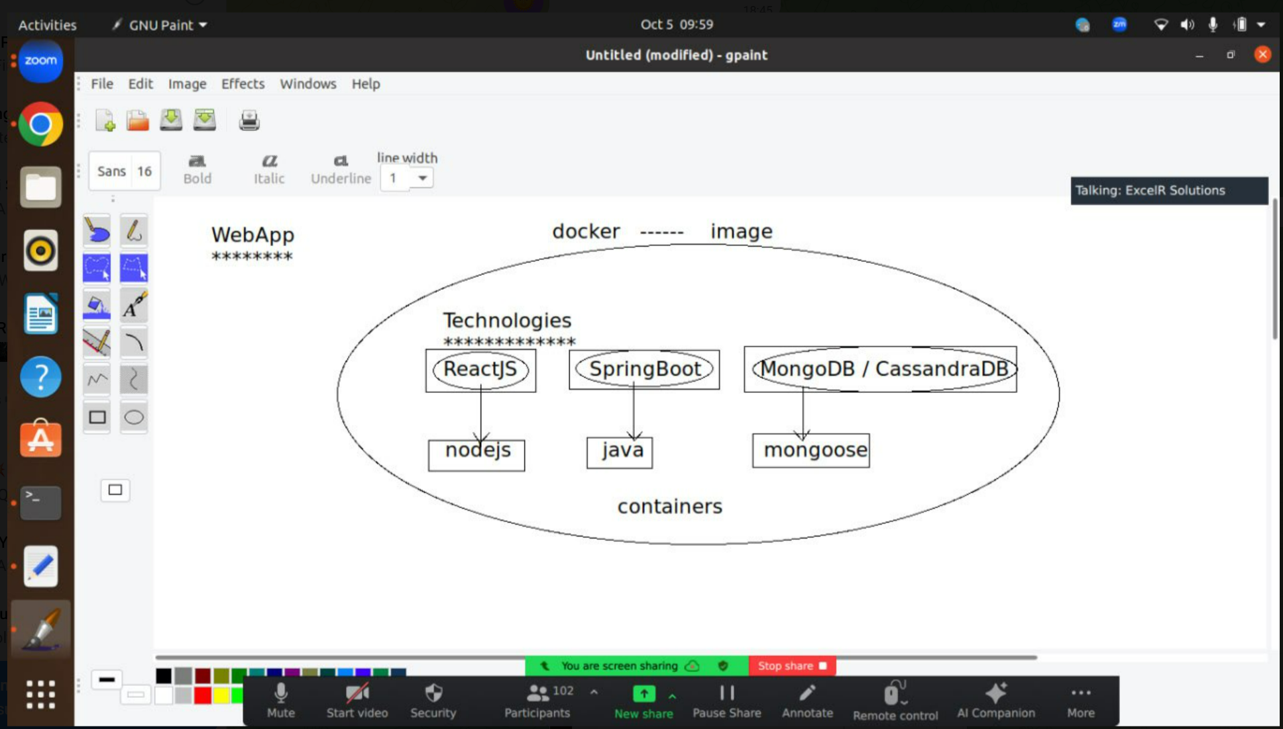

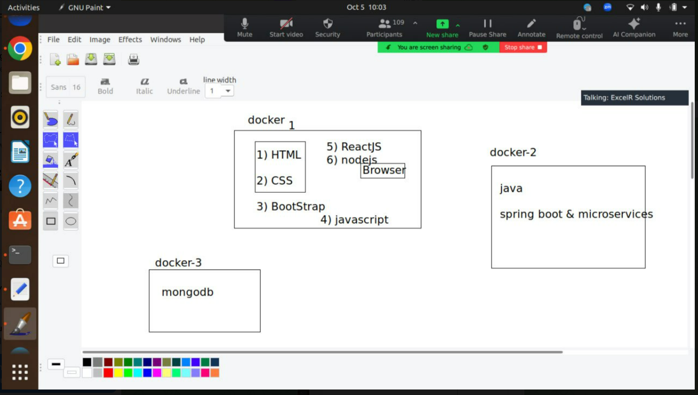

Linux comsds in docker

docker uninstallation

*********************

docker ps -q | xargs -r docker stop

sudo apt-get purge -y docker-engine docker docker.io docker-ce docker-ce-cli

sudo apt-get autoremove -y --purge docker-engine docker docker.io docker-ce

sudo apt-get autoclean

sudo rm -rf /var/lib/docker

sudo rm -rf /etc/docker

docker --version

docker installation

*******************

sudo apt update

sudo apt install apt-transport-https ca-certificates curl software-properties-common

curl -fsSL https://download.docker.com/linux/ubuntu/gpg | sudo gpg --dearmor -o /usr/share/keyrings/docker-archive-keyring.gpg

echo "deb [arch=$(dpkg --print-architecture) signed-by=/usr/share/keyrings/docker-archive-keyring.gpg] https://download.docker.com/linux/ubuntu $(lsb_release -cs) stable" | sudo tee /etc/apt/sources.list.d/docker.list > /dev/null

sudo apt update

sudo apt install docker-ce

docker –version

create Dockerfile in vs code

convert docker to image in vs code terminal

docker –version

sudo systemctl start docker

sudo systemctl enable docker

docker build -t my_html.app

Docker in windows

1. Install desktop docker file in windows <https://docs.docker.com/desktop/install/windows-install/>
2. In vs code also install docker in extensions
3. The files required are
   1. Index.html
   2. Styles.css
   3. Dockerfile

Code of these respective files

**Index.html**

<!DOCTYPE html>

<html lang="en">

<head>

    <meta charset="UTF-8">

    <meta name="viewport" content="width=device-width, initial-scale=1.0">

    <title>About Me</title>

    <link rel="stylesheet" href="styles.css">

</head>

<body>

    <!-- Navbar -->

    <nav class="navbar">

        <div class="nav-content">

            <div class="nav-left">

                <img src="logo1.png" alt="Profile Picture" class="nav-profile-img">

                <h1 class="logo">Gogineni Krishna chaitanya</h1>

            </div>

            <div class="nav-right">

                <ul class="nav-links">

                    <li><a href="#">Home</a></li>

                    <li><a href="#">About</a></li>

                    <li><a href="#">Projects</a></li>

                    <li><a href="#">Contact</a></li>

                </ul>

            </div>

        </div>

    </nav>

    <!-- About Me Section -->

    <section class="about-me">

        <h2>ABOUT ME</h2>

        <p class="intro-text">Lorem ipsum dolor sit amet consectetur adipisicing elit. Hic facilis tempora explicabo quae quod deserunt eius sapiente</p>

        <div class="content">

            <div class="description">

                <h3>Get to know me!</h3>

                <p>

                    Hey! It's <strong>Chaitanya</strong> and I'm a <strong>Frontend Web Developer</strong> located in vijayawada. I've done remote projects for agencies, consulted for startups, and collaborated with talented people to create <strong>digital products</strong> for both business and consumer use.

                </p>

                <p>

                    I'm a bit of a digital product junky. Over the years, I've used hundreds of web and mobile apps in different industries and verticals. Feel free to <a href="#">contact</a> me here.

                </p>

                <button class="contact-btn">CONTACT</button>

            </div>

            <div class="skills">

                <h3>My Skills</h3>

                <div class="skills-list">

                    <span>HTML</span>

                    <span>CSS</span>

                    <span>JavaScript</span>

                    <span>React</span>

                    <span>SASS</span>

                    <span>GIT</span>

                    <span>Shopify</span>

                    <span>Wordpress</span>

                    <span>Google ADS</span>

                    <span>Facebook Ads</span>

                    <span>Android</span>

                    <span>iOS</span>

                </div>

            </div>

        </div>

    </section>

</body>

</html>

**Styles.css**

* {

    margin: 0;

    padding: 0;

    box-sizing: border-box;

}

body {

    font-family: Arial, sans-serif;

    background-color: #f8f8f8;

    color: #333;

    line-height: 1.6;

}

/* Navbar Styling */

.navbar {

    background-color: #fff;

    padding: 15px;

    box-shadow: 0 4px 8px rgba(0,0,0,0.1);

    position: sticky;

    top: 0;

    width: 100%;

    z-index: 100;

}

.nav-content {

    display: flex;

    justify-content: space-between;

    align-items: center;

    max-width: 1100px;

    margin: 0 auto;

}

.nav-left {

    display: flex;

    align-items: center;

}

.nav-profile-img {

    border-radius: 50%;

    width: 50px;

    height: 50px;

    margin-right: 15px;

}

.skills-list {

    display: flex;

    flex-wrap: wrap;

    justify-content: center;

    gap: 10px; /* Adjust the gap as needed */

  }

  .skill {

    background-color: #fff; /* White background for skills */

    padding: 10px;

    border-radius: 5px;

    text-align: center;

    color: #333; /* Dark gray text */

  }

  footer {

    text-align: center;

    padding: 20px;

    background-color: #333; /* Dark gray footer */

    color: #fff; /* White text */

  }

  button {

    background-color: #007bff; /* Blue button */

    color: #fff; /* White text */

    border: none;

    padding: 10px 20px;

    border-radius: 5px;

    cursor: pointer;

  }

.logo {

    font-size: 24px;

    font-weight: bold;

}

.nav-right ul {

    list-style: none;

    display: flex;

    gap: 20px;

}

.nav-right a {

    text-decoration: none;

    color: #333;

    font-size: 18px;

    transition: color 0.3s ease;

}

.nav-right a:hover {

    color: #007BFF;

}

/* About Me Section */

.about-me {

    text-align: center;

    padding: 40px 20px;

}

.about-me h2 {

    font-size: 36px;

    margin-bottom: 20px;

}

.intro-text {

    font-size: 18px;

    color: #777;

    margin-bottom: 40px;

}

.content {

    display: flex;

    justify-content: space-between;

    align-items: flex-start;

    max-width: 1100px;

    margin: 0 auto;

    padding: 20px;

}

.description {

    flex: 1;

    margin-right: 40px;

    text-align: left;

}

.description h3 {

    font-size: 24px;

    margin-bottom: 10px;

}

.description p {

    font-size: 18px;

    margin-bottom: 15px;

}

.description a {

    color: #007BFF;

    text-decoration: none;

}

.description a:hover {

    text-decoration: underline;

}

**Dockerfile**

FROM nginx:alpine

COPY index.html /usr/share/nginx/html/index.html

COPY styles.css /usr/share/nginx/html/styles.css

COPY logo1.png /sr/share/nginx/html/logo1.png

EXPOSE 80

1. In vs code create a Dockerfile
   1. FROM nginx:alpine
   2. COPY index.html /usr/share/nginx/html/index.html
   3. COPY styles.css /usr/
   4. EXPOSE 80
2. After this
   1. start docker
   2. docker build -t klu-app .
   3. docker run -d -p 8080:80 klu-app

go to docker desktop and see u file is deployed.

For ouput : <http://localhost:8080/>

Kuberneetees

Extentensions to be added

1. Kubernetes
2. WSL
3. Yaml

* from here we have send the docker image to kuberneetes
* install minicube <https://minikube.sigs.k8s.io/docs/start/?arch=%2Fwindows%2Fx86-64%2Fstable%2F.exe+download>

in the terminal of vs code

* kubectl cluster-info
* kubectl version --client
* kubectl get nodes
* kubectl get pods --all-namespaces
* kubectl get services -A

after this add deployment.yaml file to vs code

**deployment.yaml file**

apiVersion: apps/v1

kind: Deployment

metadata:

name: my-html-app

spec:

replicas: 2

selector:

matchLabels:

app: my-html-app

template:

metadata:

labels:

app: my-html-app

spec:

containers:

- name: my-html-app

image: my_html_app # This is the Docker image we built locally

imagePullPolicy: Never # Tells Kubernetes not to pull from a registry

ports:

- containerPort: 80

---

apiVersion: v1

kind: Service

metadata:

name: my-html-app-service

spec:

type: NodePort

ports:

- port: 80

targetPort: 80

nodePort: 30000

selector:

app: my-html-app

kubectl apply -f deployment.yaml

kubectl get pods

kubectl get nodes -o wide

kubectl get pods -o wide

kubectl get services

**for output: localhost:30000**