

Software Design Document

for

Expense Tracker

Version 1.0

Prepared by

Group Name: KVC Inc.

|  |  |  |
| --- | --- | --- |
| Chayse Jorgenson | 11678623 | [Chayse.jorgenson@wsu.edu](mailto:Chayse.jorgenson@wsu.edu) |
| Kevin Tong | 11686700 | [Kevin.tong@wsu.edu](mailto:Kevin.tong@wsu.edu) |
| Vitaliy Kudrik | 11603449 | [Vitaliy.kudrik@wsu.edu](mailto:Vitaliy.kudrik@wsu.edu) |

|  |  |
| --- | --- |
|  |  |
| Date: | 10/25/2019 |
|  |  |
|  |  |
|  |  |

# Activity Diagrams

## Our product is very simple and doesn’t require many intricate diagrams showing the process in each action. As stated in the project sheet I have not included diagrams for any functions due to their simplicity, except for the chart creating function and I also included a large activity diagram showing all the events that can happen in our software.

## Main Use Diagram

## Smaller Diagram depicting chart creation process

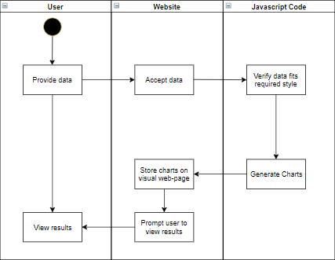

# Structural Modeling

## Class Diagram

# Behavioral Modeling

## < Sequence Diagram>

