EX NO: 10 RECRUITMENT SYSTEM
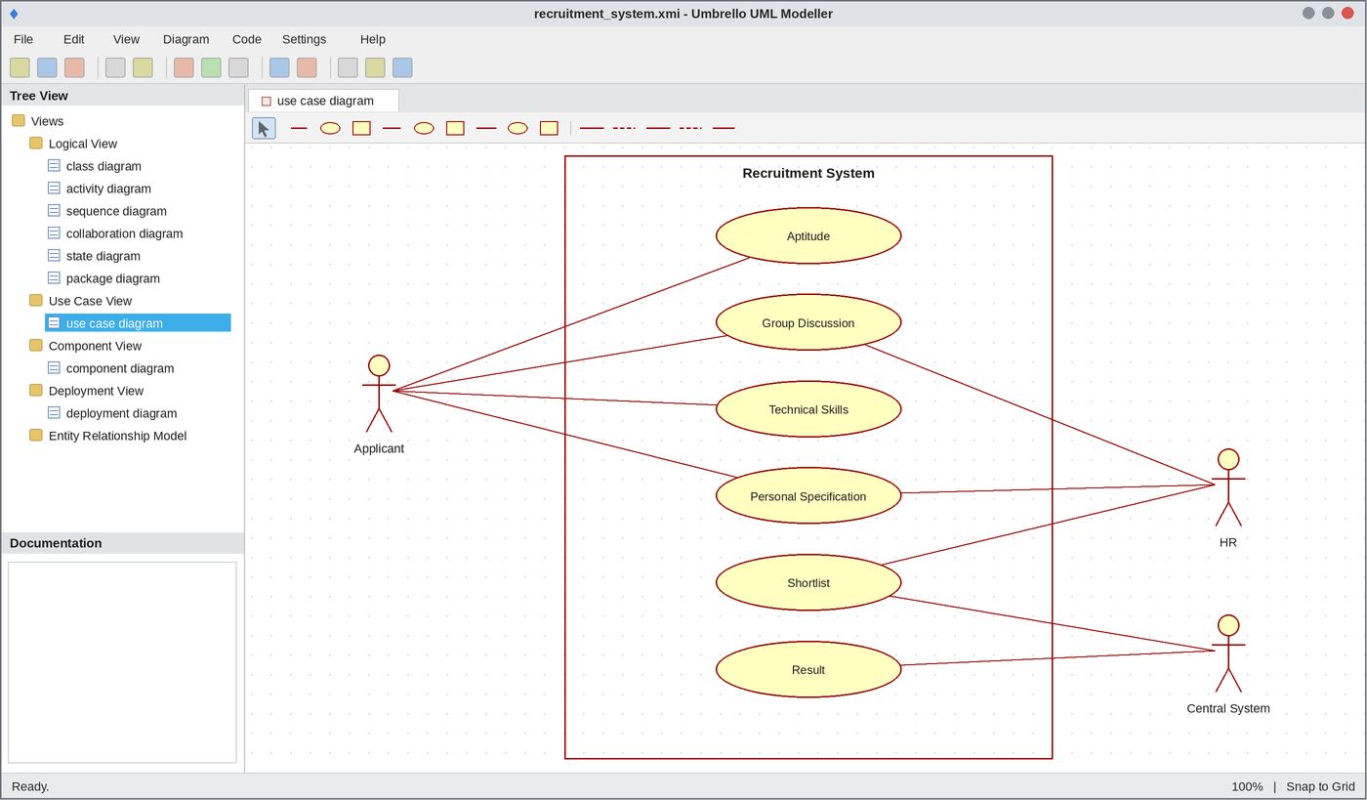
Use Case Diagram
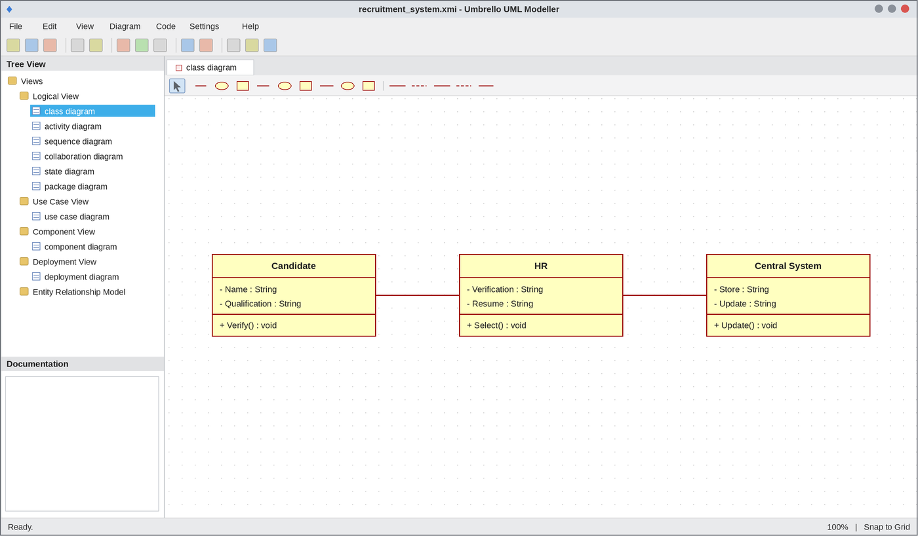
Class Diagram
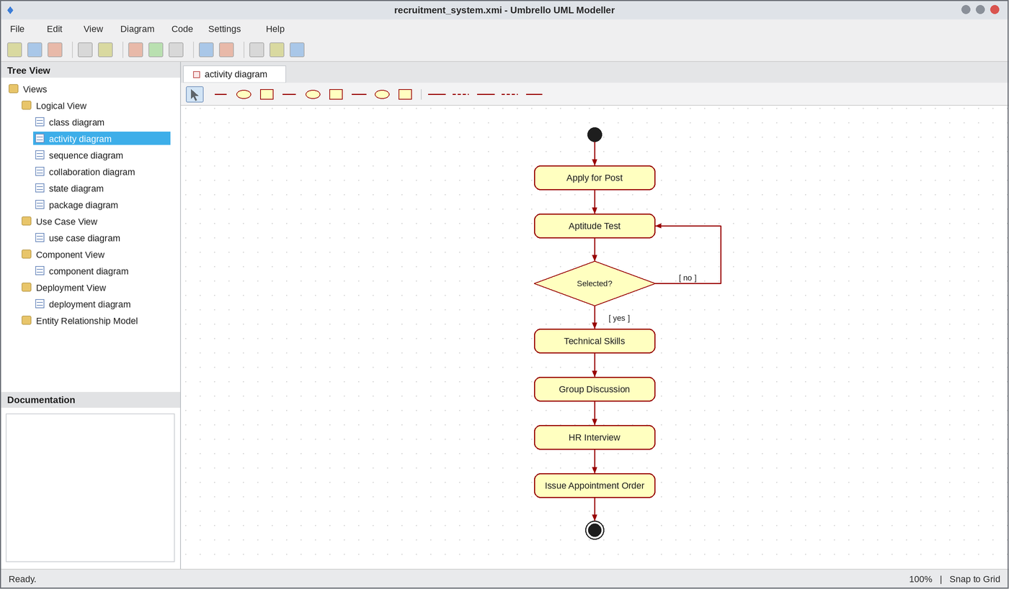
Activity Diagram
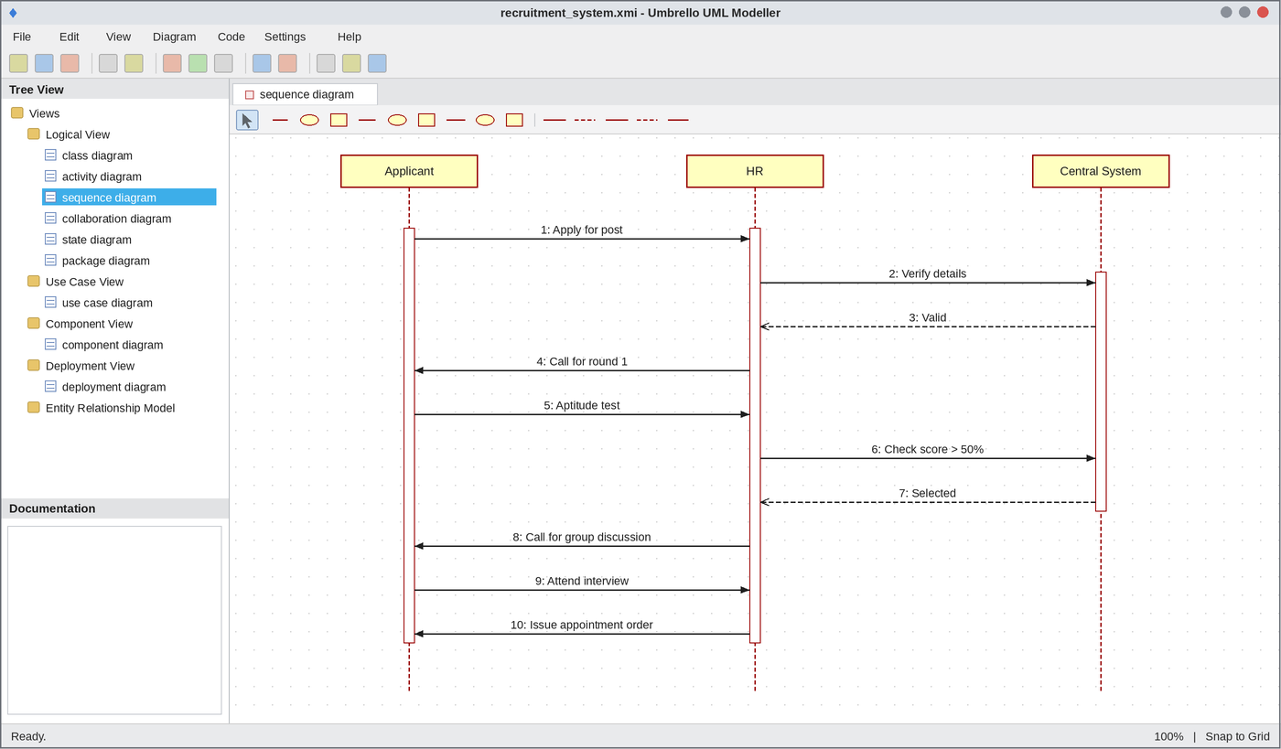
Sequence Diagram
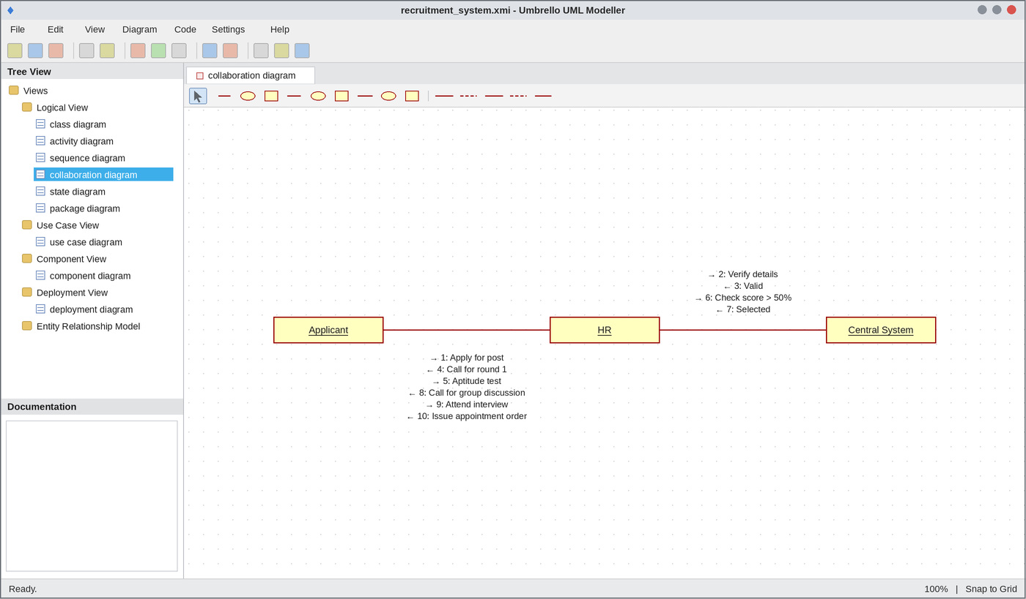
Collaboration Diagram
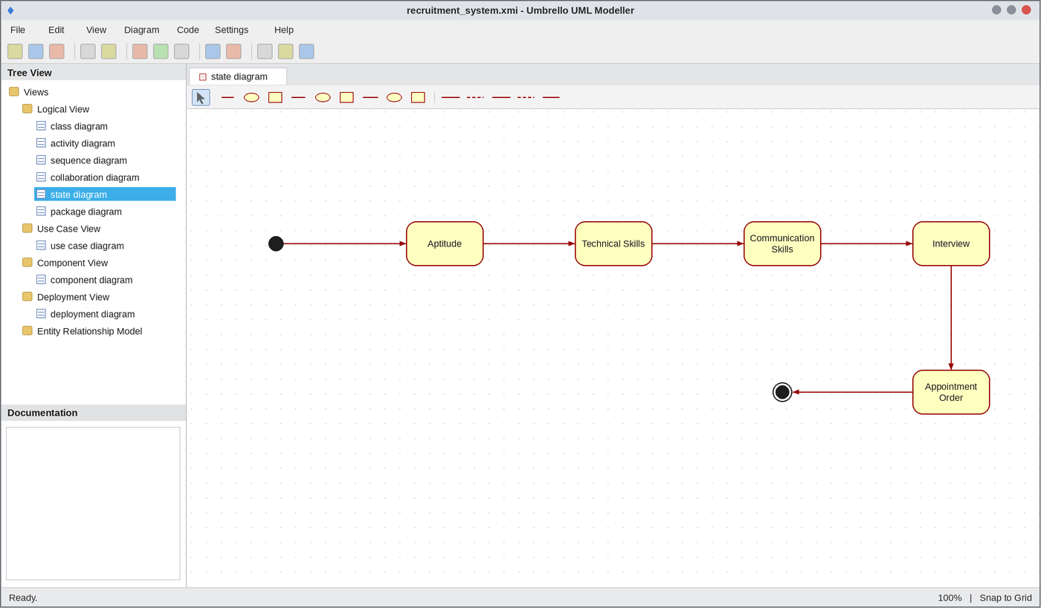
State Chart Diagram
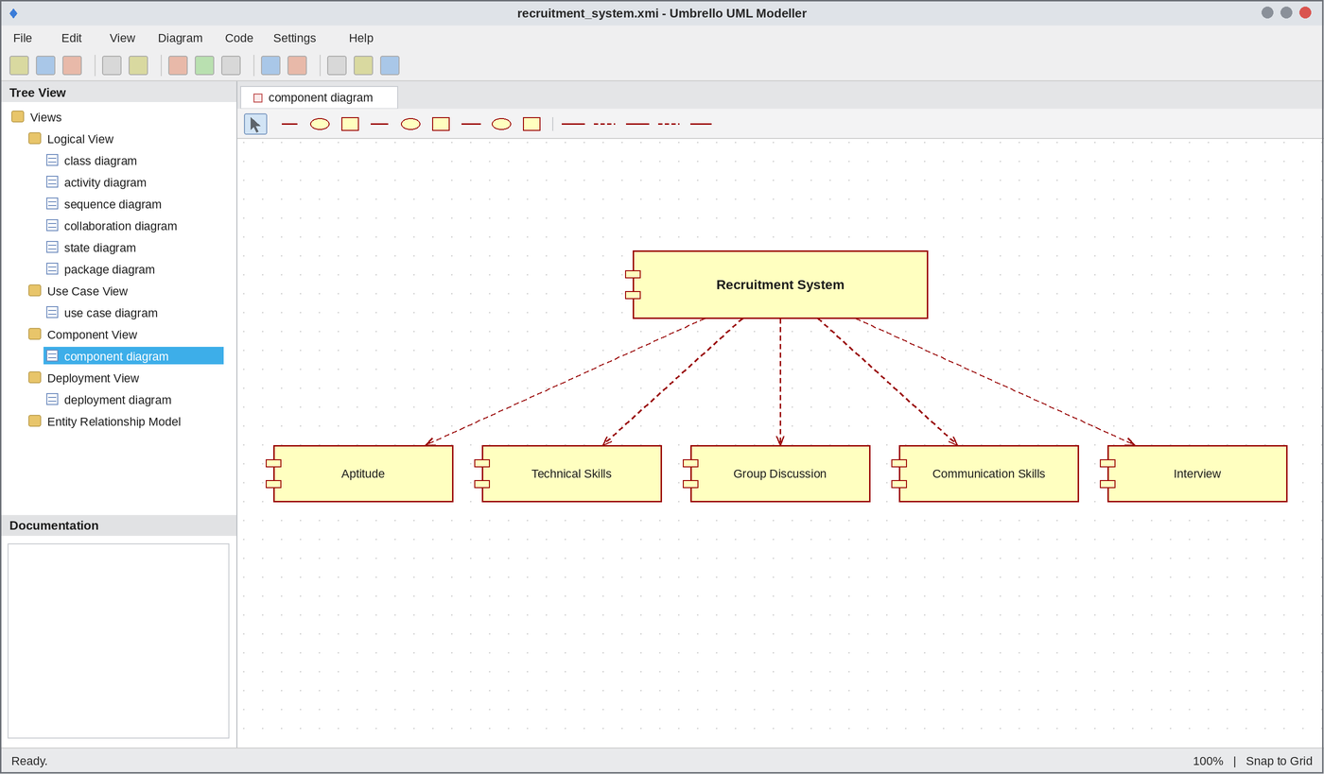
Component Diagram
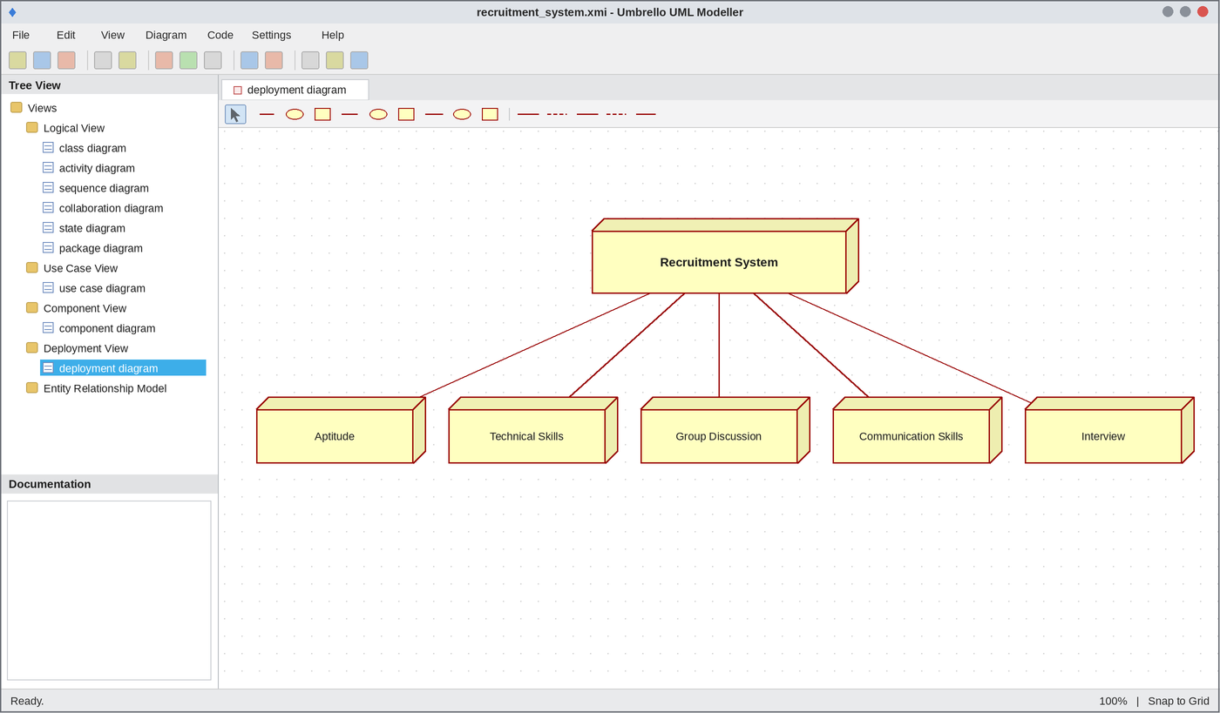
Deployment Diagram
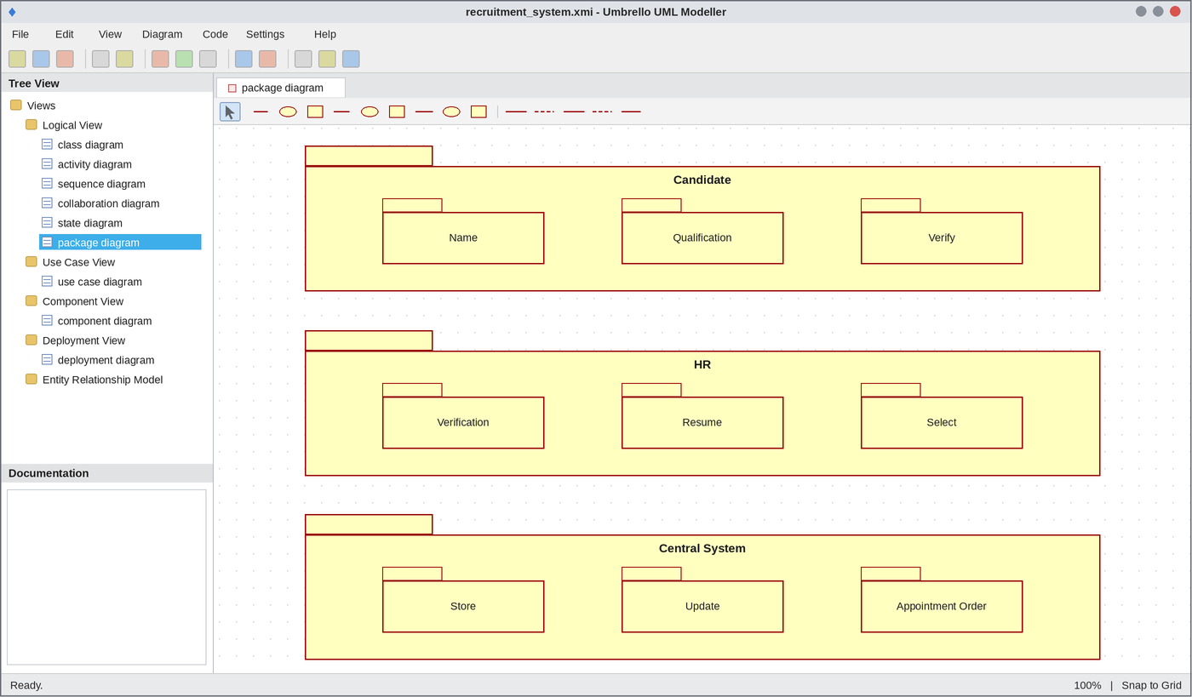
Package Diagram
WEBPAGE SCREENSHOT
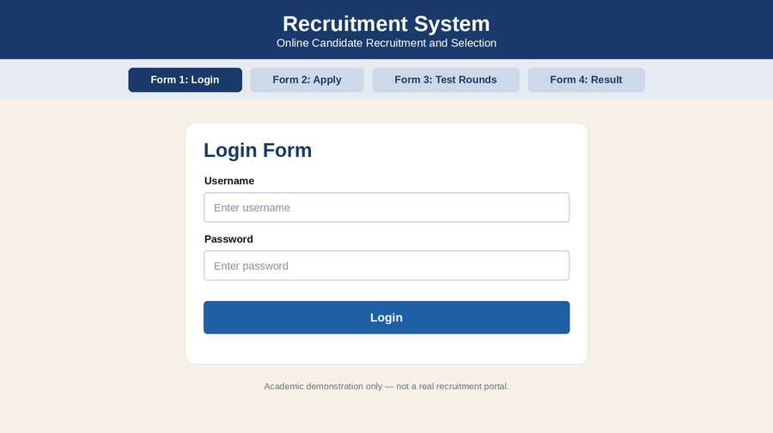
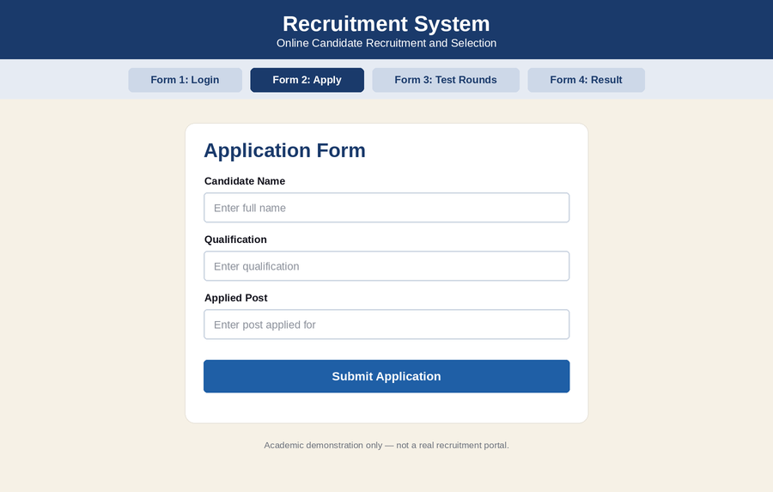
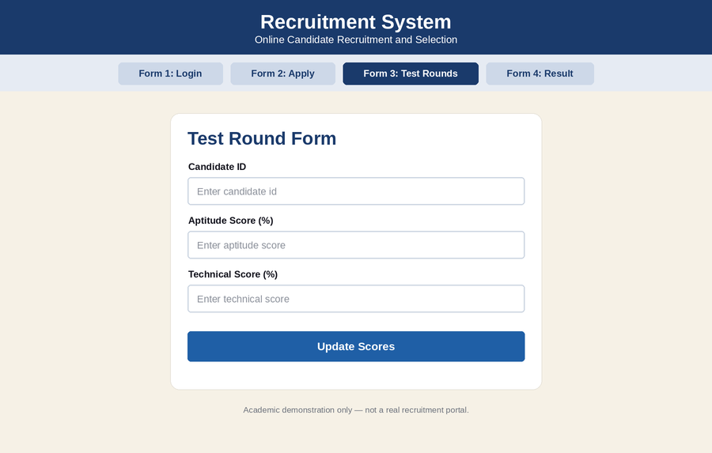
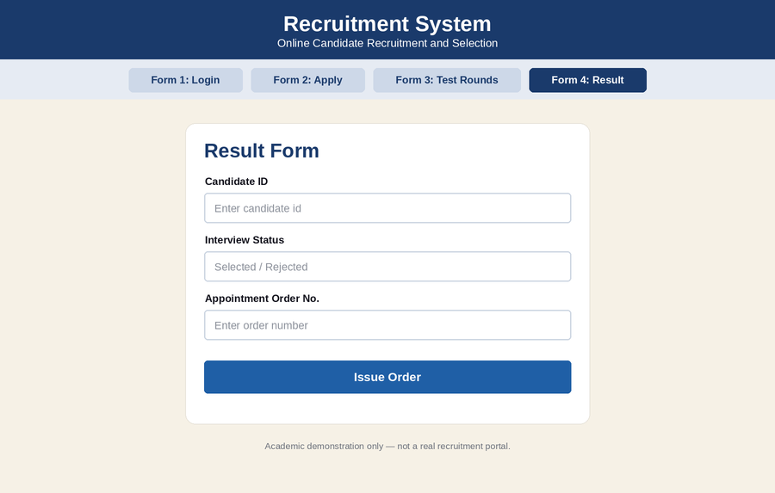
DATABASE SCREENSHOT
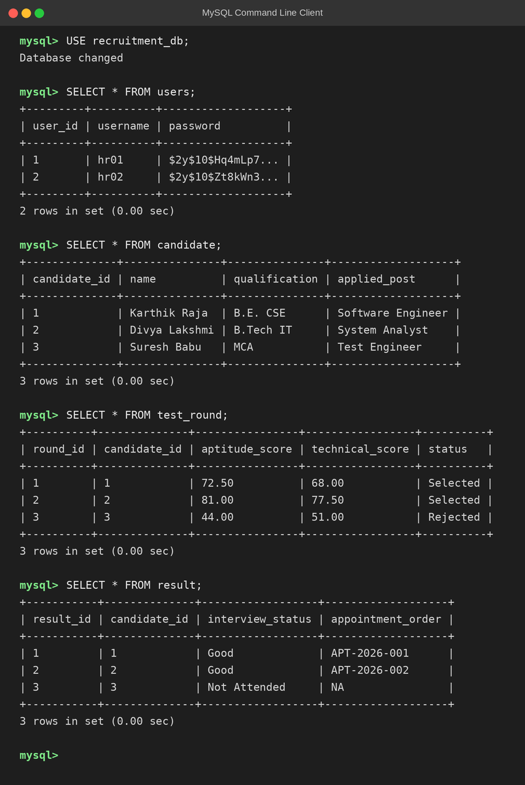
PSEUDO CODE
1. Application and Verification
BEGIN
APPLICANT enters name and qualification
APPLICANT applies for the post
HR verifies the details with CENTRAL SYSTEM
IF details are valid THEN
CALL applicant for Round 1
ELSE
DISPLAY "Application rejected"
ENDIF
END
2. Aptitude and Technical Rounds
BEGIN
READ aptitude score
IF aptitude score > 50 THEN
SET status = SELECTED
READ technical score
IF technical score > 50 THEN
CALL for group discussion
ELSE
SET status = REJECTED
ENDIF
ELSE
SET status = REJECTED
ENDIF
END
3. Interview and Appointment Order
BEGIN
CHECK communication skills in group discussion
ATTEND interview
HR checks confidence level
IF confidence is good THEN
SHORTLIST candidate
ISSUE appointment order
UPDATE result in CENTRAL SYSTEM
ELSE
DISPLAY "Not selected"
ENDIF
END

EX NO: 11 CONFERENCE MANAGEMENT SYSTEM
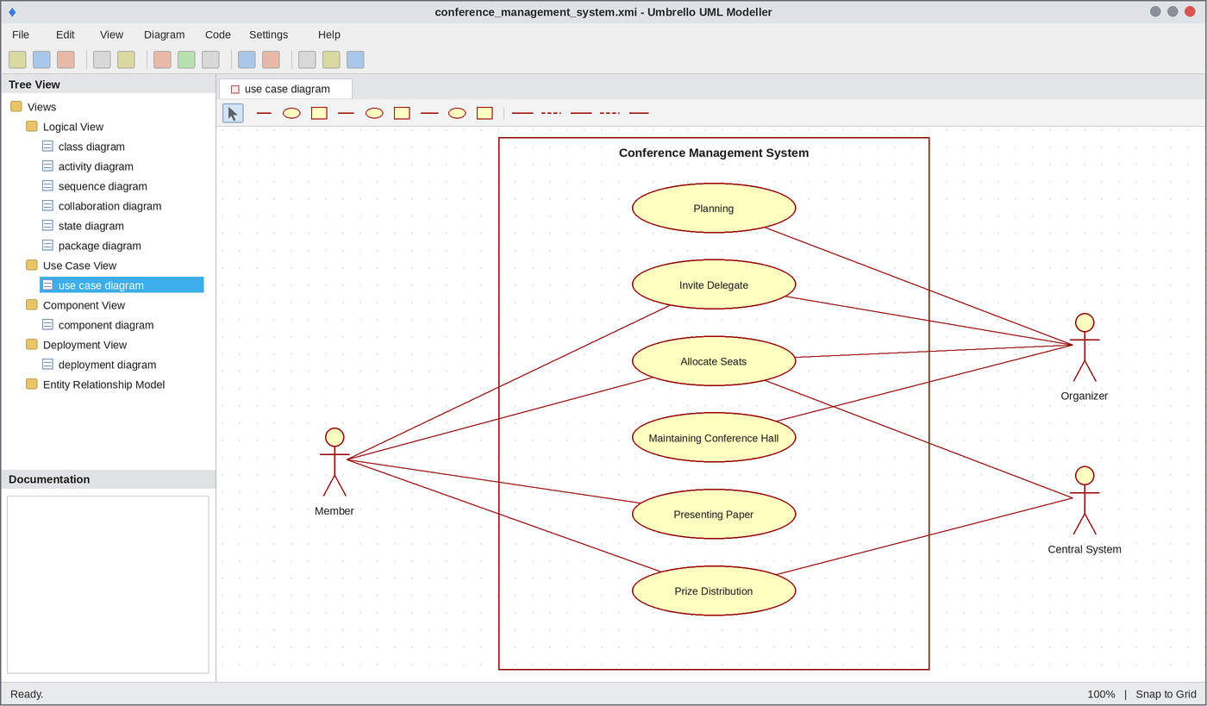
Use Case Diagram
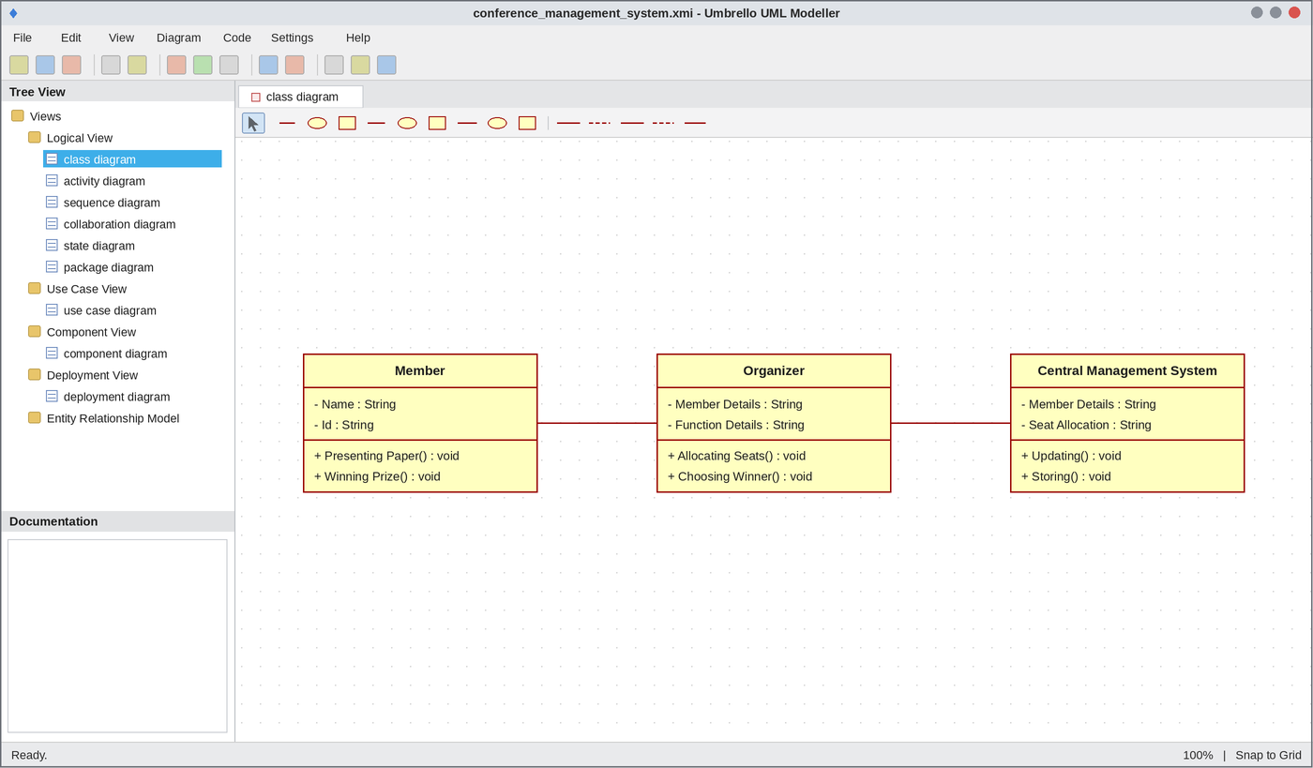
Class Diagram
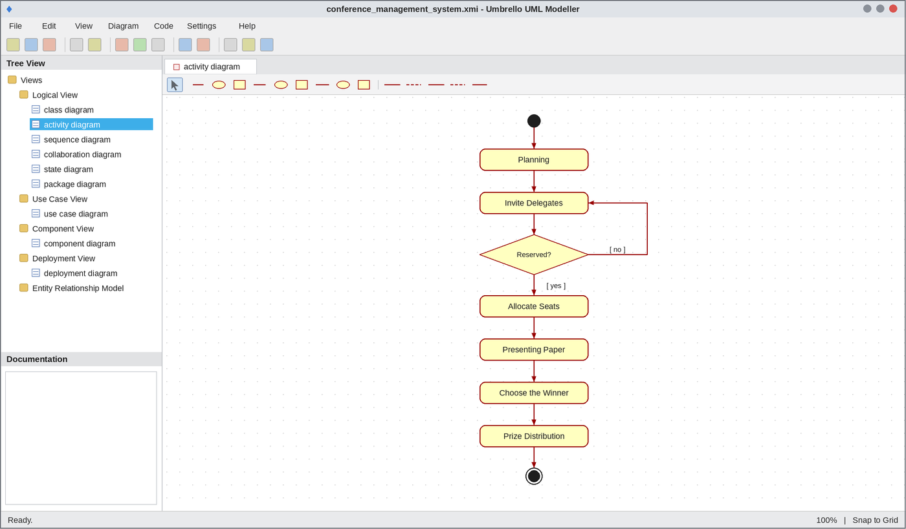
Activity Diagram
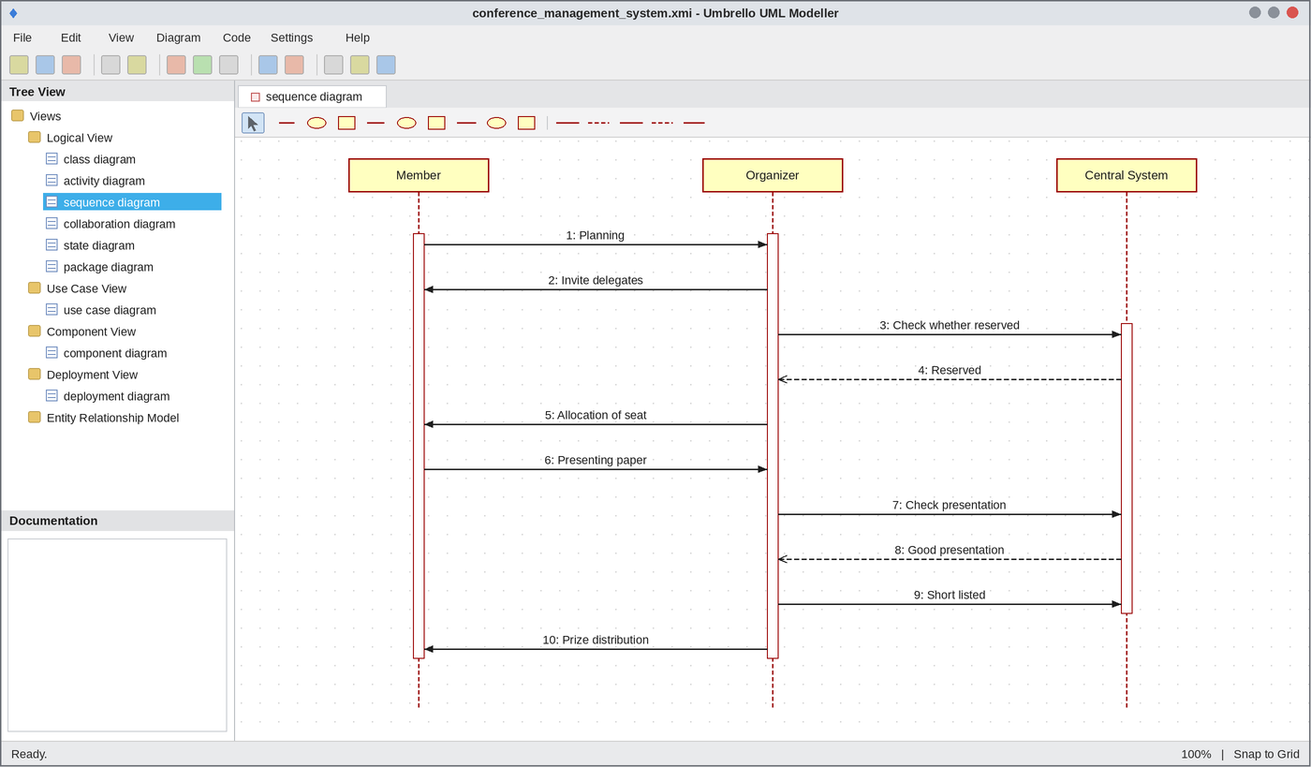
Sequence Diagram
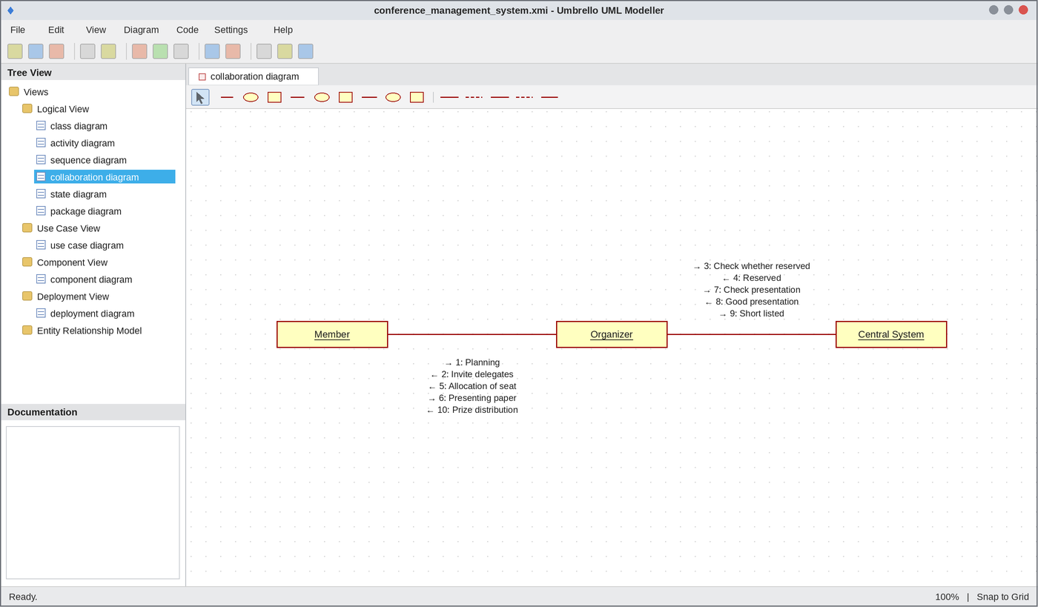
Collaboration Diagram
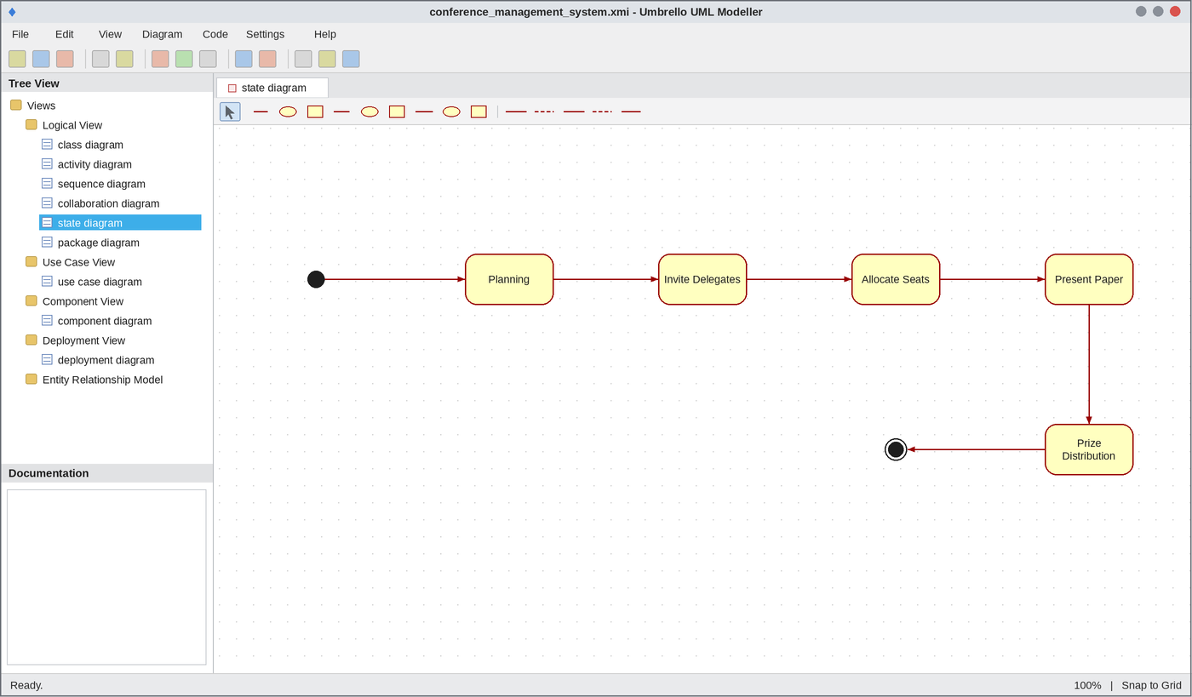
State Chart Diagram
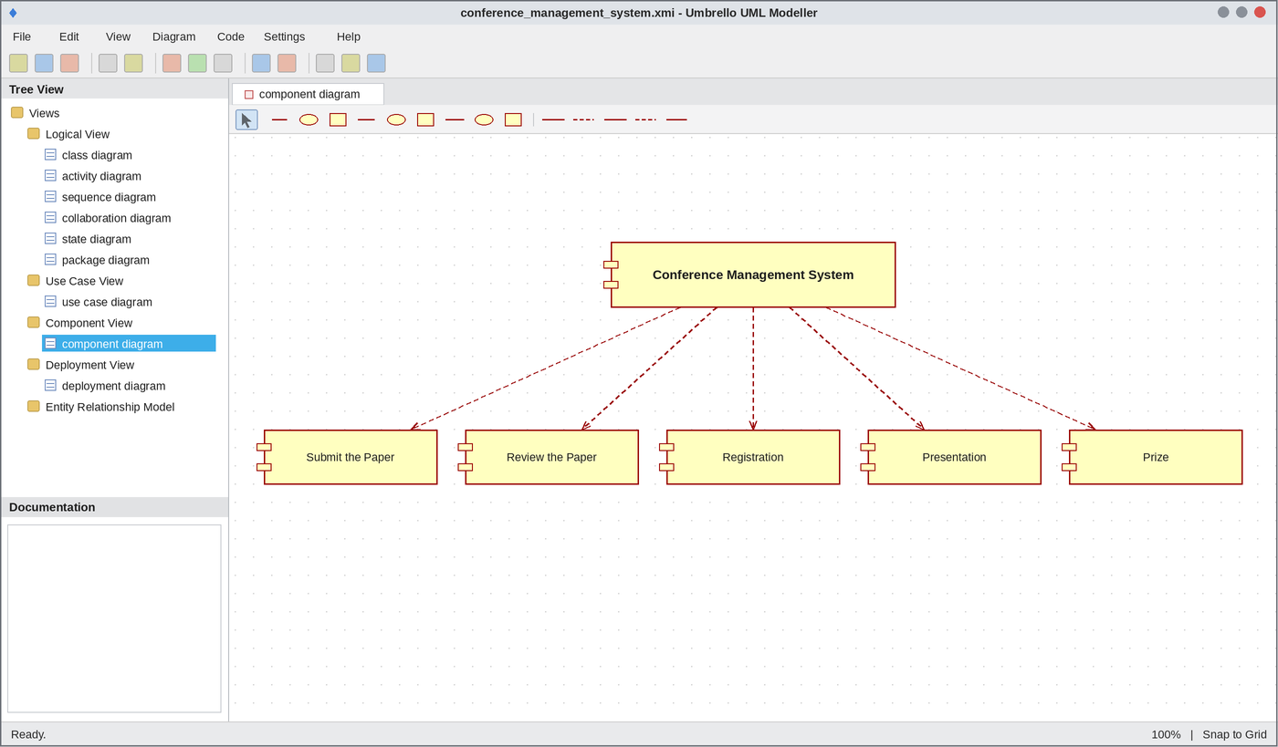
Component Diagram
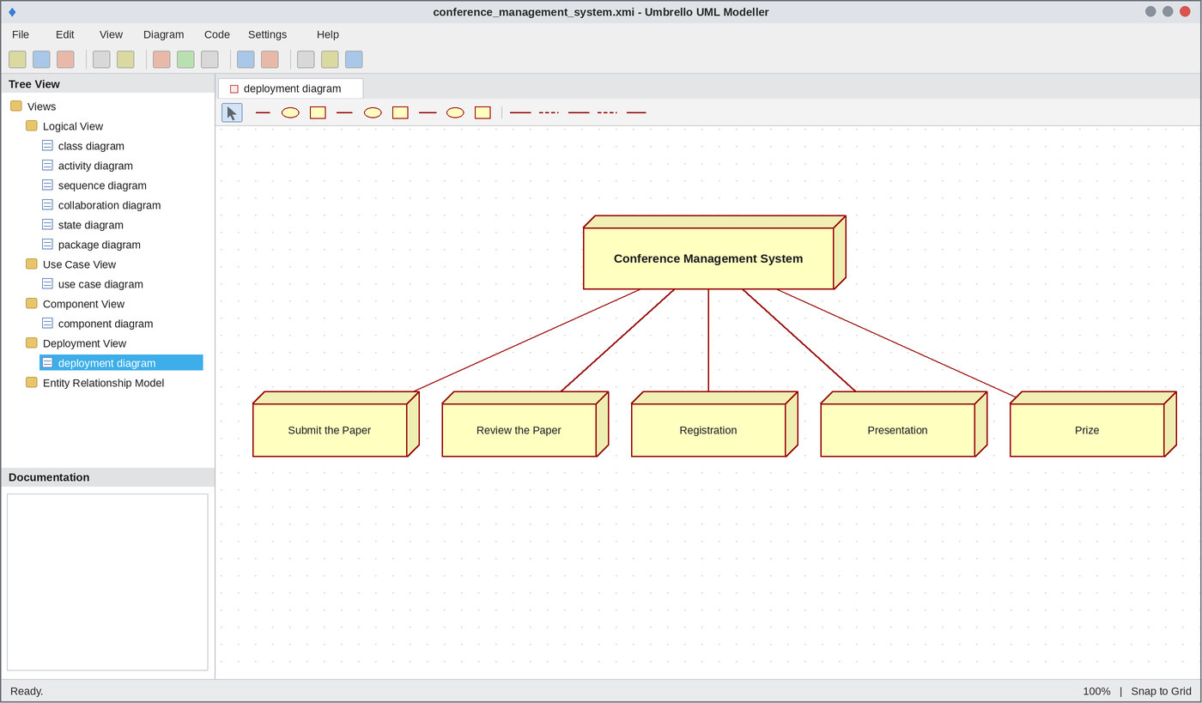
Deployment Diagram
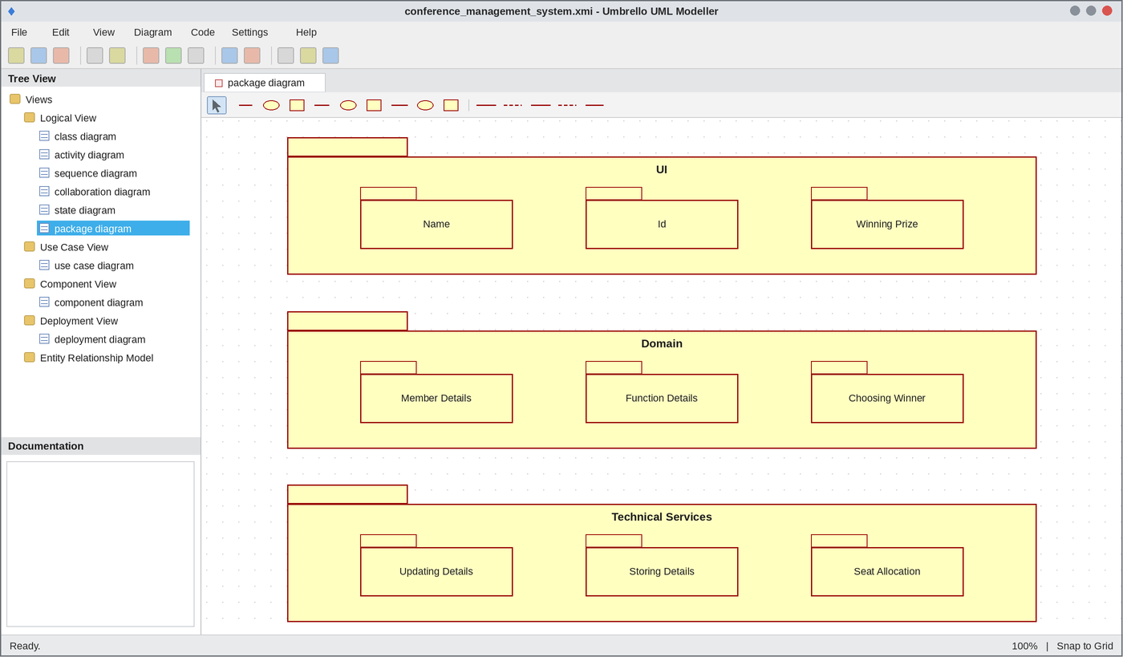
Package Diagram
WEBPAGE SCREENSHOT
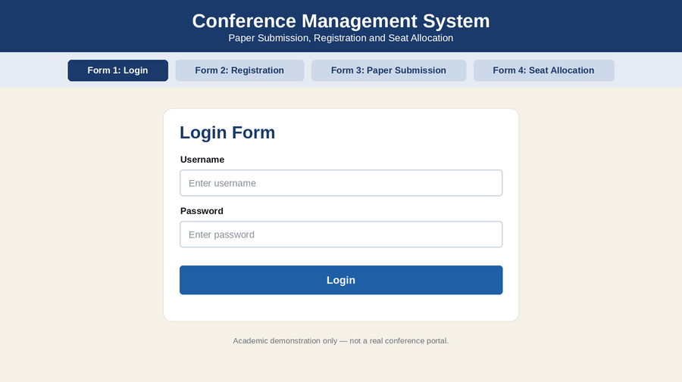
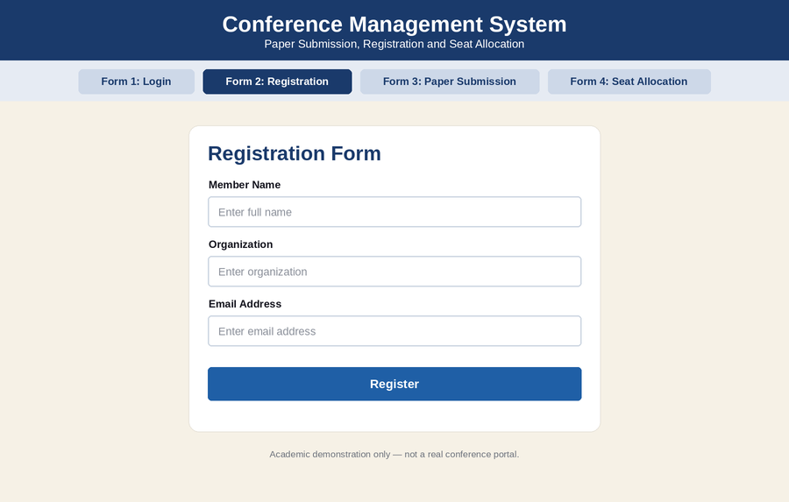
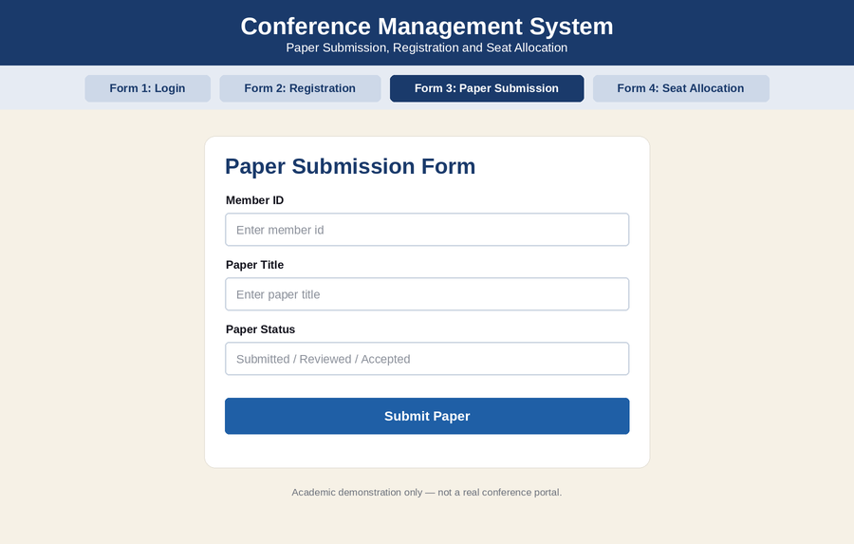
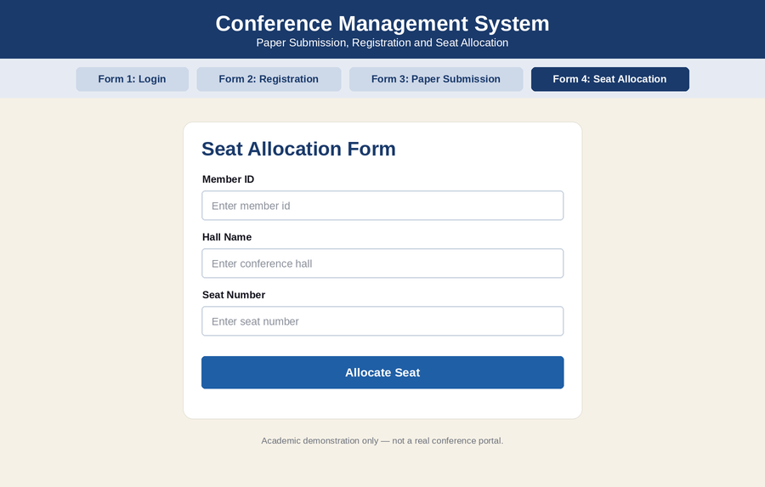
DATABASE SCREENSHOT
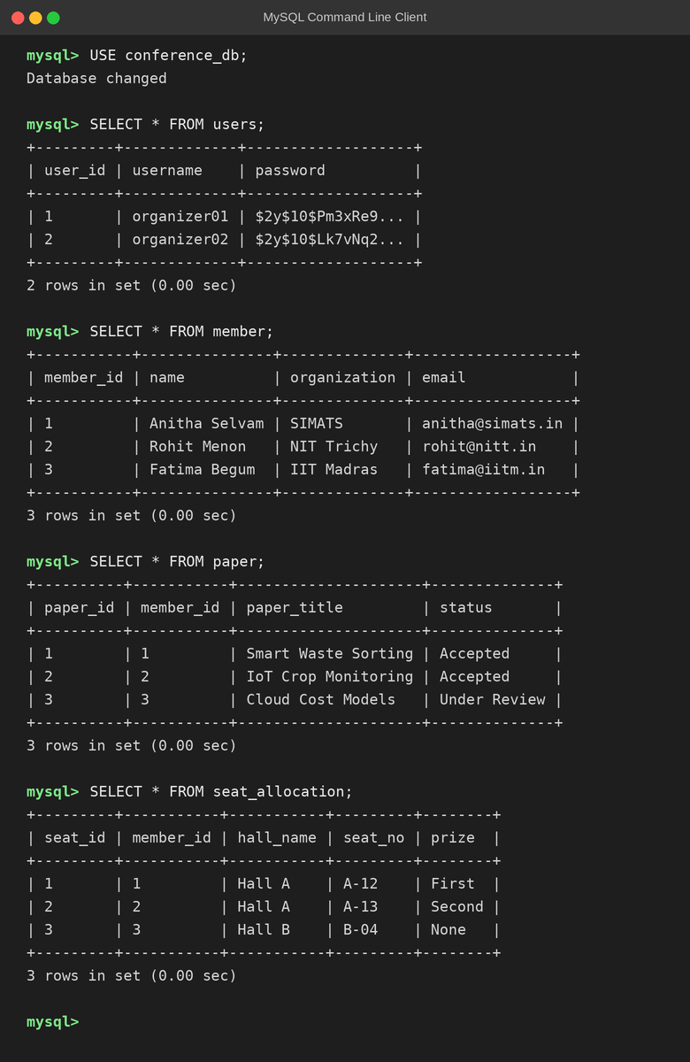
PSEUDO CODE
1. Planning and Invitation
BEGIN
ORGANIZER plans the conference
ORGANIZER invites delegates
MEMBER registers with name and id
SEND member details to CENTRAL SYSTEM
END
2. Seat Allocation
BEGIN
CHECK whether delegate has reserved
IF reserved THEN
ALLOCATE seat in conference hall
STORE seat details in CENTRAL SYSTEM
ELSE
DISPLAY "Reservation required"
ENDIF
END
3. Paper Presentation and Prize
BEGIN
MEMBER presents paper
ORGANIZER checks the presentation
IF presentation is good THEN
SHORTLIST member
CHOOSE the winner
DISTRIBUTE prize
ELSE
DISPLAY "Not shortlisted"
ENDIF
END

EX NO: 12 FOREIGN TRADING SYSTEM
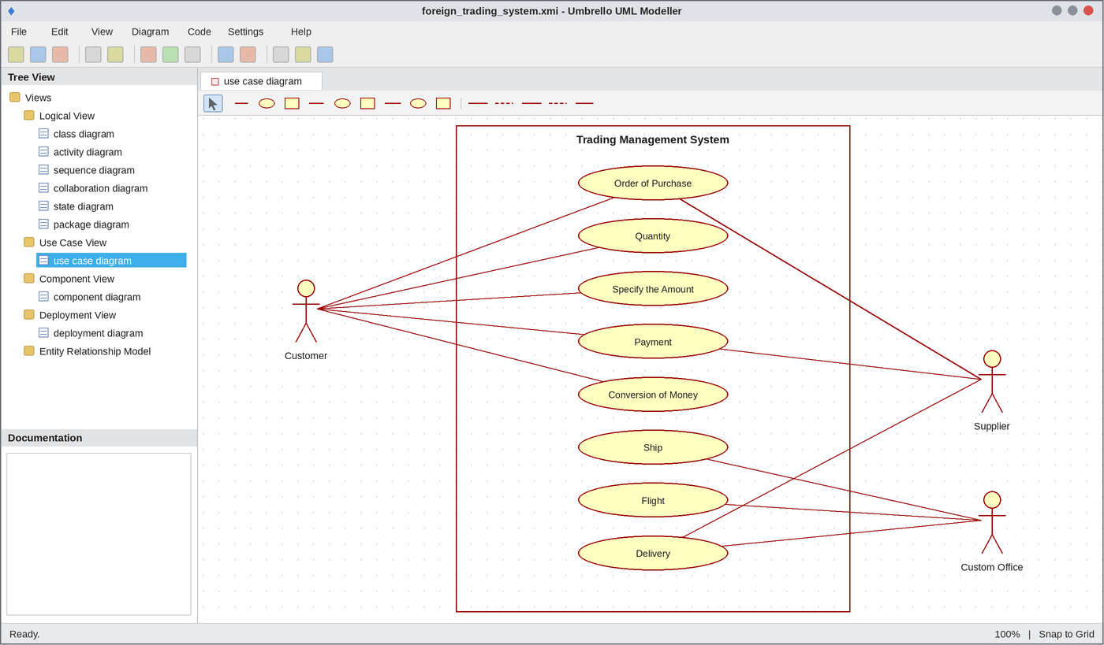
Use Case Diagram
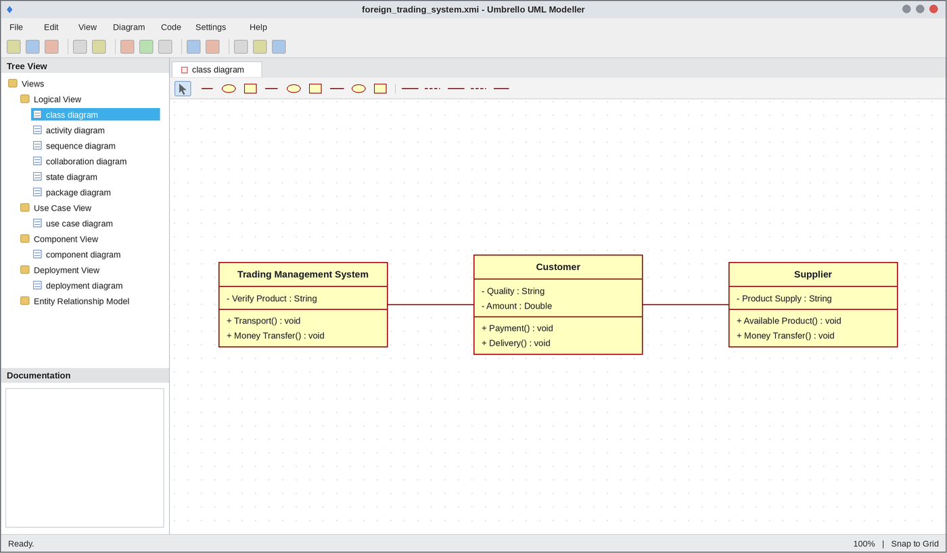
Class Diagram
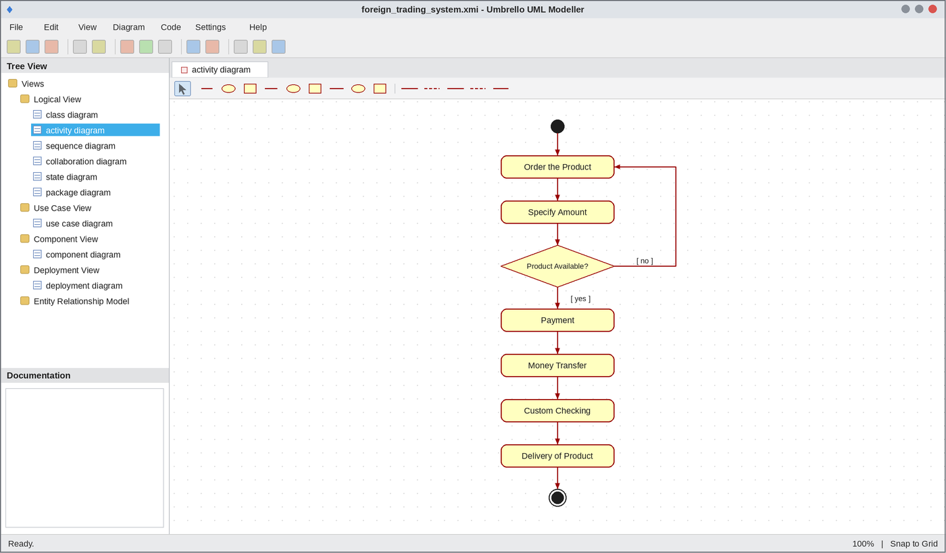
Activity Diagram
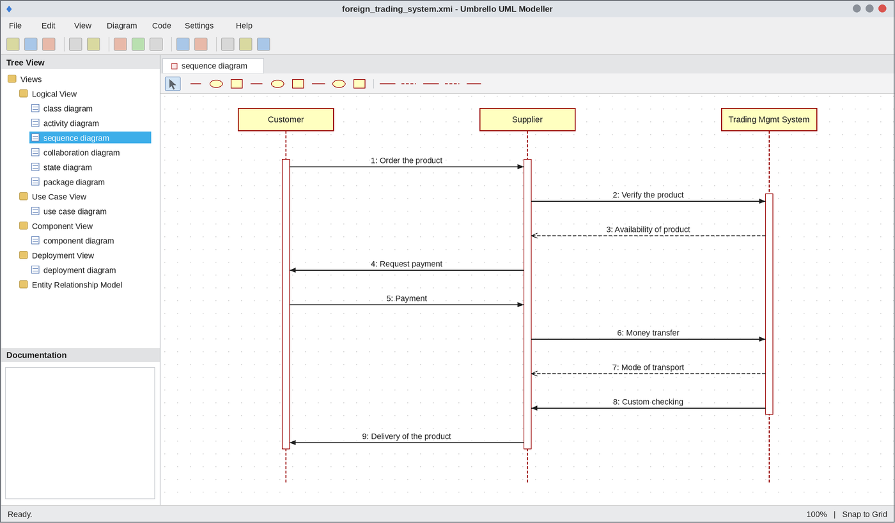
Sequence Diagram
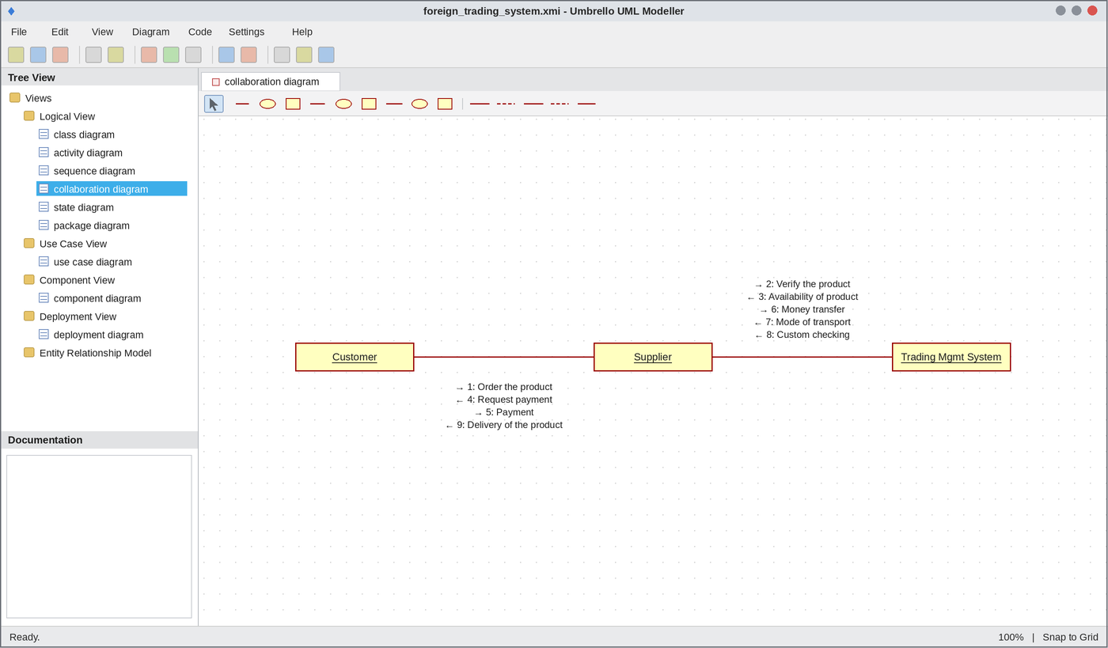
Collaboration Diagram
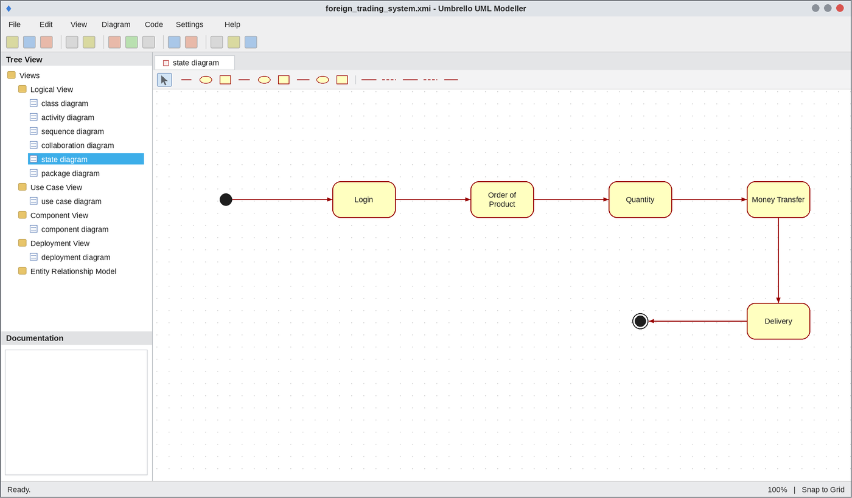
State Chart Diagram
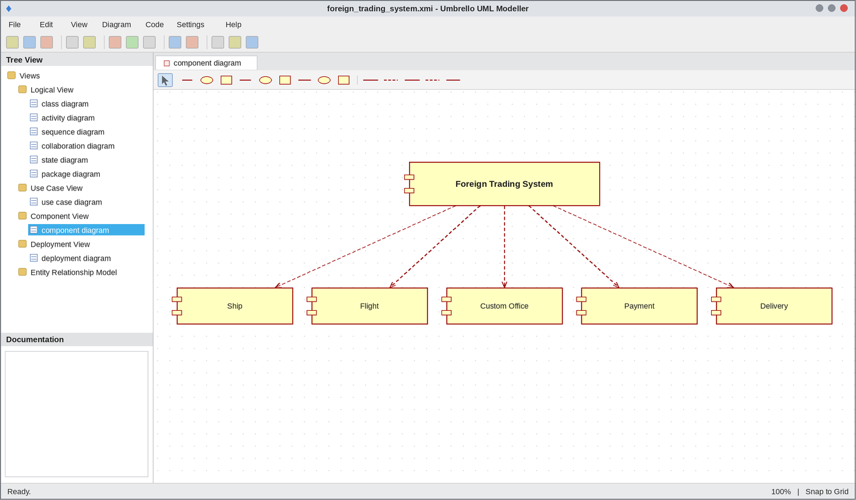
Component Diagram
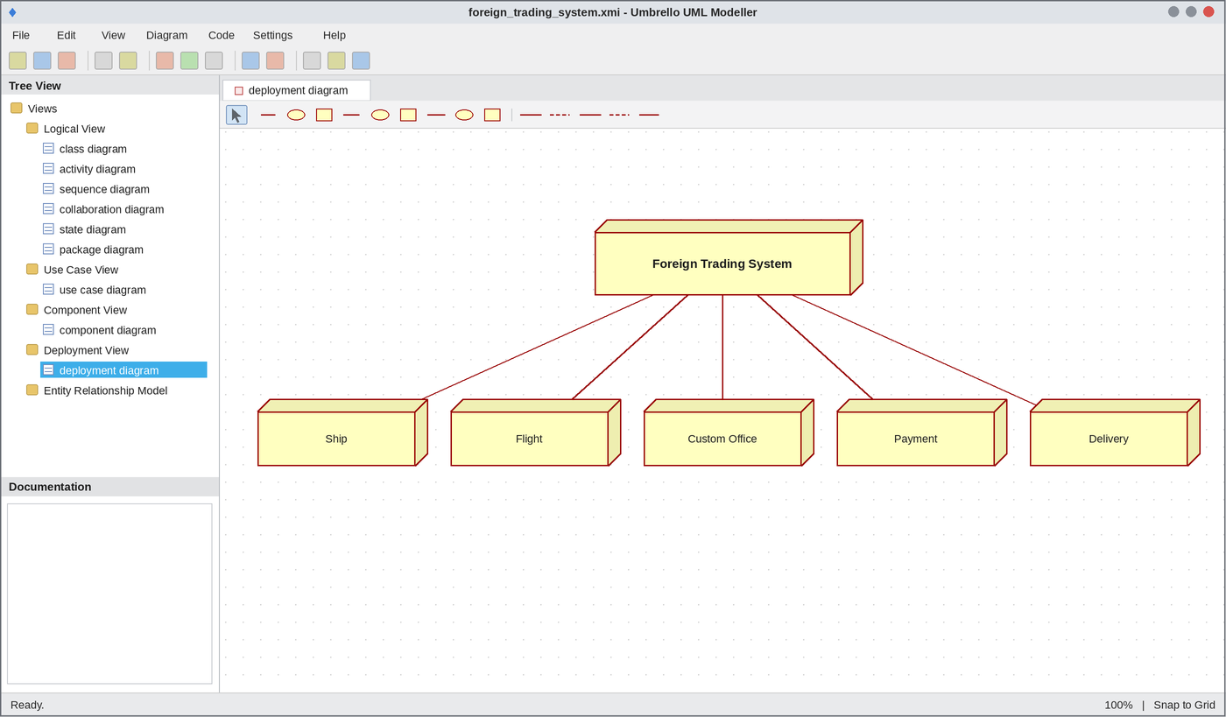
Deployment Diagram
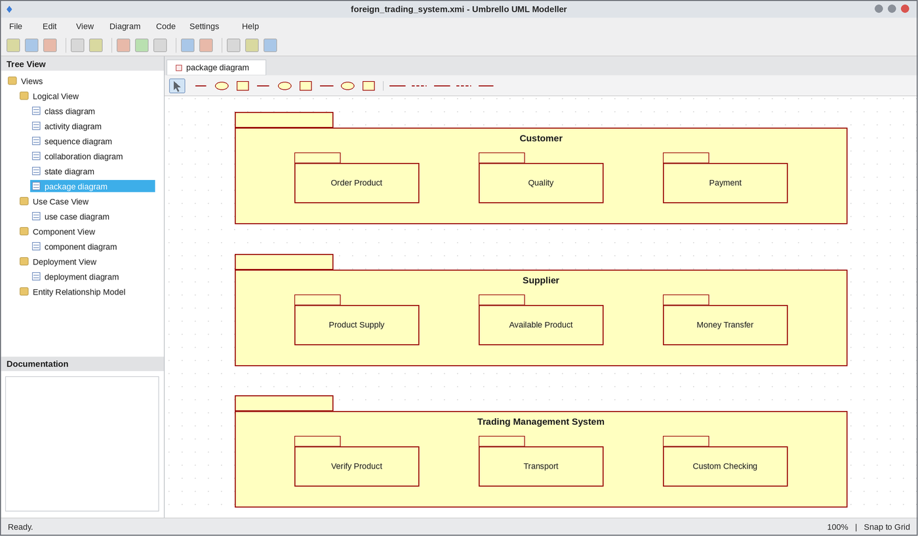
Package Diagram
WEBPAGE SCREENSHOT
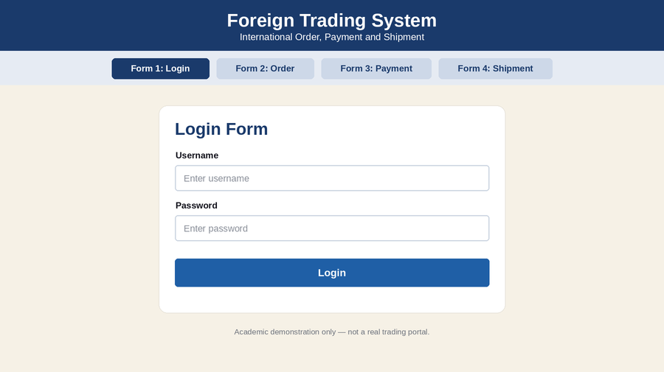
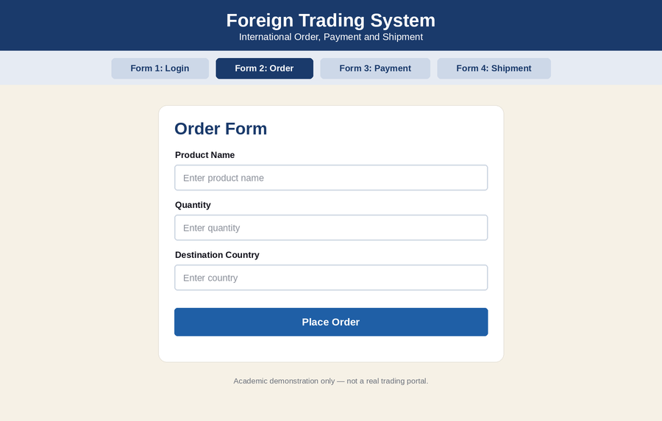
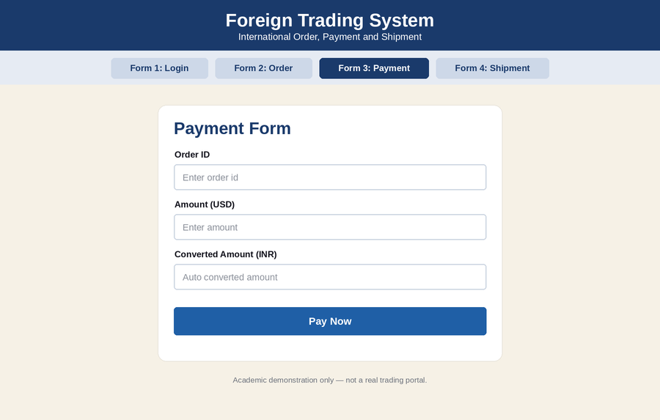
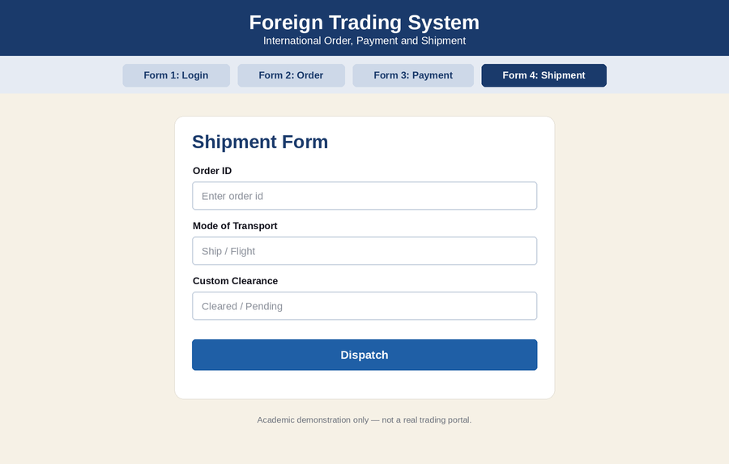
DATABASE SCREENSHOT
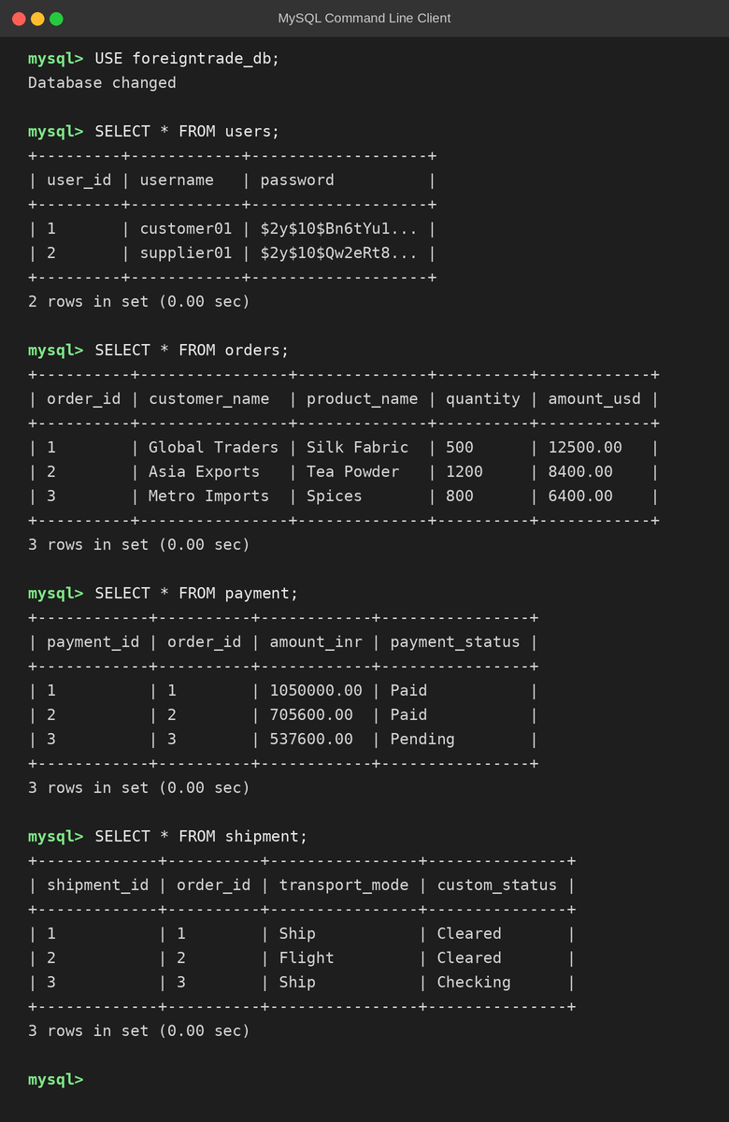
PSEUDO CODE
1. Order and Product Verification
BEGIN
CUSTOMER orders the product
CUSTOMER specifies quantity and amount
TRADING SYSTEM verifies the product with SUPPLIER
IF product is available THEN
REQUEST payment
ELSE
DISPLAY "Product not available"
ENDIF
END
2. Payment and Money Transfer
BEGIN
READ amount in foreign currency
CONVERT money to local currency
CUSTOMER makes the payment
TRANSFER money to SUPPLIER
DISPLAY "Payment successful"
END
3. Transport, Custom Check and Delivery
BEGIN
SELECT mode of transport (SHIP or FLIGHT)
CUSTOM OFFICER performs custom checking
IF custom check is cleared THEN
DELIVER product to customer
ELSE
HOLD shipment
ENDIF
END

EX NO: 13 BPO MANAGEMENT SYSTEM
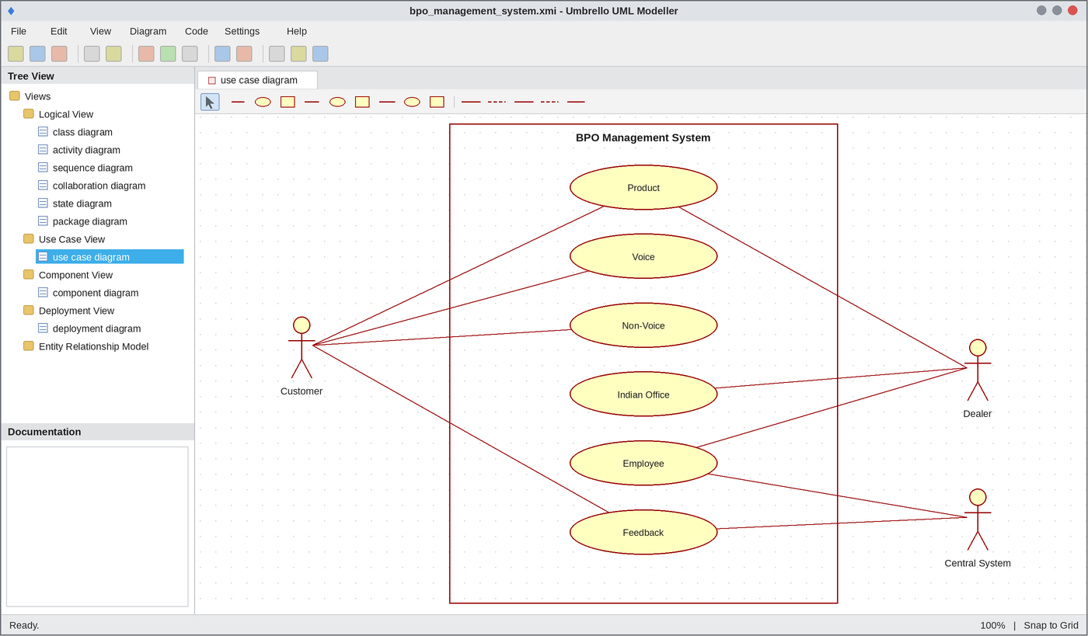
Use Case Diagram
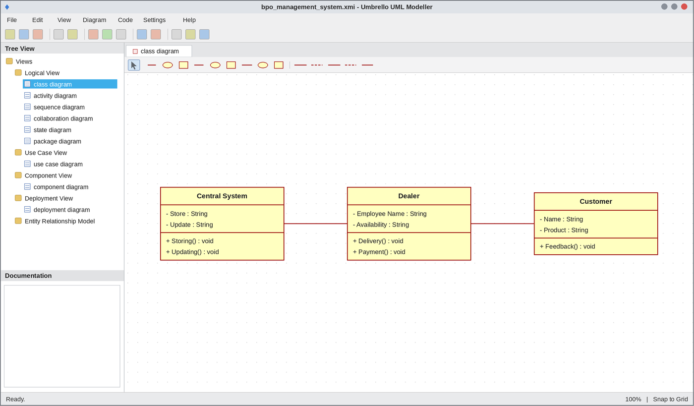
Class Diagram
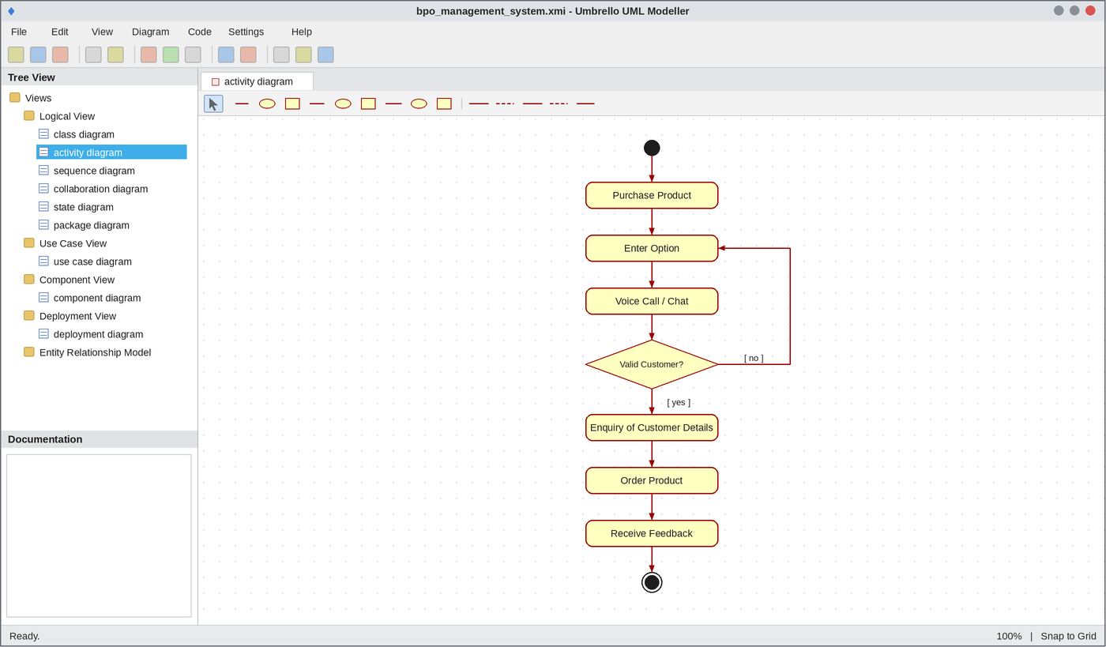
Activity Diagram
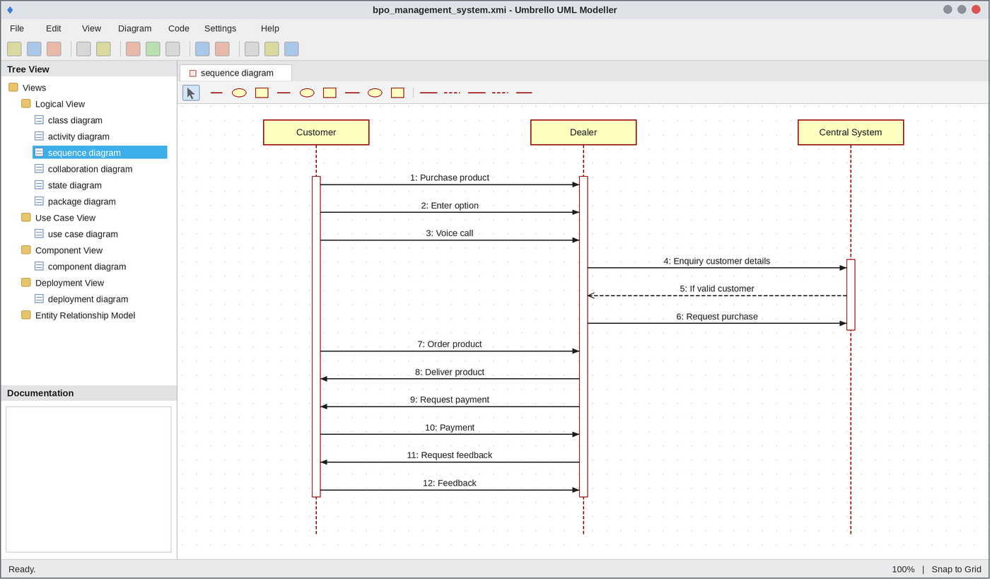
Sequence Diagram
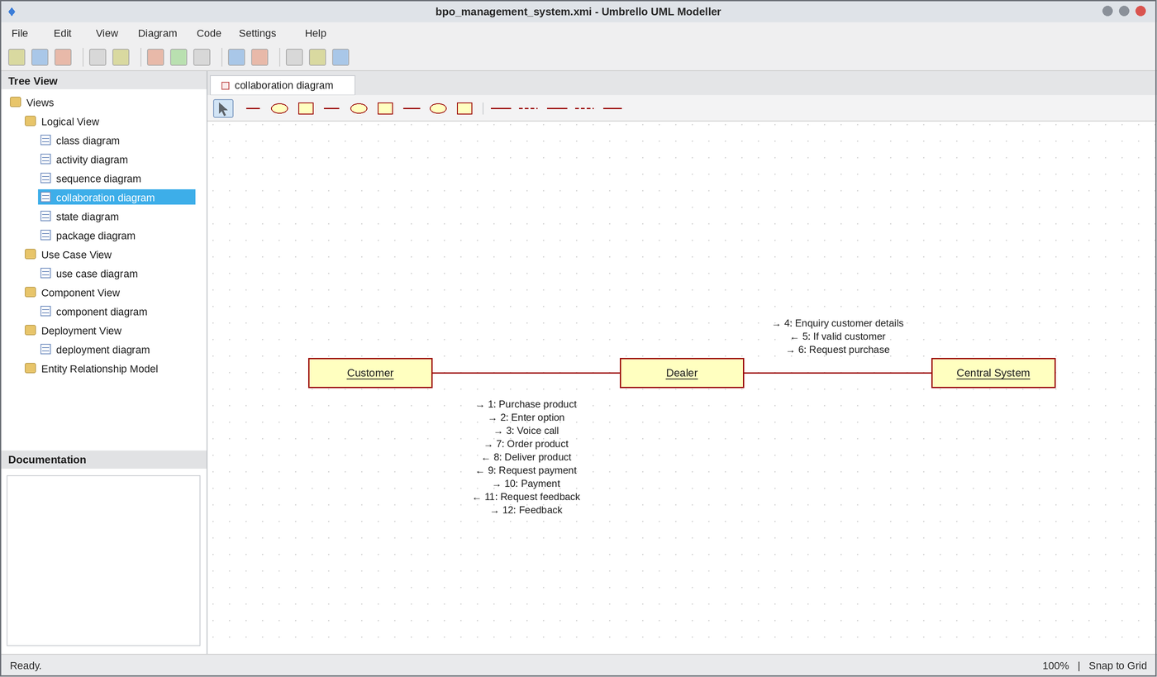
Collaboration Diagram
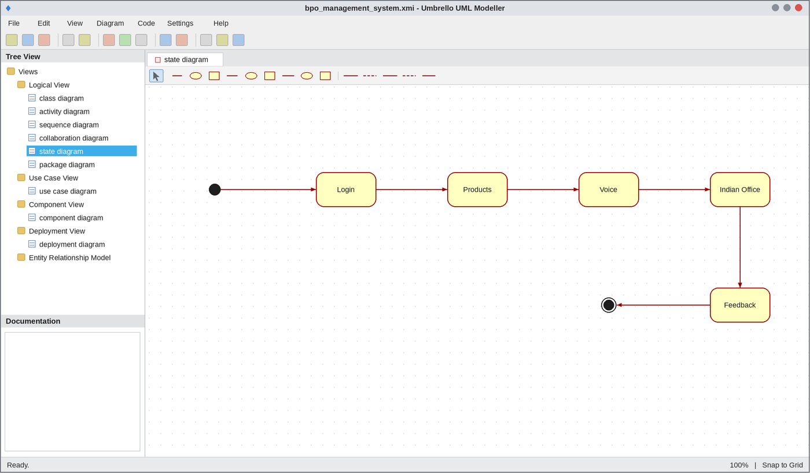
State Chart Diagram
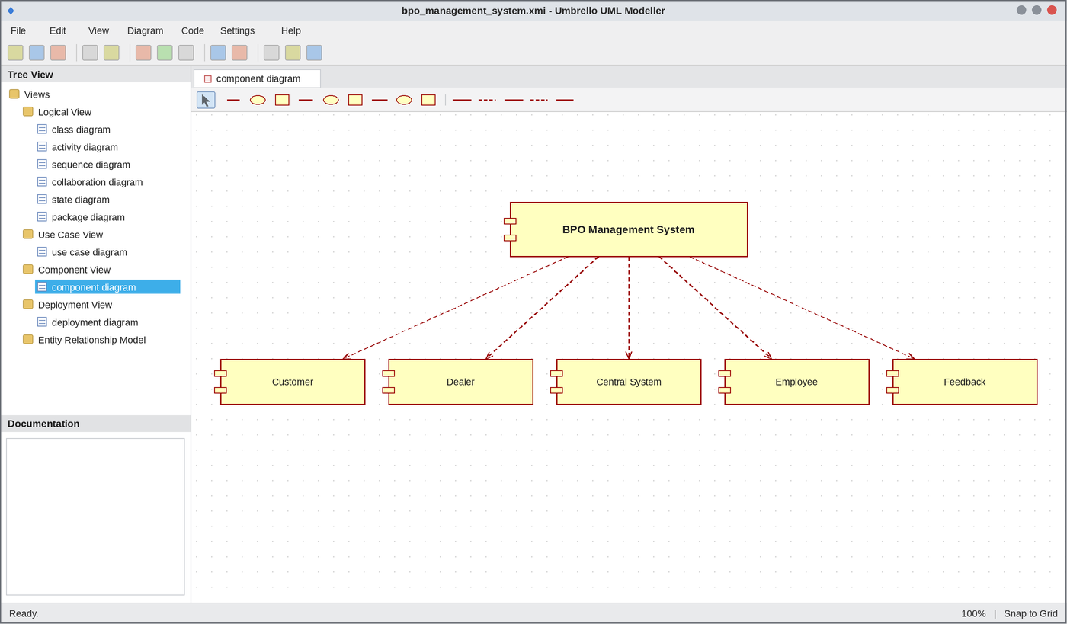
Component Diagram
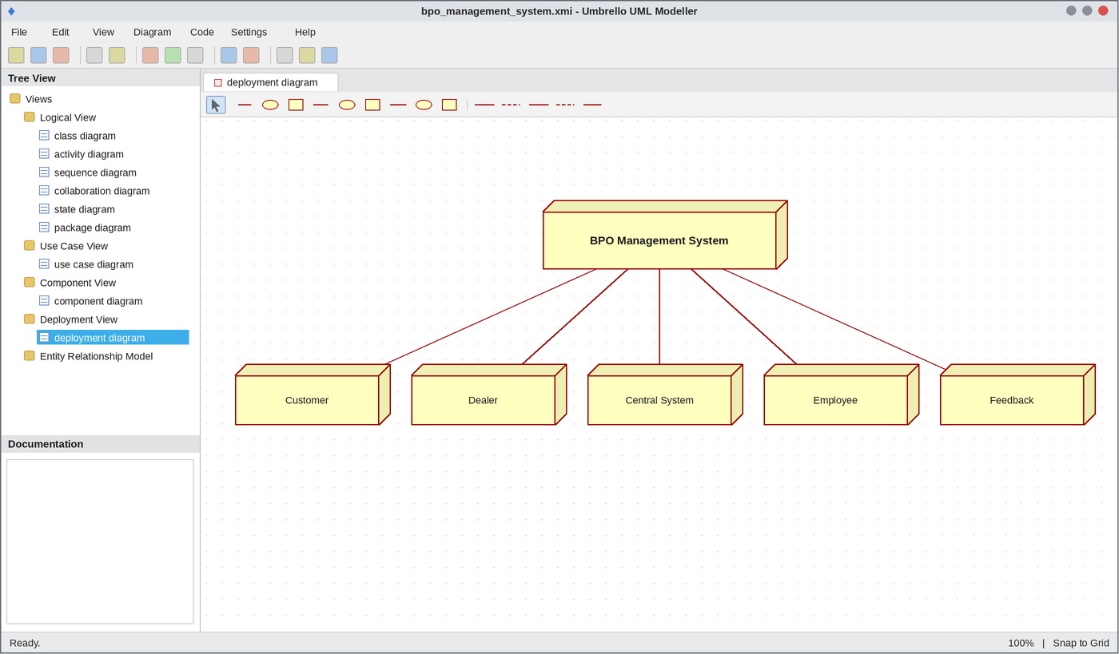
Deployment Diagram
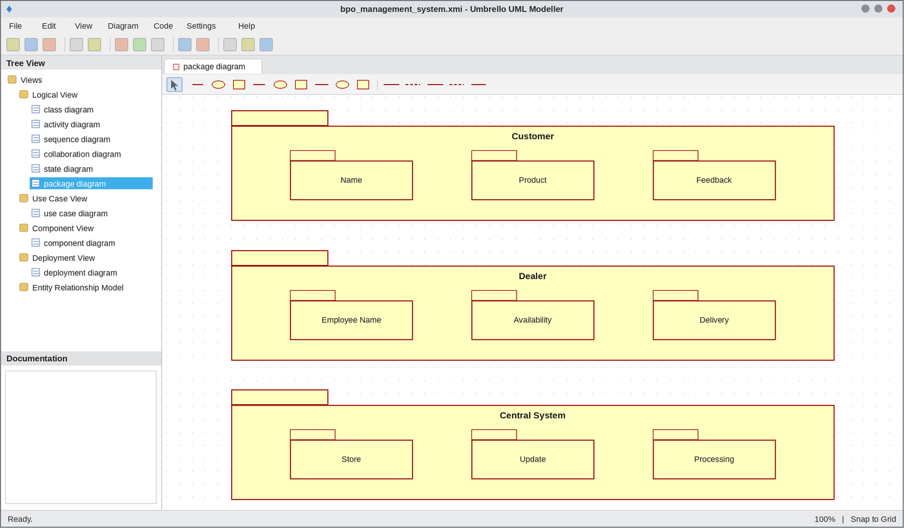
Package Diagram
WEBPAGE SCREENSHOT
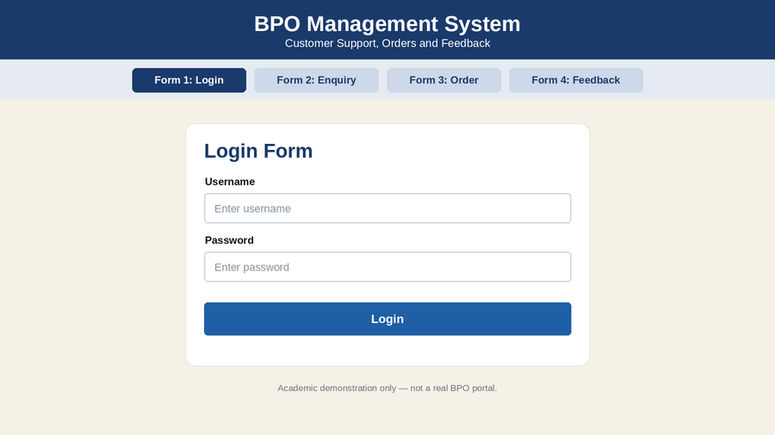
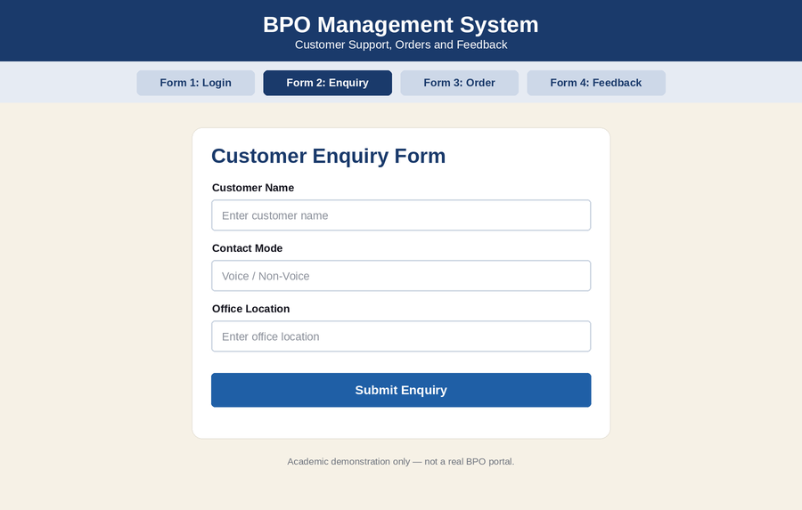
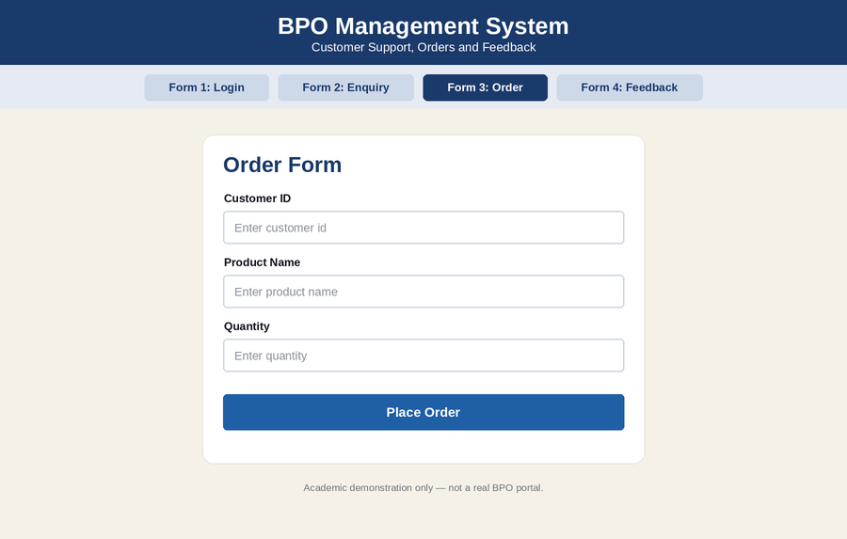
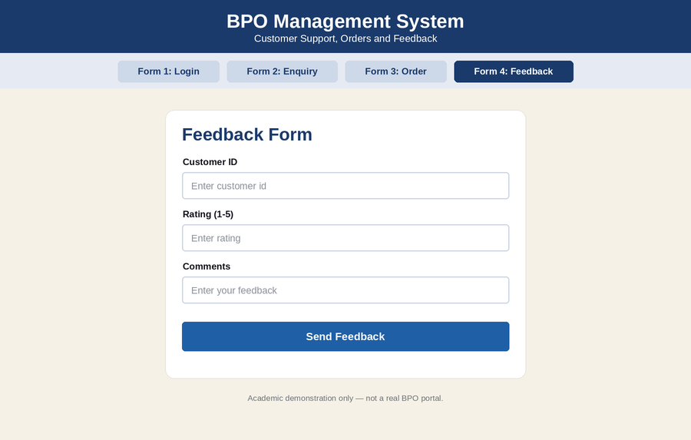
DATABASE SCREENSHOT
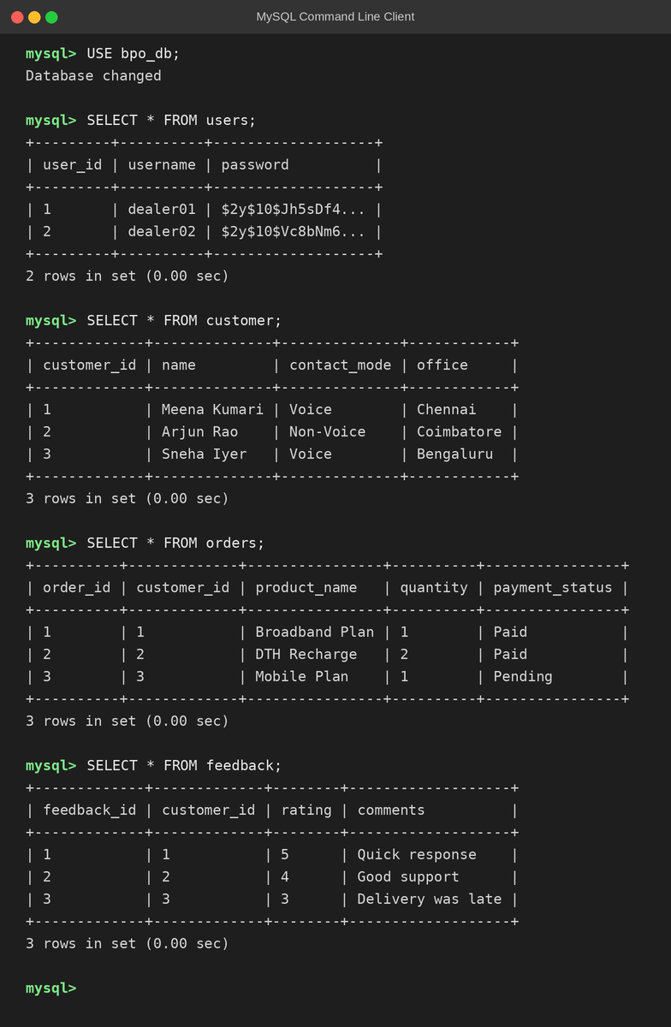
PSEUDO CODE
1. Purchase and Option Selection
BEGIN
CUSTOMER purchases a product
CUSTOMER enters the option (VOICE or NON-VOICE)
IF option is VOICE THEN
CONNECT voice call
ELSE
START chat session
ENDIF
END
2. Customer Enquiry and Order
BEGIN
DEALER enquires customer details from CENTRAL SYSTEM
IF customer is valid THEN
REQUEST purchase
ENTER product details
DELIVER product
ELSE
DISPLAY "Invalid customer"
ENDIF
END
3. Payment and Feedback
BEGIN
DEALER requests payment
CUSTOMER makes the payment
DEALER requests feedback
CUSTOMER gives feedback
UPDATE details in CENTRAL SYSTEM
DISPLAY "Regards"
END

EX NO: 14 LIBRARY MANAGEMENT SYSTEM
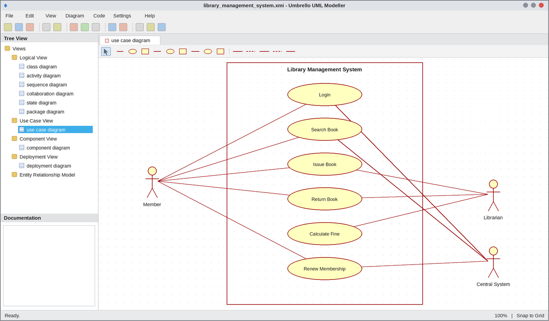
Use Case Diagram
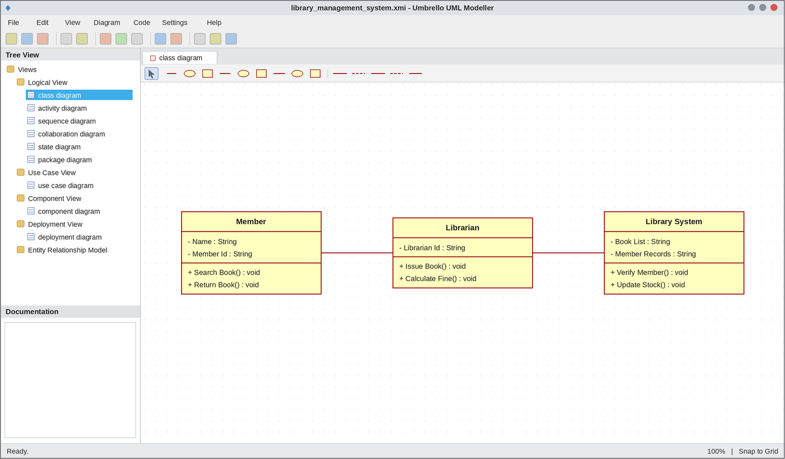
Class Diagram
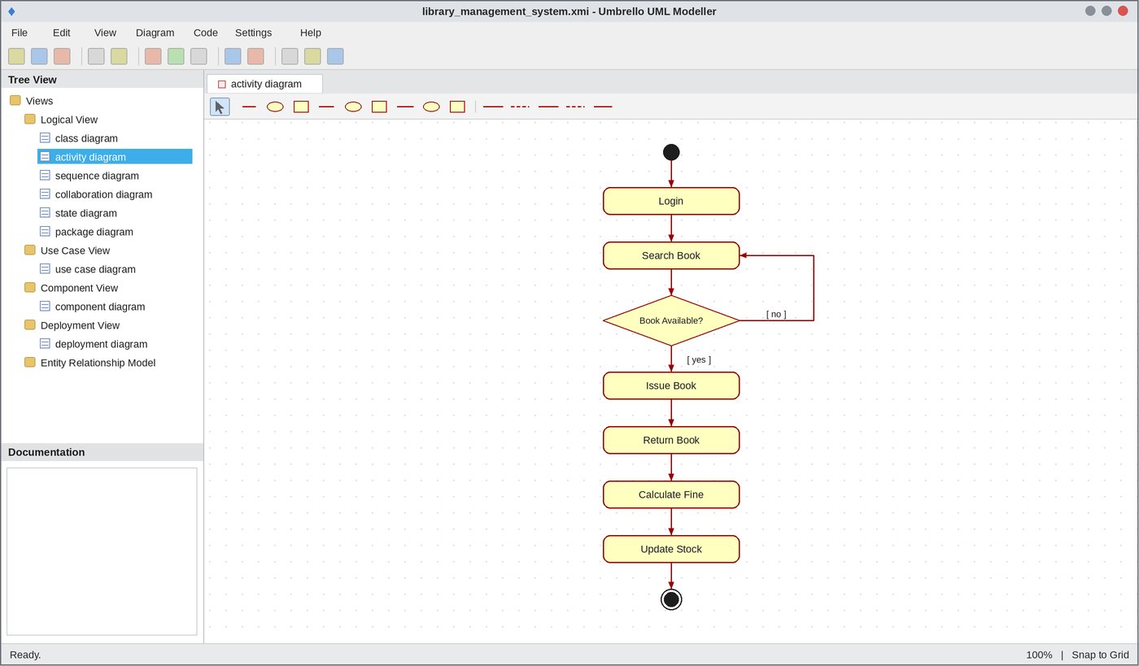
Activity Diagram
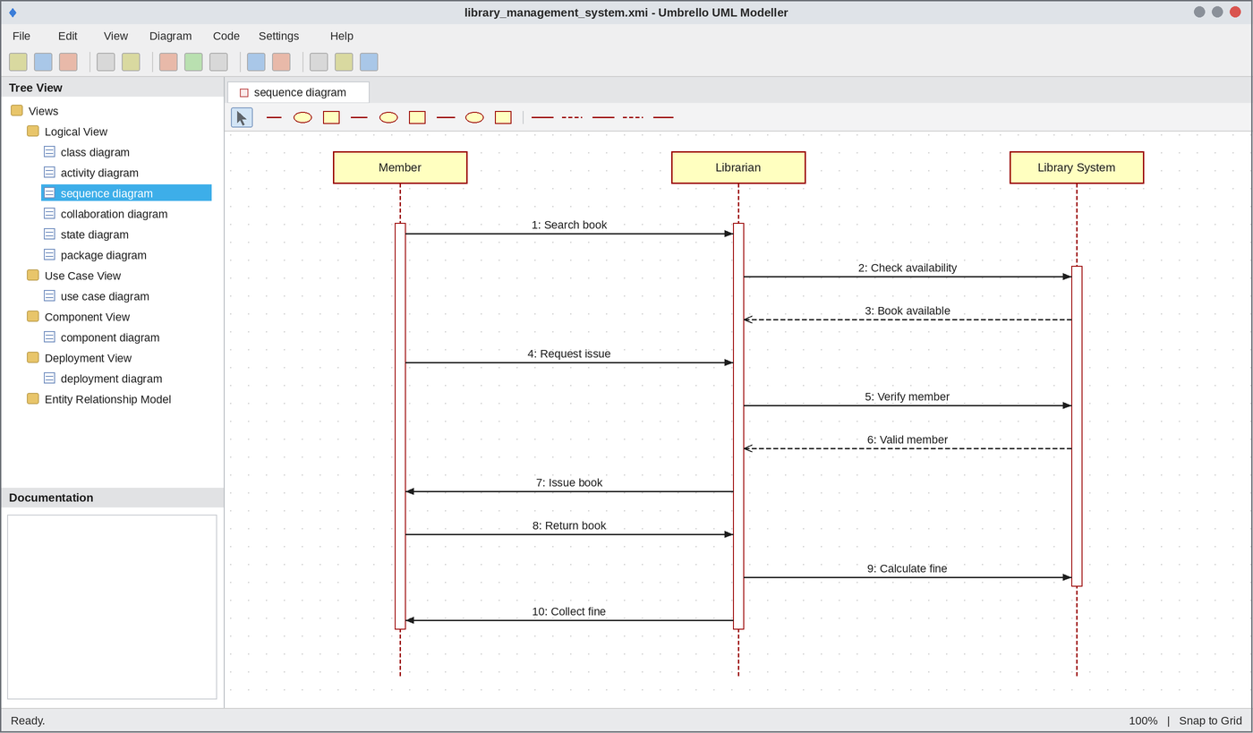
Sequence Diagram
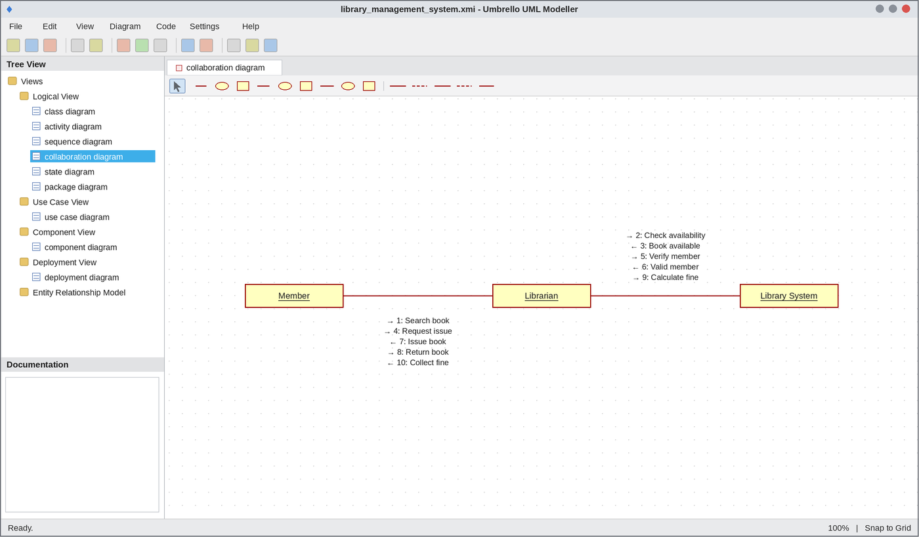
Collaboration Diagram
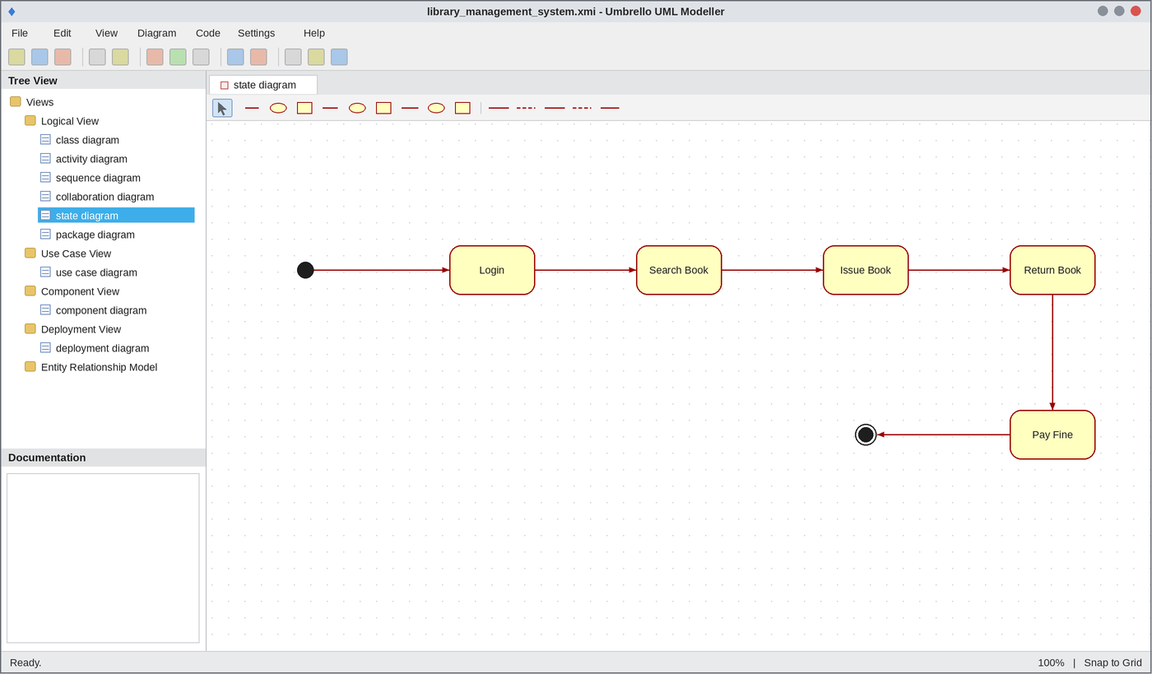
State Chart Diagram
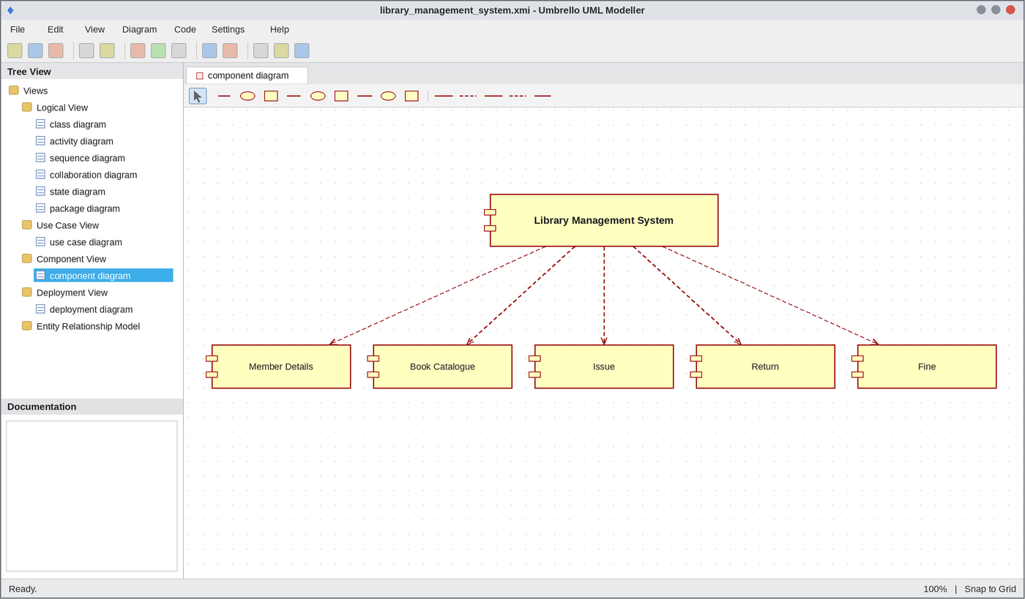
Component Diagram
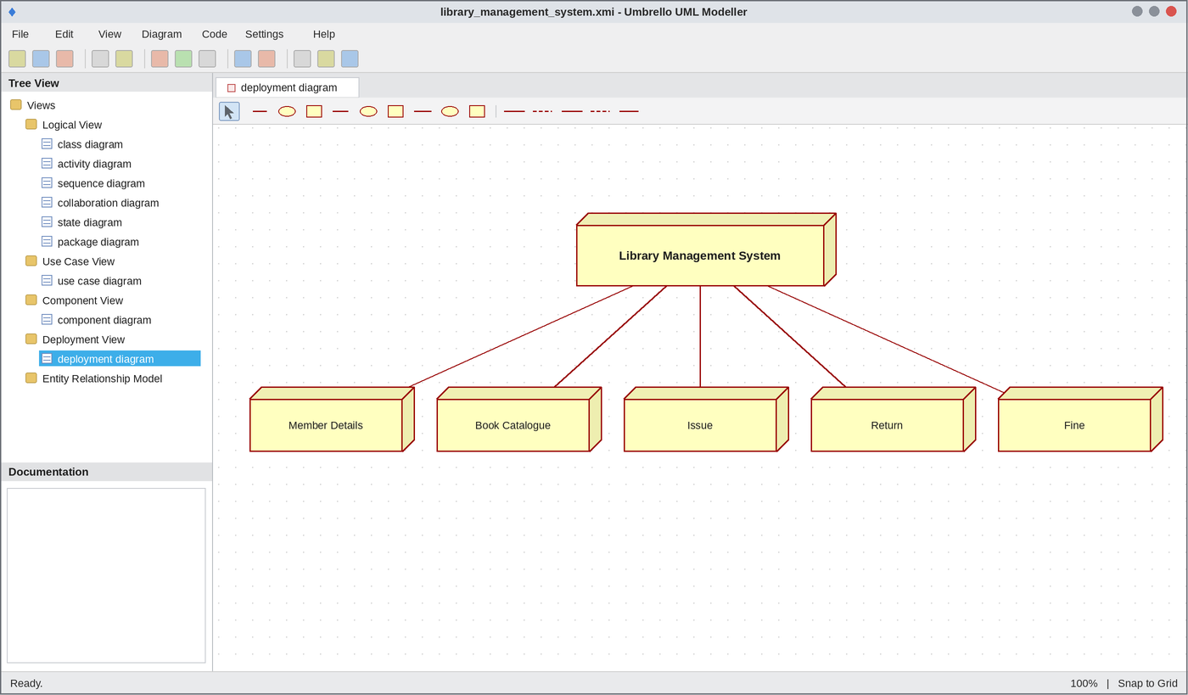
Deployment Diagram
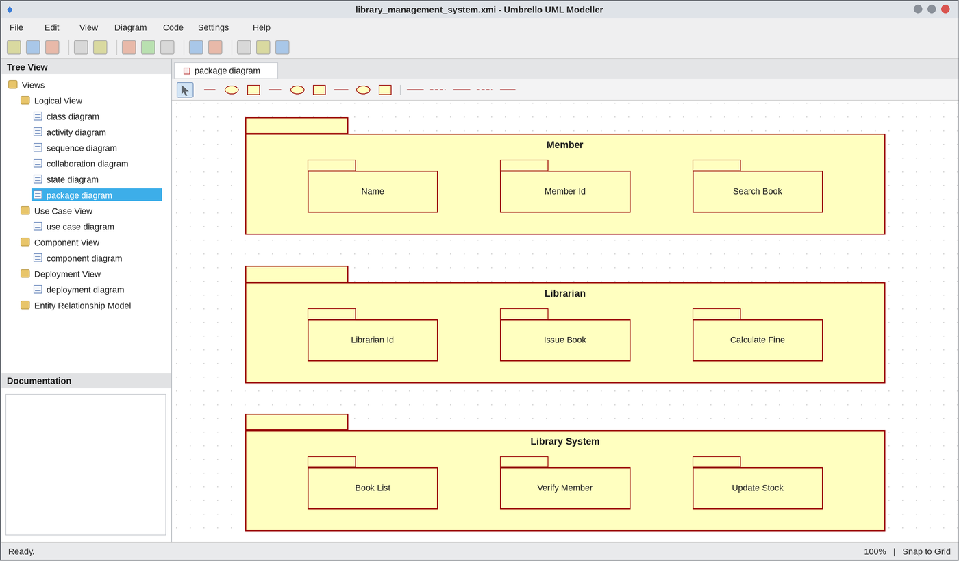
Package Diagram
WEBPAGE SCREENSHOT
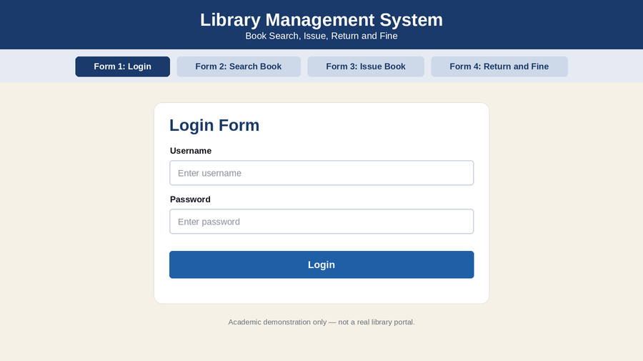
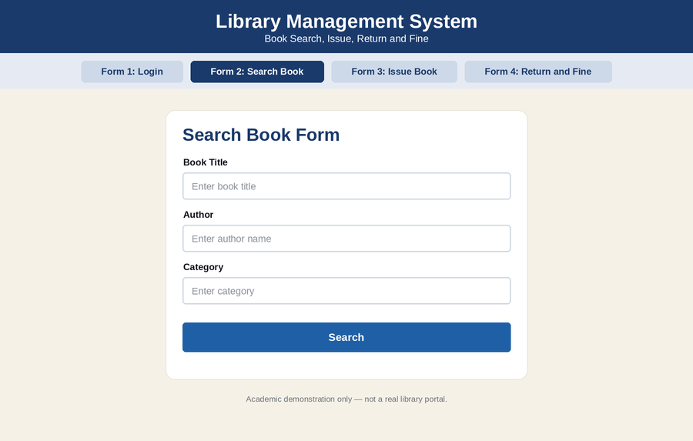
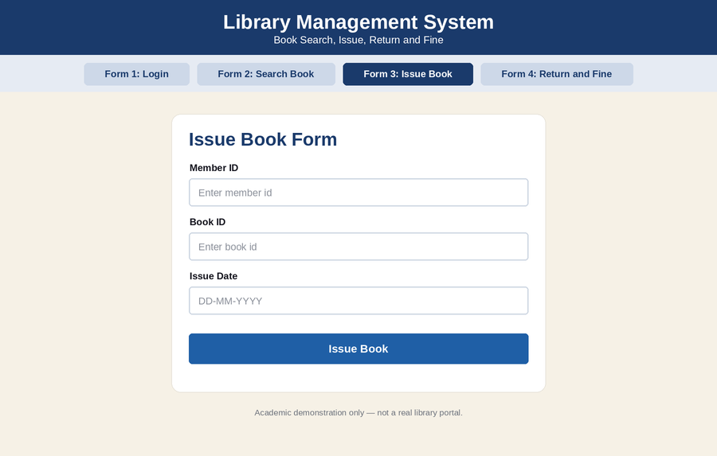
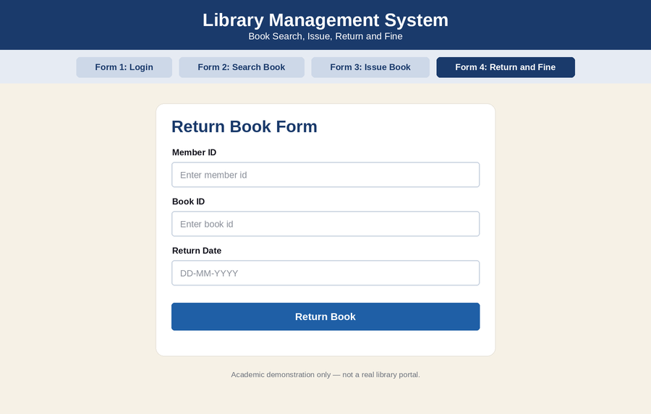
DATABASE SCREENSHOT
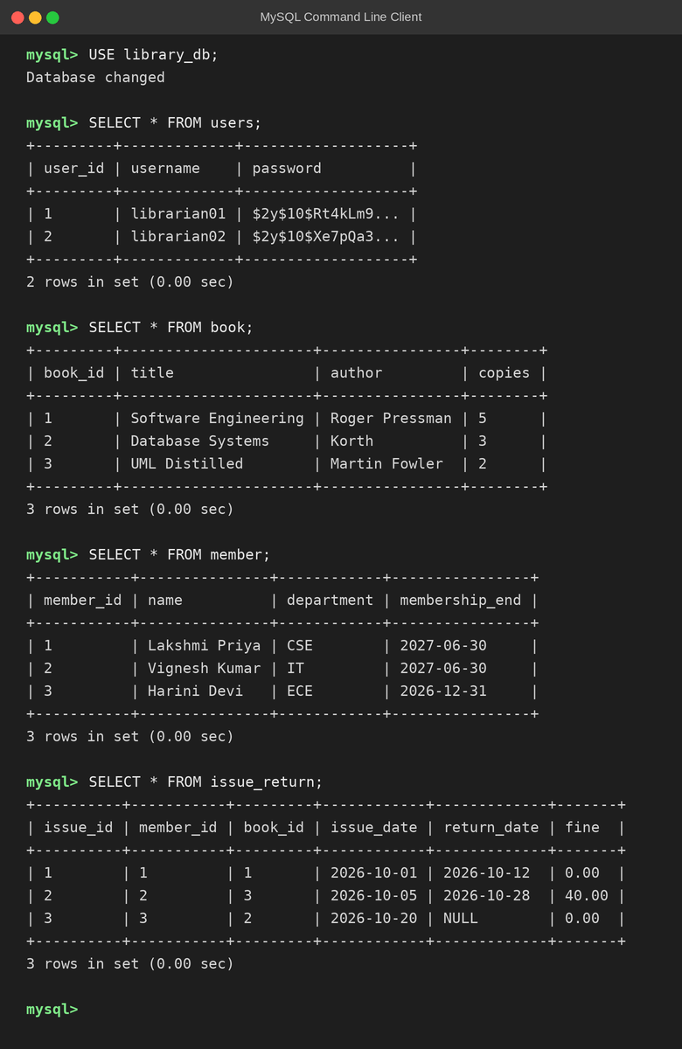
PSEUDO CODE
1. Login and Book Search
BEGIN
MEMBER enters user name and password
IF login is valid THEN
READ book title
SEARCH book in LIBRARY SYSTEM
ELSE
DISPLAY "Login failed"
ENDIF
END
2. Availability and Issue of Book
BEGIN
IF book is available THEN
VERIFY member details
LIBRARIAN issues the book
UPDATE stock and issue date
ELSE
DISPLAY "Book not available"; GOTO search
ENDIF
END
3. Return and Fine Calculation
BEGIN
MEMBER returns the book
READ return date
IF return date > due date THEN
fine = late days * 2
COLLECT fine
ELSE
SET fine = 0
ENDIF
UPDATE stock in LIBRARY SYSTEM
END

EX NO: 15 ATM SYSTEM
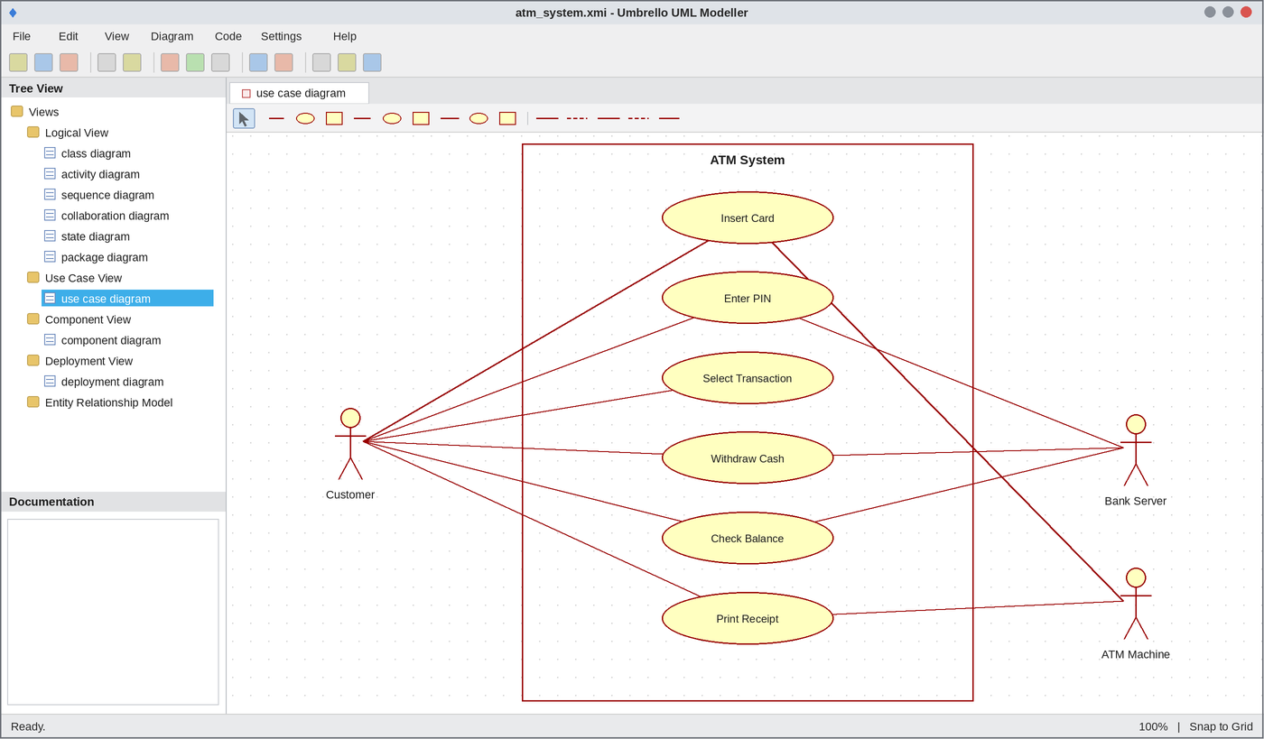
Use Case Diagram
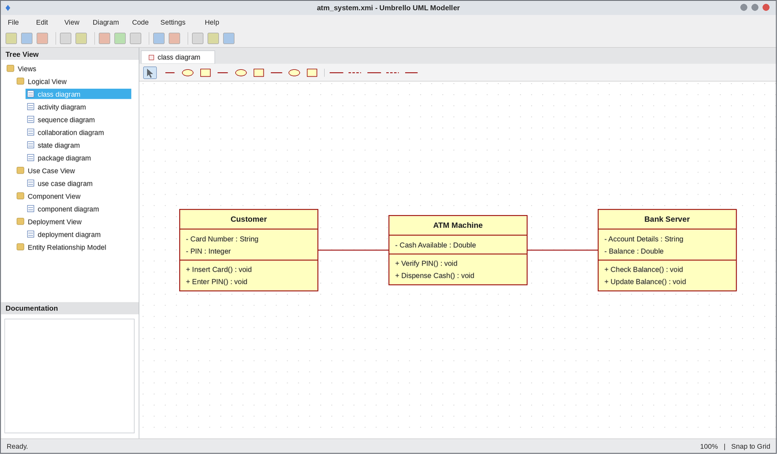
Class Diagram
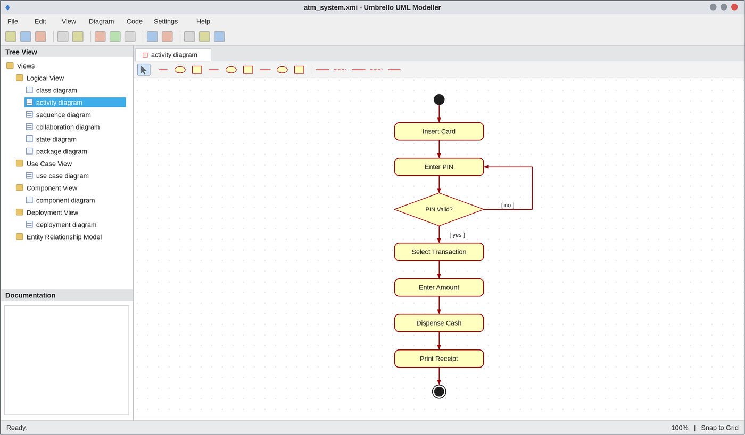
Activity Diagram
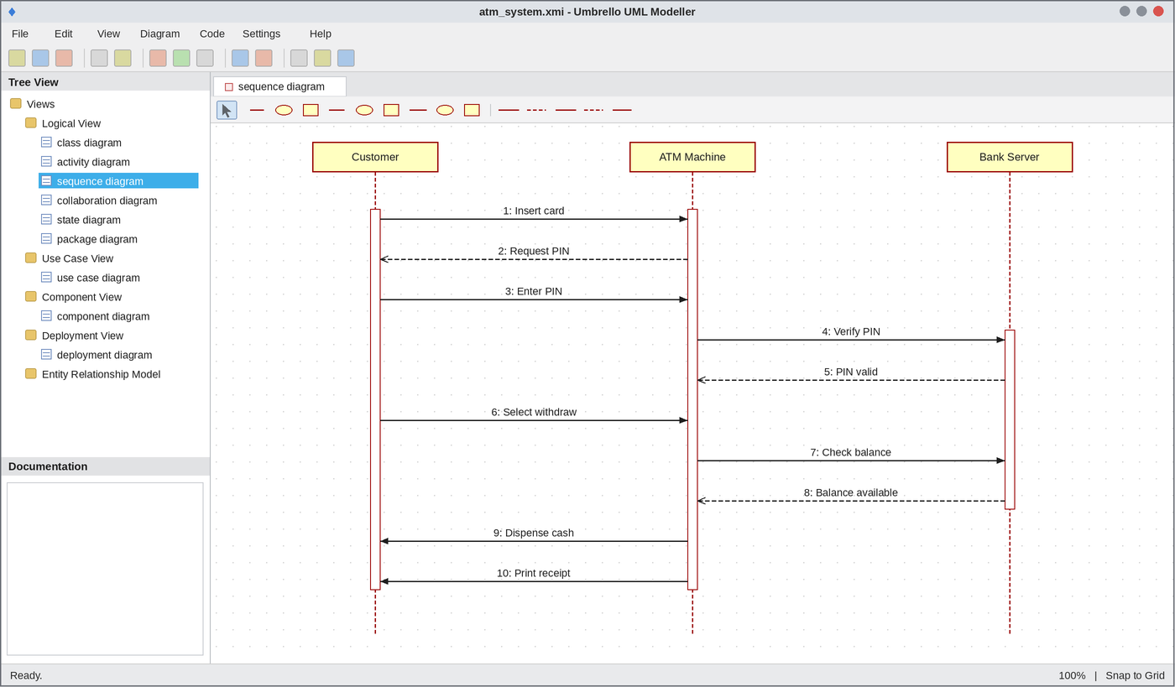
Sequence Diagram
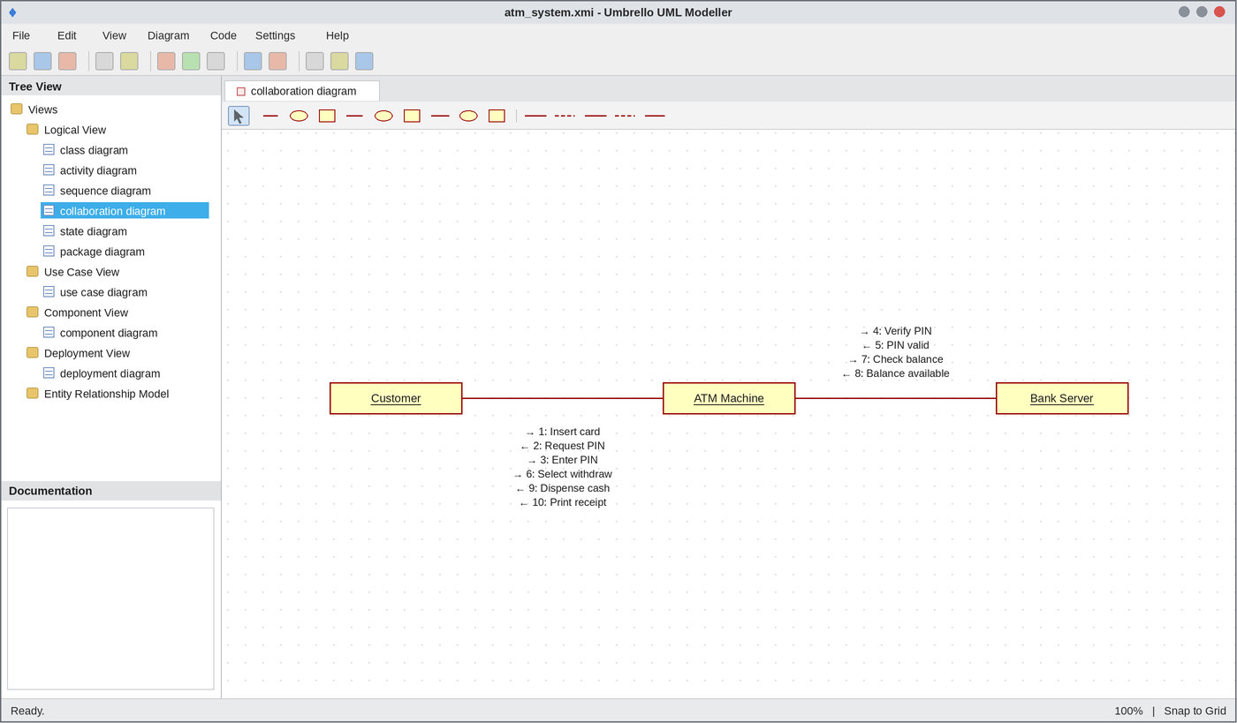
Collaboration Diagram
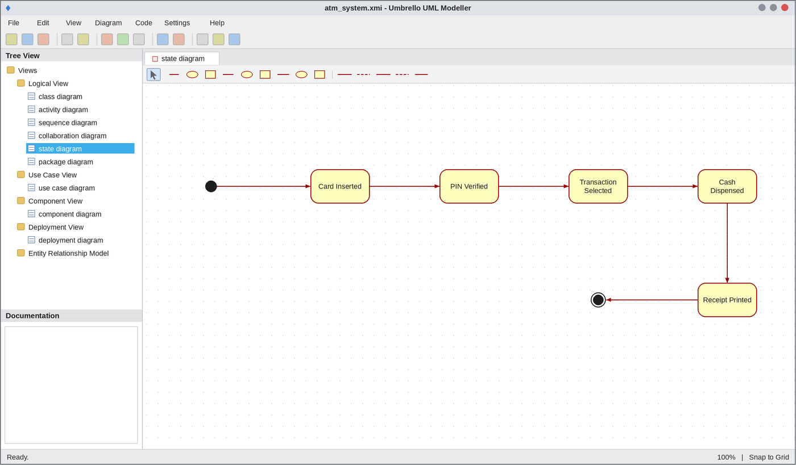
State Chart Diagram
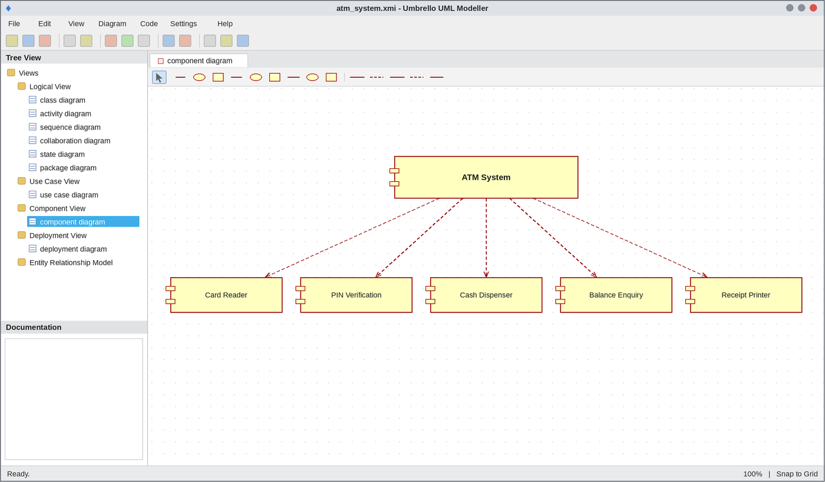
Component Diagram
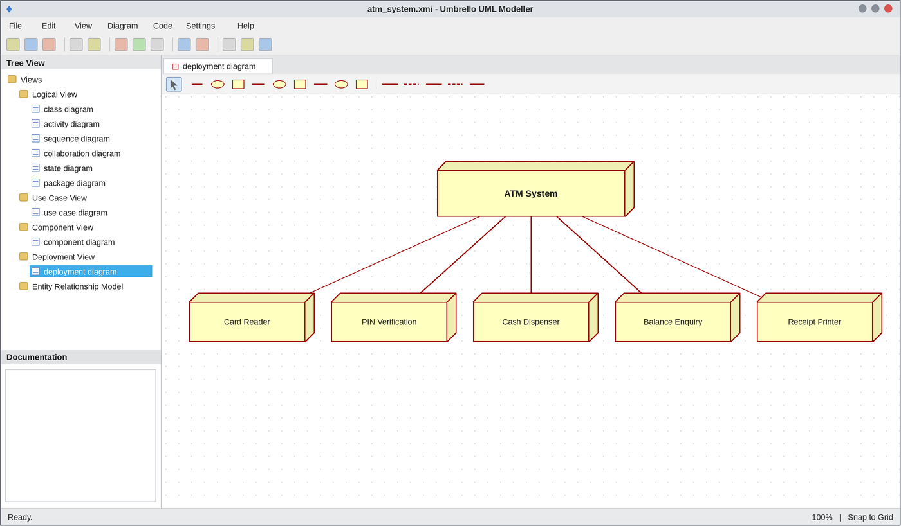
Deployment Diagram
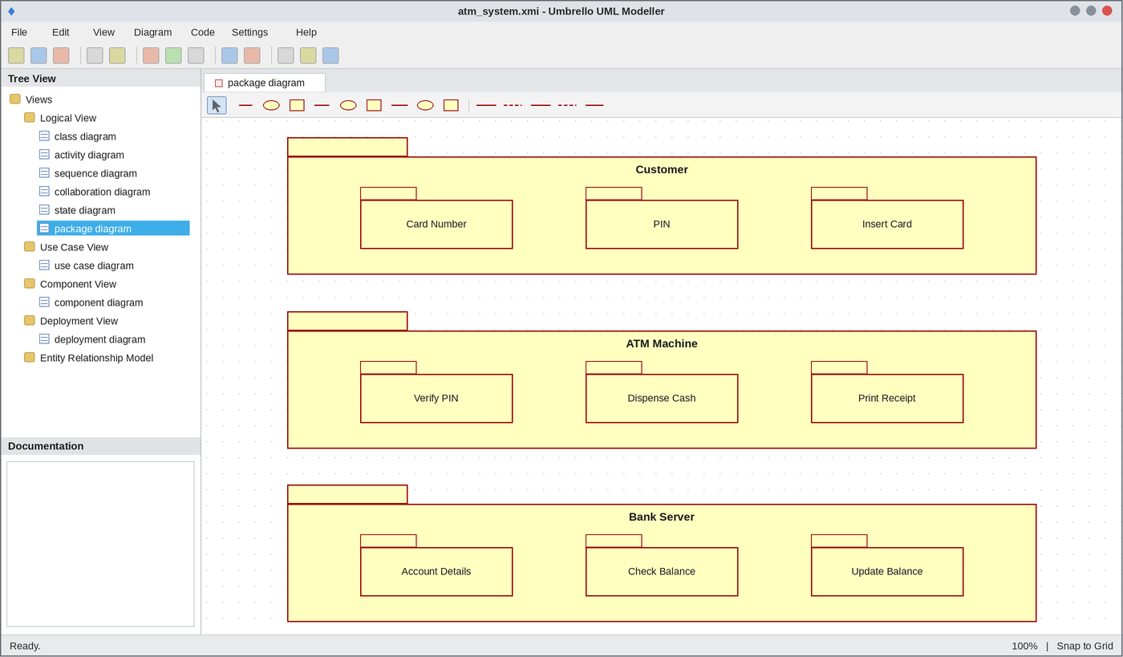
Package Diagram
WEBPAGE SCREENSHOT
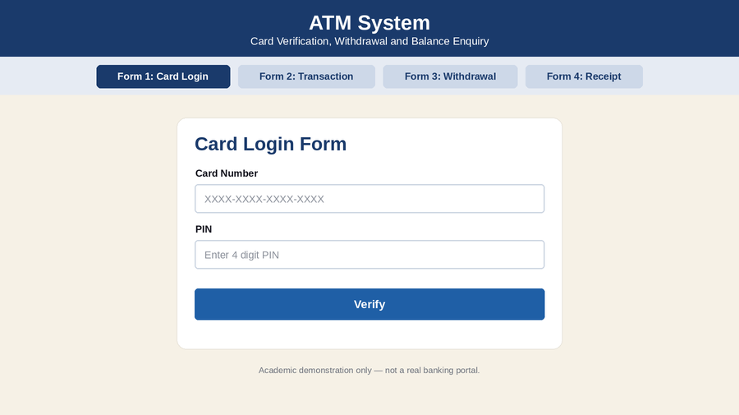
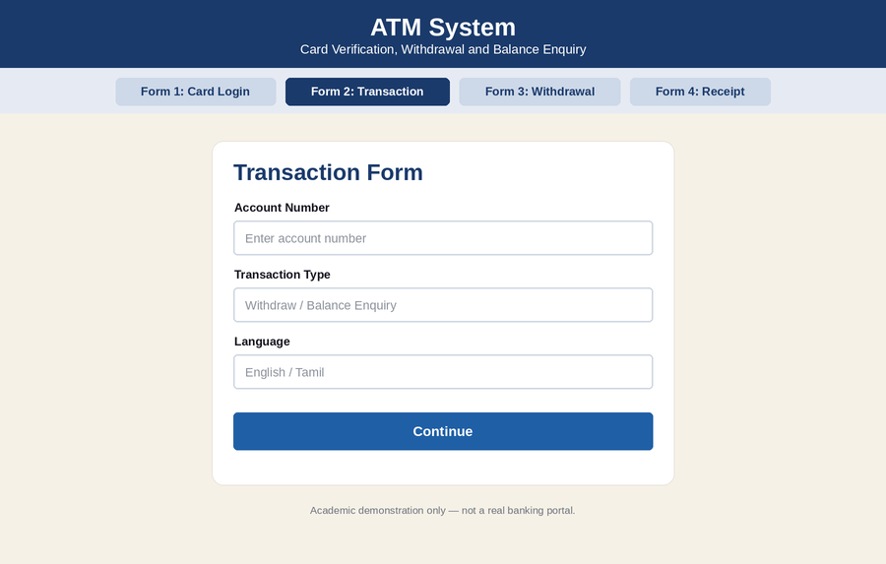
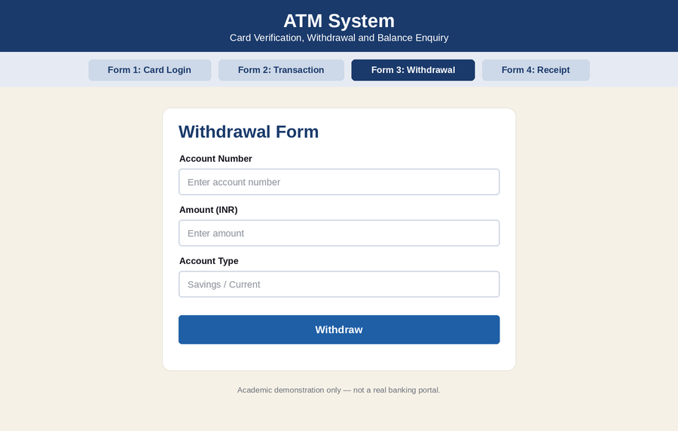
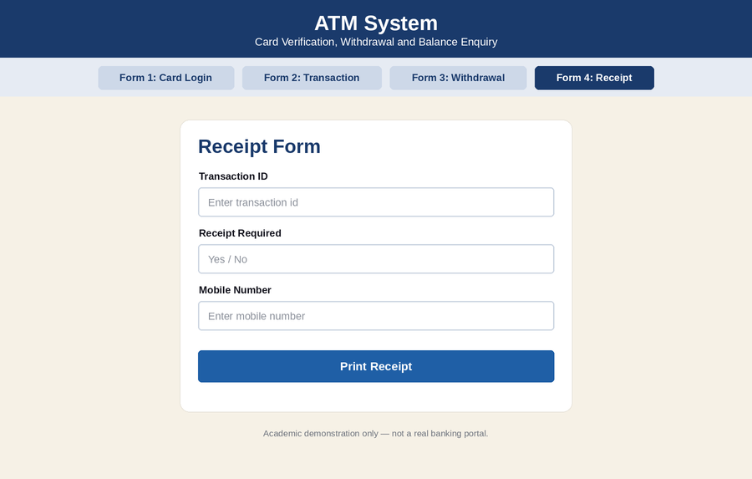
DATABASE SCREENSHOT
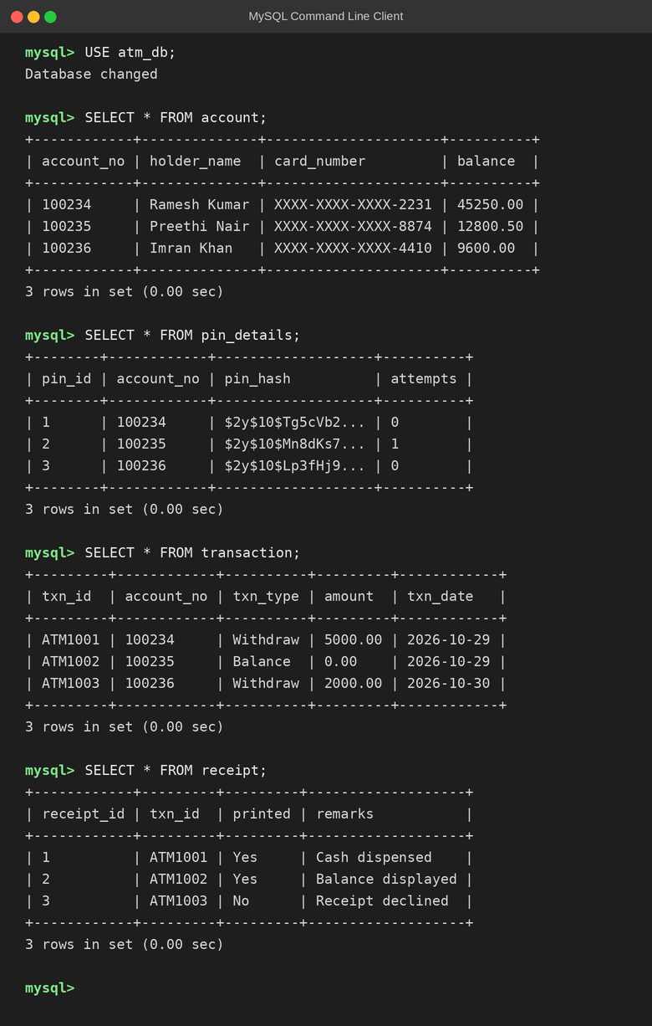
PSEUDO CODE
1. Card Insertion and PIN Verification
BEGIN
CUSTOMER inserts the card
ATM requests PIN
READ PIN
SEND PIN to BANK SERVER
IF PIN is valid THEN
DISPLAY transaction menu
ELSE
DISPLAY "Invalid PIN"; ASK PIN again
ENDIF
END
2. Withdraw Cash
BEGIN
READ amount
BANK SERVER checks balance
IF balance >= amount THEN
balance = balance - amount
DISPENSE cash
ELSE
DISPLAY "Insufficient balance"
ENDIF
END
3. Balance Enquiry and Receipt
BEGIN
IF option = BALANCE THEN
DISPLAY available balance
ENDIF
ASK whether receipt is required
IF receipt = YES THEN
PRINT receipt
ENDIF
EJECT card
END

EX NO: 16 HOSPITAL MANAGEMENT SYSTEM
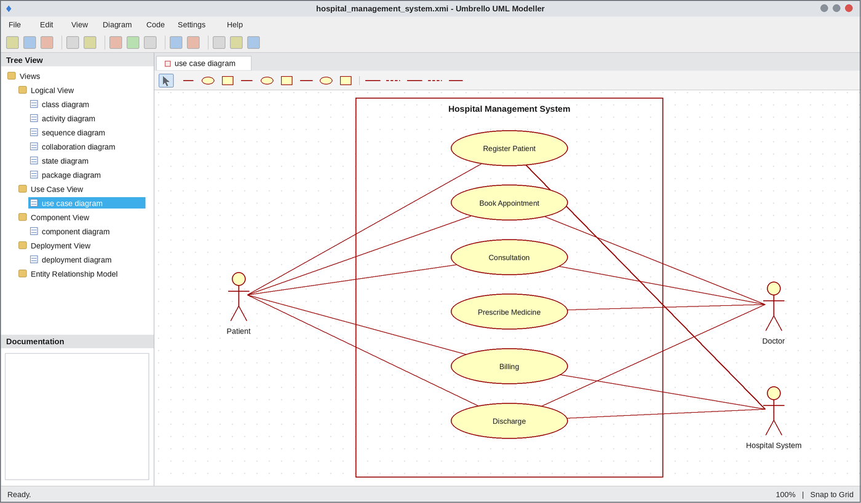
Use Case Diagram
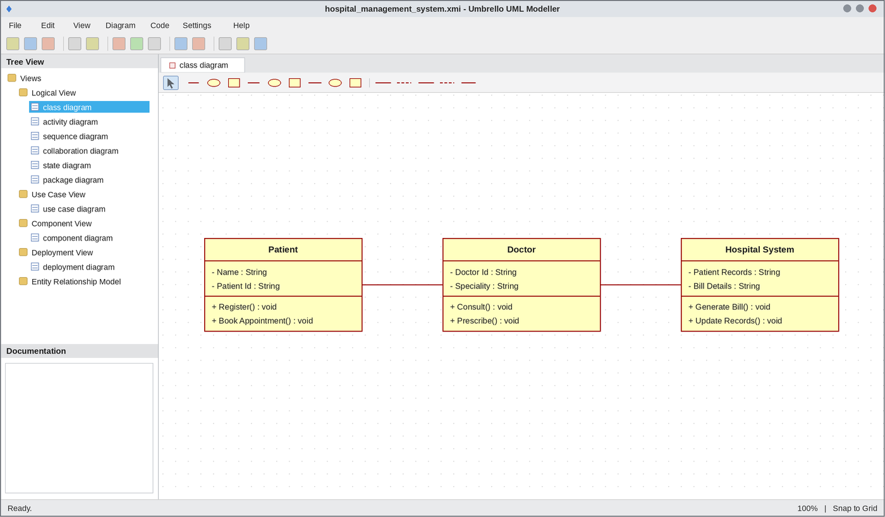
Class Diagram
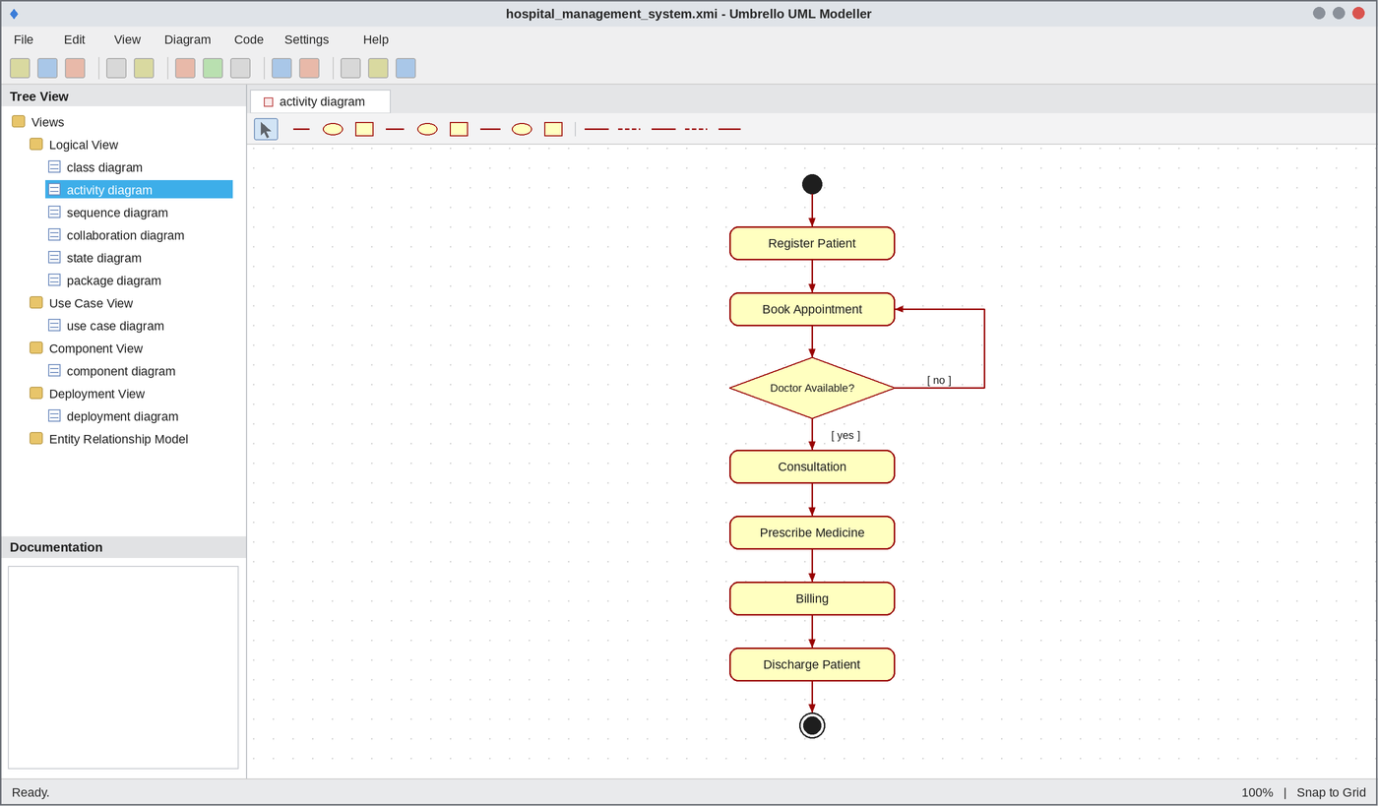
Activity Diagram
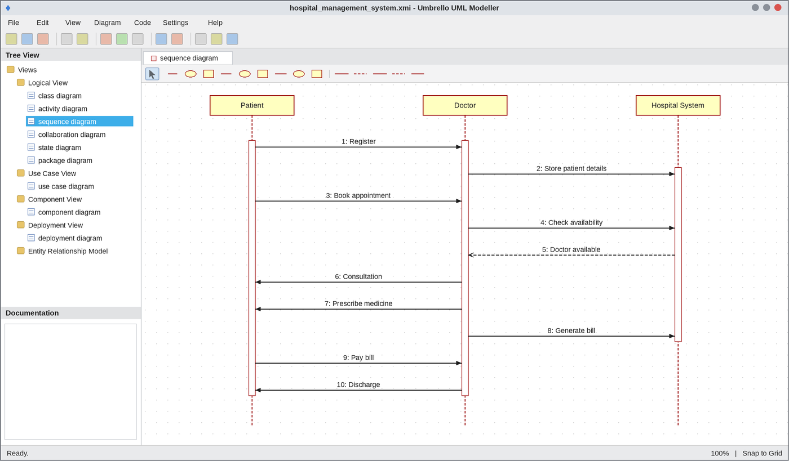
Sequence Diagram
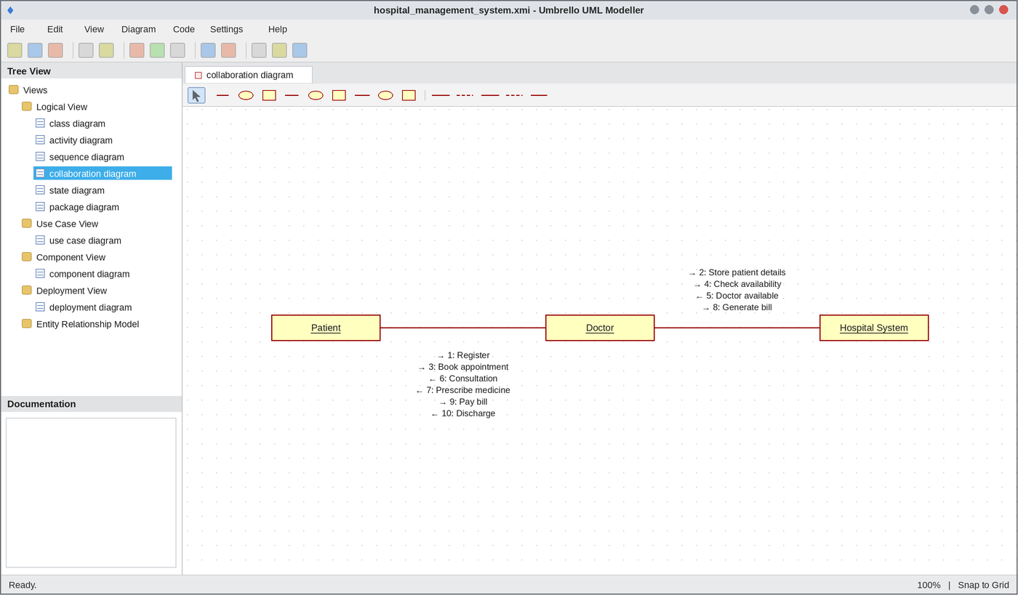
Collaboration Diagram
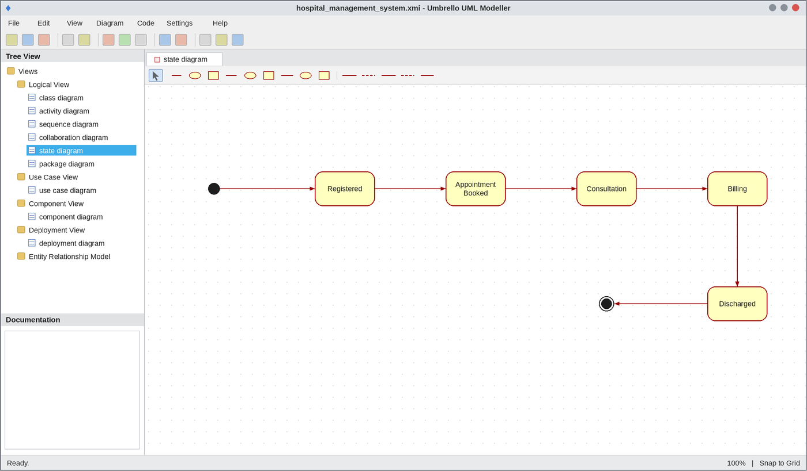
State Chart Diagram
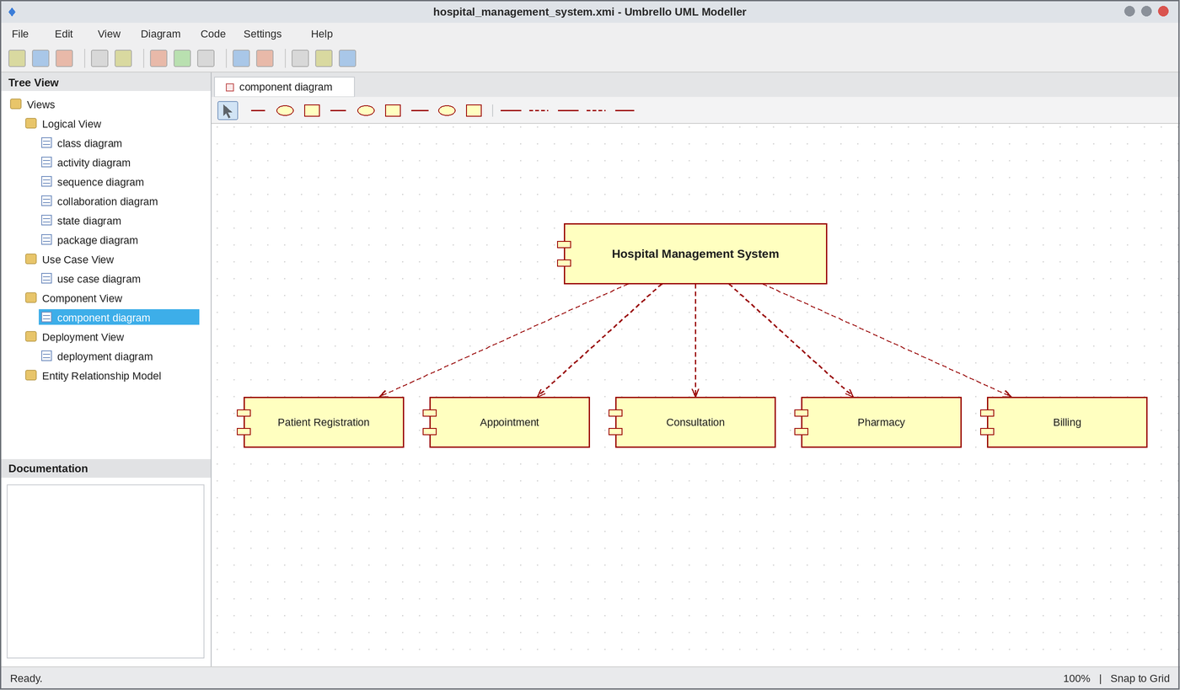
Component Diagram
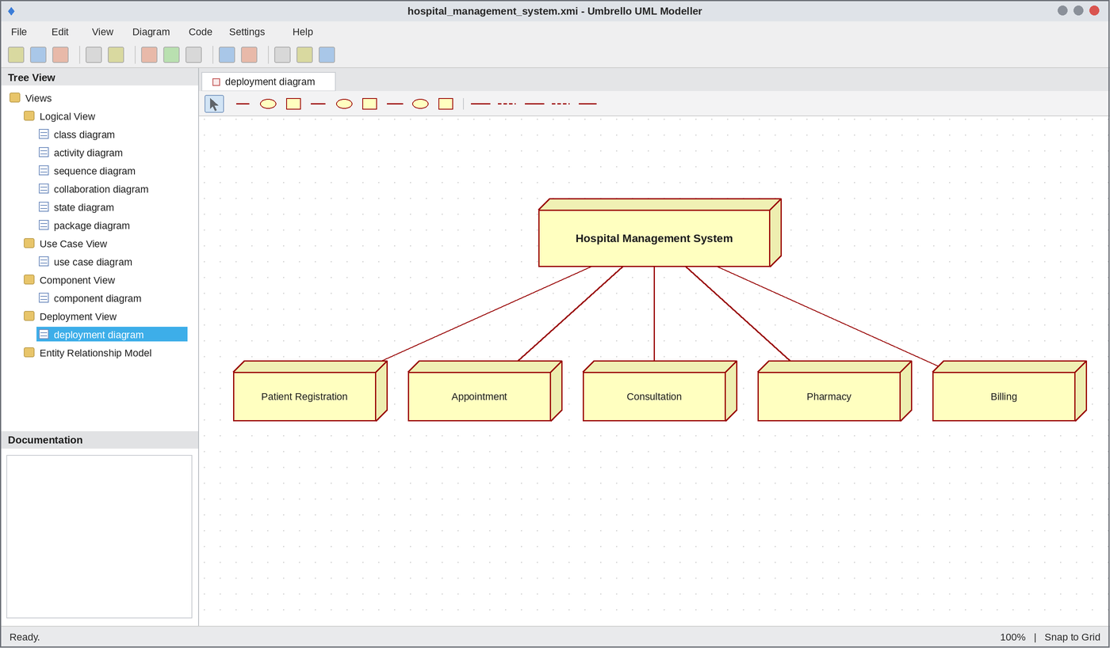
Deployment Diagram
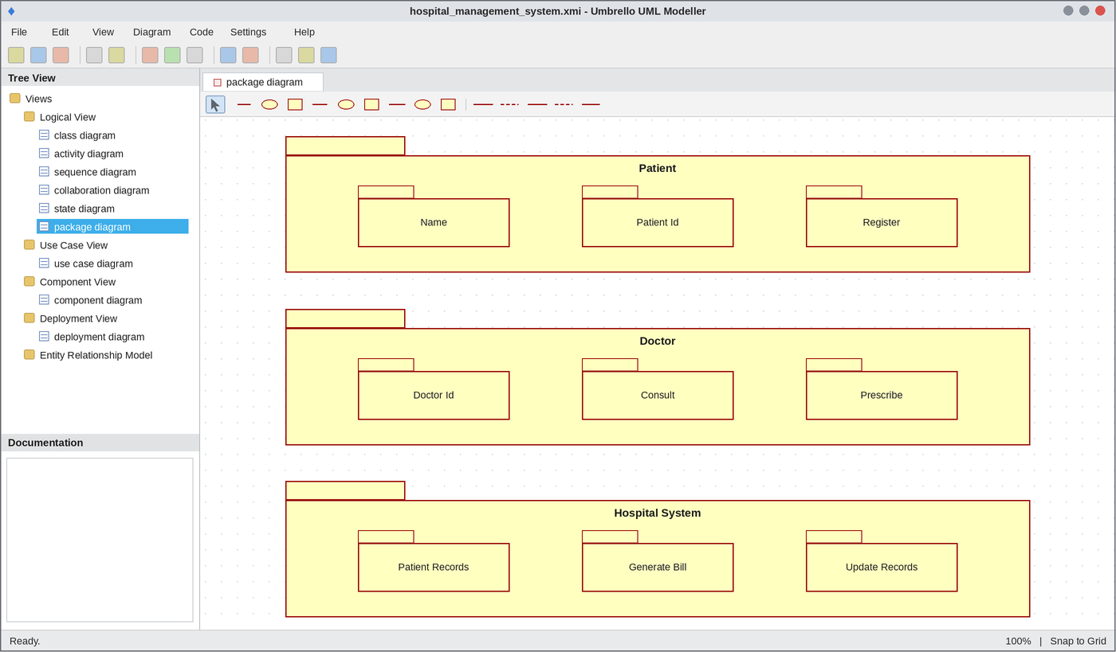
Package Diagram
WEBPAGE SCREENSHOT
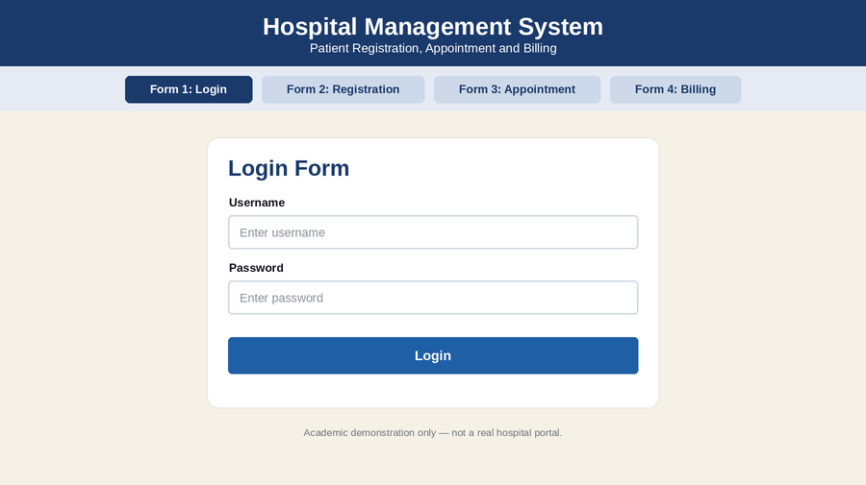
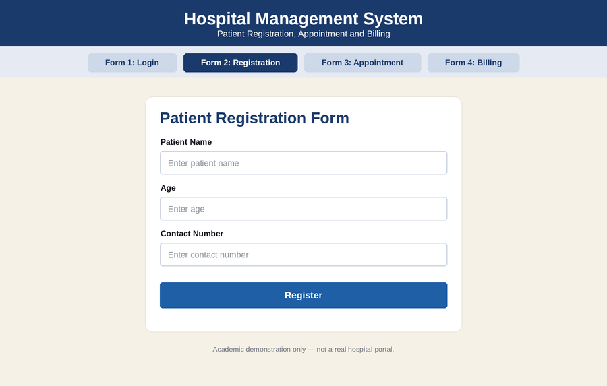
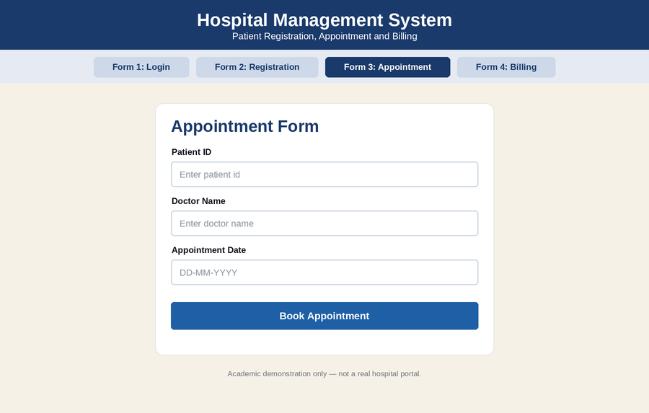
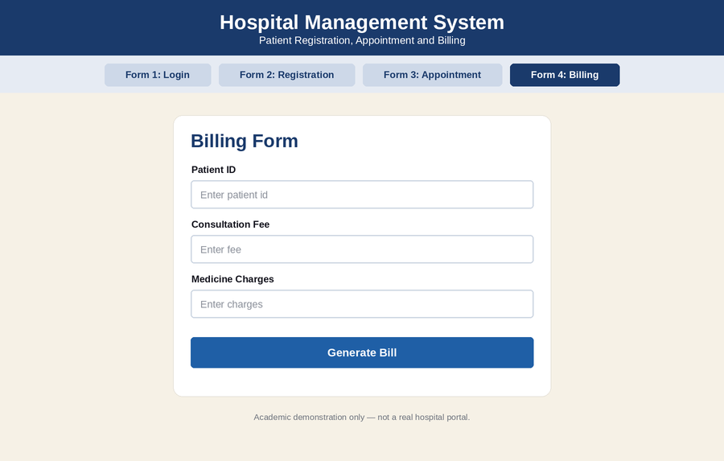
DATABASE SCREENSHOT
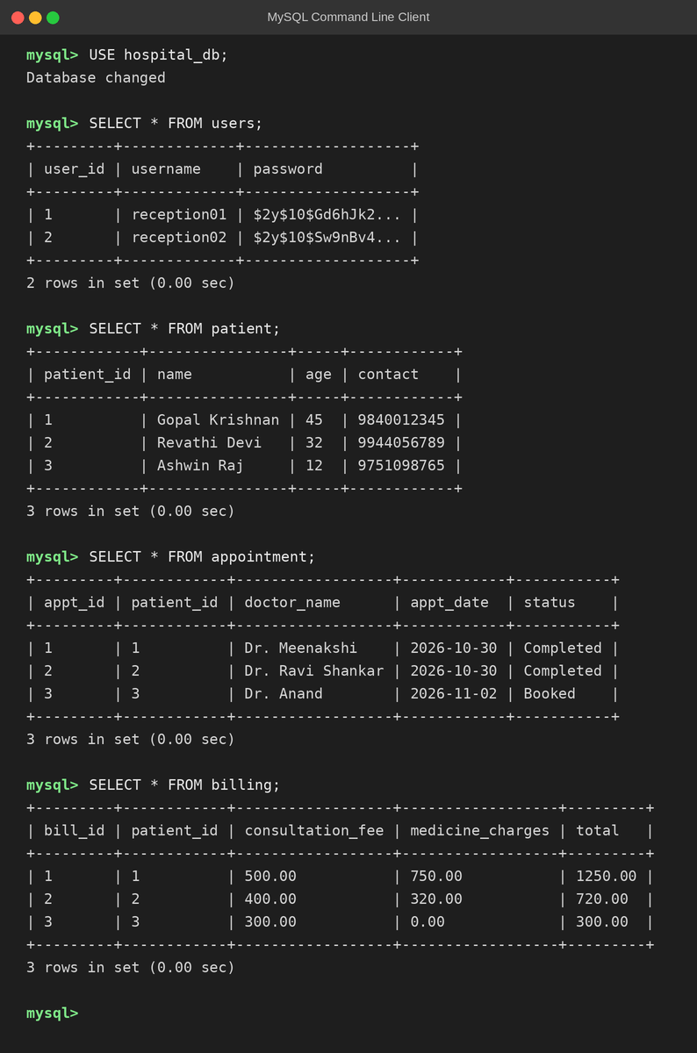
PSEUDO CODE
1. Registration and Appointment
BEGIN
PATIENT enters name, age and contact number
STORE patient details in HOSPITAL SYSTEM
PATIENT books appointment
IF doctor is available THEN
CONFIRM appointment
ELSE
DISPLAY "Doctor not available"; ASK another date
ENDIF
END
2. Consultation and Prescription
BEGIN
DOCTOR examines the patient
DOCTOR records diagnosis
DOCTOR prescribes medicine
UPDATE patient record
END
3. Billing and Discharge
BEGIN
READ consultation fee and medicine charges
total = consultation fee + medicine charges
GENERATE bill
PATIENT pays the bill
IF payment is done THEN
DISCHARGE patient
UPDATE records in HOSPITAL SYSTEM
ELSE
DISPLAY "Payment pending"
ENDIF
END

