Download Anaconda for Python:

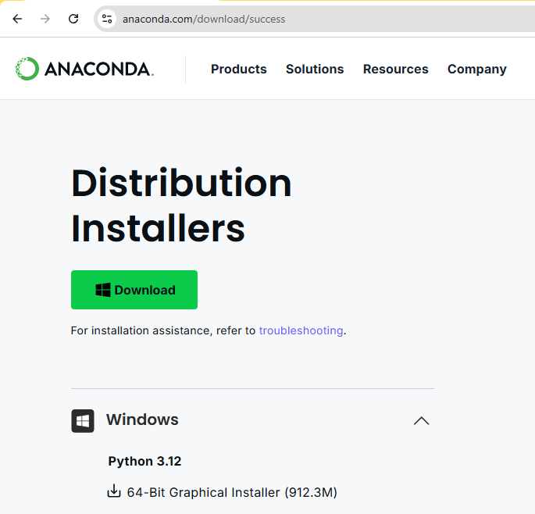

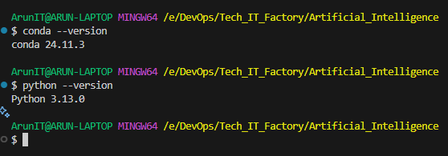

In Conda, the equivalent of Python's venv is creating a **Conda environment**, which serves the same purpose: an isolated space for dependencies and packages specific to a project.

Why use a Conda environment?

* **Manages dependencies for multiple languages** (not just Python).
* **Handles package versions** more efficiently than pip.
* **Isolates environments** to prevent conflicts between projects.

How to Create and Use a Conda Environment

1. **Create a Conda Environment**

conda create --name myenv python=3.9

* 1. This creates an environment named myenv with Python 3.9.
  2. **Activate the Environment**

conda activate myenv

* 1. **Install Packages**

conda install numpy pandas

* 1. You can also use pip inside Conda environments:

pip install requests

* 1. **List Available Environments**

conda env list

* 1. **Deactivate the Environment**

conda deactivate

* 1. **Remove an Environment (if needed)**

conda remove --name myenv --all

Unlike venv, Conda handles dependencies more smoothly, especially for data science and machine learning projects where specific library versions matter. Given your structured approach to learning, this could be useful if you're working with cloud automation tools that require Python. Want me to suggest some best practices for managing Conda environments efficiently?

C:/Users/ArunTableau/anaconda3/envs/myenv

E:/DevOps/Tech_IT_Factory/Artificial_Intelligence