Git:

<https://github.com/chakdevops/test-repo.git>

$ ssh-keygen -f chak-devops-git

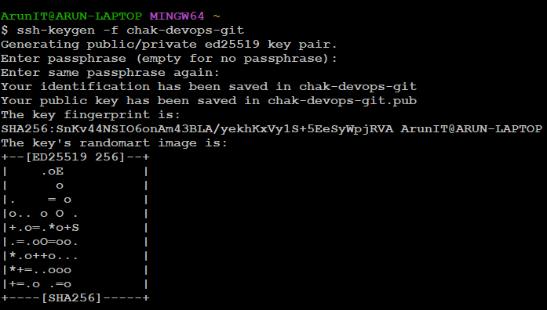

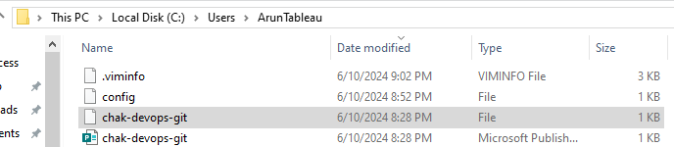



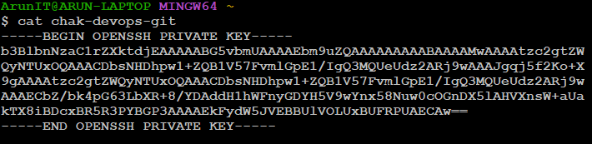



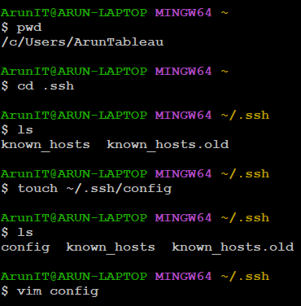

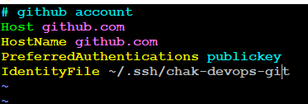

Create a folder in ‘Repos’ folder:

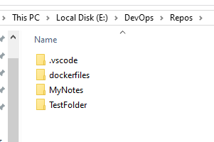





Enter ‘git init’ command:

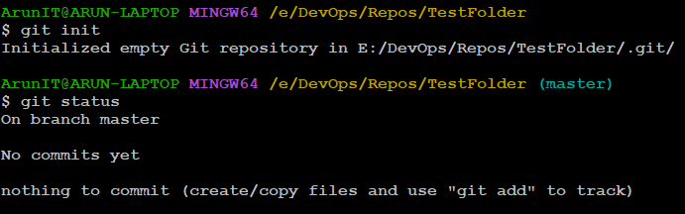

.git folder will be created in ‘TestFolder’ directory

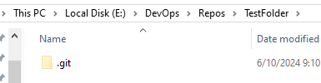

Add Sample.txt file in above folder

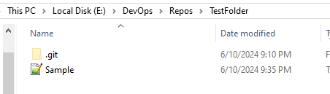

git add sample.txt



git commit -m "This is the sample file which will be pushed to Git"



$ git branch -M main

$ git remote add origin [git@github.com:chakdevops/test-repo.git](mailto:git@github.com:chakdevops/test-repo.git)

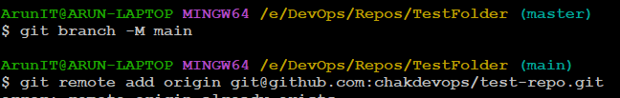

$ git push -u origin main

