Making the console application as startup project and running the application

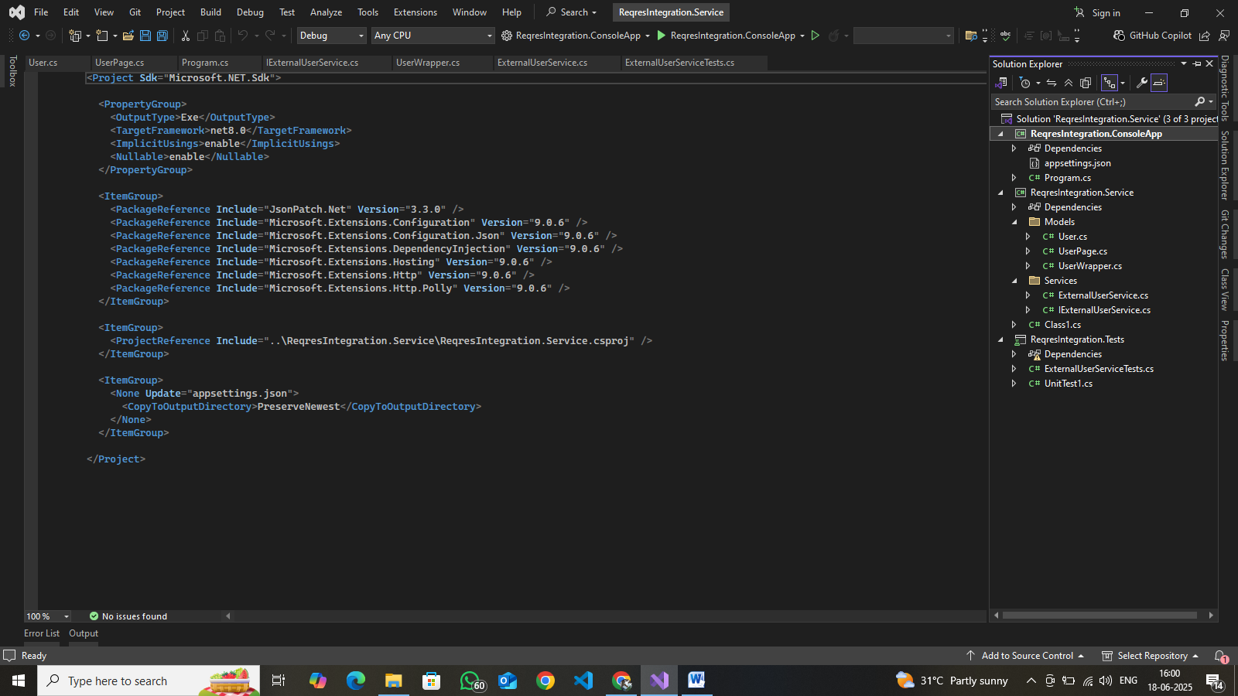

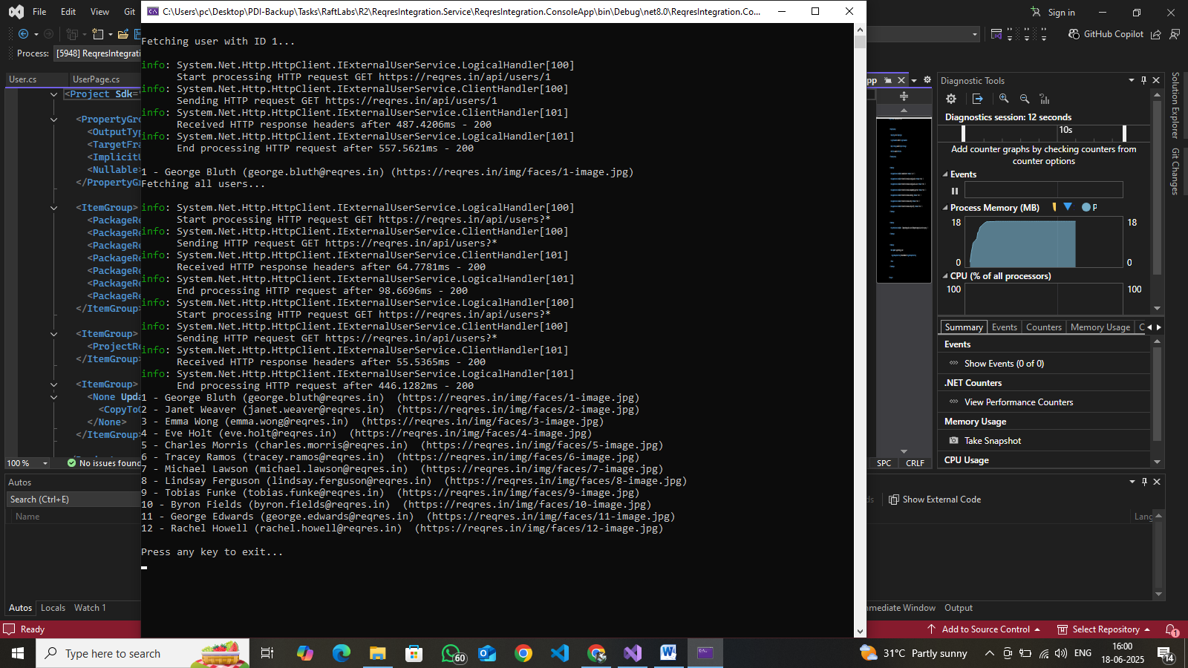

Chnging the parameter for userById to 2 and running the application

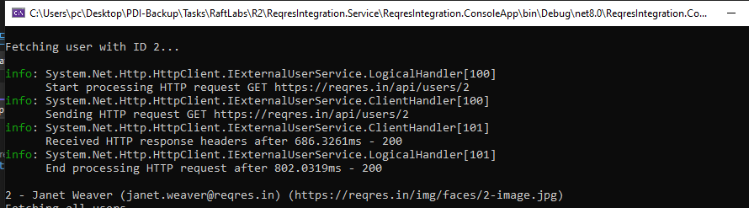

Running the Unit Test Project

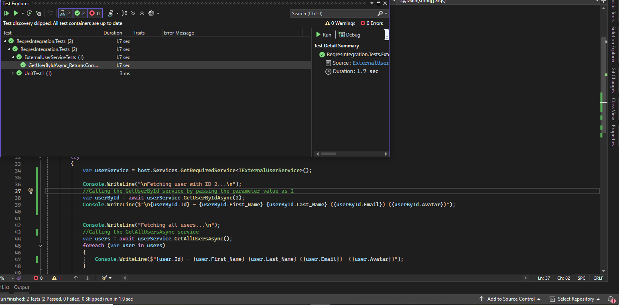

Running the created External Test project service

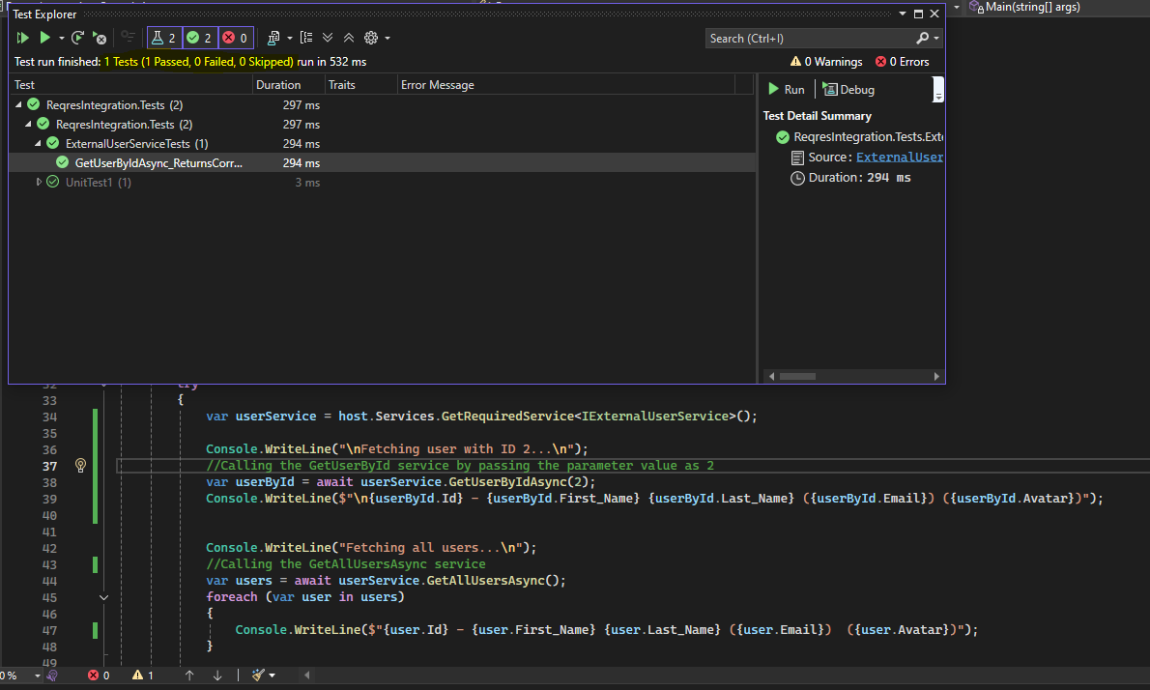

The result as passed as expected