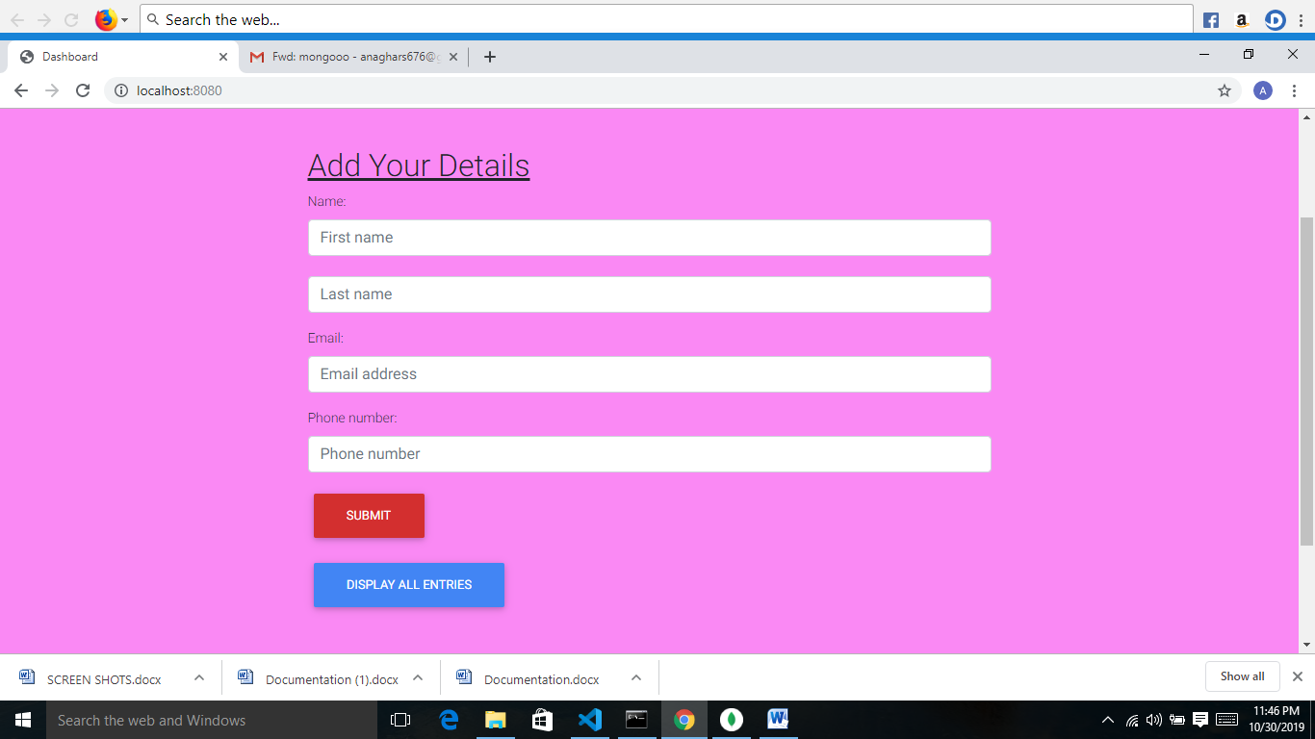
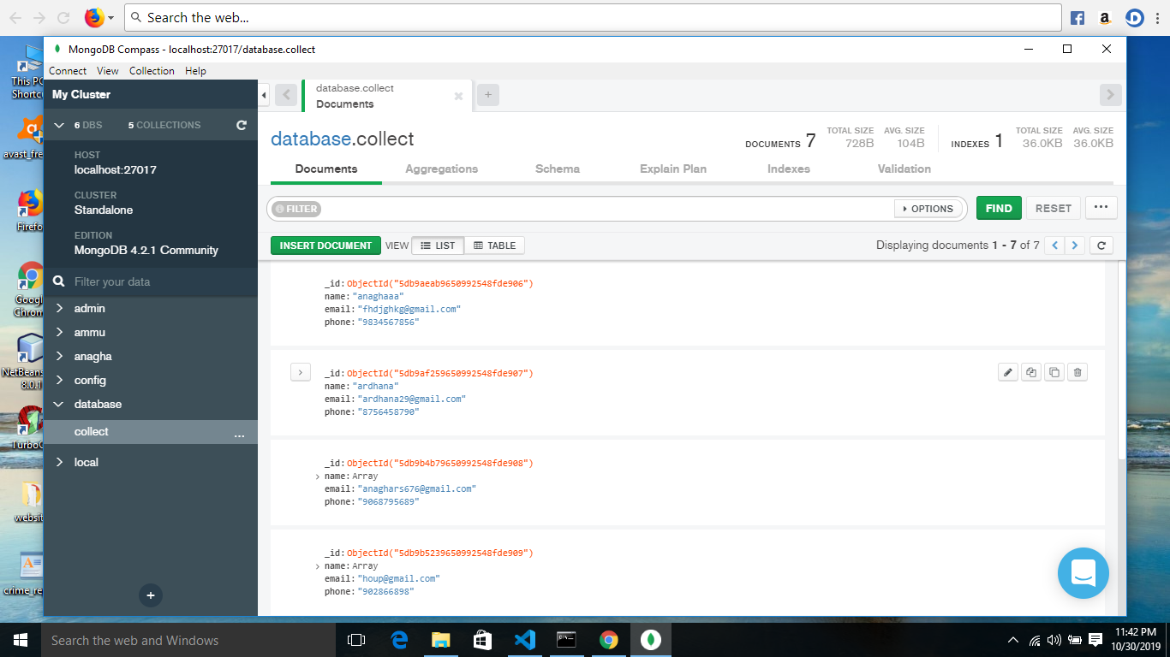
Screen Shots
Fig1:Enter the data on the web page
.

Fig2: The details entered in the website is stored on mongo database.

