CURRICULUM VITAE
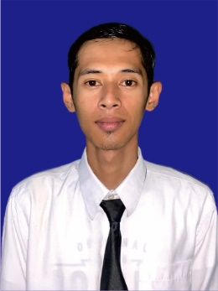
Personal Data
Name : Achmad Huzaimi
Place and date of Birth : Bangkalan, Feb-26-1998
Address : Dsn. Nangger, RT.0/RW.0, Ds. Bangsereh
Kec. Sepulu, Kab. Bangkalan
Nationality : Indonesia
Gender : Male
Religion : Moslem
Marital status : Single
Height/Weight : 168 cm / 46 kg
Mobile Phone Number : +62 83123233322
E-mail Address : huzaimiachmad98@gmail.com
Skype ID : -
Emergency Contact Name : Sirojul Izzeh
Emergency Contact Number : +62 85790448807
POSITION DESIRE : Public Area Attendant

Travel Document
Document | Number | Date of Issued | Date of Expire | Place of issued
Passport | E2854644 | Mar, 01 2023 | Mar, 01 2033 | Pamekasan
Seaman Book | J 010203 | Feb, 07 2023 | Feb, 07 2027 | Tanjung Perak
C1/D Visa
Schengen Visa

Certificates of Proficiency
Name of Certificates | Number | Date of Issued | Place of Issued
Basic Safety training | 6212349783010523 | Sep, 20 2023 | Surabaya
Security Awareness Training | 6212349783310523 | Oct, 12 2023 | Surabaya
Crowd Management | 6212349783133724 | Mar, 16 2024 | Denpasar
Crisis and Human Behavior Management | 6212349783173724 | Mar, 16 2024 | Denpasar

Hotel Experience / Sea services
Name of Hotel / Vessel | Type of Vessel | Rank | Period | Reason of Leaving
Verwood Hotel and service Residence Surabaya | Hotel  (4 Star) | Housekeeping Cleaner | Feb, 17 2022 - Jan, 09 2024 | End of Contract
Deka Hotel Surabaya | Hotel  (2 Star) | Housekeeping Cleaner | Mar, 09 2021 – Oct, 19 2021 | Training

Yours Sincerely,

( Achmad Huzaimi )

