


CURRICULUM VITAE
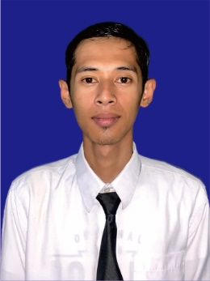
Personal Data
Name : Achmad Huzaimi
Place and date of Birth : Bangkalan, 26 February 1998
Address : Dsn. Nangger, RT.0/RW.0, Ds. Bangsereh
Kec. Sepulu, Kab. Bangkalan
Nationality : Indonesia
Gender : Male
Religion : Moslem
Marital status : Single
Height/Weight : 168 cm / 46 kg
Mobile Phone Number : +62 83123233322
E-mail Address : huzaimiachmad98@gmail.com
Skype ID : -
Emergency Contact Name : Sirojul Izzeh
Emergency Contact Number : +62 85790448807
POSITION DESIRE :

Travel Document
Document | Number | Date of Issued | Date of Expire | Place of issued
Passport | E2854644 | 01 March 2023 | 01 March 2033 | Pamekasan
Seaman Book | J 010203 | 07 February 2023 | 07 February 2027 | Tanjung Perak
C1/D Visa
Schengen Visa

Certificates of Proficiency
Name of Certificates | Number | Date of Issued | Place of Issued
Basic Safety training | 6212349783010523 | 20 September 2023 | Surabaya
Security Awareness Training | 6212349783310523 | 12 October 2023 | Surabaya
Advenced Fire Fighting | 6212349783060523 | 11 October 2023 | Surabaya

Hotel Experience / Sea services
Name of Hotel / Vessel | Type of Vessel | Rank | Period | Reason of Leaving
Deka Hotel Surabaya | 2 star | Housekeeping | 09.03.2021 – 19.10.2021 | End of Contract
Verwood Hotel and service Residence Surabaya | 4 star | Housekeeping | 17.02.2022 – 09.01.2024 | End of Contract

Yours Sincerely,

( Achmad Huzaimi )

