**SUMMARY**

**TIME-DOMAIN FEATURES**

Time-domain features helps us in analyzing the signals acquired by different sources. They are mainly used in signal processing as in audio processing/biomedical signal processing etc. They help us in analyzing how the signal varies over a period of time. They define those characteristics by which we can know about the nature of the signal as how the signal changes/evolves/fluctuates.

These features can be considered as statistical measures which we can find through our signal data and can be used as serving input.

The various features are as follows:

1. Mean-Variance: Mean helps in finding the average value of the amplitude of the signals recorded.   
   Variance helps in knowing how much the values deviate from the mean value.  
   These help in knowing how much there’s variation among all the values obtained.
2. Root Mean Square: RMS helps in knowing about the power of the signal achieved.
3. Zero Crossing Rate: ZCR helps in understanding the frequency of the signal, they would help us in knowing how fast the signal is changing.
4. Skewness & Kurtosis: They determine the asymmetric probability distribution of the signal. Kurtosis defines the distribution.
5. Peak-to-Peak: Helps in knowing the range of the signal (difference between the maximum and minimum values).

Etc..

These are the various statistical measures which actually help us in developing the model. These features when put into the model help in developing the desired output. When these input from various signals are passed onto it(varying signals from different datasets), they then give us the varied results which help us in predicting the output as what such input signals if achieved implies what the signal want to imply.

In real-life application, these features help in drawing conclusions  
For example, consider a signal recorded from ECG.

The mean value would help us in knowing the average heart rate of the person. The variance would help us in knowing about how much the person’s heart rate fluctuates from his average. RMS would tell the frequency denoting how quick the rate changes.  
The model is created as per the normal functioning of the heart and then the various deviations of the signal is feed onto it and then analyzed/predicted at which conditions, any disease or malfunctioning would be caught.

Similarly for EEG, these features help us in analyzing the proper functioning of the brain.

For example,  
For different sleep stages, the mean and the variance would be different and would help in keeping the report. The RMS signifying the power of the signal would help in knowing the active and less active brain states/stages. Similarly, ZCR would help in knowing how quick the variations is occurring.  
The sound of snoring also helps in analysing the brain activity. The mean values are different at normal breathing, snoring or other events. Signal Energy would be used in understanding the state of the brain.

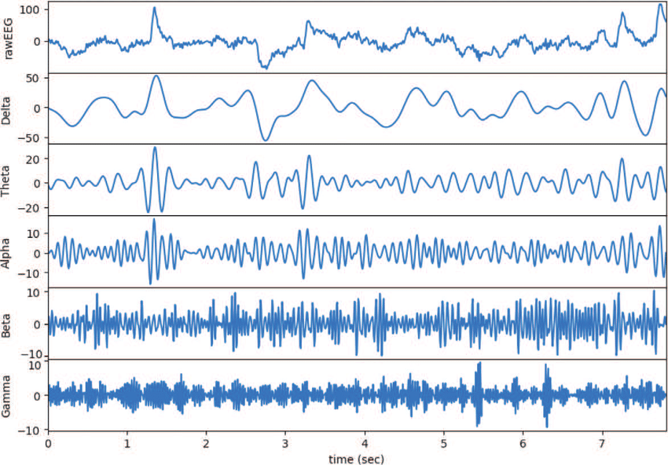

These fig shows the various signals achieved at different stages of sleep, helping in our analyzing.

These are the various ways how these features help in achieving conclusions of the working of any system and can be fed into a model for predicting results and analysis.