Project 3

CHUNG,Chak Pong

20015116

**Problem**

One dimentional shallow water equation with exact Riemann Solver

with Dam-Break Initial State UL=UR=0,HL=1,HR=0.1

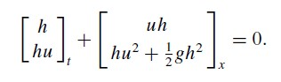

**Initial Condition**

Initial H

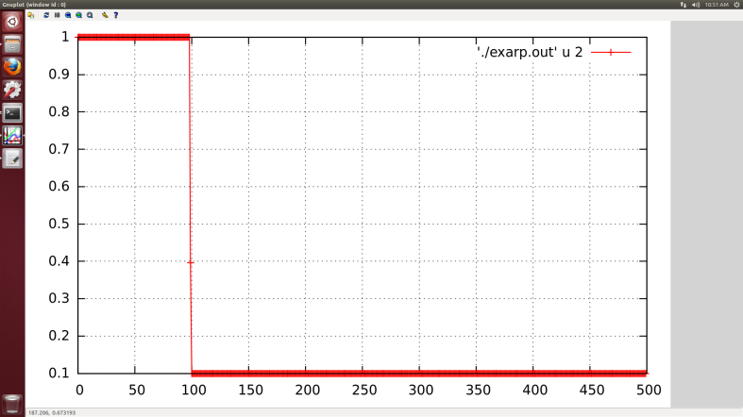

Initial HU

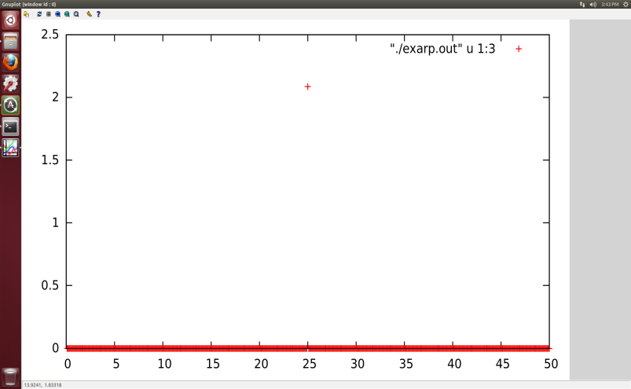

**H at 10s**

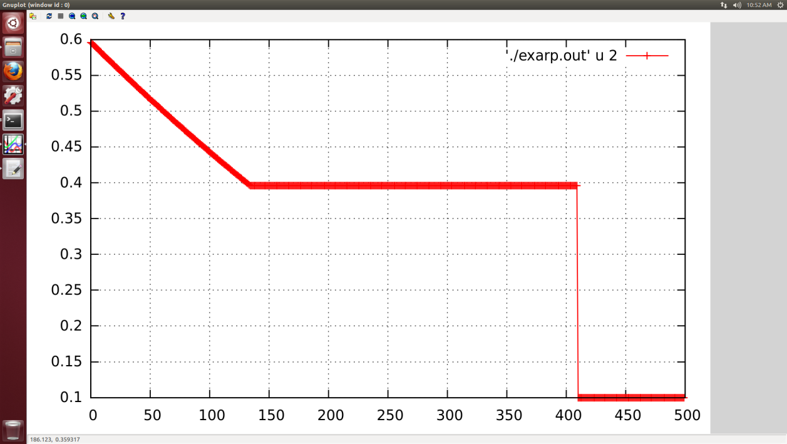

**HU at 10s**

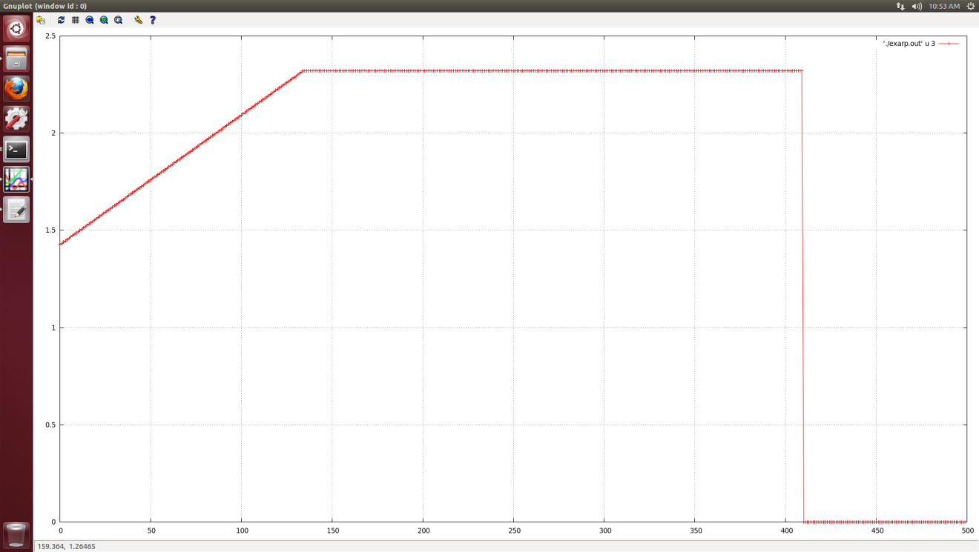

**Key steps in determing the Flux at star region**

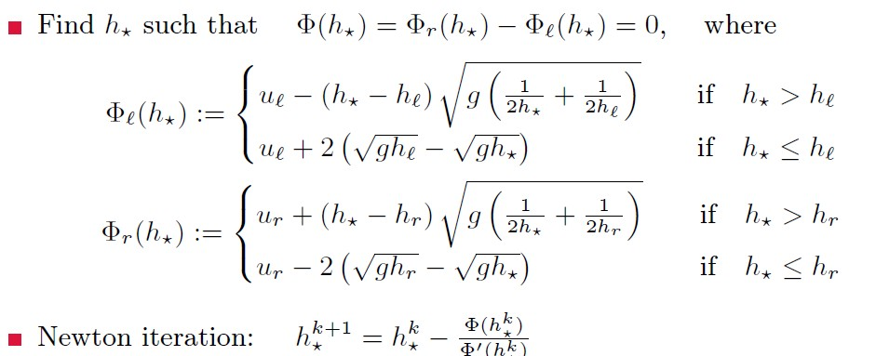

**u\*** is determined by

US = 0.5*(UL + UR) + 0.5*(FR - FL)

A more detailed derivation can be found in Toro ‘s book *Shock-Capturing Methods for Free-Surface Shallow Flows*, section 5.3.,from equation 5.5 to equation 5.12

The code used is attached.