Windows:

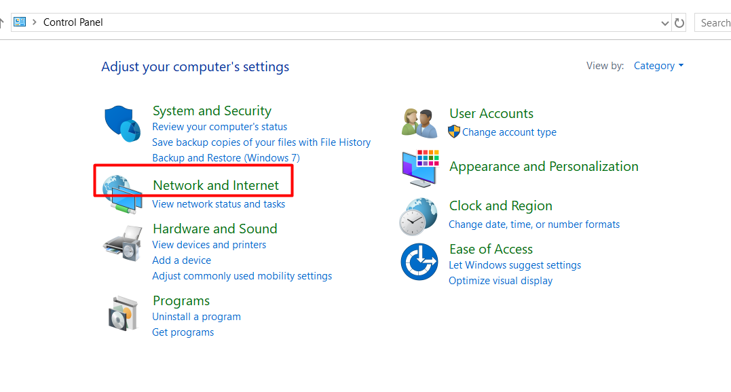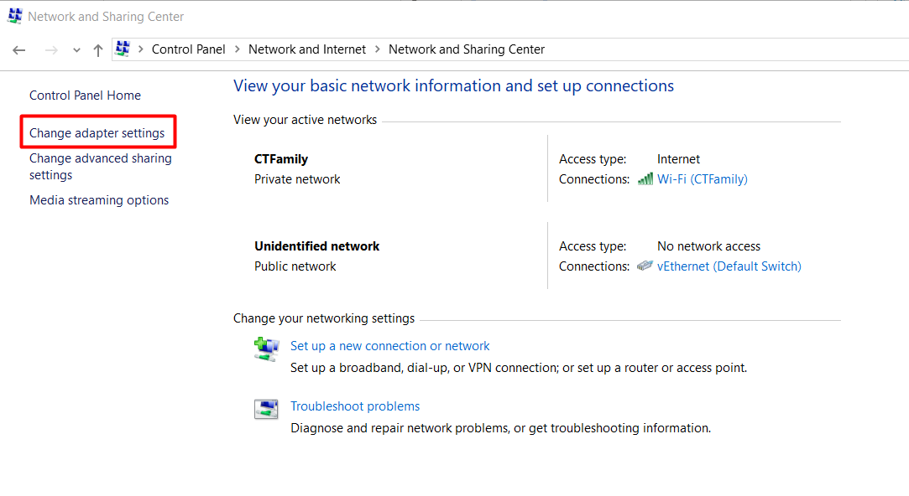

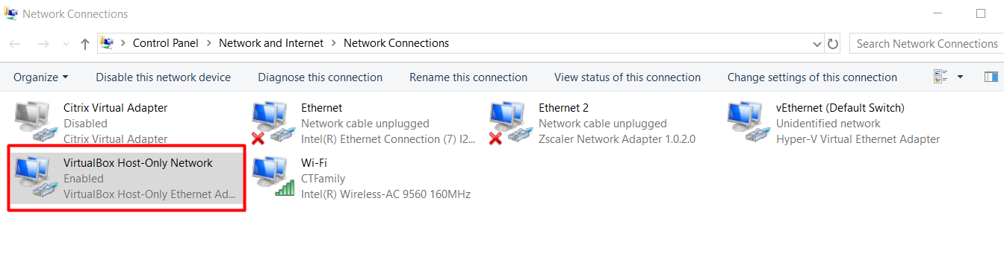

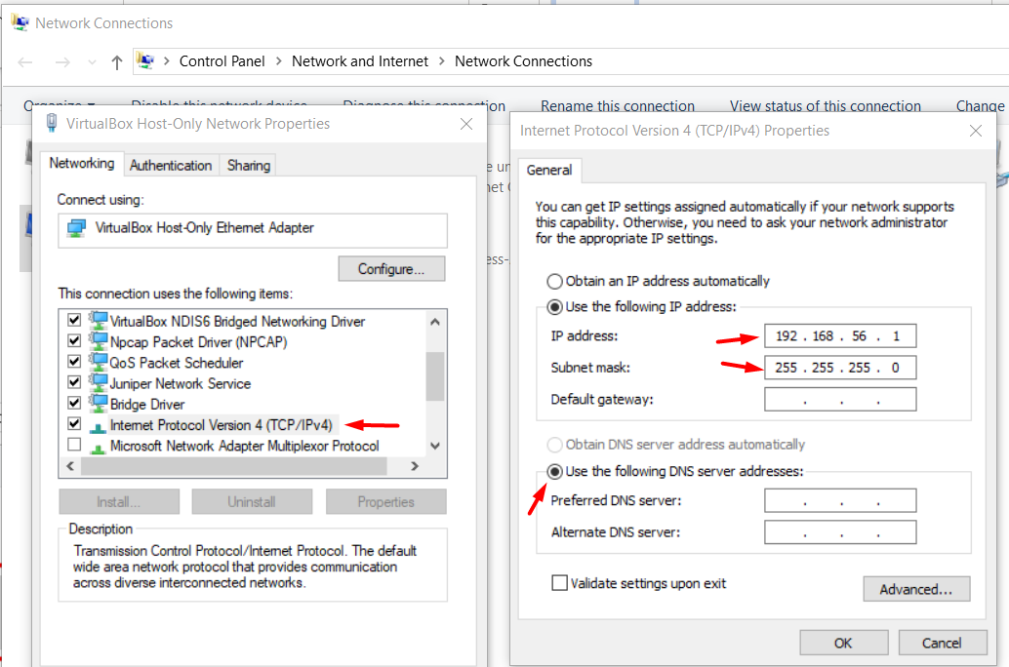

**Later run the script mentioned in the text pad**

Add additional IPs to simulate ATMs

FOR /L %A IN (1,1,20) DO netsh interface ipv4 add address "VMware Network Adapter VMnet1" 192.168.1.%A 255.255.255.0

netsh interface ipv4 show config

netsh interface ipv4 show address

===========================================================================================================================================

netsh interface ipv4 show config "VirtualBox Host-Only Network"

FOR /L %A IN (10,1,30) DO netsh interface ipv4 add address "VirtualBox Host-Only Network" 192.168.56.%A 255.255.255.0

FOR /L %A IN (11,1,30) DO netsh interface ipv4 delete address "VirtualBox Host-Only Network" 192.168.56.%A 255.255.255.0

C:\Users\ac185300>FOR /L %A IN (10,1,20) DO netsh interface ipv4 add address "VirtualBox Host-Only Network" 192.168.1.%A 255.255.255.0

C:\Users\ac185300>netsh interface ipv4 add address "VirtualBox Host-Only Network" 192.168.56.10 255.255.255.0

C:\Users\ac185300>netsh interface ipv4 add address "VirtualBox Host-Only Network" 192.168.56.11 255.255.255.0

C:\Users\ac185300>netsh interface ipv4 add address "VirtualBox Host-Only Network" 192.168.56.12 255.255.255.0

C:\Users\ac185300>netsh interface ipv4 add address "VirtualBox Host-Only Network" 192.168.56.13 255.255.255.0

C:\Users\ac185300>netsh interface ipv4 add address "VirtualBox Host-Only Network" 192.168.56.14 255.255.255.0

netsh

interface

ipv4

show config

delete address "VirtualBox Host-Only Network" 192.168.1.10

show config

netsh interface ipv4 delete address "VirtualBox Host-Only Network" 192.168.56.24

C:\windows\system32>netsh interface ipv4 show config "VirtualBox Host-Only Network"

Configuration for interface "VirtualBox Host-Only Network"

DHCP enabled: No

InterfaceMetric: 25

Statically Configured DNS Servers: None

Register with which suffix: Primary only

Statically Configured WINS Servers: None

