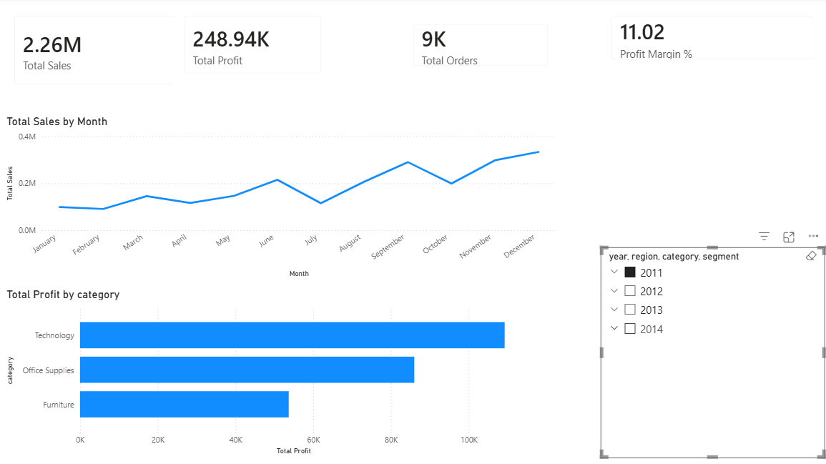
Source from – Power BI
In the year of 2011 total sales was 2.26M, Total profit- 248.94K, Total orders- 9k profit margin was 11.02% by this year in middle of the month from July to December the sales go to 2.26M
Which category of products give high profit we can technology then office supplies after that furniture.

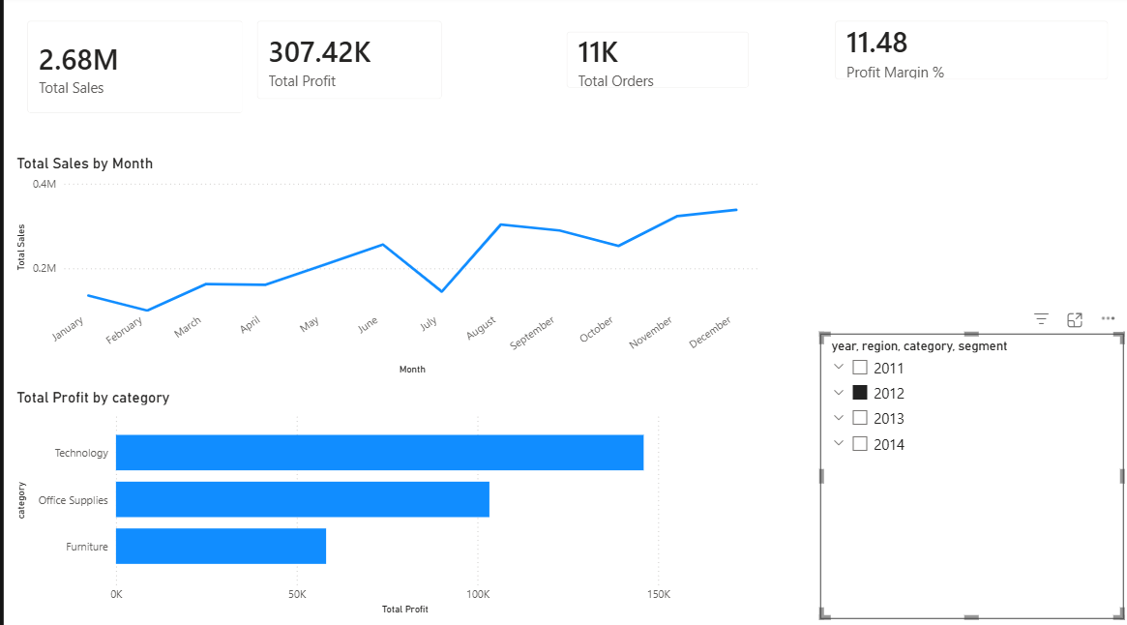
Source from – Power BI
In the year of 2012 Total sales-2.68M, Total profit – 307.42K, Total orders- 11K, and profit margin-11.48%. we can see that also in this year the month grow little may and june the down at july after the aughst to decmber the sales incres every month of that year and the top category product techonoly gives high profit like cross to 150K, office supplies 130k and very low frunture- 55K.

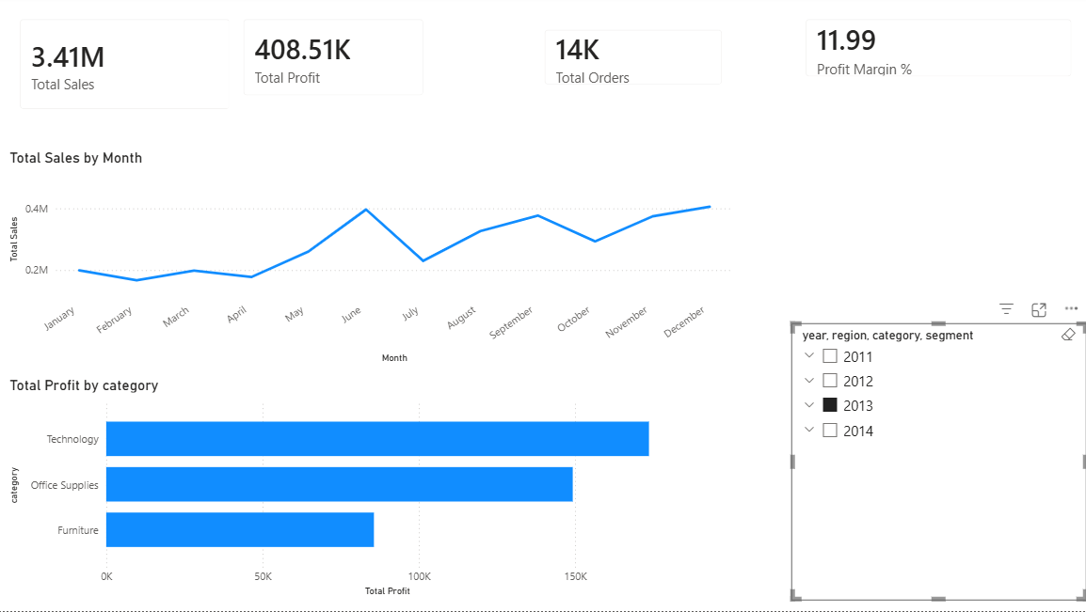
Source from – Power BI
By this year of 2013 we can saw that this year hit the sales of 3.41M, profit-408.51K, Orders-14K, and profit margin- 11.99%. if we see the bar chart the technologuy catogery corss of 150K too 200K and office supplices hit 150K also frunture crosses 85-90K profit by this year and if we see the graph in may and June month sales incres than down at July after aguhest it grows little down then high in sales

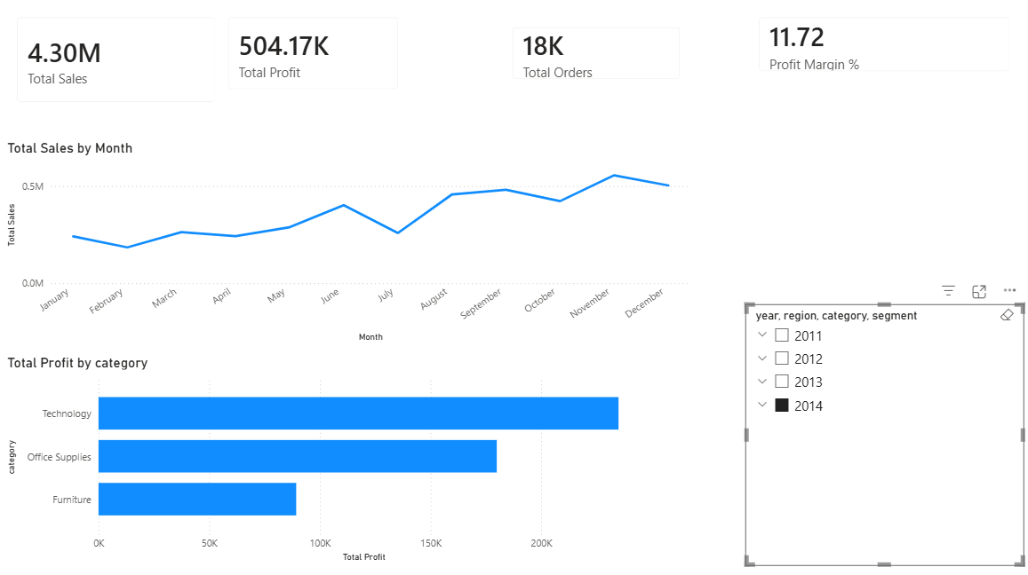
Source from – Power BI
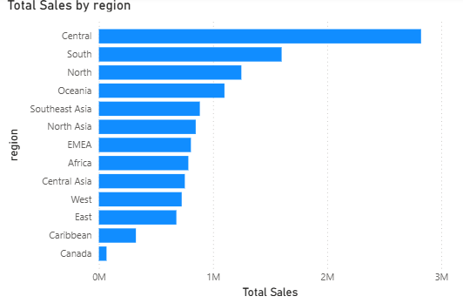
2014 the year of growth HIT the sales- 4.30M Profit – 504.17K, total Orders- 18K, Profit margin-11.72%. the profit category we can see the top technology 250K and office supplies 175K but the frunture sales are very low of all every year we have to see that if their any product issue hat cutonmer retur the prodtecs after buy of discounts and shipping cost gves the loss of the profit for that. In this year sale sare middium from the first month jan down little in July after it gets high.
Source from – Power BI

We can see the over all sales by region first 4 region gives the hugh sales and the Canada caribbben are very low .

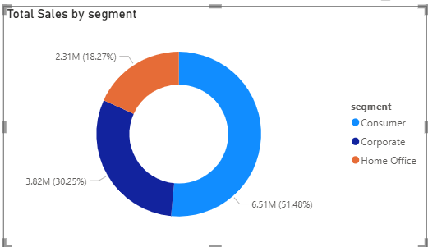
Source from – Power BI
Consumer sales are high 51.48% and corporate sales 30.25 %and the home office segment means office supplies that has low sale very low by the shipping cost and discount impact more we have tomreduced the discounts by some regions and shiiping cost.

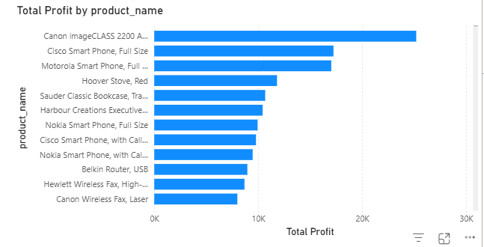

Source from – Power BI
This the name of product names that gives total profit by the customer they oreder most.

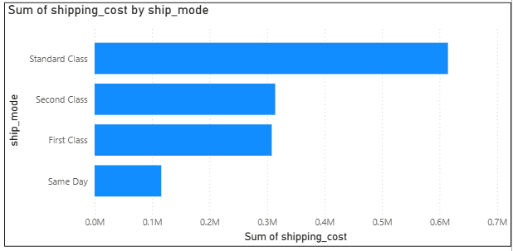
Source from – Power BI

By this graph we can see that

