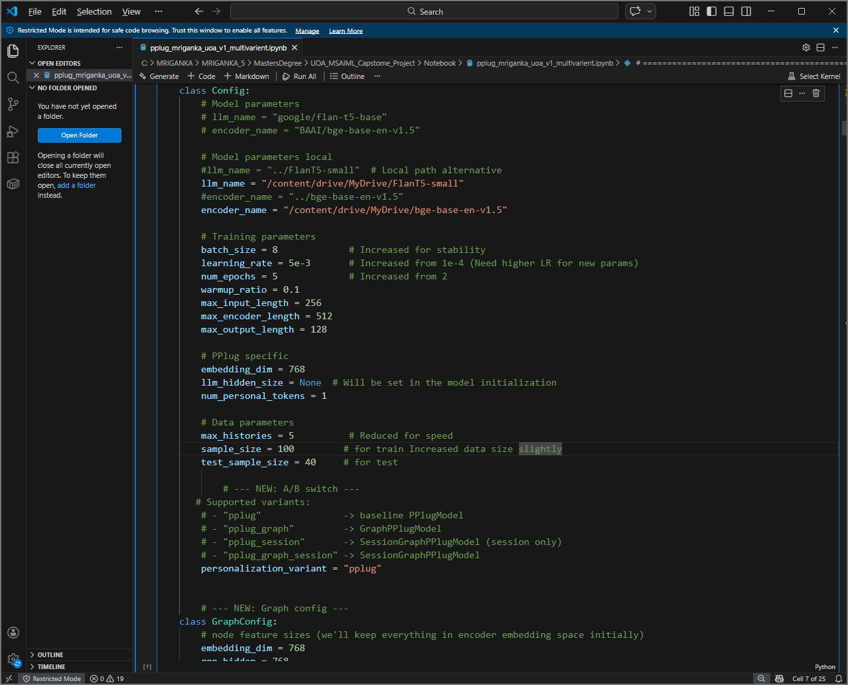

C:\Users\Mrinal\GitRepositories\PPlug-uoa\Notebook>nbdiff-web pplug_mriganka_uoa_v1_multivarient.ipynb pplug_mriganka_uoa_v2_multivarient.ipynb

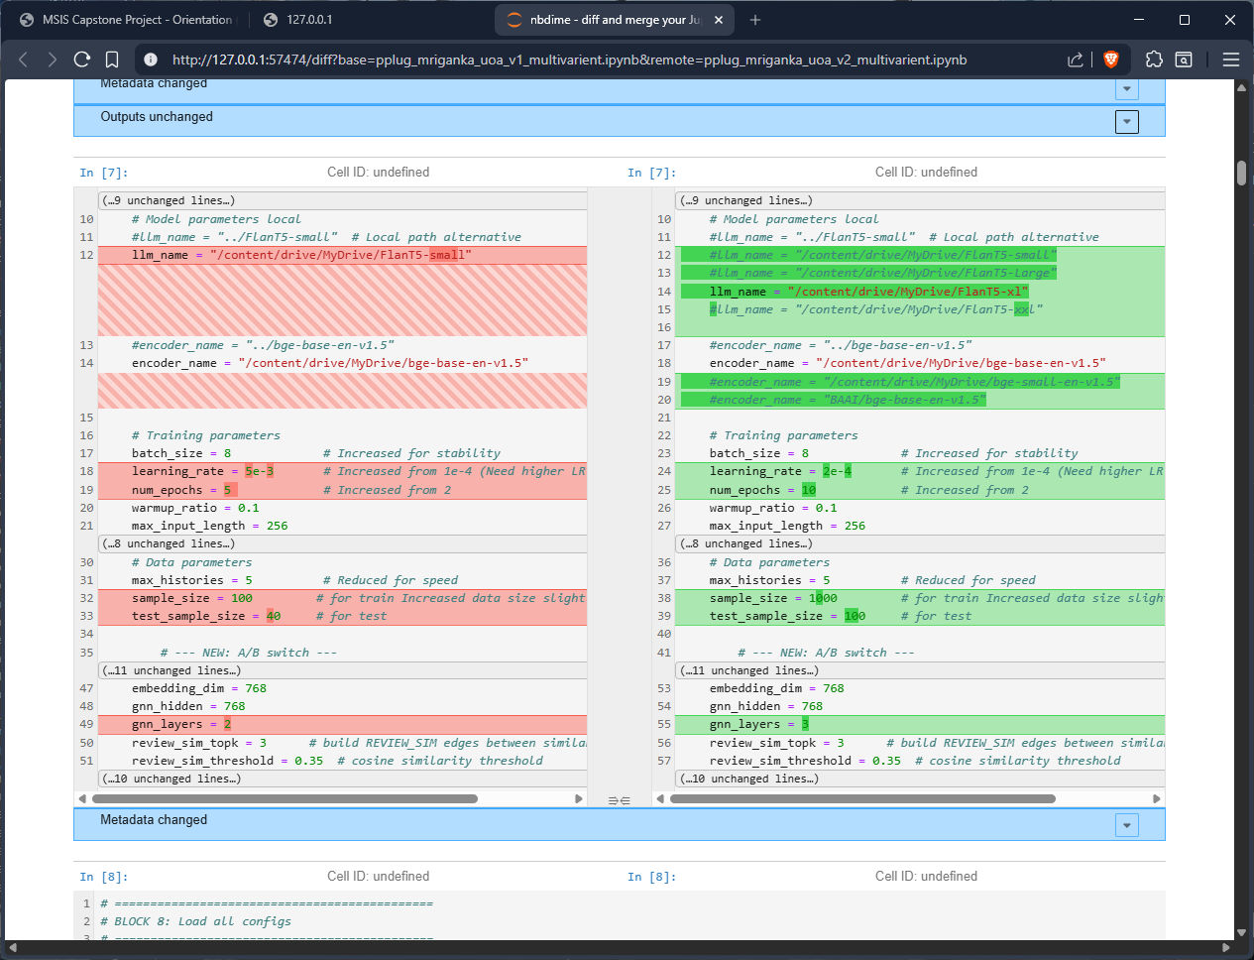

+++++++++++++++++++++++++++++++++++++++++++++++++++++++++++++++++++++++++++++++++

Config Class

# =============================================
# BLOCK 7: Set configuraions
# model, parameters , A/B switch , configs
# =============================================
class Config:
# Model parameters
# llm_name = "google/flan-t5-base"
# encoder_name = "BAAI/bge-base-en-v1.5"

# Model parameters local
#llm_name = "../FlanT5-small" # Local path alternative
#llm_name = "/content/drive/MyDrive/FlanT5-small"
#llm_name = "/content/drive/MyDrive/FlanT5-Large"
llm_name = "/content/drive/MyDrive/FlanT5-xl"
#llm_name = "/content/drive/MyDrive/FlanT5-xxl"

#encoder_name = "../bge-base-en-v1.5"
encoder_name = "/content/drive/MyDrive/bge-base-en-v1.5"
#encoder_name = "/content/drive/MyDrive/bge-small-en-v1.5"
#encoder_name = "BAAI/bge-base-en-v1.5"

# Training parameters
batch_size = 8 # Increased for stability
learning_rate = 2e-4 # Increased from 1e-4 (Need higher LR for new params)
num_epochs = 10 # Increased from 2
warmup_ratio = 0.1
max_input_length = 256
max_encoder_length = 512
max_output_length = 128

# PPlug specific
embedding_dim = 768
llm_hidden_size = None # Will be set in the model initialization
num_personal_tokens = 1

# Data parameters
max_histories = 5 # Reduced for speed
sample_size = 1000 # for train Increased data size slightly
test_sample_size = 100 # for test

# --- NEW: A/B switch ---
# Supported variants:
# - "pplug" -> baseline PPlugModel
# - "pplug_graph" -> GraphPPlugModel
# - "pplug_session" -> SessionGraphPPlugModel (session only)
# - "pplug_graph_session" -> SessionGraphPPlugModel
personalization_variant = "pplug"

# --- NEW: Graph config ---
class GraphConfig:
# node feature sizes (we'll keep everything in encoder embedding space initially)
embedding_dim = 768
gnn_hidden = 768
gnn_layers = 3
review_sim_topk = 3 # build REVIEW_SIM edges between similar history reviews
review_sim_threshold = 0.35 # cosine similarity threshold

# ==================== session config ====================
class SessionConfig:
session_len = 3
session_layers = 2
session_heads = 4
session_dropout = 0.1

+++++++++++++++++++++++++++++++++++++++++++++++++++++++++++++++++++++++++++++++++

pplug_mriganka_uoa_v3_multivarient.ipynb

Enabled Checkpointing
flan-t5-xl
bge-base

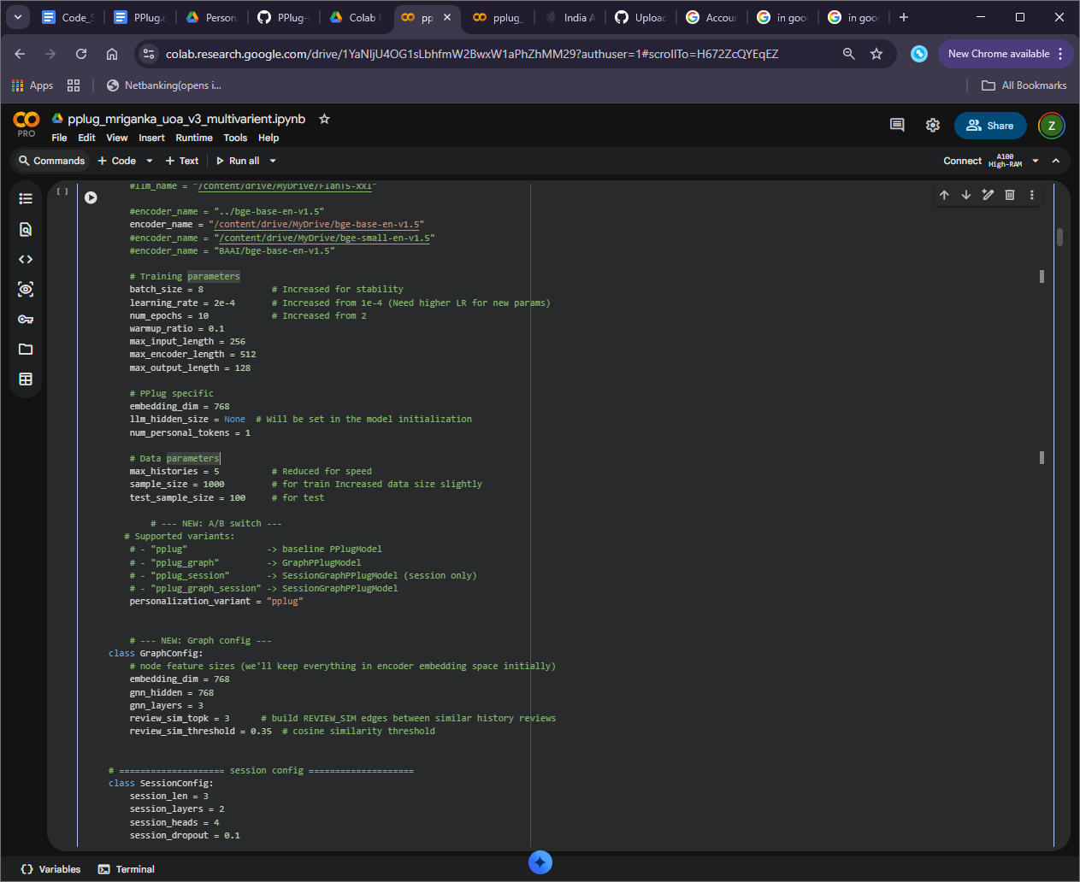

=== RUN START: pplug ===
{
"run_id": "20260214_190718",
"variant": "pplug",
"start_time": "2026-02-14T19:07:18.701131",
"log_path": "/content/drive/MyDrive/logs/20260214_190718_pplug.log",
"config": {
"sample_size": 1000,
"test_sample_size": 100,
"batch_size": 8,
"learning_rate": 0.0002,
"num_epochs": 10,
"max_histories": 5
}
}

=== CHECKPOINT SAVED ===
ckpt: /content/drive/MyDrive/logs/checkpoints/20260214_190718/pplug/model.pt
meta: /content/drive/MyDrive/logs/checkpoints/20260214_190718/pplug/meta.json

=== METRICS ===
{
"accuracy": 0.69,
"mae": 0.34,
"rmse": 0.6324555320336759
}
=== RUN END: pplug ===

^^^^^^^^^^^^^^^^^^^^^^^^^^^^^^^^^^^^^^
=== RUN START: pplug_graph ===
{
"run_id": "20260214_190718",
"variant": "pplug_graph",
"start_time": "2026-02-14T19:39:03.437924",
"log_path": "/content/drive/MyDrive/logs/20260214_190718_pplug_graph.log",
"config": {
"sample_size": 1000,
"test_sample_size": 100,
"batch_size": 8,
"learning_rate": 0.0002,
"num_epochs": 10,
"max_histories": 5
}
}

=== CHECKPOINT SAVED ===
ckpt: /content/drive/MyDrive/logs/checkpoints/20260214_190718/pplug_graph/model.pt
meta: /content/drive/MyDrive/logs/checkpoints/20260214_190718/pplug_graph/meta.json

=== METRICS ===
{
"accuracy": 0.63,
"mae": 0.41,
"rmse": 0.7
}
=== RUN END: pplug_graph ===

^^^^^^^^^^^^^^^^^^^^^^^^^^^^^^^^^^^^^^^^^
=== RUN START: pplug_graph_session ===
{
"run_id": "20260214_190718",
"variant": "pplug_graph_session",
"start_time": "2026-02-14T20:17:03.038449",
"log_path": "/content/drive/MyDrive/logs/20260214_190718_pplug_graph_session.log",
"config": {
"sample_size": 1000,
"test_sample_size": 100,
"batch_size": 8,
"learning_rate": 0.0002,
"num_epochs": 10,
"max_histories": 5
}
}

=== CHECKPOINT SAVED ===
ckpt: /content/drive/MyDrive/logs/checkpoints/20260214_190718/pplug_graph_session/model.pt
meta: /content/drive/MyDrive/logs/checkpoints/20260214_190718/pplug_graph_session/meta.json

=== METRICS ===
{
"accuracy": 0.68,
"mae": 0.34,
"rmse": 0.6164414002968976
}
=== RUN END: pplug_graph_session ===

+++++++++++++++++++++++++++++++++++++++++++++++++++++++++++++++++++++++++++++++++

+++++++++++++++++++++++++++++++++++++++++++++++++++++++++++++++++++++++++++++++++

+++++++++++++++++++++++++++++++++++++++++++++++++++++++++++++++++++++++++++++++++

pplug_mriganka_uoa_v4_multivarient.ipynb

Enabled Checkpointing
flan-t5-xl
bge-base

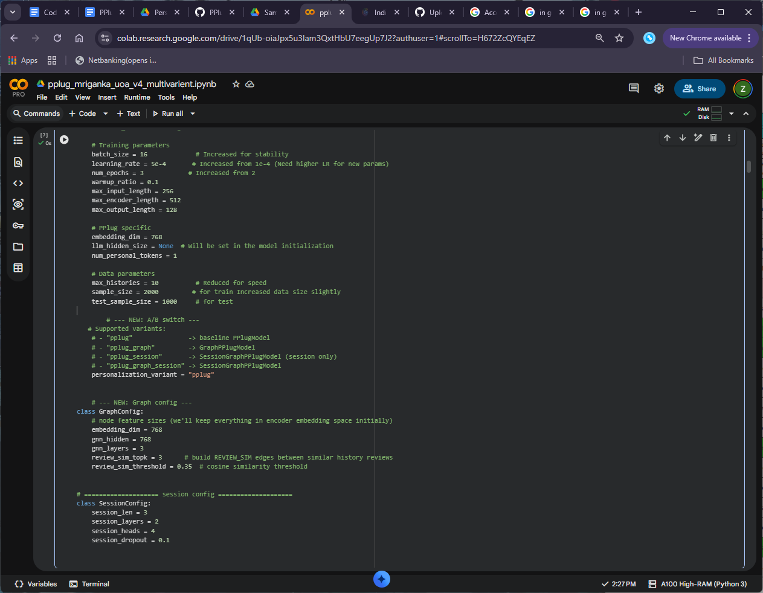

run_variants_and_log():Current Working Directory: /content
=== RUN START: pplug ===
{
"run_id": "20260215_073327",
"variant": "pplug",
"start_time": "2026-02-15T07:33:27.840604",
"log_path": "/content/drive/MyDrive/logs/20260215_073327_pplug.log",
"config": {
"sample_size": 2000,
"test_sample_size": 1000,
"batch_size": 16,
"learning_rate": 0.0005,
"num_epochs": 3,
"max_histories": 10
}
}
============================================================
PPlug: Personalized LLM Implementation
Based on: LLMs + Persona-Plug = Personalized LLMs
============================================================

1. Loading datasets...
LaMP3_Dataset::__init__():Current Working Directory: /content
LaMP3_Dataset::__init__():Current Working Directory: /content
Train size: 2000, Test size: 1000

2. Initializing model...
Loading weights: 100%
558/558 [03:52<00:00, 1.46it/s, Materializing param=shared.weight]
The tied weights mapping and config for this model specifies to tie shared.weight to lm_head.weight, but both are present in the checkpoints, so we will NOT tie them. You should update the config with `tie_word_embeddings=False` to silence this warning
Loading weights: 100%
199/199 [00:05<00:00, 93.29it/s, Materializing param=pooler.dense.weight]
BertModel LOAD REPORT from: /content/drive/MyDrive/bge-base-en-v1.5
Key | Status | |
------------------------+------------+--+-
embeddings.position_ids | UNEXPECTED | |

Notes:
- UNEXPECTED :can be ignored when loading from different task/architecture; not ok if you expect identical arch.
Loading weights: 100%
199/199 [00:00<00:00, 509.50it/s, Materializing param=pooler.dense.weight]
BertModel LOAD REPORT from: /content/drive/MyDrive/bge-base-en-v1.5
Key | Status | |
------------------------+------------+--+-
embeddings.position_ids | UNEXPECTED | |

Notes:
- UNEXPECTED :can be ignored when loading from different task/architecture; not ok if you expect identical arch.
Variant: pplug | Model: PPlugModel
Total parameters: 3,074,494,976
Trainable parameters: 115,255,552 (3.75%)

3. Training...
Epoch 1/3: 100%
125/125 [05:21<00:00, 2.57s/it, loss=9.8230, avg_loss=9.8273]
Epoch 1 completed. Average loss: 9.8273
Epoch 2/3: 100%
125/125 [05:21<00:00, 2.62s/it, loss=9.8056, avg_loss=4.9073]
Epoch 2 completed. Average loss: 9.8147
Epoch 3/3: 100%
125/125 [05:21<00:00, 2.59s/it, loss=9.7937, avg_loss=3.2706]
Epoch 3 completed. Average loss: 9.8119

4. Evaluating...

==================================================
EVALUATION EXAMPLES
==================================================

--- Example 1 ---
Input: Predict the product rating (1-5): What is the score of the following review on a scale of 1 to 5? just answer with 1, 2, 3, 4, or 5 without further explanation. review: If You Were Me and Lived In...G...
Predicted: '5' (Cleaned: '5')
Ground Truth: '5' (Cleaned: '5')
Match: True

--- Example 2 ---
Input: Predict the product rating (1-5): What is the score of the following review on a scale of 1 to 5? just answer with 1, 2, 3, 4, or 5 without further explanation. review: This is more than a cookbook; i...
Predicted: '5' (Cleaned: '5')
Ground Truth: '5' (Cleaned: '5')
Match: True

--- Example 3 ---
Input: Predict the product rating (1-5): What is the score of the following review on a scale of 1 to 5? just answer with 1, 2, 3, 4, or 5 without further explanation. review: I LOVE how she evolved from a l...
Predicted: '5' (Cleaned: '5')
Ground Truth: '5' (Cleaned: '5')
Match: True

--- Example 4 ---
Input: What is the score of the following review on a scale of 1 to 5? just answer with 1, 2, 3, 4, or 5 without further explanation. review: I would like to give this story a 5-star rating but the editing i...
Predicted: '3' (Cleaned: '3')
Ground Truth: '3' (Cleaned: '3')
Match: True

--- Example 5 ---
Input: Predict the product rating (1-5): What is the score of the following review on a scale of 1 to 5? just answer with 1, 2, 3, 4, or 5 without further explanation. review: I haven't used the remote funct...
Predicted: '4' (Cleaned: '4')
Ground Truth: '5' (Cleaned: '5')
Match: False

==================================================
Accuracy: 0.6780
Mean Absolute Error (MAE): 0.3720
Root Mean Squared Error (RMSE): 0.6899
==================================================

============================================================
Training and Evaluation Complete!
============================================================

=== CHECKPOINT SAVED ===
ckpt: /content/drive/MyDrive/logs/checkpoints/20260215_073327/pplug/model.pt
meta: /content/drive/MyDrive/logs/checkpoints/20260215_073327/pplug/meta.json

=== METRICS ===
{
"accuracy": 0.678,
"mae": 0.372,
"rmse": 0.6899275324264136
}
=== RUN END: pplug ===
=== RUN START: pplug_graph ===
{
"run_id": "20260215_073327",
"variant": "pplug_graph",
"start_time": "2026-02-15T08:00:21.085117",
"log_path": "/content/drive/MyDrive/logs/20260215_073327_pplug_graph.log",
"config": {
"sample_size": 2000,
"test_sample_size": 1000,
"batch_size": 16,
"learning_rate": 0.0005,
"num_epochs": 3,
"max_histories": 10
}
}
============================================================
PPlug: Personalized LLM Implementation
Based on: LLMs + Persona-Plug = Personalized LLMs
============================================================

1. Loading datasets...
LaMP3_Dataset::__init__():Current Working Directory: /content
LaMP3_Dataset::__init__():Current Working Directory: /content
Train size: 2000, Test size: 1000

2. Initializing model...
Loading weights: 100%
558/558 [00:00<00:00, 1047.61it/s, Materializing param=shared.weight]
The tied weights mapping and config for this model specifies to tie shared.weight to lm_head.weight, but both are present in the checkpoints, so we will NOT tie them. You should update the config with `tie_word_embeddings=False` to silence this warning
Loading weights: 100%
199/199 [00:00<00:00, 748.86it/s, Materializing param=pooler.dense.weight]
BertModel LOAD REPORT from: /content/drive/MyDrive/bge-base-en-v1.5
Key | Status | |
------------------------+------------+--+-
embeddings.position_ids | UNEXPECTED | |

Notes:
- UNEXPECTED :can be ignored when loading from different task/architecture; not ok if you expect identical arch.
Loading weights: 100%
199/199 [00:00<00:00, 937.23it/s, Materializing param=pooler.dense.weight]
BertModel LOAD REPORT from: /content/drive/MyDrive/bge-base-en-v1.5
Key | Status | |
------------------------+------------+--+-
embeddings.position_ids | UNEXPECTED | |

Notes:
- UNEXPECTED :can be ignored when loading from different task/architecture; not ok if you expect identical arch.
Variant: pplug_graph | Model: GraphPPlugModel
Total parameters: 3,112,797,441
Trainable parameters: 153,558,017 (4.93%)

3. Training...
Epoch 1/3: 100%
125/125 [08:18<00:00, 4.01s/it, loss=9.8321, avg_loss=9.8303]
Epoch 1 completed. Average loss: 9.8303
Epoch 2/3: 100%
125/125 [08:14<00:00, 3.93s/it, loss=9.8101, avg_loss=4.9088]
Epoch 2 completed. Average loss: 9.8175
Epoch 3/3: 100%
125/125 [08:17<00:00, 4.01s/it, loss=9.8055, avg_loss=3.2688]
Epoch 3 completed. Average loss: 9.8065

4. Evaluating...

==================================================
EVALUATION EXAMPLES
==================================================

--- Example 1 ---
Input: Predict the product rating (1-5): What is the score of the following review on a scale of 1 to 5? just answer with 1, 2, 3, 4, or 5 without further explanation. review: If You Were Me and Lived In...G...
Predicted: '5' (Cleaned: '5')
Ground Truth: '5' (Cleaned: '5')
Match: True

--- Example 2 ---
Input: Predict the product rating (1-5): What is the score of the following review on a scale of 1 to 5? just answer with 1, 2, 3, 4, or 5 without further explanation. review: This is more than a cookbook; i...
Predicted: '5' (Cleaned: '5')
Ground Truth: '5' (Cleaned: '5')
Match: True

--- Example 3 ---
Input: Predict the product rating (1-5): What is the score of the following review on a scale of 1 to 5? just answer with 1, 2, 3, 4, or 5 without further explanation. review: I LOVE how she evolved from a l...
Predicted: '5' (Cleaned: '5')
Ground Truth: '5' (Cleaned: '5')
Match: True

--- Example 4 ---
Input: What is the score of the following review on a scale of 1 to 5? just answer with 1, 2, 3, 4, or 5 without further explanation. review: I would like to give this story a 5-star rating but the editing i...
Predicted: '3' (Cleaned: '3')
Ground Truth: '3' (Cleaned: '3')
Match: True

--- Example 5 ---
Input: Predict the product rating (1-5): What is the score of the following review on a scale of 1 to 5? just answer with 1, 2, 3, 4, or 5 without further explanation. review: I haven't used the remote funct...
Predicted: '5' (Cleaned: '5')
Ground Truth: '5' (Cleaned: '5')
Match: True

==================================================
Accuracy: 0.6790
Mean Absolute Error (MAE): 0.3890
Root Mean Squared Error (RMSE): 0.7301
==================================================

============================================================
Training and Evaluation Complete!
============================================================

=== CHECKPOINT SAVED ===
ckpt: /content/drive/MyDrive/logs/checkpoints/20260215_073327/pplug_graph/model.pt
meta: /content/drive/MyDrive/logs/checkpoints/20260215_073327/pplug_graph/meta.json

=== METRICS ===
{
"accuracy": 0.679,
"mae": 0.389,
"rmse": 0.7300684899377592
}
=== RUN END: pplug_graph ===
=== RUN START: pplug_graph_session ===
{
"run_id": "20260215_073327",
"variant": "pplug_graph_session",
"start_time": "2026-02-15T08:30:26.147231",
"log_path": "/content/drive/MyDrive/logs/20260215_073327_pplug_graph_session.log",
"config": {
"sample_size": 2000,
"test_sample_size": 1000,
"batch_size": 16,
"learning_rate": 0.0005,
"num_epochs": 3,
"max_histories": 10
}
}
============================================================
PPlug: Personalized LLM Implementation
Based on: LLMs + Persona-Plug = Personalized LLMs
============================================================

1. Loading datasets...
LaMP3_Dataset::__init__():Current Working Directory: /content
LaMP3_Dataset::__init__():Current Working Directory: /content
Train size: 2000, Test size: 1000

2. Initializing model...
Loading weights: 100%
558/558 [00:00<00:00, 1003.03it/s, Materializing param=shared.weight]
The tied weights mapping and config for this model specifies to tie shared.weight to lm_head.weight, but both are present in the checkpoints, so we will NOT tie them. You should update the config with `tie_word_embeddings=False` to silence this warning
Loading weights: 100%
199/199 [00:00<00:00, 615.89it/s, Materializing param=pooler.dense.weight]
BertModel LOAD REPORT from: /content/drive/MyDrive/bge-base-en-v1.5
Key | Status | |
------------------------+------------+--+-
embeddings.position_ids | UNEXPECTED | |

Notes:
- UNEXPECTED :can be ignored when loading from different task/architecture; not ok if you expect identical arch.
Loading weights: 100%
199/199 [00:00<00:00, 868.02it/s, Materializing param=pooler.dense.weight]
BertModel LOAD REPORT from: /content/drive/MyDrive/bge-base-en-v1.5
Key | Status | |
------------------------+------------+--+-
embeddings.position_ids | UNEXPECTED | |

Notes:
- UNEXPECTED :can be ignored when loading from different task/architecture; not ok if you expect identical arch.
Variant: pplug_graph_session | Model: SessionGraphPPlugModel
Total parameters: 3,129,600,770
Trainable parameters: 60,879,106 (1.95%)

3. Training...
Epoch 1/3: 100%
125/125 [07:14<00:00, 3.32s/it, loss=9.8206, avg_loss=9.8290]
Epoch 1 completed. Average loss: 9.8290
Epoch 2/3: 100%
125/125 [07:10<00:00, 3.40s/it, loss=9.8320, avg_loss=4.9088]
Epoch 2 completed. Average loss: 9.8176
Epoch 3/3: 100%
125/125 [07:11<00:00, 3.53s/it, loss=9.7995, avg_loss=3.2682]
Epoch 3 completed. Average loss: 9.8046

4. Evaluating...

==================================================
EVALUATION EXAMPLES
==================================================

--- Example 1 ---
Input: Predict the product rating (1-5): What is the score of the following review on a scale of 1 to 5? just answer with 1, 2, 3, 4, or 5 without further explanation. review: If You Were Me and Lived In...G...
Predicted: '5' (Cleaned: '5')
Ground Truth: '5' (Cleaned: '5')
Match: True

--- Example 2 ---
Input: Predict the product rating (1-5): What is the score of the following review on a scale of 1 to 5? just answer with 1, 2, 3, 4, or 5 without further explanation. review: This is more than a cookbook; i...
Predicted: '5' (Cleaned: '5')
Ground Truth: '5' (Cleaned: '5')
Match: True

--- Example 3 ---
Input: Predict the product rating (1-5): What is the score of the following review on a scale of 1 to 5? just answer with 1, 2, 3, 4, or 5 without further explanation. review: I LOVE how she evolved from a l...
Predicted: '5' (Cleaned: '5')
Ground Truth: '5' (Cleaned: '5')
Match: True

--- Example 4 ---
Input: What is the score of the following review on a scale of 1 to 5? just answer with 1, 2, 3, 4, or 5 without further explanation. review: I would like to give this story a 5-star rating but the editing i...
Predicted: '1' (Cleaned: '1')
Ground Truth: '3' (Cleaned: '3')
Match: False

--- Example 5 ---
Input: Predict the product rating (1-5): What is the score of the following review on a scale of 1 to 5? just answer with 1, 2, 3, 4, or 5 without further explanation. review: I haven't used the remote funct...
Predicted: '4' (Cleaned: '4')
Ground Truth: '5' (Cleaned: '5')
Match: False

==================================================
Accuracy: 0.6310
Mean Absolute Error (MAE): 0.4565
Root Mean Squared Error (RMSE): 0.8103
==================================================

============================================================
Training and Evaluation Complete!
============================================================

=== CHECKPOINT SAVED ===
ckpt: /content/drive/MyDrive/logs/checkpoints/20260215_073327/pplug_graph_session/model.pt
meta: /content/drive/MyDrive/logs/checkpoints/20260215_073327/pplug_graph_session/meta.json

=== METRICS ===
{
"accuracy": 0.631,
"mae": 0.45645645645645644,
"rmse": 0.8103435423674681
}
=== RUN END: pplug_graph_session ===

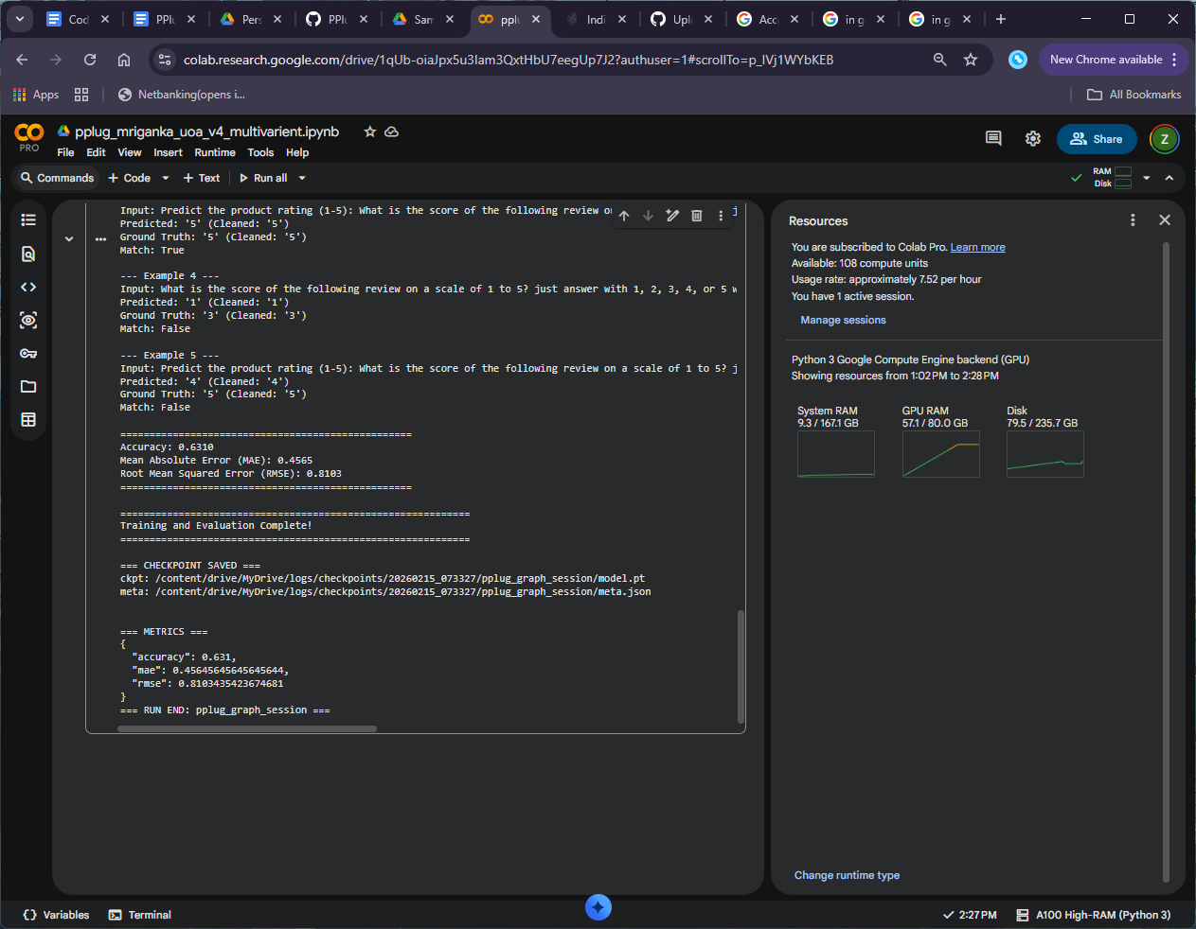

Inference
Loading weights: 100%
558/558 [00:00<00:00, 1048.96it/s, Materializing param=shared.weight]
The tied weights mapping and config for this model specifies to tie shared.weight to lm_head.weight, but both are present in the checkpoints, so we will NOT tie them. You should update the config with `tie_word_embeddings=False` to silence this warning
Loading weights: 100%
199/199 [00:00<00:00, 667.48it/s, Materializing param=pooler.dense.weight]
BertModel LOAD REPORT from: /content/drive/MyDrive/bge-base-en-v1.5
Key | Status | |
------------------------+------------+--+-
embeddings.position_ids | UNEXPECTED | |

Notes:
- UNEXPECTED :can be ignored when loading from different task/architecture; not ok if you expect identical arch.
Loading weights: 100%
199/199 [00:00<00:00, 1055.30it/s, Materializing param=pooler.dense.weight]
BertModel LOAD REPORT from: /content/drive/MyDrive/bge-base-en-v1.5
Key | Status | |
------------------------+------------+--+-
embeddings.position_ids | UNEXPECTED | |

Notes:
- UNEXPECTED :can be ignored when loading from different task/architecture; not ok if you expect identical arch.
LaMP3_Dataset::__init__():Current Working Directory: /content
5

+++++++++++++++++++++++++++++++++++++++++
Number of Bin:

END

