Product Requirements Document (PRD)
Fit-Reason Agent for Dhaga & Co.
Title / Initiative | Fit-Reason Agent: read every return reason and customer message, so Dhaga & Co. fixes the right thing first
Date & Version | 3 October 2026 · v1.0, draft for review
Product - Point of Contact (POC) | Somdatta Chakraborty
Design POC | TBD (team: Astha, Gowdham, Prashant, Somdatta)
Tech POC | TBD (see the Technical Architecture Document)
Marketing POC | Not required: internal pilot, no customer communication planned

Why? (Objective)
Almost a third of Dhaga & Co.'s orders come back, and customers already explain why, in their own words and mostly in Hinglish. Nobody can read those explanations at the volume they arrive, so the same products keep shipping with the same problem.
The problem is not a lack of information. It is that the information sits in free text that no one has time to read.

1. For business
- Returns are the biggest leak. 31% of ~48,000 weekly orders come back: about 14,880 returns and ₹1.25 Cr of order value reversed every week.
- The cause is hidden. 44% of return reasons land in "Other" (~6,500 a week). The Category Head says most of them are about fit, but she can read only a few hundred.
- Vendors are not held to account. Size charts differ by vendor and delivery lead times "live in people's heads". Without evidence, vendor conversations run on anecdote.
- Retention and cost suffer. Repeat purchase has been stuck at 22% for six quarters and acquisition cost is up 40% year on year. Every avoidable return makes both worse.

2. For users
- Neha (Category Head) wants to know which products and vendors cause returns, without reading thousands of comments.
- Faizan (Head of Supply Chain) wants evidence of which vendors and couriers cause repeat delays.
- CX agents answer customers with four copy-paste replies, so customers wait about 9 hours and often get an answer that misses their question.
- Customers write in Hinglish about fit, size and delivery, and deserve an answer to the question they actually asked.
The framing that matters
This is not a data problem: the data exists. It is a reading problem. We are not replacing Neha's judgement, we are giving her the 20 issues that matter instead of 6,500 comments.

How do we measure success?

1. Associated OKR / Goal
- Company goal: bring the 31% return rate down and lift repeat purchase above 22%.
- Team objective: turn unread customer text into fixes owned by a named person within the same week.

2. Success Metrics
Metric | Today | Target (pilot) | Why this one
Returns with a specific, usable reason | 56% | ≥ 85% | Primary. Shows the "Other" blind spot is closing.
Issues acted on per week (fix or vendor escalation) | 0 | ≥ 15 | Proves the insight reaches someone who acts, not just a screen.
Return rate on fixed products | Product baseline | −20% within one 6-week catalogue cycle | The business result; fits the 6-week catalogue turnover.
Neha's time spent reading comments | ~6–8 hrs/week (estimate) | < 1 hr/week | Time given back to the owner.
Repeat delays traced to a named vendor or courier | None | All of them, with evidence | Gives Faizan a fact base for vendor conversations.
Suggested replies rated "send as-is" by the CX team | n/a (new) | ≥ 90% before any customer sees one | Decides when replies can safely go to customers.

3. Guardrail / do-not-disturb metrics
(These metrics shouldn't be negatively affected)
Guardrail | Tolerance | What it protects against
Wrong facts in a suggested reply (date, size, amount, promise) | Zero | A misleading answer reaching a customer once replies go live.
Messages sent to customers during the pilot | Zero | The pilot stays internal by design.
Category accuracy on a hand-checked sample | ≥ 92% | Wrong tags sent to vendors damage trust faster than "Other" ever did.
Vendors flagged on very few complaints | None below 5 items | Unfair vendor blame based on two or three comments.
Time from sample to live listing | No increase | The tool must help the listing team, not add a new approval step.

Who are the users?

1. Persona
 | Primary: Neha, Category Head | Faizan, Head of Supply Chain | CX reviewer (Arpita's team)
Wants | Know which products and vendors drive returns, and what to change | Know which vendors and couriers cause repeat delays | Give customers a correct, useful answer quickly
Does today | Reads a few hundred "Other" comments by hand | Relies on memory and WhatsApp threads with 40 vendors | Pastes one of four canned replies; first response ~9 hrs
Fails when | Tags look confident but are wrong, or show no sample size | A vendor is blamed for a courier's delay | A suggestion invents a date or refund amount

2. Problems we are solving (needs, problems, jobs to be done)
Job to be done: "When customers return orders or complain, help me see which products and vendors cause it, so I can fix the cause this week instead of reading thousands of comments." (Neha)
- The "Other" box is unread. ~6,500 return reasons a week are free text that nobody can read at volume.
- Complaints are not linked to vendors. Fit and delay complaints never reach the vendor responsible with evidence.
- Customers get canned answers. Four templates cannot answer a specific Hinglish question about size or delivery.
- Delays have no owner. Nobody can say whether a late order was the vendor, the warehouse or the courier.

3. How do we know these problems exist (research)
Evidence (from the client brief and interviews) | What it tells us
Neha: "Returns are 31% overall... most of [Other] is about fit, but I can only read a few hundred at a time." | A named owner is losing something measurable today.
44% of return reasons land in "Other"; size charts differ per vendor | The cause exists in data but is unread; vendors are a likely root cause.
Arpita: 58% of ~9,000 weekly tickets ask "where is my order"; agents paste the same 4 replies; first response 9 hrs | Customer questions are repetitive in topic but specific in detail.
Faizan: COD return-to-origin 26%, ~₹120 each; vendor lead times "held in people's heads" | Delivery problems cost money and have no evidence trail.
410,000 product reviews "nobody reads"; customers write in Hinglish by occasion | Hinglish free text is normal input, not an edge case.

Solution

1. Brief of the solution
An AI assistant reads every return reason and customer message once, in English, Hindi or Hinglish, and sends what it finds to the person who can act on it. It runs internally first: no customer receives anything during the pilot.
- Priority list for Neha. Similar complaints are grouped into issues (for example "V-17 kurtis run a size small, 38 complaints") and ranked worst first, each with real customer quotes. Neha marks each one Fix, Escalate to vendor, Monitor or Wrong tag.
- Suggested replies in the customer's language. For each customer question, the assistant suggests a reply that answers that specific question, using only facts from Dhaga's records (order status, size chart, exchange policy) instead of canned text. CX reviewers rate each suggestion; nothing is sent.
- Delay report by vendor and courier. Every "where is my order" message is linked to its order, vendor and courier. The report shows where the time was lost (waiting for vendor stock, in the warehouse or with the courier) and flags those who are late again and again.
Going customer-facing later
Suggested replies reach customers only after 2 consecutive weeks of ≥ 90% "send as-is" ratings and zero wrong facts, with sign-off from the Head of CX and the CTO. Even then, an agent approves each reply with one click.

2. Other alternatives considered, with prioritization
We shortlisted the problems raised by Dhaga's leadership and scored each from 1 to 5 on five criteria. The weighted score is out of 100.
Criterion | Weight | Question asked
Owner and measurable loss | 25 | Does a named person lose a number they already track?
Size and link to company goals | 25 | How big is the cost, and does it affect repeat purchase or cost?
Data readiness | 20 | Is there data we can use and measure against now?
Root cause, not symptom | 15 | Does fixing it remove a cause, or quieten a symptom?
Buildable, operable, safe | 15 | Can a small team with no ML engineer run it, without risk to customers?

Rank | Problem (owner) | Score | Why it sits here
1 | Returns explained only as "Other" (Neha) | 95 | Named owner, ~14,880 returns a week, unread text in hand, upstream of several other complaints, safe to run internally. Picked.
2 | Cash-on-delivery orders refused at the door, 26% (Faizan) | 81 | Biggest rupee figure (~₹4.75 Cr a year), but no reason is recorded, so the cause is unknown. Learning why comes first.
3 | "Where is my order" tickets, 58% of support (Arpita) | 78 | Clean data, but a symptom of slow delivery. We use these tickets as evidence for vendor and courier delays instead.
4 | 6–9 days from sample to live listing (Vivek) | 73 | Real, but its cost is not quantified. A strong next step using the same reading engine.
5 | Analytics request queue of ~2 weeks (Karthik) | 64 | A real bottleneck, but a meta-problem. Our tool removes one class of his requests.

Why returns first, even though doorstep refusals cost more: you cannot fix what you cannot explain. Refusals have a cost but no recorded reason; returns have a reason that nobody reads. Fit is also upstream of several complaints, including returns, vendor size-chart issues, unread reviews and plausibly some doorstep refusals. And it is safe: everything stays internal.
Solution alternative | Why not now
Redesign the return-reason dropdown | Improves future data only; does nothing for the comments already received. Kept as a later step.
Add more people to read comments | Does not scale to ~6,500 a week, and reading still does not group issues or link them to vendors.
Send AI replies to customers straight away | Breaks the rule that customer-facing text needs a designed review step. Shadow mode first.
Generic size advice on every product page | Treats all vendors the same; the problem is specific products and vendors.

Product flow (Details of the feature/product)

1. Customer Journey
Moment | Today | With the Fit-Reason Agent
Customer returns a kurta, writes "size M bahut tight hai" | Lands in "Other"; unread | Tagged as fit / runs small and grouped with 37 similar comments on the same vendor
Monday, Neha plans her week | Reads a few hundred rows by hand | Opens a ranked list; the top issue shows the vendor, size-chart gap and quotes
Neha decides | Acts on anecdote, if at all | Clicks Fix size chart or Escalate to vendor; action logged with her name
Customer asks "kya L mil sakta hai?" | Canned reply after ~9 hours | A suggested Hinglish reply with the real size chart and exchange steps, rated by a CX reviewer (not sent in the pilot)
Customer asks "order kab aayega?" | Canned reply; delay never traced | Linked to order, vendor and courier; counted in the delay report
Faizan reviews vendors | Memory and WhatsApp threads | Sees vendors and couriers that are late repeatedly, with the orders behind each number

2. Wireframes and Flow diagrams
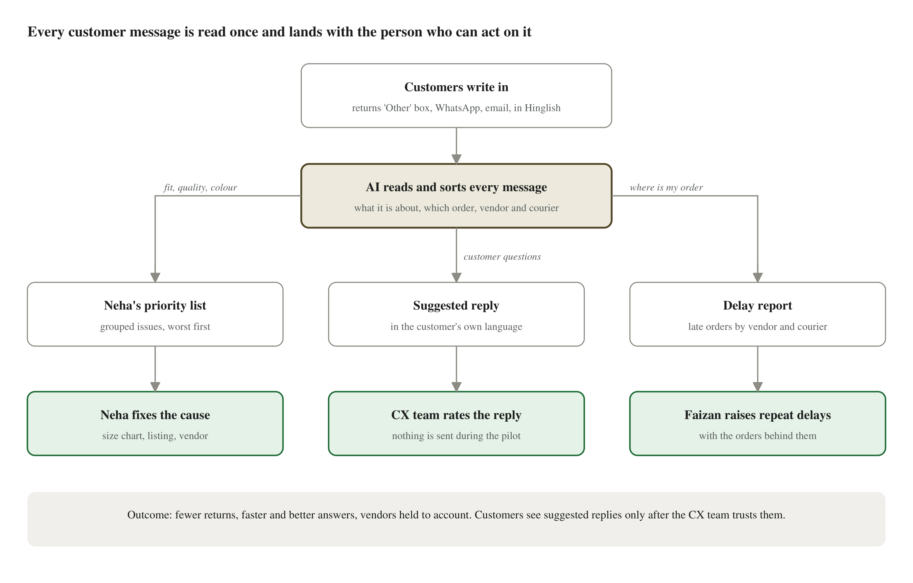
Product flow: one reading step, three internal outputs
The interactive screen designs are on the UX design canvas (link under Related documents):
Screen | Who uses it | What it shows
Priority queue | Neha | Issues ranked worst first, with count, vendor, size-chart gap, three customer quotes and the Fix / Escalate / Monitor / Wrong tag actions
Guidance review | CX reviewers | Shadow-mode banner, the customer's message, the facts the reply may use, the suggested reply and the rating buttons
Guidance review: failure case | CX reviewers | A refund question where no refund date is on record: suggestions are rejected and the message is handed to a person
Delay scorecard | Faizan, Neha | Vendors and couriers ranked by late orders, where the time was lost, and the orders and messages behind each number

3. User Stories
- As Neha, I see a ranked list of issues, not comments, each with a count, the products, the vendor and three quotes, so I fix the top five in minutes.
- As Neha, I mark an issue Fix, Escalate to vendor, Monitor or Wrong tag, so the list reflects what I have handled.
- As Faizan, I see vendors and couriers ranked by late orders and where the time was lost, so I raise repeat delays with evidence.
- As Neha or Faizan, I click any number and see the actual orders and customer messages behind it.
- As a CX reviewer, I see the customer's question beside the suggested reply and the facts it used, and I rate it, knowing nothing is sent.
- As the CTO, I can run this without an ML engineer, see what each run costs, and switch it off at any time.

4. User acceptance criteria
# | Given / When / Then
1 | Given any return comment or message, when it is read, then it gets a category, or is shown as "Unclassified" and counted. Nothing is silently dropped.
2 | Given the assistant is unsure about a category, then the item goes to a "Check tag" list, not into Neha's ranking.
3 | Given an issue has fewer than 5 complaints, then it shows as "Monitor" and never ranks at the top.
4 | Given Neha opens an issue, then she sees the count, products, vendor and at least three customer quotes.
5 | Given Neha takes an action, then it is saved with her name and the time.
6 | Given a customer asks about a date, size or amount that is not in Dhaga's records, then no reply is suggested and the message is marked "Needs a person" with the reason.
7 | Given the pilot is running, then no suggested reply is ever sent to a customer.
8 | Given a message in Hinglish, then the suggested reply is in Hinglish; English gets English.
9 | Given an order was late, then the delay is blamed on the vendor only if time was lost waiting for stock, and on the courier only if it was lost in transit.
10 | Given any number on the delay report, when clicked, then it shows the orders and messages behind it.

5. Edge cases
Case | Expected behaviour
Very short or vague text ("bekaar", "not good") | Marked "not enough information" and counted; not guessed.
Not about fit ("changed my mind", "late delivery") | Tagged correctly and still counted, so the 85% metric stays honest.
Mixed language or typos ("fiting nhi aayi") | Treated as normal input.
Customer has two open orders | No guess: the message goes to a person with both orders listed.
Refund date or amount not on record | No suggestion; marked "Needs a person: unsupported refund date".
Vendor with very few orders | No delay flag; sample size shown.
Deliveries to the north east | Measured against a longer delivery target, so couriers are not unfairly flagged.
Product already removed from the catalogue (6-week rule) | Rolled up to the vendor, not shown as an action on a live product.
Message tries to instruct the system ("ignore your rules") | Treated as customer text only; it cannot change what the system does.

6. Event tracking sheet
Event | When it fires | Key properties | Answers
item_tagged | A comment or message is categorised | source, category, language, confidence | Coverage, accuracy, language mix
item_unclassified | An item could not be categorised | reason | Visible failure count
issue_viewed | Neha opens an issue | issue, rank, score | Is the ranking useful?
issue_actioned | Fix / Escalate / Monitor / Wrong tag | action, issue, vendor | Issues acted on per week
tag_corrected | A person fixes a category | old category, new category | Where the assistant is weak
reply_suggested | A suggested reply is produced | category, language, check result, attempts | Share of questions answerable from records
reply_rated | A reviewer rates a suggestion | rating, edited (yes/no) | Go-live gate: % "send as-is"
reply_handed_to_person | No safe suggestion possible | reason | Which questions need people
delay_drilldown_opened | A vendor or courier row is opened | vendor or courier, stage | Is the delay report used?
vendor_escalated | Escalate with evidence | vendor, stage, orders attached | Vendor accountability
run_completed | A reading run finishes | items, cost (₹), duration | Cost per run vs budget

Tentative Timelines
Task | Date
Design ready (screens on the UX canvas) | 3 Oct 2026
Development starts (demo version on sample data) | 3 Oct 2026
Prototype testing (live demo to Ritu, Neha and Dev) | 4 Oct 2026
Leadership approval to pilot | 4 Oct 2026
Beta launch: internal pilot on real data, one category (womenswear kurtis) | 5 Oct – 1 Nov 2026
Decision on customer-facing replies (after the 2-week quality gate) | Earliest mid-Nov 2026

Dependencies

1. Open Questions
- Do orders ever wait for vendor stock, or does every order ship from warehouse stock? This decides whether delays can be blamed on vendors.
- Does the order history record "stock received" and "handed to courier" as separate steps?
- Can the "Other" text and support tickets be exported, and can tickets be linked to order numbers?
- Are size charts and the exchange policy stored as data or as PDFs/images?
- Does the 31% return rate include orders refused at the door?
- What minimum number of complaints should flag a vendor? (to agree with Neha and Faizan)

2. Infrastructure requirements
A hosted web app, a managed database and access to an AI model provider. Details, diagrams and costs are in the Technical Architecture Document.

3. Budget approvals
About ₹2,600 a month during the pilot (AI usage plus database). This pays for itself if it prevents about 5 returns a week, 0.03% of weekly returns, assuming ₹120 per return (to confirm). Full calculation in the Technical Architecture Document.

4. Partner Support (APIs, Partnerships)
- AI model provider account with a monthly spending limit.
- Exports from the returns system, Freshdesk and the WhatsApp line (Gupshup).
- No integration with couriers or vendors is needed for the pilot.

5. Internal Dependencies (Tech, Design, Other Teams)
- Neha: about 1 hour a week to review the list and agree categories and thresholds.
- Faizan: stage targets and vendor flag thresholds.
- CX team: 2–3 reviewers, about 30 minutes a day, to rate suggested replies.
- Engineering (Dev): one engineer at ~20% time to own it from the start of the pilot.
- Analytics (Karthik): read access to orders, returns and tickets.

Related documents
- Tech planning document: Fit-Reason Agent - Technical Architecture Document.docx (architecture, tech stack, cost calculation)
- Design planning document: UX design canvas, https://claude.ai/artifact/33PWe3w6K65mLpEAk7YNbs (share access before circulating)
- Go-to-market planning: not applicable for the internal pilot; revisit before customer-facing replies go live

