Technical Architecture Document
Fit-Reason Agent for Dhaga & Co.
System | Fit-Reason Agent: priority queue, Hinglish reply suggestions (shadow mode) and vendor/courier delay scorecard
Date & Version | 4 October 2026 · v1.6, reviewed against the deployed demo app
Related PRD | Fit-Reason Agent - Product Requirements Document (PRD).docx
Owner | Somdatta Chakraborty (product); Tech POC TBD
Scope | Demo app on sample data (live at dhaga-fit-reason.streamlit.app) and the 4-week internal pilot on real data

1. Purpose and scope
This document describes how the Fit-Reason Agent is built: its components, tech stack, data model, model usage, security, operations and what it costs to run. The product requirements are in the PRD.
- In scope: reading returns and support tickets, tagging and grouping them, ranking issues, suggesting replies in shadow mode, delay attribution by stage, and three internal screens.
- Out of scope: sending anything to customers, live integrations with Freshdesk, Gupshup, Unicommerce or couriers, production-grade scaling, and single sign-on with Dhaga's company accounts.
- Design principles: models only read and write language; counting, maths, lookups and every fact come from code. Every model output is a validated schema. Failures show on screen.

2. Architecture overview
Four parts: a Streamlit app on Streamlit Community Cloud, a LangChain pipeline, a Supabase (Postgres) database and the Groq API. Supabase is the hub. There are two kinds of database access: the screens read and write as the signed-in person, so the database's own access rules decide what each role sees; the AI pipeline uses a service connection, server-side only, to write its results. Only the pipeline calls a model.
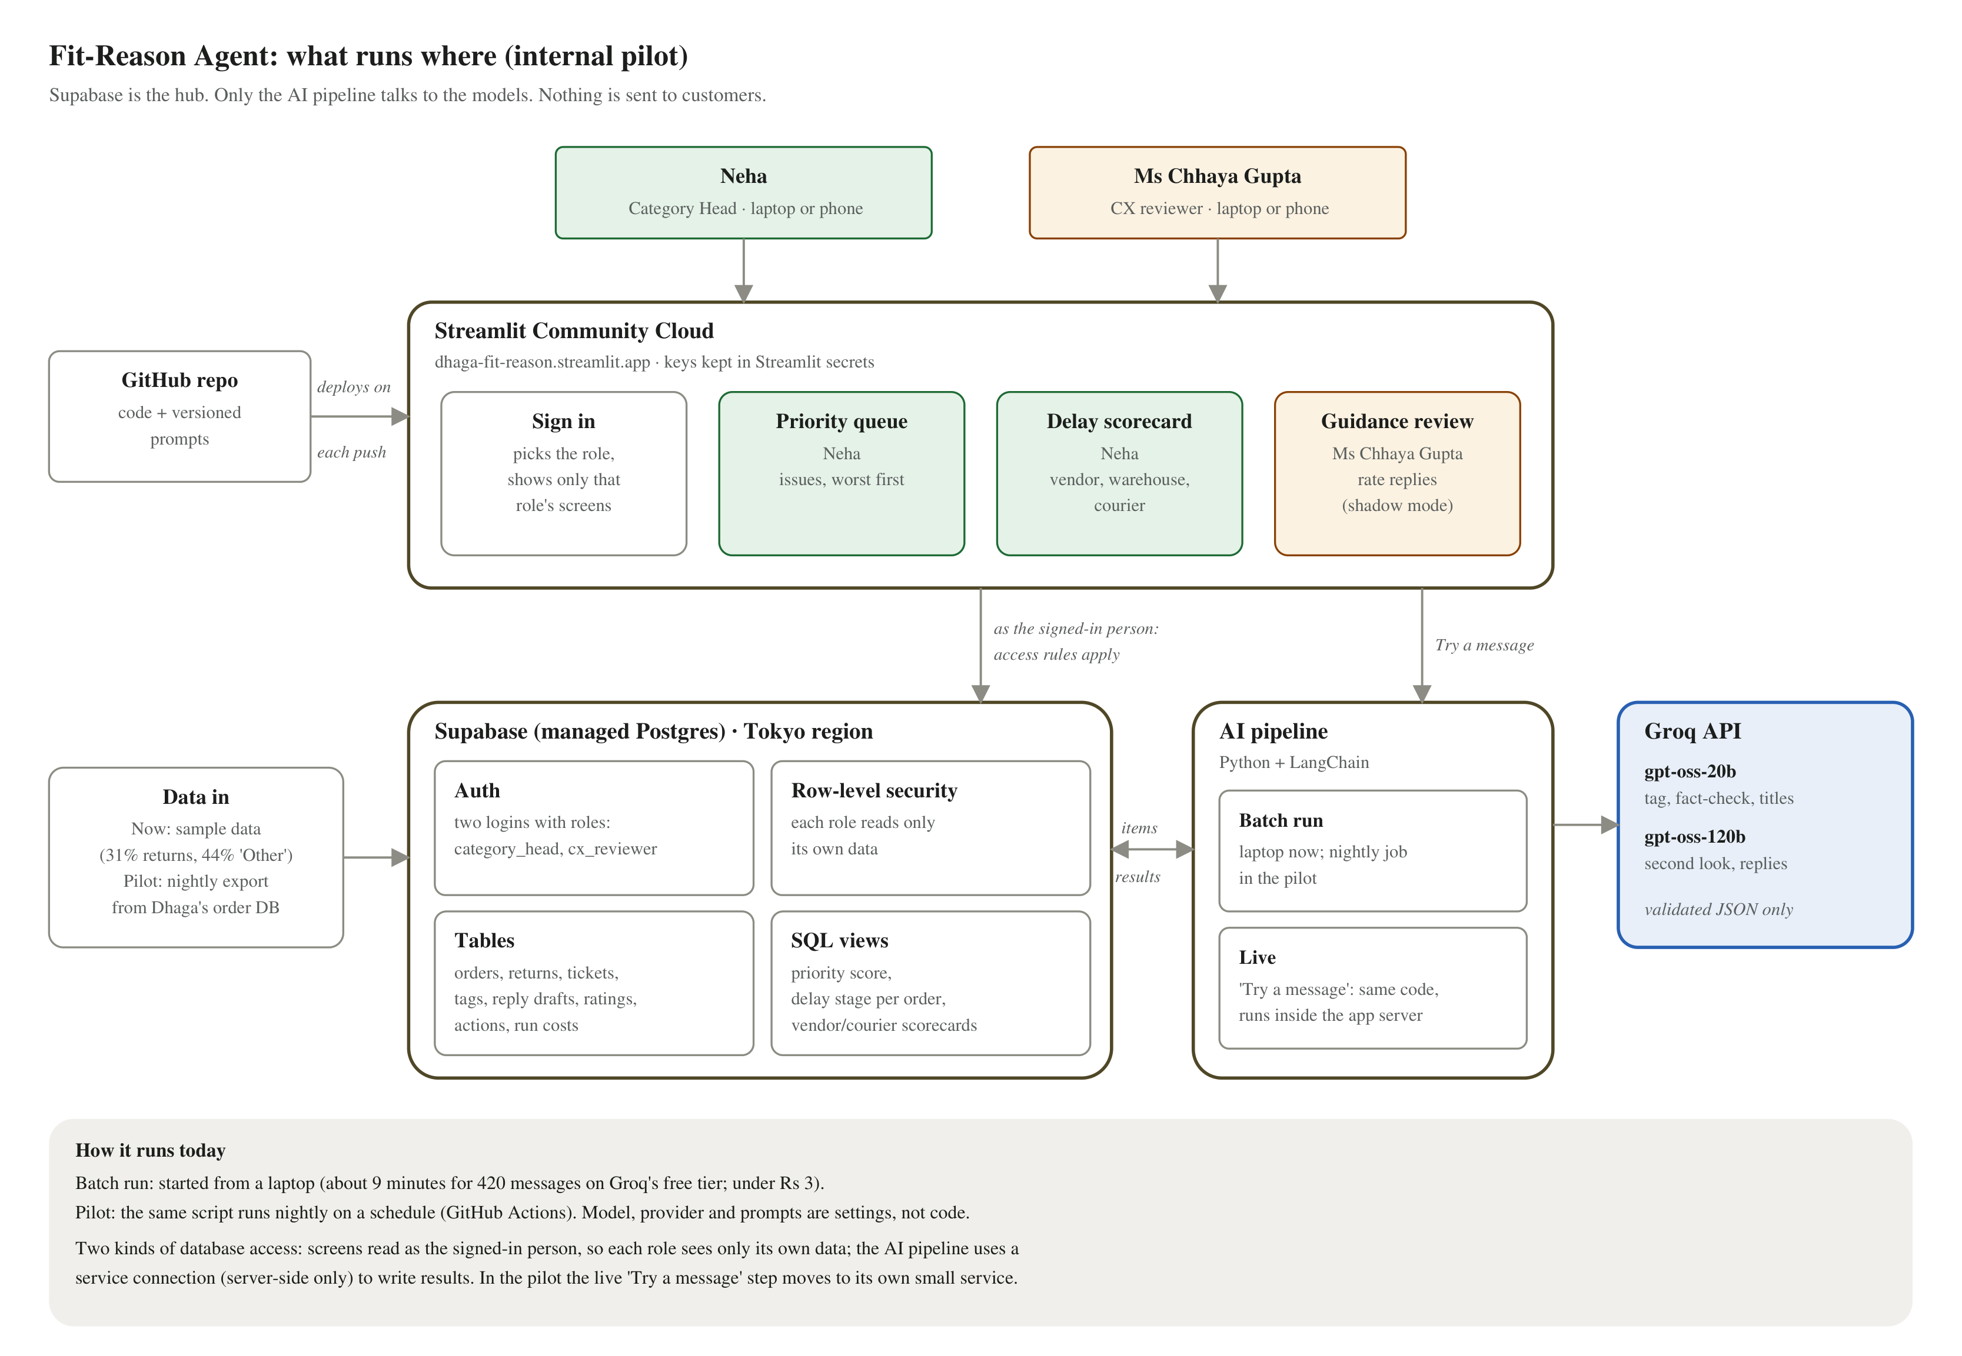
Figure 1. System architecture, as deployed
Component | Responsibility
Streamlit app | Sign-in (or, in demo mode, straight in as Neha with a switch to Ms Chhaya Gupta), then only the screens for that role: Priority queue and Delay scorecard (Neha), Guidance review (Ms Chhaya Gupta). Hosted on Streamlit Community Cloud; redeploys on every push to GitHub.
LangChain pipeline (Python) | Runs the tag, draft and check chains. Batch run: started from a laptop today (scripts/run_pipeline.py), a nightly scheduled job in the pilot. Live: the same code runs inside the app server for the "Try a message" box. Uses the service database connection.
Supabase (Postgres, Tokyo) | Single store for source data, model outputs, human decisions and the run/cost log. Supabase Auth holds the two logins and their roles; row-level security enforces them. Views hold the priority score and the delay stage per order.
Groq API | openai/gpt-oss-20b for bulk tagging, issue titles and fact-checks; openai/gpt-oss-120b for second looks and reply drafts. Provider and models are settings, so OpenRouter (Claude) can be swapped in without code changes.
Data loader | MVP: a Python script that generates realistic sample data. Pilot: a nightly export of only the needed columns from Dhaga's Postgres replica.

3. Processing flow
One cheap tagging pass reads every item, then routing sends it down the lane that needs it. A "where is my order" ticket can take two lanes: it feeds the delay scorecard and also gets a reply suggestion.
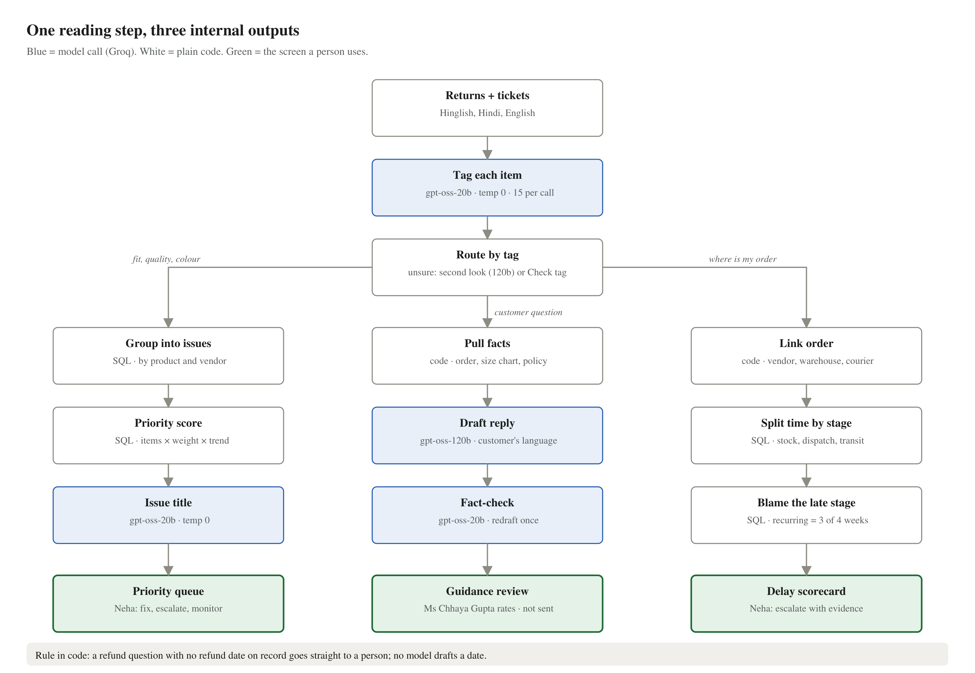
Figure 2. Processing pipeline: one intake, three internal outputs

Data flow
Figure 3 follows the data itself: where it enters, which step changes it, where it is stored and who sees it. Squares are people and systems outside the app; rounded boxes are steps (blue = an AI model is used); open boxes are stored data.
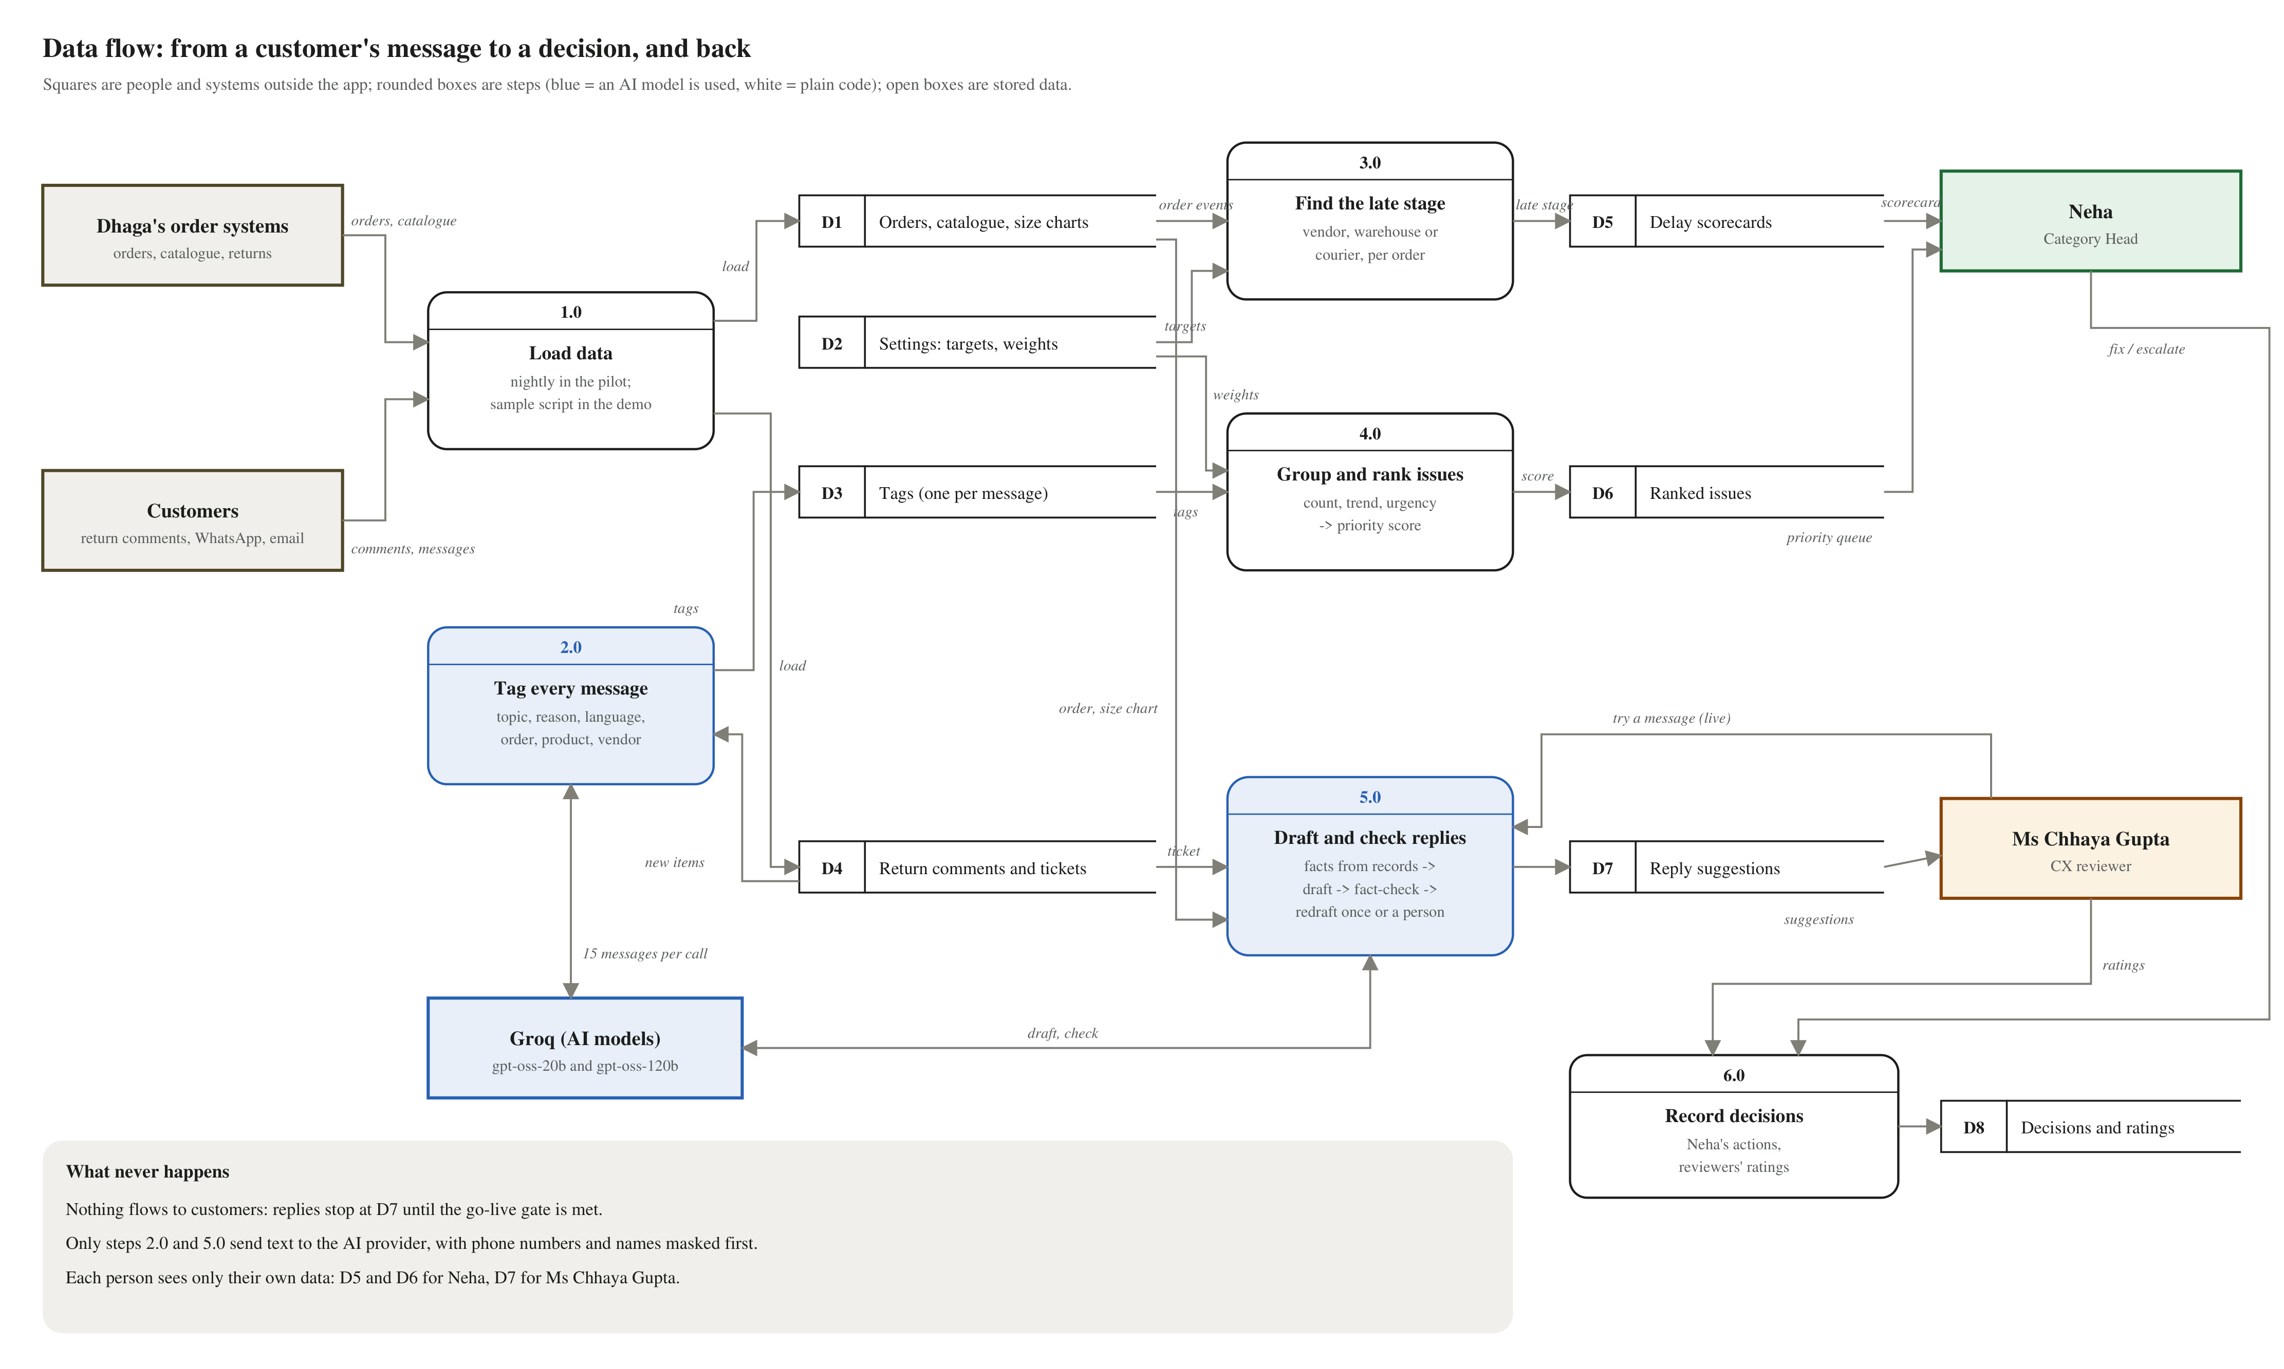
Figure 3. Data flow diagram (level 1)
Step | Reads | Writes | Who sees the result
1.0 Load data | Dhaga's order systems; customer messages | D1 orders, catalogue, size charts; D4 comments and tickets | No one directly
2.0 Tag every message (AI) | D4 new comments and tickets | D3 one tag per message | Feeds 4.0
3.0 Find the late stage | D1 order events; D2 targets | D5 delay scorecards | Neha
4.0 Group and rank issues | D3 tags; D2 weights | D6 ranked issues | Neha
5.0 Draft and check replies (AI) | D4 ticket; D1 order and size chart | D7 reply suggestions | Ms Chhaya Gupta
6.0 Record decisions | Neha's actions; reviewers' ratings | D8 decisions and ratings | Audit trail

Patterns used, and what breaks without each
Pattern | Where | What breaks without it
Parallelization (batching) | 15 messages tagged per model call | One call per message would take ~50 minutes for the sample and hit the provider's request limits.
Routing | By category (fit / question / WISMO) and by confidence | Unsure tags pollute the queue; WISMO items never reach delay attribution.
Prompt chaining | Facts → draft → check; tag → group → title | One large prompt invents order facts and cannot be inspected.
Evaluator-optimizer | Fact-check rejects a draft, which is redrafted once | An invented date or amount reaches the reviewer, and later a customer.

4. Tech stack
Layer | Choice | Why | Tier / cost
Language | Python 3.12 | One language for pipeline and UI; Dhaga's engineers can maintain it | Free
Frontend | Streamlit | Three data screens in a day; buttons and forms built in | Free
Hosting | Streamlit Community Cloud | Built for Streamlit; redeploys from GitHub on every push; secrets store; phone-friendly link | Free
Orchestration | LangChain: ChatGroq / ChatOpenAI, ChatPromptTemplate, with_structured_output (strict JSON schema), LCEL chains (prompt | model) called with .invoke(); no LangGraph, agents or memory. Batching is done in the prompt (15 messages per call), not with .batch() | Team standard; one small wrapper (core/llm.py) for every model call; provider can be swapped by a setting | Free (open source)
Models | Groq: openai/gpt-oss-20b (fast) and openai/gpt-oss-120b (strong) via langchain-groq | Cheap, very fast model for bulk work; stronger model only for unsure tags and customer-visible replies | Pay per token (section 10); free tier for the demo
Schemas | Pydantic v2 | Every model boundary returns a validated object | Free
Database and logins | Supabase (managed Postgres, Auth, row-level security) + supabase-py and psycopg | Tables, views, logins and access rules in one service | Free tier (demo); Pro $25/month (pilot)
Scheduling (pilot) | GitHub Actions cron | Nightly batch run without a server | Free
Source control | GitHub repository | README cold start in 5 minutes; prompts versioned as files | Free
Testing | Playwright with Microsoft Edge | Signs in as each role and checks every screen at desktop and phone size | Free

5. Code vs model responsibilities
Step | Code or model | Why | Output
Load returns and tickets, mask phone numbers, remove duplicates | Code | Rules | Clean items
Tag each item (category, sub-tag, urgency, language, order ID, evidence) | gpt-oss-20b, temperature 0 | Hinglish free text into fixed labels; high volume, so it must be cheap | ItemTag
Second look at tags with confidence below 0.65 | gpt-oss-120b, temperature 0 | Judgment on ambiguous text; still below 0.60 goes to the Check tag list | ItemTag
Group into issues and compute the priority score | Code (SQL) | Counting and arithmetic | issues
One-line issue title | gpt-oss-20b, temperature 0 | Summarising quotes is language work | title
Order lookup, vendor/courier/FC join, stage durations, late and recurring flags | Code (SQL) | Lookup and date maths; never a model | delay_attribution
Draft a reply in the customer's language | gpt-oss-120b, temperature 0.4 | Customer-facing Hinglish that answers the actual question | ReplyDraft
Fact-check the draft against the facts provided | gpt-oss-20b, temperature 0 | Is every claim in the facts? | FactCheck
Neha's actions, reviewer ratings, run and cost log | Code | Audit trail | Supabase rows

Priority score (computed in SQL)
score = items in the last 7 days × category weight × trend × (1 + 0.5 × share of high-urgency items)
- Category weights: fit 3, quality 3, WISMO 2, refund 2, others 1 (editable by Neha).
- Trend = this week ÷ last week, capped at 3. Issues below the minimum (5 on real volume, 3 on the sample) show as Monitor; the minimum is a setting.
- Delay complaints are filed under whoever caused that order's delay (vendor, warehouse or courier); complaints about on-time orders are left out.

Delay attribution (computed in SQL)
Stage | From → to | Target (to confirm with Faizan) | Blamed on
Stock wait | Order placed → stock available at FC | 0 days | Vendor
Fulfilment | Stock available → handed to courier | ≤ 1 day | Fulfilment centre
Transit | Handed over → delivered (or now) | 4–7 days by zone; longer for the north east | Courier

Recurring = late share above target in 3 of the last 4 weeks.

6. Data model (Supabase)
One Supabase (Postgres) database holds everything: 23 tables and 6 views, defined in db/01_schema.sql, 02_views.sql and 03_security.sql in the repository.
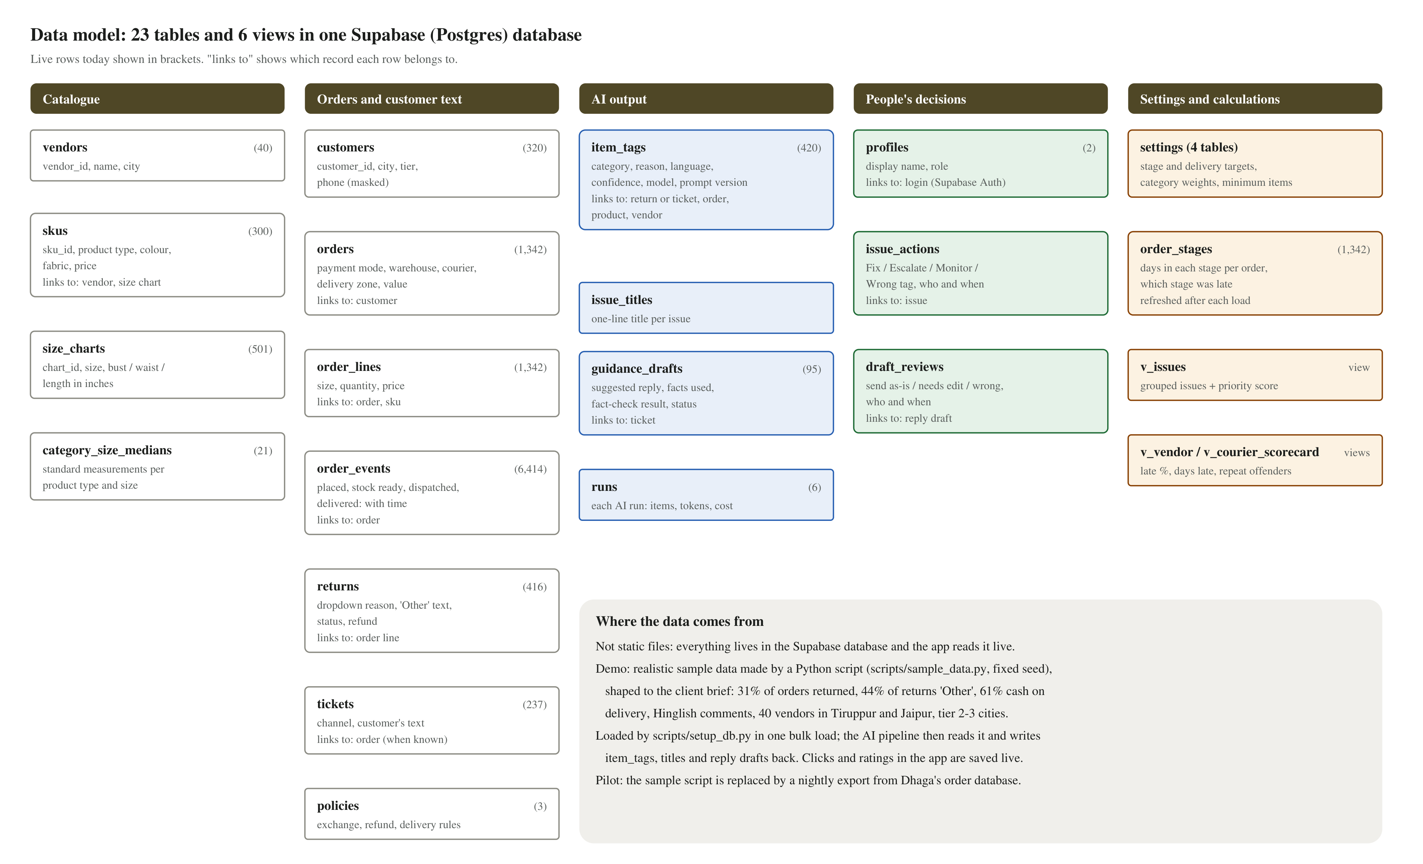
Figure 4. Data model, with live row counts from the demo database

Where the data comes from
- Live, not static. The data sits in the Supabase database and every screen reads it live. Neha's actions and the reviewers' ratings are written back as they happen.
- Demo data is sample data, said openly. scripts/sample_data.py generates it with a fixed seed (the same data every time), shaped to the client brief: 31% of orders returned, 44% of returns marked "Other", 61% cash on delivery, Hinglish comments with typos, 40 vendors in Tiruppur and Jaipur, customers in tier 2-3 cities.
- Patterns planted so the demo has something to find: V-17 kurtas with a size chart 2 inches under the category median, short V-31 frocks, loose V-12 palazzos, V-23 and V-08 late with stock, and Ekart slow to the north east.
- Loaded once, then enriched. scripts/setup_db.py creates the tables, views and access rules, bulk-loads the sample data (1,342 orders, 6,414 order events, 416 returns, 237 tickets) and creates the two logins. scripts/run_pipeline.py then reads it and writes 420 tags, issue titles and 95 reply drafts back.
- Pilot: real data. A nightly export of only the needed columns from Dhaga's order database replaces the sample script; screens, access rules and AI steps stay the same.

Core tables
Table / view | Key columns | Written by
vendors, skus, size_charts | vendor_id, city · sku_id, vendor_id, category, chart_id · chart_id, size, bust/waist/length (in) | Loader
orders, order_lines, order_status_events | order_id, customer_ref (masked), payment_mode, fc, courier, pin_zone · sku_id, size · status, at | Loader
returns, tickets | return_id, order_line_id, reason_dropdown, other_text · ticket_id, channel, text, order_id?, created_at | Loader
item_tags | item_id, source, category, sub_tag, urgency, language, confidence, evidence_span, model, route, prompt_version, run_id | Pipeline
issues (view) + issue_actions | issue_key, items_7d, trend, score, monitor flag · action, actor, at | SQL / app
guidance_drafts, draft_reviews | item_id, facts jsonb, reply, check_result, attempts, status · rating, edited_text, reviewer, at | Pipeline / app
delay_attribution (view) | order_id, vendor_id, courier, fc, stage_days, blamed_stage, is_late, week | SQL
order_stages (+ refresh function) | Pre-computed stage durations per order, refreshed after each data load; keeps the scorecard under 1 second | SQL
profiles, app_settings | user_id, display_name, role · min_issue_items and other tunable settings | Setup
runs | run_id, started_at, items, tokens in/out per model, cost_inr, unclassified_count | Pipeline

7. Model configuration and failure handling
Call | Model | Sampling | Structured output | On failure
Tag 15 items | gpt-oss-20b | temperature 0, reasoning low | TagBatch (Pydantic, strict JSON schema) | Retry once with the error; missing item -> second look; then "Unclassified", counted on screen
Second look | gpt-oss-120b | temperature 0 | ItemTag | Still unsure -> Check tag list
Issue title | gpt-oss-20b | temperature 0 | IssueTitle | Fallback to category + owner text
Draft reply | gpt-oss-120b | temperature 0.4 | ReplyDraft with facts_used[] and can_answer | Fact-check fail -> redraft once -> "Needs a person" with reason
Fact-check | gpt-oss-20b | temperature 0 | FactCheck: passed, problems[] | Schema fail counts as a check fail

- Tagging and checking run at temperature 0 for repeatable labels; the customer-facing draft runs at 0.4 for natural wording, kept safe by the fact-check.
- Rules in code, not the model: messages under two words are not sent to a model; refund questions with no refund date on record go straight to a person; replies use Roman script unless the customer wrote in Devanagari.
- API errors, timeouts and rate limits: retry with backoff, then mark the item "retry pending" and show the count in the run summary.
- Prompts live as versioned files in the repository; every output row records the prompt version and model.

8. Security and privacy
- Phone numbers and names are masked before any text goes to a model; only order IDs are kept.
- API keys live in Streamlit Community Cloud secrets, server-side only; the code repository holds no keys.
- Customer text is passed to models only as data inside schema-bound prompts; the pipeline has read-only access to source tables. Text such as "ignore your rules" cannot change behaviour.
- Nothing is sent to customers or vendors by the system; all outbound actions are manual.
- Built now: Supabase Auth logins with a role each, and row-level security tested per role (Neha cannot read reply drafts; Ms Chhaya Gupta cannot read returns, orders or scorecards; signed-out users see nothing).
- The demo app holds only sample data. The Supabase admin (secret) key is not stored in the hosted app.
- Demo mode (on for the evaluation link): the link opens without a sign-in page. The app signs in server-side as Neha, or as Ms Chhaya Gupta via the switch button or ?as=chhaya, using the two demo passwords held in its secrets; they never reach the browser, and the database still applies that person's access rules. Trade-off: anyone with the link can click actions and try messages. For a pilot on real data, DEMO_MODE=false brings back the sign-in page.
- Known gap, stated plainly: the hosted app holds the database connection string in its secrets, because the live "Try a message" step writes its result. That connection bypasses the access rules. It is used only by server-side code and never reaches the browser. Pilot fix: move the live step to its own small service with a restricted database role, so the app holds only the public key.

9. Deployment and operations
- Live demo: https://dhaga-fit-reason.streamlit.app. Streamlit Community Cloud rebuilds automatically on every push to the main branch. Its settings are stored in Streamlit secrets as one entry (FIT_REASON = { ... }), which the app reads alongside ordinary environment variables.
- Cold start: clone the repository, copy .env.example to .env, run scripts/setup_db.py (tables, sample data, logins), scripts/run_pipeline.py, then streamlit run app.py.
- Batch run today: started from a laptop; about 9 minutes for 420 messages on Groq's free tier. Pilot: the same script on a nightly schedule (GitHub Actions).
- Owner after handover: one backend engineer at ~20% time. No model training anywhere, so no ML engineer is needed.
- Controls: kill switch (MODEL_CALLS_ENABLED=false stops every model call), cost logged per run, spending limit at the provider.
- Quality check: a browser test signs in as each role and checks every screen on desktop and phone; a weekly accuracy check on a hand-labelled sample in the pilot.
- Known limits: refreshing the browser signs the person out (Streamlit sessions); free-tier apps sleep after a few days without visits and take about 30 seconds to wake.

10. Cost calculation

Assumptions
- Groq list prices per million tokens: gpt-oss-20b $0.075 input / $0.30 output; gpt-oss-120b $0.15 / $0.60.
- Exchange rate Rs 88 = $1 (assumption). Token counts are measured from the demo run (runs table), not estimated.
- Volume (from the client brief): 48,000 orders/week x 31% returns x 44% "Other" = 6,547 comments; ~9,000 tickets. Total 15,547 items/week.

Unit cost, measured on the demo run
Step | Model | Measured tokens | Cost per item
Tag one message (15 per call) | gpt-oss-20b | 316 messages: 24,285 in / 22,599 out | Rs 0.0024
Second look (4% of messages) | gpt-oss-120b | 14 messages: 9,498 in / 1,996 out | Rs 0.017
Reply suggestion incl. fact-check and redrafts | both | 55 suggestions: Rs 1.50 in total | Rs 0.027
Issue title | gpt-oss-20b | ~340 in / ~60 out | Rs 0.003

Pilot run-rate (reply suggestions on a 20% sample of tickets)
Line item | Volume / week | Unit cost | Rs / week
Tagging | 15,547 items | Rs 0.0024 | 37
Second look | ~620 items (4%) | Rs 0.017 | 10
Reply suggestions | 1,800 tickets (20% sample) | Rs 0.027 | 49
Issue titles | ~60 issues | Rs 0.003 | 0.2
Delay attribution | All WISMO tickets | SQL | 0
Model total |  |  | ~96 / week = ~420 / month
Supabase Pro | $25 / month |  | ~2,200 / month
Streamlit Community Cloud | Free plan |  | 0
Total pilot |  |  | ~Rs 2,620 / month

Full rollout (reply suggestions on all ~9,000 tickets)
Line item | Rs / week | Rs / month
Tagging + second look + titles | ~47 | ~205
Reply suggestions: 9,000 x Rs 0.027 | ~243 | ~1,050
Supabase Pro |  | ~2,200
Total | ~290 + database | ~Rs 3,460

Limits and break-even
- Groq's free tier allows 8,000 tokens per minute and about 1,000 requests a day per model: enough for the demo, not for the pilot. The pilot needs Groq's pay-as-you-go plan (same per-token prices, much higher limits).
- Break-even: ~Rs 605 a week all in. At ~Rs 120 per return (assumption, using the doorstep-refusal cost as a proxy), the pilot pays for itself by avoiding about 5 returns a week, 0.03% of the 14,880 weekly returns.
- Model cost is now under a fifth of the bill; the database plan dominates. Switching to Claude through OpenRouter (a setting) would raise model cost to roughly Rs 16,000 a month at the pilot volume.
- The demo itself (420 messages read, ~95 reply suggestions) cost Rs 2.89 in model calls.

11. Risks and open technical questions
Item | Impact | Mitigation / next step
Order history may not record "stock received" and "handed to courier" separately | Stage-level blame is impossible | Confirm with Faizan and Karthik; fall back to FC-vs-courier split only
Tickets may not carry an order ID | WISMO items cannot be linked | Extract order ID or phone from the text; ask for a Freshdesk field mapping
Token estimates are off | Costs differ from plan | Measure on the first real run; costs logged per run
Free tiers pause or sleep | Demo URL wakes up slowly | Open the app before the demo; paid tiers in the pilot
Groq free-tier rate limits | Batch runs slow down or stop for the day | Batching (15 per call) and a 0.65 second-look threshold; pay-as-you-go plan for the pilot
Open-source models on Hinglish | Wrong script or tone in replies | Script rule in the prompt, fact-check, human rating in shadow mode; provider switch is a setting
Model behaviour changes on a new version | Accuracy or tone drifts | Pin model IDs; weekly check against the labelled sample
Database connection string in the hosted app | A leak of app secrets would expose the database | Sample data only today; pilot moves the live step to a separate service with a restricted role

12. Likely questions, short answers
Question | Answer
Why Streamlit and not a mobile app? | The pilot users work at desks; Streamlit gave a working, phone-friendly screen in hours and only Python to maintain. An installable phone app is the next step once replies go to customers; the database, rules and AI steps carry over unchanged.
Why Groq and open models, not a big-name model? | Cost and speed: a message costs about a quarter of a paisa to read. Provider and models are settings, so we can switch to Claude via OpenRouter without code changes if quality needs it.
What stops a wrong answer reaching a customer? | Nothing is sent in the pilot. Every reply is fact-checked against our records, refund questions without a date go to a person, and a reviewer rates every suggestion. Go-live needs 2 weeks of 90%+ approved and zero wrong facts.
Can Neha see support replies, or the support team see returns? | No. The database itself enforces it: each login has a role, and access rules return only that role's data. We tested both directions and signed-out access.
What if the AI returns something malformed? | Every answer must match a fixed structure; it is retried once with the error, then shown as Unclassified and counted on screen. Nothing is silently dropped.
Who runs it on Monday? | One backend engineer at about 20% time. No model training anywhere, prompts are plain files in the repository, and there is a kill switch for all AI calls.
What does it cost to run? | About Rs 2,600 a month in the pilot, mostly the database plan; the AI calls are about Rs 420 a month at pilot volume.
What is the weakest part today? | The live 'Try a message' step runs inside the app with a full database connection; the pilot moves it to its own service. And the free Groq tier is too small for daily volume, so the pilot needs the pay-as-you-go plan.

