Your name

A Project Report On

Project Title

Submitted By:
Your Name

In partial fulfillment for the award of the degree of

YOUR DEGREE NAME
In

COMPUTER SCIENCE & ENGINEERING

YOUR UNIVERSITY NAME

DATE-YEAR

STUDENT’S DECLARATION

We the students of VIII semester B.Tech. Your University Name____, ABC(your name) declare that he technical Project work entitled “ONLINE SHOPPING SYSTEM” has been carried out and submitted in the partial fulfilment of the course requirements for the award of degree in B.Tech. Computer Science Engineering at ________during the academic year 2023-24. The matter submitted in the synopsis has been not submitted to any other university or institutions for the award of any other degree or diploma in the concerned stream.

Your name
Place: Date:

CERTIFICATE

This is to certify that the dissertation report entitled, “Online Shopping System” submitted by your name , India, is a record of bonafide project work carried out by them under our supervision and guidance and is worthy of consideration for award of Degree of Bachelor of Technology in Computer Science Engineering of the Institute.

Project Guide: Mr. __________
Assistant Professor
Department Of Computer science Engineering

Project Coordinator: Mr. ___________
Assistant Professor
Department Of Computer science Engineering

Head Of The Department: _____________
HOD / Asst. Professor
Department Of Computer Science Engineering ____________

1.INTRODUCTION

1.1ABOUT THE PROJECT
This Project report entitled as “PHARMACY MAINTENANCE SYSTEM”. Computerization is necessary to avoid complexity of human tasks. In Pharmacy Maintenance System, we can avoid the difficulty to maintain the medicine details and bill and patient details. Manual handling of records creates many problems maintaining the records of each students of the department are tedious work. Generating various reports becomes tedious. To overcome the above problems, the current project is developed.

An efficient pharmacy management system can make the work easier by giving the details of the medicine when its name is entered. A computer gives the details of the medicine like rate of medicine, and the e10iry date and the row and rack location of the medicine. It becomes very difficult in big medical stores to handle the details of all the medicines manually, so by using this pharmacy manage system we can maintain the records of all the medicines.

A computerized pharmacy system developed for a health maintenance organization is described. The system has been operational for nearly three years. It is based on a coding scheme for all drugs in the formulary and prescribing information. The information is processed by a computer which generates a variety of usage information.

The system produces reports on frequency of drugs dispensed, number and percentage of patients obtaining each drug, and age-sex distribution of patients using a particular drug. The special characteristics of a pharmacy as they relate to computerized systems are discussed. System requirements, maintenance procedures and cost estimates are also presented.

The registration module accepts the name and password for existing user and validates it. For new user create a account. This module will allow the user to buy and enjoy the accessibilities if they have an account (User-Id & Password) .only admin can access have permission to change the password. When users have no account earlier they can create an account through admin.
Stock details module the availability of stock is checked by entering the code. If the stock is available it shows the stock detail otherwise it does not show the details. If stock is not available it can be purchased. Stock detail displays icode, iname, iprice, quantity, here the availability of stock, quantity, prices are checked.

Bill detail module the bill detail are shown. Whenever the bill no is entered it shows the product to de bought by the customer. It is very useful for resales of product and also to check the bill details of the certain customer.

Purchasing module will give the information that supports to buy a fresh product or to sell a second hand product. Also it shows the icode, inumber, unit price, quanity, and amount. It will also give bill detail in it.

This system has been developed using Jsp and servlet as front-end and Mysql as back-end under Windows 10 environment.

1.2 HARDWARE SPCIFICATION
The configuration given below is the hardware for the system development.

Processor :
RAM : 256 MB RAM
Hard Disk : 500 db
Monitor : Lcd
Mouse : Zenith 3 button optical mouse
Keyboard : 110 Keys (Zenith)

  - SOFTWARE SPECIFICATION

The configuration given below is the software handled for the system development.
Operating system : Windows 10
Front- End : Jsp
Back-End : Mysql
1.3.1 SOFTWARE DESCRIPTION

Java Jsp
akarta Server Pages (JSP; formerly JavaServer Pages) is a collection of technologies that helps software developers create dynamically generated web pages based on HTML, XML, SOAP, or other document types. Released in 1999 by Sun Microsystems, JSP is similar to PHP and ASP, but uses the Java programming language.

The “” part refers to the method used to create the Graphical User Interface (GUI). Rather than writing numerous line of code to describe the appearance and location of interface elements, simply add pre built object into place on screen. The “Jsp” part refers to the JSP language, a language used by more programmers than any other language in the history of computing.

Java Jsp
Jsp software comes in three editions:
- Learning Editions: which includes the Jsp development environment and use of standard tools to develop applications
- Oracle Source safe for source code control and Automation and Component manager

- Jsp’s internet capability allows one to create powerful applications hosted by standard browser.
Jsp as a front-end
Jspis Windows application development platform with a strong combination of a front-end tool and programming language .The ease of the approach coupled with the power of programming and the straightforward JSP language syntax makes programming easy. By using

Using MDI in Jsp:
MDI stands for Multiple Document Interface. Jsp application can have only one MDI form. A child form is an ordinary form that has its MDI-Child property set to true. The application can include MDI-Child forms. At run time, child forms are displayed within the internal areas of MDI form. When a child form is minimized, its icon appears on the MDI form instead of appearing on the desktop.

Element of Jsp
Jspinterface consists of the following elements.

MYSQL
Mysql is a powerful multi user relational database managements system developed by Oracle used to implement large amount of information with minimum memory allocation and auto make repetitive task, such as maintaining and generating invoice. Data in mysql is organized in the form of tables within a table records are arranged to a common reference value known as primary key.

FEATURE OF MYSQL
- Access is window based application and therefore it has an interface similar to windows.
- Access maintains a single disk file for a database and all its associated objects.
- Access lets you import from or e10ort to fo10ro, oracle and other data form.
- Access wizard is a vitality that helps to perform complex task by guiding through out the access. Access contains nearly hundred.
- Wizards to design database application, tables, forms, reports, graphs, mailing labels, control and properties.

ADVANTAGES MYSQL:
- Less time consumption and quick response.
- Access has a friendly environment.
- Oracle access is not needed for keeping register for recording.

2. SYSTEM ANALYSIS

System analysis is the process of gathering and interpreting facts, diagnosing problems, and using the information or recommend improvements to the system. This is the job of the system analyst.

In the case of systems analysis, the substance is the business system under investigation and the parts are the various sub-systems, which work together to support the business. Before designing a computer system, which will satisfy the information requirements of a company, it is important that the nature of the business and the way it currently operates are clearly understood.

The proposed system can be accessed from any part of the world, as opposed to stand alone or manual system, and provides information at anytime, anywhere. Even though it is a web-based application it will keep the details of its clients private and nobody is allowed to tinker with the details. No need to own any computer for this specific ordering of products, it just requires user to register with the system. It provides easy to use and user friendly interface for the user.

The system provides freedom to the user to move freely around various screens and status of the system returned, as it was when he left the screen. User is given freedom to update any information in his database. He is relieved from maintenance and back up works, as it will be done by e10ert personalities maintaining. The user can access the system at any time, because it’s 24-hour availability. The organization people can do administration over the products, vendor, customer (only deletion in case of dealer ship cancellation) etc. The organization can generate reports for sales like day-wise, month-wise, year-wise, product-wise, order-wise etc. at any time without any problem. The organization can save the time and money as they own the project, and they can provide effective service to its distributors.

2.1 PROBLEM DEFINITION

Every business needs marketing system to carry out its day-today operation faster and to reach all in all way. This topic is closely concerned with the purchase raw Medicine , production, and purchase return, sales return and stock details to run a day-today activity very effectively. Nowadays the computer, software packages are useful in analyzing the purchase and sales details. Successful business planning requires information about potential target of market, the competition prevailing in the market, the individual and their reactions towards the products. To give the accurate information and to simplify the manual system and also against the requirement of the company we have split the project into three major modules.

2.2 SYSTEM STUDY
System is not independent entities but exists in an environment. There are many relationships between a system and its environment and some of these are indirect rather than the direct relationships. The functioning of a system can be affected by changes in the system environment in ways that can be very difficult to predict. As in the physical environment systems are also situated in an organizational environment. In this organizational is not properly understood. Systems may be inappropriate and rejected by users and organizational managers.

System analysis aims in providing a scientific approach for solving the problems created by complex situations. The system analysis helps in finding out the various ways in which the system can be developed and also helps mainly in making beneficial decisions in an organization. So, System analysis is mainly needed for decision making and planning in an organization.
Drawbacks of the Existing System
- There is chance for loss of record due to mishandling.
- There is possibility for error while updating details.
- The time required to process data and generate the reports is very high.

2.3 PROPOSED SYSTEM

The drawbacks which are faced during existing system can be eradicated by using the proposed system. The main objective of the existing system is to provide a user-friendly interface. The proposed system now computerizes all the details that are maintained manually. Once the details are fed into the computer there is no need for various persons to deal with separate sections. Only a single person is enough to maintain all the reports. The security can also be given as per the requirement of the users.
This school management system is a proposed system, which replace the existing manual system in an appropriate way. This System is having all the details about products having wider usage. It makes all work to be easy and saves the time. The correctness of data is tested at the time of input. The proposed system generally has the facilities like
- Control data redundancy
- Supports data independence
- Providing more information at low cost
- Supports accuracy and integrity
- Do away with as much payer work as possible

Advantages of the Proposed System
- Large volumes of data can be stored easily.
- Maintenance of file is flexible.
- Records stored are updated easily.
- Reports can be generated with ease.
- Accurate calculations are made.
- Less manpower required.
- Accuracy and error free transaction process.
- Neat and clear representation of report.
- User satisfaction at high level.
- Efficient service.
- Reduce data redundancy.
- Any form of reports can be produced instantaneously.
- Updating is very easy.
- Accurate information will be provided when the information is needed.

Objectives of the Proposed System
- The Data redundancy is eliminated
- Validation checks are performed at instances.
- Data Integrity is maintained.
- Hundred percent Client Server techniques can be achieved.
- Providing table level locking, Row level locking.
- Providing user friendly entry screens to the end users as GUI based.
- Reliability, Portability and Flexibility are the main advantages.
- Even a non Computer professional can also handle.
.

- SYSTEM DESIGN
  - FILE SPECIFICATION

A database is defined as a collection of data items organized in such a way that the specific data or record can be retrieved and processed when required.
The proposed system has following tables.

Table Name : User
Purpose : The table is used to creating the fields for user login which stores the details
about the user login information

Name | Data Type | Size | Constraints | Description
Username | Text | 20 | Primary Key | User Name
Password | Text | 8 | Not Null | Password

Table Name : Medicine
Purpose : To store details of Medicine
Field Name | Field Type | Size | Constraints | Description
Code | Number | 10 | Primary Key | Medicine Code
Name | Text | 20 | Not Null | Medicine Name
Sno | Number | 10 | Not Null | Medicine Serial No
MDate | Date | 8 | Not Null | Medicine Make Date
Type | Text | 20 | Not Null | Medicine Type
BNo | Number | 8 | Not Null | Medicine Bill Number
BDate | Date | 8 | Not Null | Medicine Bill Date
CName | Text | 20 | Not Null | Medicine Company Name
MCA | Text | 25 | Not Null | Medicine Manufacture  Company Name
Inc | Text | 25 | Not Null | Medicine In charge Name
Table Name : Product Details
Purpose : To store details of Product
Field Name | Field Type | Field Size | Constraints | Description
P_Code | Number | 5 | Primary Key | Product Code
P_Name | Text | 20 | Not Null | Product Name
P_Sno | Number | 10 | Not Null | Product Serial No
P_Qty | Number | 10 | Not Null | Product Quantity
P_Date | Date | 8 | Not Null | Product Quantity Date
P_Weight | Number | 8 | Not Null | Product Total Weight
P_Price | Number | 8 | Not Null | Product Unit Price
P_TPrice | Text | 8 | Not Null | Product Total Price
Inc | Text | 25 | Not Null | Medicine In charge Name

Table Name : Vendor Details
Purpose : The table is used to creating the fields for Employee which stores the details about the
Employee
Name | Data Type | Size | Constraints | Description
empno | Number | 10 | Primary Key | Employee No
empname | Text | 25 | Not Null | Employee Name
address | Text | 50 | Not Null | Address
city | Text | 10 | Not Null | City
pin | Number | 6 | Not Null | Pincode
state | Text | 20 | Not Null | State
phone | Number | 12 | Not Null | Phone Number
mobile | Number | 12 | Not Null | Mobile Number
email | Text | 50 | Not Null | Email ID
sex | Text | 10 | Not Null | Sex
status | Text | 4 | Not Null | Medicine Status
dob | Date |  | Not Null | Date of birth
doj | Date |  | Not Null | Date of Joining
dept | Text | 20 | Not Null | Department
nature_of_job | Text | 20 | Not Null | Designation

3.2 MODULE SPECIFICATION
The user interface screens are used to get the data from the user with required validation. The various user interface screens designed to this project are the following.
MASTER MODULE
MEDICINE DETAILS
This form is used to get and maintain the details about the Medicine. It includes the Medicine id, Medicine name, Doctor , supplier, category, stock, discount.
SUPPLIER DETAILS
This form is used to get and maintain the details about the Supplier. It maintains detail about the supplier id, Medicine name, supplier name, price, and discount.
TRANSACTION MODULE
PURCHASE DETAILS
This form is used to maintain the details about the Medicine purchased from the suppliers. It contains purchase order number, Medicine id, Medicine name, Doctor, category, quantity, Supplier, Medicine price, discount, purchase date.
SALES DETAILS
This form is used to maintain the details about the Medicine supplied to the customers. It contains sales bill number, Medicine id, Medicine name, Doctor, category, quantity, customer, Medicine price, discount, sales date.
MEDICINE SEARCH
This form is used to search the Medicine details and stock of the book. If the Medicine name and Doctor Name are coinside with each other then only the related books will be displayed. It includes the Medicine id, Medicine name, category, Doctor.

PURCHASE RETURN DETAILS
This form is used to maintain the details about Medicine returned to suppliers. It includes sales bill number, Medicine id, Medicine name, Doctor, category, Supplier name, return date, return quantity, return amount.
SALES RETURN DETAILS
This form is used to maintain the details about Medicine returned by customers. It includes purchase order number, Medicine id, Medicine name, Doctor , category, customer name, return date, return quantity, return amount.
REPORTS MODULE
REPORTS
The reports are used to provide reliable and timely information to the users. The various reports generated in this project are the following.
MEDICINE REPORT
This report is used to show the details about the book. It displays the information such as Medicine id, Medicine name, Doctor, Supplier, category, stock, and discount.
PURCHASE REPORT
This report contains information about purchasing of books from supplier. It displays the information such as purchase order number, Medicine id, Medicine name, Doctor , category, quantity, Supplier , Medicine price, discount, purchase date.
SALES REPORT
This report contains information about sales of books to customer. It displays the information such as purchase order number, Medicine id, Medicine name, Doctor , category, quantity, customer, Medicine price, discount, purchase date.

4. SYSTEM TESTING AND IMPLEMENTATION

TESTING
Testing is the set of activities that can be planned in advance and conducted systematically. It is a process of executing programs with the intention of finding errors.

SYSTEM TESTING:
Software testing is a critical element of software quality assurance and represents the ultimate view of specification, design and coding. The user tests the developed system and changes are made according to their needs. The testing phase involves the testing of developed system using various kinds of data. System testing is an important task in implementing the system. The system tested with the best case values and worst case values for its response and not produce an undesirable runtime errors and providing the user with proper message and correcting the wrong inputs.
System testing is a style of implementation which is aimed at ensuring works at all levels and effective before live operation starts. The system test before implementation should give confirmation that all is correct and it provides opportunity to show the users that the system works well.
System testing is actually a series of different tests whose primary purpose is to fully exercise the computer-based system. System testing is the state of implementation that is aimed at assuring that the system works accurately and efficiently before the operations commence. Testing is vital to the success of the system. System testing makes the logical assumption that if all the parts of the system are correct, the goal will be successfully achieved. The candidate system is subject to variety of tests. A series of testing is performed for the proposed system before the system is ready for the acceptance test.
The following tests are conducted.
- Module Testing
- Integration Testing
- User Acceptance Testing
Module Testing
Unit testing focuses verification effort on the smallest unit of the software design module. This is known as module testing. The modules of the Job Consultancy Management System are tested separately. This testing was carried out during programming stage itself. In this testing step each module was found to be working satisfactorily with regard to the e10ected output from the module.
Integration Testing
Data can be lost across an interface; one module can have an adverse effect on another, sub functions when combined, may not produce the desired major function. Integration Testing is a systematic technique for constructing errors associated with in the interface. The objective is to take unit tested modules and to build a program structure. All the modules are combined and tested as a whole. Here correction is difficult because the isolation of causes is complicated by the vast e10enses of the entire program. Thus in the integration testing step, all the errors uncovered are corrected for the next testing steps.
User Acceptance Testing
User acceptance is a key factor for a success of any system. The system under consideration is tested for user acceptance by constantly keeping in touch with the perspective system users at the time of developing and making changes whenever required. Preparation of test data plays a vital role in the system testing. After preparing the test data, the system under study is tested using the test data. While testing the system using the test data errors are again uncovered. These errors are again corrected by using the above testing steps and corrections are also noted for future use.

4.2 IMPLEMENTATION

Implementation includes all those activities that take place to convert from the old system to the new. The new system may be totally new; replacing an existing manual or automated system, or it may be a major modification to an existing system. In either case, proper implementation is essential to provide a reliable system to meet organization requirements. Successful implementation may not guarantee improvement in the organization using the new system (that is a design question), but improper installation will prevent it. Implementation is the process of having systems personnel check out and put new equipment into use, train users, install the new application, and construct any files of data needed to use it.
Depending on the size of the organization that will be involved in using the application and the risk associated with its use, systems developers may choose to pilot (test) the operation in only one area of the firm, say in one department or with only one or two persons. Sometimes they will run the old and new systems together to compare the results. In still other situations, developers will stop using the old system one day and begin using the new one the next. As we will see, each implementation strategy has its merits, depending on the business situation in which it is considered. Regardless of the implementation strategy used, developers strive to ensure that the system’s initial use is trouble-free.
Once installed, applications are often used for many years. However, both the organization and the users will change, and the environment will be different over weeks and months. Therefore, the application will undoubtedly have to be maintained; modifications and changes will be made to the software, files, or procedures to meet emerging user requirements. Since organization systems and the business environment undergo continual change, the information systems should keep pace. In this sense, implementation is an ongoing process.

5. CONCLUSION AND SUGGESTIONS

CONCLUSION
An efficient pharmacy management system can make the work easier by giving the details of the medicine when its name is entered. A computer gives the details of the medicine like rate of medicine, and the e10iry date and the row and rack location of the medicine. It becomes very difficult in big medical stores to handle the details of all the medicines manually, so by using this pharmacy manage system we can maintain the records of all the medicines.
By using this management system the time gets saved and there will be very negligible chance for the errors to occur. We can check the records instantly which is not possible by manual methods. As the system gives the information of the e10ired medicines we can discard them and replace them with new stock. Thus we can conclude that pharmacy management system is helpful for handling the tasks efficiently in the store.
SUGGESTIONS
The system makes the possibilities smoothen to the manual system and this software with volumes of input/output data of all possible validations and results have been found to be excellent. The design of this package can be extended to any extent in the case of inclusion or number of facilities with the system. Including certain needs can extend this project. Therefore lot of advantages, including the following features can enhance the proposed system.

APPENDICES
APPENDIX – A (SCREEN FORMAT)
A1. USER LOGIN

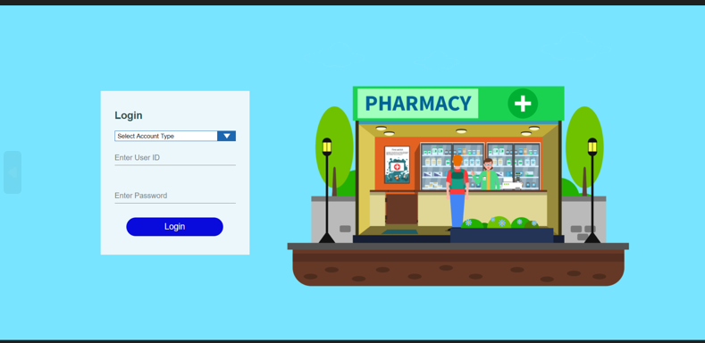
A2. Index
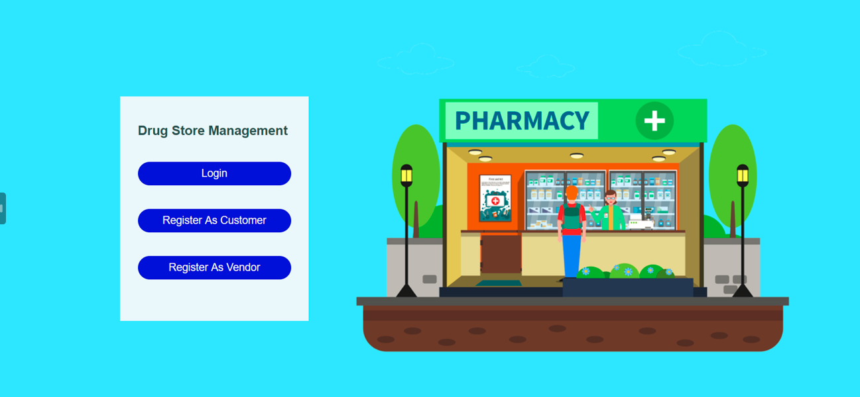
A3. Restock
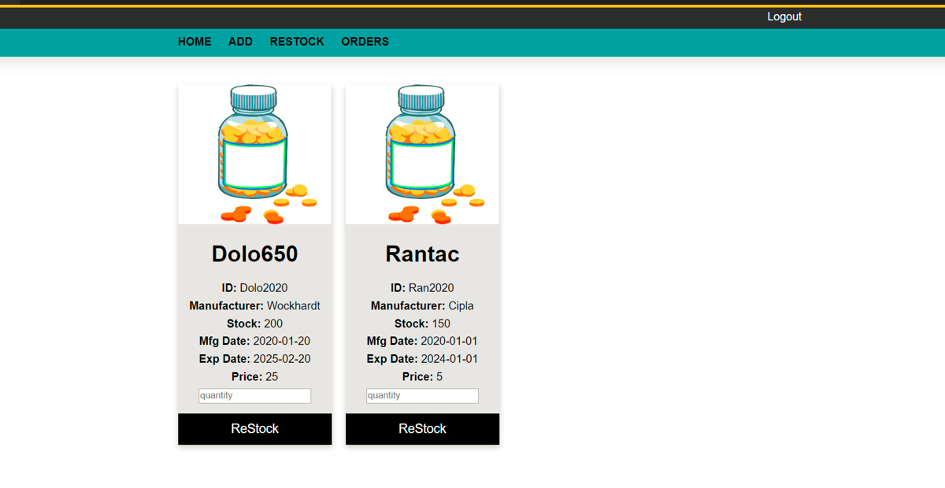

A4. New Register Vendor
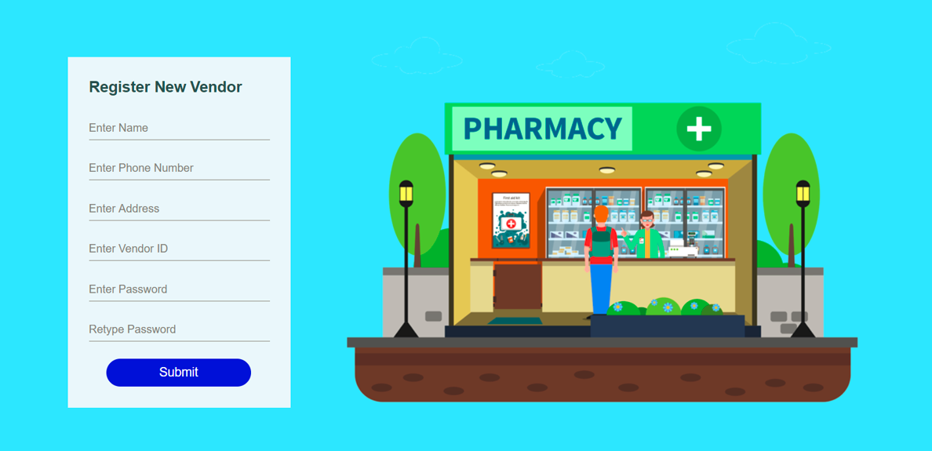
A5. Customer details

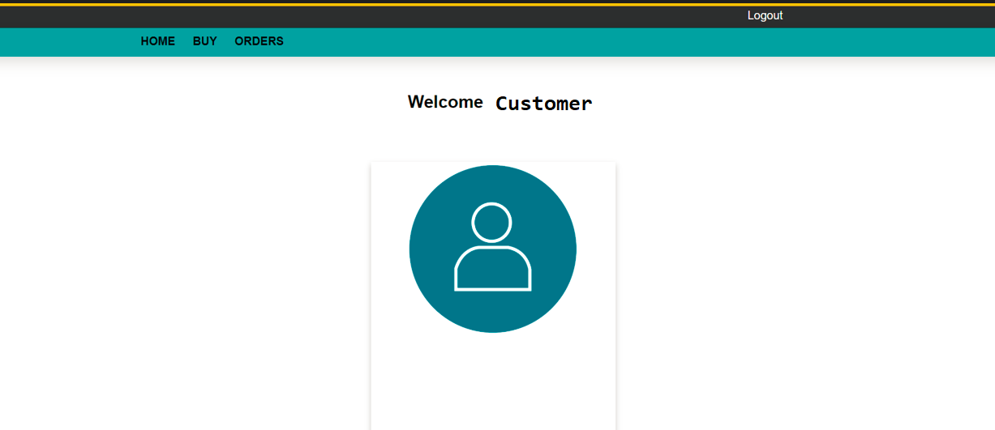
A6. PRODUCT PURCHASE DETAILS
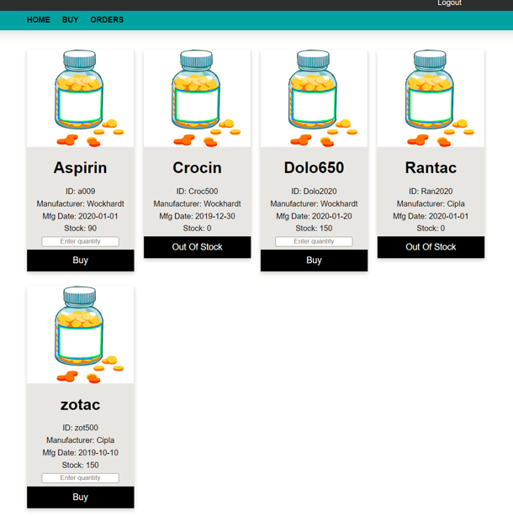
A6. Vendor Home page
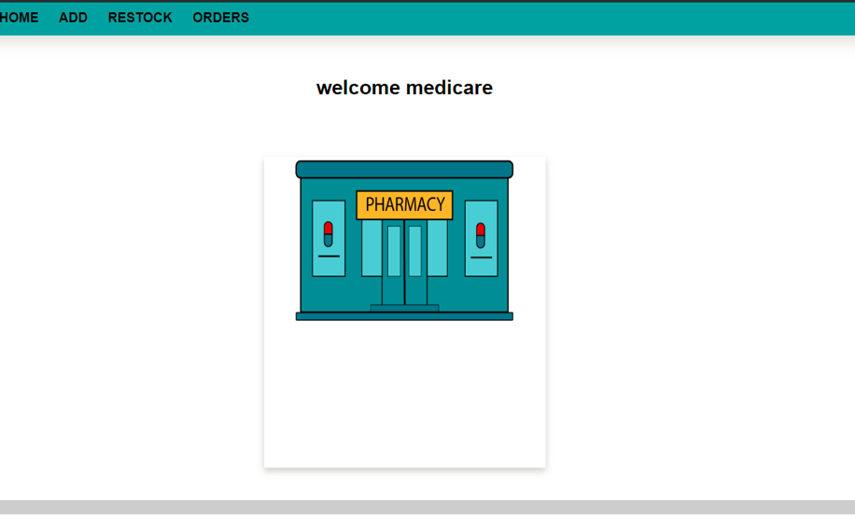

ER Diagram

Constraints and the Relational Schema: 1. CUSTOMER(Patient_ID,Name,Address,Contact_No,Name) a. Patient_ID is primary key 2. DRUG_MANUFACTURER(Company_ID,Name) a. Company_ID is primary key 3. DOCTOR(Doctor_ID,Contact_No,Name,Specialization) a. Doctor_ID is primary key 4. SALE_TRANSCATION(Sale_ID,Date,Employee_ID) a. Sale_ID and Employee_ID form the primary key b. Sale_ID and Employee_ID are also foreign keys 5. PURCHASE(Date,Purchase_ID) a. Purchase_ID is primary key 6. SELLS(Sale_ID,Drug_ID,Patient_ID,Quantity) a. Sale_ID,Drug_ID and Patient_ID form the primary key b. Sale_ID,Drug_ID and Patient_ID are also foreign keys 7. PRESCRIBES(Patient_ID,Doctor_ID,Drug_ID) a. Drug_ID,Doctor_ID and Patient_ID form the primary key b. Drug_ID,Doctor_ID and Patient_ID are also foreign keys 8. DRUG(Location,Cost_Price,Stock,Drug_ID,Name,Discount,MRP,Company_ID,Expiry) a. Drug_ID is the primary key b. Company_ID is foreign key 9. SUPPLIES(Quantity,Purchase_ID,Distributor_ID,Drug_ID) a. Distributor_ID,Drug_ID and Purchase_ID form the primary key b. Distributor_ID,Drug_ID and Purchase_ID are also foreign keys 10. DISTRIBUTOR(Distributor_ID,Contact_No) a. Distributor_ID is the primary key 11. EMPLOYEE(Employee_ID,Name,Contact_No) a. Employee_ID is the primary key 12. Quantity can never be 0 13. No attributes can be NULL in general 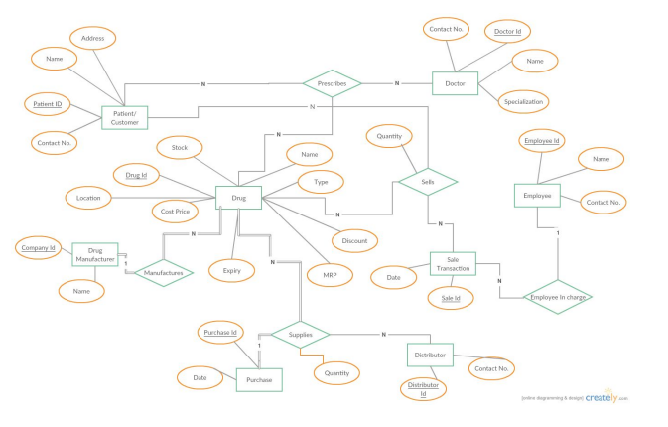
DFD Diagram

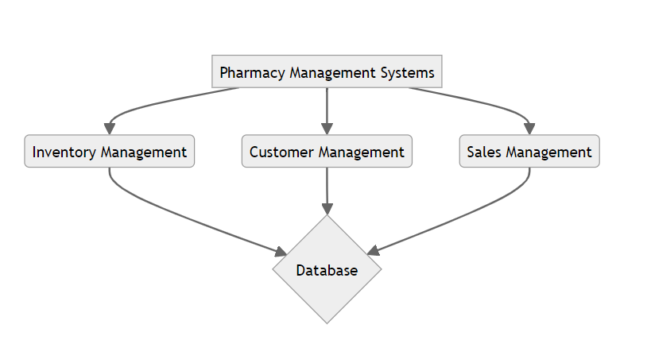

UML Digram

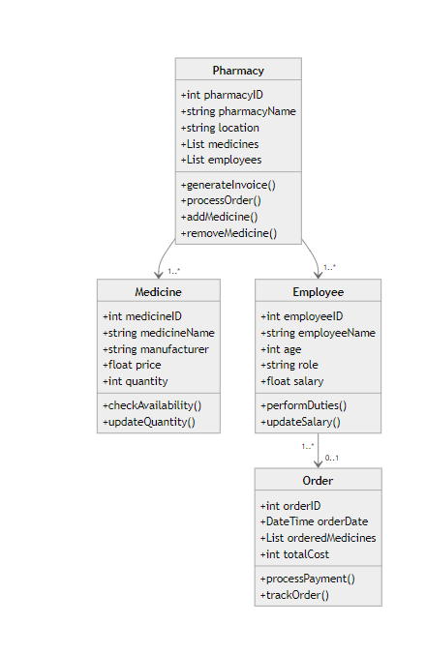

BIBLIOGRAPHY

I.BOOKS:
JSP and Servlets: A Comprehensive Study : Matha
JSP (JavaServer Pages), Web Programming, Books

II.URL REFERENCE
https://www.javatpoint.com/jsp-tutorial
https://www.geeksforgeeks.org/introduction-to-jsp/
https://www.mysql.com/
other Resources
https://www.altexsoft.com/blog/pharmacy-management-system/

