**Project Report**

**Book Store Management System**

- IMT2020021

1. **Use Case Diagram**

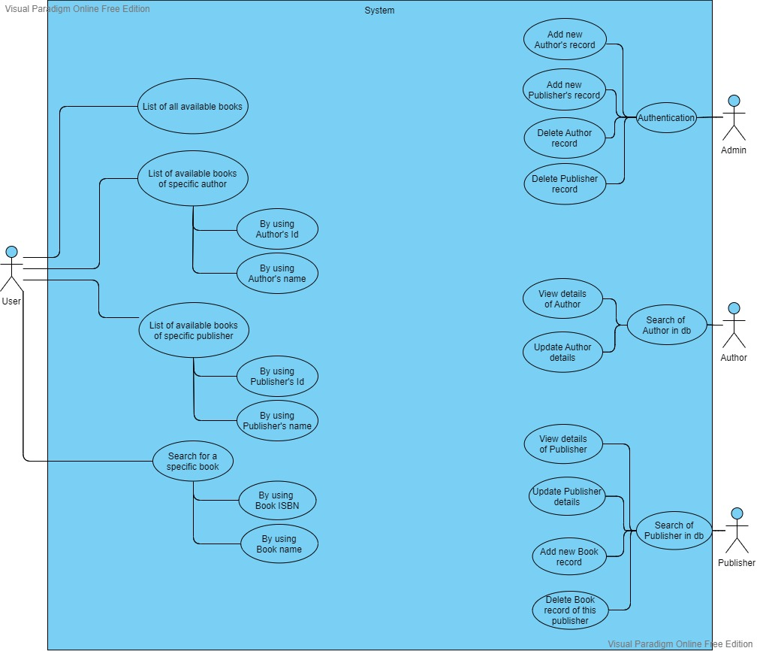

1. **UML Diagram**

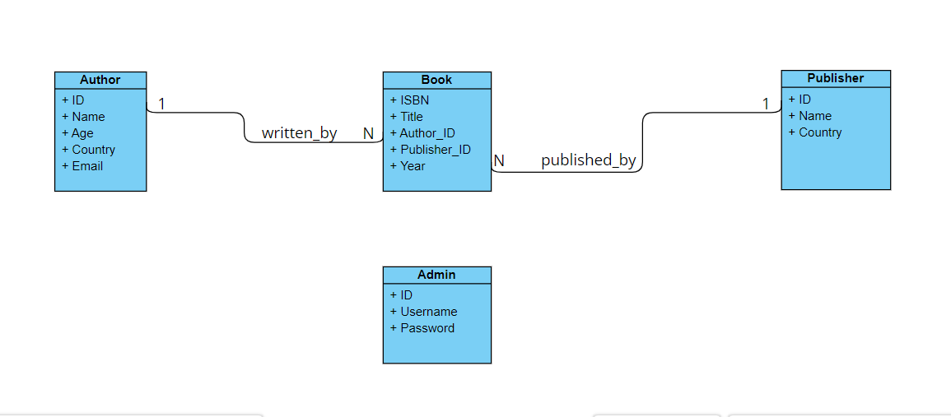

1. **OR Mapping (DB Design)**

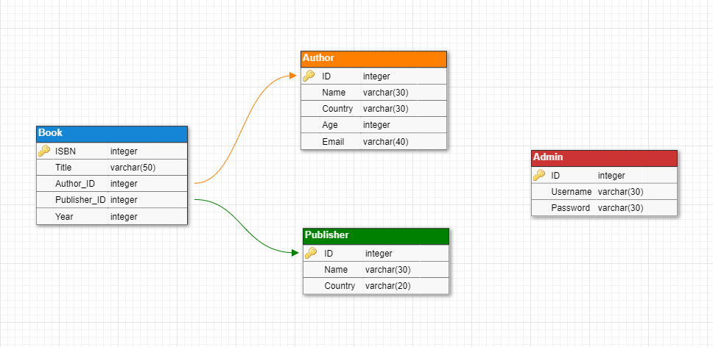

1. **Output Screenshots**

Main menu

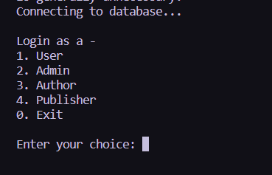

User menu

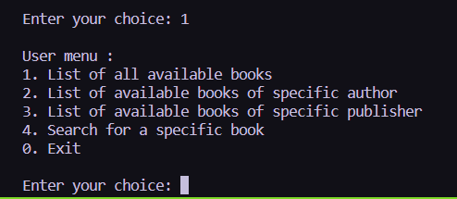

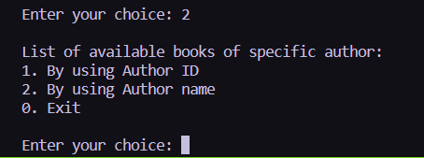

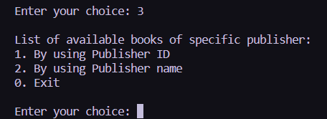

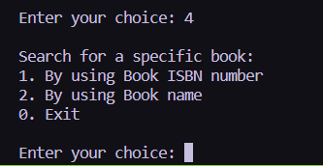

Authentication for Admin

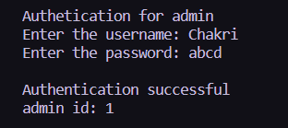

Admin menu

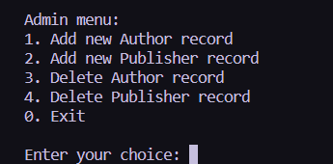

Author’s menu

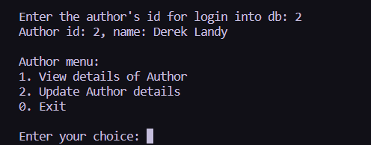

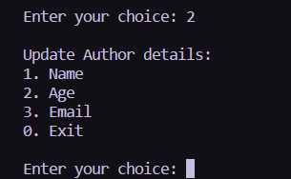

Publisher’s menu

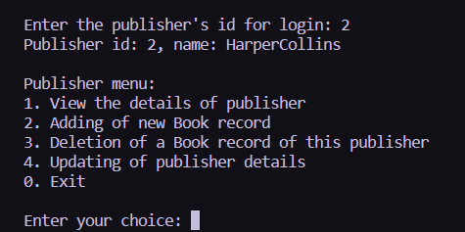

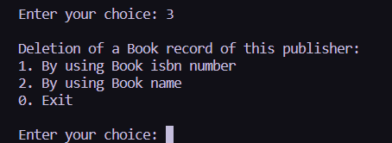

1. **Notes & Instructions to run the code**
2. First login to the mysql server
3. Then create the database in sql :

**create database projectdb;**

1. Use the created databse in sql:

**use projectdb;**

1. Create and alter the tables in the database:

**source sql/create_db.sql;**

**source sql/alter_db.sql;**

1. Populate the tables in the databases:

**source sql/insert_db.sql;**

1. Link the mysql jar file in terminal:

**export CLASSPATH='sql/mysql-connector-java-8.0.18.jar:.'**

1. After everything is done if you want to drop the database in MYSQL: **drop database projectdb;**
2. Admin credentials:

Username : Chakri

Password : abcd