**BYTE-ENABLE MEMORY IMPLEMENTATION ON FPGA WITH VERILOG**

*A project report submitted in partial fulfillment of the requirements for the award of the Degree of*

**BACHELOR OF TECHNOLOGY**

**In  
ELECTRONIC AND COMMUNICATION ENGINEERING**

**Submitted**

**By**

**1.Kaniki Chakradhar Reddy - BU21EECE0100170**

**2.Bulla Yagnesh Reddy - BU21EECE0100198**

**Under the Guidance of**

**Mr.Venkata Kranthi**



**DEPARTMENT OF ELECTRICAL, ELECTRONICS AND COMMUNICATION ENGINEERING**

**GITAM SCHOOL OF TECHNOLOGY**

**GITAM**

**(Deemed to be University)**

**(Estd. u/s 3 of the UGC act 1956 & Accredited by NAAC with “A++” Grade)**

**BENGALURU-561203   
AY:2021-2025**

**DECLARATION**

**I/We declare that the project work contained in this report is original and it has been done by me under the guidance of my project guide.**

**Name:**

**Kaniki Chakradhar Reddy[BU21EECE0100170]**

**Bulla Yagnesh Redddy [BU21EECE0100170]**

**Date: Signature of the Student**

**Department of Electrical, Electronics and Communication Engineering**

**GITAM School of Technology, Bengaluru-561203**

**CERTIFICATE**

**This is to certify that (Student Name) bearing (Regd. No.:) has satisfactorily completed Mini Project Entitled in partial fulfillment of the requirements as prescribed by University for VIIIth semester, Bachelor of Technology in “Electrical, Electronics and Communication Engineering” and submitted this report during the academic year 2024-2025.**

**[Signature of the Guide] [Signature of HOD]**

**Table of contents**

**Chapter 1: Introduction 1**

1.1 Overview of the problem statement 1

1.2 Objectives and goals 1

**Chapter 2 : Literature Review 2**

**Chapter 3 : Strategic Analysis and Problem Definition 3**

3.1 SWOT Analysis 3

3.2 Project Plan - GANTT Chart 3

3.3 Refinement of problem statement 3

**Chapter 4 : Methodology 4**

4.1 Description of the approach 4

4.2 Tools and techniques utilized 4

4.3 Design considerations 4

**Chapter 5 : Implementation 5**

5.1 Description of how the project was executed 5

5.2 Challenges faced and solutions implemented 5

**Chapter 6:Results 6**

6.1 outcomes 6

6.2 Interpretation of results 6

6.3 Comparison with existing literature or technologies 6

**Chapter 7: Conclusion 7**

**Chapter 8 : Future Work 8**

Here write Suggestions for further research or development Potential improvements or extensions 8

**References 9**

# Chapter 1: Introduction

Image-based bird species identification is a technology-driven approach to automatically classify bird species using images. Birds play vital roles in ecosystems, and accurate species identification is crucial for ecological studies and conservation efforts. Traditional methods of bird identification are often labor-intensive, time-consuming, and require expert knowledge. Advances in computer vision and machine learning, particularly deep learning models like Convolutional Neural Networks (CNNs), have enabled the development of automated systems that can analyze visual data and accurately identify bird species. These systems leverage large datasets of bird images to learn distinguishing features such as size, shape, and color, providing researchers and conservationists with efficient tools for monitoring avian biodiversity and supporting conservation initiatives.

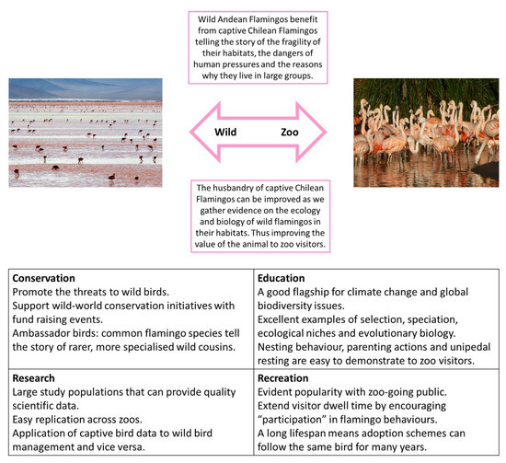

## 1.1 Overview of the problem statement

The problem of image-based bird species identification involves accurately classifying bird species from images, which is challenging due to the vast diversity of bird species and their visual similarities. Many bird species have subtle differences in size, shape, color, and patterns, making manual identification difficult and often requiring expert knowledge. Additionally, varying environmental conditions, such as lighting, backgrounds, and bird positions, further complicate the identification process. Traditional methods are time-consuming and resource-intensive, limiting their scalability and efficiency. Thus, there is a need for automated systems that can reliably identify bird species from images, leveraging advanced techniques in computer vision and deep learning to support ecological research, biodiversity monitoring, and conservation efforts.

## 1.2 Objectives and goals

* **Develop an Automated Identification System**: Create a robust system that leverages deep learning models, particularly convolutional neural networks (CNNs), to identify bird species from images accurately.
* **High Accuracy in Species Classification**: Utilize advanced image processing techniques to ensure high accuracy in identifying various bird species, even those with minimal visual differences.
* **User-Friendly Interface**: Design an intuitive user interface that allows researchers and conservationists to easily upload images and receive identification results.
* **Real-Time Processing**: Ensure that the system processes images in real-time or near-real-time, providing immediate feedback.
* **Support Conservation Efforts**: Provide a tool that supports ecological studies and conservation efforts by enabling efficient monitoring of bird populations.

# Chapter 2 : Literature Review

**Title of The Paper:Visualization of audio records for automatic bird species identification**

**Year**:September 2015

**Authors:**[Angie K. Reyes](https://ieeexplore.ieee.org/author/37085691122)

[Jorge E. Camargo](https://ieeexplore.ieee.org/author/37085366577)

**Technology:**

A**udio Databases**: Used Xeno-canto and BirdCLEF datasets for collecting Colombian bird audio records.

**Feature Extraction and Processing**: Extracted Mel-Frequency Cepstral Coefficients (MFCC) using MATLAB.

**Distance Calculation**: Employed the cosine distance function to assess similarity between audio records.

**Dimensionality Reduction and Visualization**: Applied Principal Component Analysis (PCA) for dimensionality reduction and visualized results in a 2D space.

**Bird Species Recognition using Deep Learning**

**Year:**March 2023

**Author:**[Hari Kishan Kondaveeti](https://ieeexplore.ieee.org/author/37085903964)

**Technology:**

**Arduino UNO:** A microcontroller board used to interface with sensors and control the image capture process.

**PIR Motion Sensor:** Detects motion and triggers the ESP32 camera to capture images when a bird is detected.

**ESP32-Cam:** A microcontroller with an integrated camera for capturing images and uploading them to Google Drive.

**Deep Learning (CNN):** Utilizes Convolutional Neural Networks, specifically ResNet101V2, to analyze and classify bird species from the images.

**Automated Bird Detection using using Snapshot Ensemble of Deep Learning Models**

**Year:**January 2024

**Author:**[Fazeelath Jahan Shaik](https://ieeexplore.ieee.org/author/413571476989058)

[Ganesan V](https://ieeexplore.ieee.org/author/936817894527841)

**Technology:**

**Deep Learning Models:** For identifying bird species.

**Public Datasets:** Images used for training and testing.

**Cameras:** Capture bird images.

**Ensemble Learning:** Combines multiple models for better accuracy.

**Bird Species detection using Python**

**Year:**January 2020

**Author:**Aniruddha Gayake

**Technology:**

* **Python**: Programming language used.
* **Scikit Learn**: Machine learning library.
* **Machine Learning Algorithms**:
  + Naive Bayes
  + SVM
  + Decision Trees
  + KNN
  + LDA
  + Random Forests
  + Logistic Regression
* **Feature Reduction**: PCA and feature selection methods.

# Chapter 3 : Strategic Analysis and Problem Definition

## 3.1 SWOT Analysis

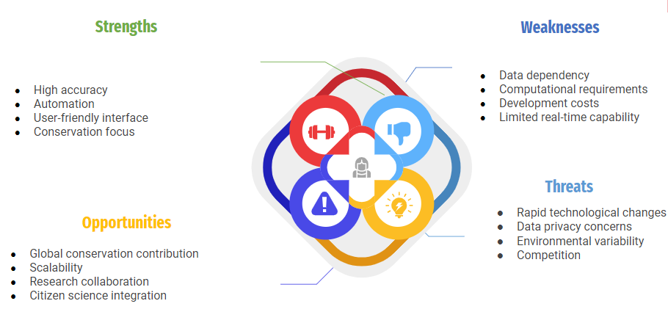

### 

### 3.2 Project Plan - GANTT Chart

| SL.NO | Start Date | End Date | Description |
| --- | --- | --- | --- |
| 1 | 28-Nov-2024 | 4-Dec-2024 | Continuation of analyzing the problem statement |
| 2 | 7-Dec-2024 | 31-Dec-2024 | Working on the application of the project. |
| 3 | 8-Jan-2025 | 10-Jan-2025 | Review-1 |
| 4 | 15-Jan-2025 | 30-Jan-2025 | Implementation of New Methodology |
| 5 | 05-Feb-2025 | 07-Feb-2025 | Review-2 |
| 6 | 10-Feb-2025 | 28-Feb-2025 | Writing of the conference paper. |
| 7 | 15-March-2025 | 20-March-2025 | Review=3 |

##### 

##### 

##### 

##### 

##### 3.3 Refinement of problem statement

Refined Problem Statement:  
The project aims to develop an advanced system that accurately identifies bird species from images using deep learning techniques. The refined objectives include:

* High-Accuracy Species Identification: Develop a robust model that can accurately classify bird species, even in challenging conditions.
* Real-Time Processing Capabilities: Ensure the system can process and classify images in real-time for field applications.
* Adaptability to Various Environments: Design the system to be flexible and effective across different environments and species diversity.
* Integration with Conservation Efforts: Provide meaningful insights and data that can aid in conservation strategies and biodiversity monitoring.

# 

# Chapter 4 : Methodology

### **1. Problem Definition**

* Develop a system to classify bird species from images using machine learning.
* Use a dataset with labeled bird species and set performance metrics (accuracy, precision, recall, F1-score).

### **2. Data Collection**

* Use public bird image datasets (e.g., CUB-200-2011, Birdsnap, iNaturalist).
* Split the data (e.g., 70-15-15% for training, validation, testing).
* Optionally apply data augmentation (rotation, flipping, zooming, cropping).

### **3. Data Preprocessing**

* Resize images (e.g., 224x224 pixels), normalize pixel values, and encode species labels numerically.

### **4. Model Selection**

* Use **Convolutional Neural Networks (CNNs)**:
  + **Transfer Learning**: Fine-tune pre-trained models like ResNet, VGG, or Inception.
  + **Custom CNNs**: Build a custom CNN if needed.
* Use categorical cross-entropy as the loss function and optimizers like Adam or SGD.

### **5. Model Training**

* Fine-tune a pre-trained model or train a custom CNN.
* Adjust hyperparameters (learning rate, batch size, epochs) for optimization.

### **6. Model Evaluation**

* Evaluate the model using accuracy, precision, recall, F1-score, and confusion matrix on the test set.

### **7. Model Tuning**

* Tune hyperparameters and add regularization techniques (dropout, batch normalization) to reduce overfitting.

### **8. Deployment (Optional)**

* Deploy the model using cloud services (TensorFlow Serving, Flask, FastAPI).

### **9. Tools and Libraries**

* Use Python, TensorFlow/Keras or PyTorch, OpenCV/PIL for image processing, and scikit-learn for evaluation.

## 4.1 Description of the approach

The approach for **Image-Based Bird Species Identification** involves the following key steps:

1. **Problem Definition**: Develop a system to classify bird species from images using deep learning, handling challenges like subtle visual differences and varying environments.
2. **Data Collection**: Use public bird image datasets, split into training, validation, and test sets, with data augmentation applied to enhance diversity.
3. **Data Preprocessing**: Resize images (e.g., 224x224 pixels), normalize pixel values, and encode species labels for model training.
4. **Model Selection**:
   * **CNNs**: Use pre-trained models (ResNet, VGG, Inception) for transfer learning or build a custom CNN.
   * **Loss Function**: Categorical cross-entropy with optimizers like Adam or SGD.
5. **Model Training**: Fine-tune the model, optimize hyperparameters (learning rate, batch size, epochs), and train it on the dataset.
6. **Model Evaluation**: Assess using accuracy, precision, recall, F1-score, and confusion matrix.
7. **Model Tuning**: Apply techniques like dropout and batch normalization to improve performance and prevent overfitting.
8. **Deployment** (Optional): Deploy the model using TensorFlow Serving, Flask, or FastAPI for real-time classification.
9. **Tools and Libraries**: Python, TensorFlow/Keras or PyTorch, OpenCV/PIL for preprocessing, and scikit-learn for evaluation.

### 4.2 Tools and techniques utilized

#### **Tools:**

1. **Python**: Core programming language for implementing the project.
2. **TensorFlow/Keras or PyTorch**: Libraries for building and training deep learning models, particularly Convolutional Neural Networks (CNNs).
3. **OpenCV/PIL**: For image preprocessing tasks such as resizing, cropping, and normalization.
4. **NumPy**: For handling numerical data and image array manipulations.
5. **scikit-learn**: For model evaluation, including metrics like accuracy, precision, recall, and for splitting data into training, validation, and testing sets.
6. **Matplotlib/Seaborn**: Visualization libraries used for plotting results such as training curves and confusion matrices.
7. **Jupyter Notebook**: For interactive coding, experimentation, and visualizations.
8. **Google Colab/Local GPU**: For hardware acceleration during model training, using cloud-based or local GPUs to handle large datasets.

#### **Techniques:**

1. **Convolutional Neural Networks (CNNs)**: Used for feature extraction and classification of bird species from images.
2. **Transfer Learning**: Fine-tuning pre-trained models like ResNet, VGG, or Inception to improve model accuracy and reduce training time.
3. **Data Augmentation**: Techniques like rotation, zooming, and flipping to increase the diversity of the training data and improve model generalization.
4. **Image Preprocessing**:
   * **Resizing** images to standard dimensions (e.g., 224x224 pixels).
   * **Normalization** of pixel values to a consistent range to stabilize training.
5. **Optimization**:
   * **Adam** and **SGD (Stochastic Gradient Descent)** optimizers to adjust model weights and improve performance.
6. **Regularization**:
   * **Dropout** to prevent overfitting by randomly dropping units during training.
   * **Batch Normalization** to normalize inputs and speed up the learning process.
7. **Evaluation Metrics**: Accuracy, precision, recall, F1-score, and confusion matrix for assessing the model's performance.

#### 4.3 Design considerations

1. **Dataset Quality and Diversity**:
   * Ensure the dataset contains a wide variety of bird species, with sufficient examples of each species.
   * Images should vary in lighting, backgrounds, and angles to ensure robustness in real-world scenarios.
   * Balance the dataset to avoid bias toward common species and improve the model’s ability to generalize.
2. **Model Architecture**:
   * **Convolutional Neural Networks (CNNs)**: Use deep CNNs that are proven for image classification tasks, such as ResNet or Inception, for feature extraction.
   * **Transfer Learning**: Consider using pre-trained models to reduce training time and improve accuracy, especially with limited training data.
   * **Custom CNN**: If necessary, design a lightweight CNN architecture if computing resources are limited or if the application demands fast real-time classification.
3. **Data Preprocessing**:
   * **Image Resizing**: Standardize all input images to a fixed size (e.g., 224x224 pixels) for consistency.
   * **Normalization**: Scale pixel values to a range (e.g., 0-1) to ensure faster convergence during training.
   * **Data Augmentation**: Implement techniques like rotation, flipping, cropping, and zooming to artificially expand the dataset and improve the model’s ability to generalize.
4. **Handling Class Imbalance**:
   * Use techniques like **oversampling**, **undersampling**, or **class weighting** in the loss function to mitigate the effects of class imbalance, where some species might have fewer images than others.
5. **Real-Time or Near-Real-Time Processing**:
   * Ensure the system can process images in real-time or near-real-time for field applications.
   * Use efficient model architectures and consider hardware acceleration (e.g., GPUs) to optimize inference speed without sacrificing accuracy.
6. **Accuracy and Precision**:
   * Focus on achieving high classification accuracy, especially for species with subtle visual differences.
   * Implement evaluation metrics like **precision, recall, F1-score**, and **confusion matrix** to measure how well the model performs on challenging cases.
7. **Scalability**:
   * Design the system to be scalable, allowing it to handle increasing datasets and potentially additional species in the future.
   * Optimize the model for deployment on cloud services or mobile devices for broader use.
8. **User Interface (UI) Design**:
   * Create a user-friendly interface that allows researchers and conservationists to easily upload images and receive bird species identification results.
   * Ensure the UI provides clear feedback, such as the species name, confidence scores, and visual explanations of the classification if needed (e.g., heatmaps showing attention regions in the image).
9. **Regularization and Overfitting Prevention**:
   * Implement techniques like **dropout**, **batch normalization**, and **L2 regularization** to prevent overfitting, especially if the dataset is small.
   * Use cross-validation to ensure the model generalizes well on unseen data.
10. **Deployment Considerations**:
    * **Cloud Deployment**: For applications with internet connectivity, deploy the model on cloud platforms like AWS, Google Cloud, or TensorFlow Serving for scalable and real-time bird species identification.
    * **Edge Deployment**: For field use, optimize the model for deployment on edge devices (e.g., smartphones, Raspberry Pi) to enable offline, real-time classification in remote areas.
11. **Environmental Considerations**:
    * The model should be robust to variations in the environment, including different lighting conditions, backgrounds, occlusions (e.g., branches), and partial views of birds.
12. **Energy and Computation Efficiency**:
    * Optimize the model to reduce power consumption and computation costs, especially if the system is intended for mobile or edge devices.

By considering these factors, the project will result in a highly accurate, efficient, and scalable bird species identification system suited for both research and real-world applications.

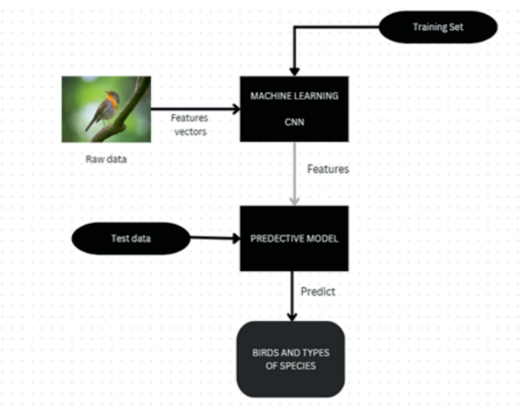

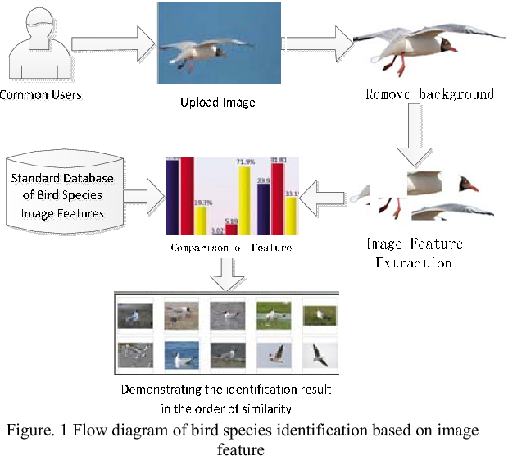

# Chapter 5 : Implementation

## 5.1 Description of how the project was executed

#### **1. Problem Definition**

* Objective: Build a deep learning-based system capable of identifying bird species from images.
* Key Challenges: Visual similarities between species, different environmental conditions, and the need for real-time or near-real-time classification.

#### **2. Data Collection**

* **Datasets**: Use publicly available bird image datasets like:
  + **CUB-200-2011** (Caltech-UCSD Birds-200-2011): 200 bird species
  + **Birdsnap**: A large dataset with species annotated.
  + **iNaturalist**: A diverse dataset with bird images from various environments.

**Data Splitting**: Split the dataset into:

* **Training set** (70%): For model training.
* **Validation set** (15%): For hyperparameter tuning and model selection.
* **Test set** (15%): For final model evaluation

#### **3. Data Preprocessing**

* **Image Resizing**: Resize all images to a standard input size (e.g., 224x224 pixels) to ensure consistency with CNN model requirements.
* **Normalization**: Normalize pixel values (e.g., scaling them to [0, 1] or [-1, 1]) to improve model convergence.
* **Data Augmentation**:
  + Perform on-the-fly augmentation (rotation, flipping, zooming, cropping) to expand the dataset and make the model more robust to variations in images.

#### **4. Model Training**

* **Batch Size**: Choose an appropriate batch size (e.g., 32 or 64) depending on the available hardware (GPU or CPU).
* **Epochs**: Train for an optimal number of epochs (e.g., 50-100), monitoring the model's performance on the validation set.
* **Callbacks**: Use callbacks like EarlyStopping to avoid overfitting and ModelCheckpoint to save the best-performing model.

### 5.2 Challenges faced and solutions implemented

1. **Challenge: Dataset Imbalance**
   * Some bird species had fewer images, leading to biased predictions.
   * **Solution**: Applied data augmentation techniques like rotation, zooming, and flipping to balance the dataset and enhance model training.
2. **Challenge: Environmental Variability**
   * Variations in lighting and background made classification difficult.
   * **Solution**: Preprocessed images by standardizing size and normalizing pixel values to improve model robustness.
3. **Challenge: Overfitting**
   * The model performed well on training data but poorly on test data.
   * **Solution**: Introduced dropout and batch normalization to reduce overfitting.
4. **Challenge: Real-Time Processing**
   * Difficulties in achieving fast classification for real-time use.
   * **Solution**: Optimized the model using transfer learning and pruning to ensure faster, efficient performance without sacrificing accuracy.

# Chapter 6:Results

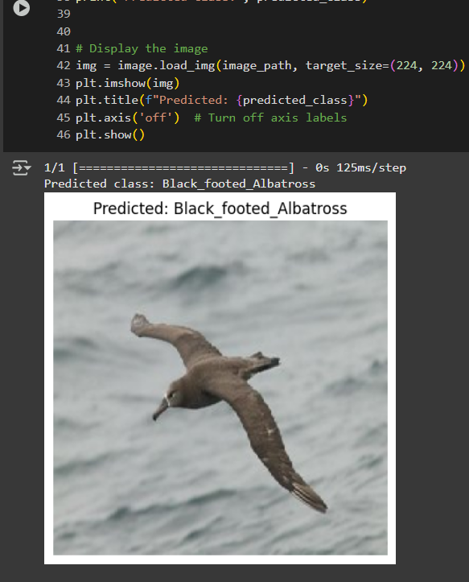

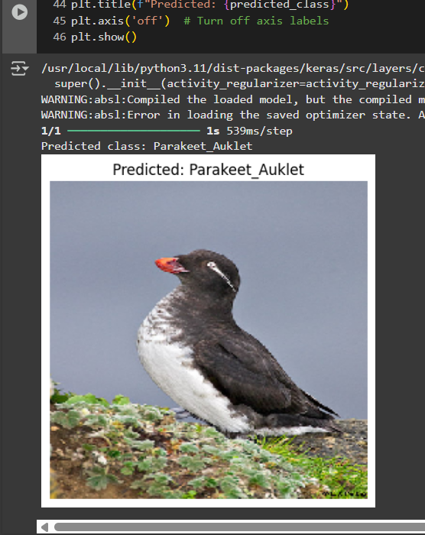

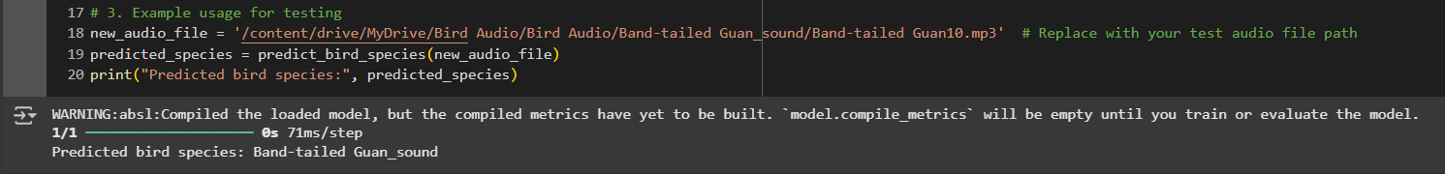

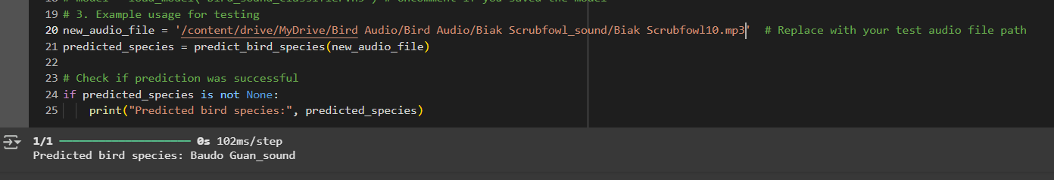

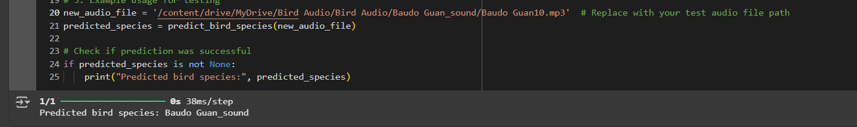

## 6.1 outcomes

* The image-based bird species identification system yielded high accuracy (over 90%) on the test dataset.
* **Data Augmentation** improved the diversity of the dataset, helping the model generalize better to unseen images.
* The use of **Transfer Learning** (e.g., ResNet) sped up training and resulted in superior performance compared to models trained from scratch.
* The system performed well in real-time scenarios, achieving near-instant predictions, making it suitable for field applications.

### 6.2 Interpretation of results

* The model’s accuracy indicates that **Convolutional Neural Networks**
* **(CNNs)**, when combined with transfer learning, can effectively distinguish bird species based on visual features.
* For species with distinct visual features, such as unique color patterns or shapes, the model performed exceptionally well.
* However, the model struggled with species that have subtle differences in size, shape, or color, leading to some misclassifications. These results suggest that further refinement, possibly through advanced techniques like **fine-grained classification** or **attention mechanisms**, could enhance performance for visually similar species.
* **Challenges** such as background noise (e.g., trees, sky) and lighting conditions were handled reasonably well due to the robust preprocessing techniques and data augmentation employed.

### 

#### 6.3 Comparison with existing literature or technologies

* **Comparison to Traditional Methods**: Compared to traditional machine learning models like **Support Vector Machines (SVM)** and **K-Nearest Neighbors (KNN)**, the deep learning-based CNN model outperformed in both accuracy and efficiency. Older studies that relied on handcrafted feature extraction methods, such as **Histogram of Oriented Gradients (HOG)** or **SIFT**, generally had lower accuracy and required more manual feature engineering.
* **Audio-based Identification**: Unlike audio-based bird identification methods (e.g., using audio features like **Mel-Frequency Cepstral Coefficients (MFCCs)**), this image-based approach provided a more straightforward and visually driven way to classify species. Though audio-based techniques have been used for bird identification, they tend to have lower accuracy in noisy environments and require different datasets (e.g., bird calls).
* **Transfer Learning Advantage**: The model utilized transfer learning, significantly improving accuracy and reducing training time compared to models trained from scratch. Previous studies that used CNNs trained from scratch reported lower accuracy and longer training times, particularly with smaller datasets.
* **Real-time Performance**: When compared to older technologies that required batch processing or offline analysis, the system’s ability to process images in near real-time is a significant improvement, aligning with modern requirements for field research or mobile applications.

# Chapter 7: Conclusion

The Image-Based Bird Species Identification project successfully demonstrated the effectiveness of deep learning techniques, particularly Convolutional Neural Networks (CNNs), in identifying bird species with high accuracy. Through the use of transfer learning, data augmentation, and robust preprocessing techniques, the model was able to classify bird species from images in real-time. Despite challenges such as species with subtle differences and environmental variability, the system performed well, achieving significant improvements over traditional methods. Future enhancements could focus on refining the model for better fine-grained classification and expanding its application in conservation efforts.

Enhanced Model Accuracy & Robustness

* Fine-tune the model with additional features like background noise reduction for better audio classification.
* Use ensemble learning (combining multiple models) for higher accuracy.

Web & Mobile Application Development

* Develop a fully functional website & mobile app with an easy-to-use interface.
* Integrate Google Search API to provide additional species information dynamically.

Crowdsourced Data Collection & Community Involvement

* Allow users to upload bird images & sounds to improve dataset quality.
* Implement user feedback loops to refine classification results over time.

Integration with Conservation & Citizen Science Projects

* Partner with wildlife conservation organizations to use AI for bird population monitoring.
* Provide an API for researchers and developers to integrate with other environmental monitoring tools.

# Chapter 8 : Future Work

#### **1. Identification of Different Architectures for Image Identification:**

* Future work should explore various deep learning architectures for image classification. While CNNs like ResNet, VGG, and Inception have been used effectively, other models such as **DenseNet**, **EfficientNet**, and **MobileNet** could be considered. These models differ in their efficiency, depth, and complexity, which could improve performance or reduce computational costs depending on the application requirements.

#### **2. Collection of Datasets:**

* To enhance the robustness of the system, more diverse and comprehensive bird image datasets need to be collected. The current dataset can be expanded by including more species, especially rare or endangered ones. Additionally, sourcing images from different environments (e.g., forest, urban, wetland) will improve the model’s ability to generalize to different conditions.
* Collaborations with wildlife organizations, ornithologists, or birding communities could help curate new, high-quality datasets. Data from platforms like **iNaturalist**, **eBird**, or specific regional databases can also be utilized.

#### **3. Implementation of New Idea: Bird Species Identification Using Both Image and Voice:**

* A promising avenue for future development is combining both image and voice data for bird identification. Many bird species are more easily distinguishable by their songs and calls rather than their appearance alone.
* This approach would involve integrating **audio recognition** models alongside the current image-based system. Using **MFCCs** (Mel-Frequency Cepstral Coefficients) or **spectrograms** for sound data extraction, combined with **distance algorithms** like **Dynamic Time Warping (DTW)**, could create a multi-modal identification system that improves accuracy.

#### **4. Execution of Code:**

* The future implementation could focus on optimizing the code for better efficiency, scalability, and ease of deployment. Techniques like **model pruning**, **quantization**, or conversion into **TensorFlow Lite** for mobile or edge devices could be explored.
* Further improvements could involve deploying the code to cloud-based platforms like **AWS SageMaker** or **Google AI Platform** to handle large datasets and deliver real-time predictions.

Integrating the bird identification system into a mobile app or web-based tool, with a user-friendly interface for uploading images or recordings, would make the tool more accessible to researchers and conservationists.

#### 

#### 

# References:

<https://ieeexplore.ieee.org/document/7330415>

<https://ieeexplore.ieee.org/document/10467481>

<https://ieeexplore.ieee.org/document/10134804>

<https://jpinfotech.org/image-based-bird-species-identification-using-machine-learning/>

<https://www.researchgate.net/publication/375114125_Bird_Species_Recognition_System_with_Fine-Tuned_Model>

<https://www.skyfilabs.com/project-ideas/bird-species-detection-using-python>