Carbon Management System – User Manual

1. Introduction
This system is designed to help users upload documents (e.g., Excel FAQs, PDF manuals),
convert them into searchable knowledge using embeddings + Chroma vector DB, and then ask natural language questions via a web interface (FastAPI/Streamlit UI).

2. System Requirements
- Python 3.10+
- Installed dependencies (requirements.txt)
- Internet connection (for Google Gemini API)
3. Installation & Setup
1. Clone or copy the project to your machine.
2. Create and activate virtual environment:
conda create -n carbonrag python=3.10 -y
conda activate carbonrag
3. Install dependencies:
pip install -r requirements.txt
4. Set environment variables in main.py:
GEMINI_API_KEY=your_google_api_key
4. Running the Application
1. Start the FastAPI backend:
uvicorn main:app --reload
→ The service runs at: http://127.0.0.1:8000
2. Open the UI in your browser to interact with the system.
5. Features & Workflow
(a) File Upload
- Navigate to /upload
- Upload Excel (FAQ sheet) or PDF documents.
- System automatically parses and embeds content into Chroma Vector DB.
(b) Ask a Question
- Go to /ask endpoint (or the Streamlit UI).
- Enter a natural language query.
- System retrieves the most relevant chunks from the database.
- Response is generated via Gemini LLM and shown in UI.
(c) Excel Report Generation
- Navigate to /generate.
- Creates a structured Excel output (e.g., generated_user_manual.xlsx) with Q&A results.
- Download directly to your system.

(d) Health & Metrics Check
- Health check:
- curl http://127.0.0.1:8000/health
Should return:
{"status":"ok"}
- Metrics check (Prometheus):
- curl http://127.0.0.1:8000/metrics
Returns Prometheus-compatible text output for monitoring
# HELP python_gc_objects_collected_total Objects collected during gc
# TYPE python_gc_objects_collected_total counter
python_gc_objects_collected_total{generation="0"} 10123.0
python_gc_objects_collected_total{generation="1"} 1662.0
python_gc_objects_collected_total{generation="2"} 285.0
# HELP python_gc_objects_uncollectable_total Uncollectable objects found during GC
# TYPE python_gc_objects_uncollectable_total counter
python_gc_objects_uncollectable_total{generation="0"} 0.0
python_gc_objects_uncollectable_total{generation="1"} 0.0
python_gc_objects_uncollectable_total{generation="2"} 0.0
# HELP python_gc_collections_total Number of times this generation was collected
# TYPE python_gc_collections_total counter
python_gc_collections_total{generation="0"} 1362.0
python_gc_collections_total{generation="1"} 123.0
python_gc_collections_total{generation="2"} 8.0
# HELP python_info Python platform information
# TYPE python_info gauge
python_info{implementation="CPython",major="3",minor="10",patchlevel="18",version="3.10.18"} 1.0
# HELP cms_requests_total Total requests
# TYPE cms_requests_total counter
cms_requests_total{endpoint="/ask"} 1.0
# HELP cms_requests_created Total requests
# TYPE cms_requests_created gauge
cms_requests_created{endpoint="/ask"} 1.7579416828760223e+09
# HELP cms_request_latency_seconds Latency in seconds
# TYPE cms_request_latency_seconds histogram
cms_request_latency_seconds_bucket{endpoint="/ask",le="0.005"} 0.0
cms_request_latency_seconds_bucket{endpoint="/ask",le="0.01"} 0.0
cms_request_latency_seconds_bucket{endpoint="/ask",le="0.025"} 0.0
cms_request_latency_seconds_bucket{endpoint="/ask",le="0.05"} 0.0
cms_request_latency_seconds_bucket{endpoint="/ask",le="0.075"} 0.0
cms_request_latency_seconds_bucket{endpoint="/ask",le="0.1"} 0.0
cms_request_latency_seconds_bucket{endpoint="/ask",le="0.25"} 0.0
cms_request_latency_seconds_bucket{endpoint="/ask",le="0.5"} 0.0
cms_request_latency_seconds_bucket{endpoint="/ask",le="0.75"} 0.0
cms_request_latency_seconds_bucket{endpoint="/ask",le="1.0"} 0.0
cms_request_latency_seconds_bucket{endpoint="/ask",le="2.5"} 1.0
cms_request_latency_seconds_bucket{endpoint="/ask",le="5.0"} 1.0
cms_request_latency_seconds_bucket{endpoint="/ask",le="7.5"} 1.0
cms_request_latency_seconds_bucket{endpoint="/ask",le="10.0"} 1.0
cms_request_latency_seconds_bucket{endpoint="/ask",le="+Inf"} 1.0
cms_request_latency_seconds_count{endpoint="/ask"} 1.0
cms_request_latency_seconds_sum{endpoint="/ask"} 1.152784400008386
# HELP cms_request_latency_seconds_created Latency in seconds
# TYPE cms_request_latency_seconds_created gauge
cms_request_latency_seconds_created{endpoint="/ask"} 1.7579416828760223e+09

(e) throughput measurement
(carbonrag) C:\Users\USER\Downloads\CMS_AI_Engineer_Assg_updated>python my_async_test.py
Total requests: 200
Total time: 0.37s
Requests per second: 539.10

6. System Architecture

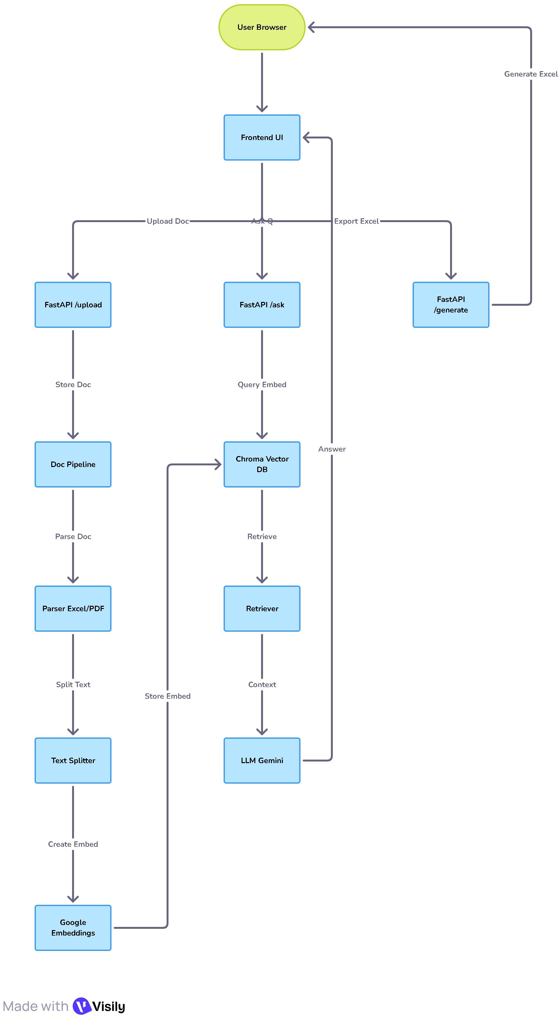
7. Troubleshooting
- Error: API Key missing → Check .env file.
- Database not loading → Delete old chroma folder and restart server.
- Wrong language output → Update Excel FAQ to English or enable translator integration.
8. Future Enhancements
- Add translation layer (auto EN ↔ CN).
- Add Docker deployment.
- Support multi-file uploads.
- Add Redis caching for faster query responses.

