**Exploratory analytics and classification**

* **D.Chakravardhan Reddy**
* **IMT2014015**

**Target users:** Doctors or CXO’s of the companies

* Among the people who have mental illness, how many people have sought treatment?
* The following graph indicates the number of people who have sought treatment among the people with mental illness.

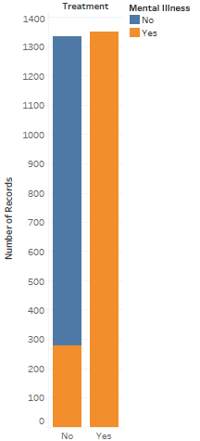

* We can see that there are few people who have mental illness and who have not sought for treatment. But the number is few compared to the people who have sought treatment. So, we can say that there is awareness about the mental illness.

**Target user:** Higher officials in the companies (HR, CXO’s)

**Report -** 1

* If you have mental illness, how does it interfere your work?
* The following graph indicates how mental illness vary across work interference.

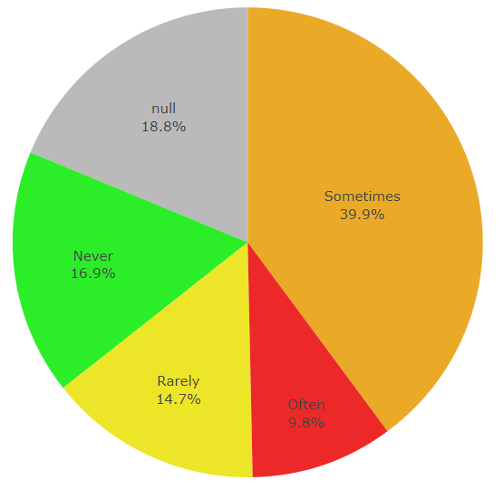

* We can see that nearly 50% of the people have they sometimes or often encounter interference with their work due to a mental health condition, whereas the other 50% did not answer, or indicated they never or rarely encounter such interference.

**Report – 2**

* How employees feel about the medical health resources provided by the employer?
* The following graph indicates seek_help vs mental illness