**git init** = **initializes the working directory with .git file**

Example = if we had a folder and we need to convert the folder to git working director which is in your computer/ which is created by yourself. Then we should use “git init” command to make the folder as git working directory. When you use this command it automatically generate “ .git ” file in the folder/or we should call it as working directory. Here we will place all the required files.

Ex : suppose consider this path as your working directory.

**C:\Users\chakravarthi\Desktop\learngit>**

From the above path. Here the path is set to “learngit” folder. And wants to initialize the the “ learngit ” folder as working directory. Then we will use this command.

**C:\Users\chakravarthi\Desktop\learngit>git init**

Then we get the conformation message like this

**Initialized empty Git repository in C:/Users/chakravarthi/Desktop/learngit/.git/**

**working directory staging area local repository Remote repository**

**add commit push**

**git status :- This command is used to find the status of the git command prompt.**

**Like the files in the working directory.**

It show the git status whether the files in the working directory are added to staging area or not. It shows the untracked files if the files in working directory is not added to staging area.

Example :

Suppose consider there is a file in the working directory named as “example3”

And it is not added to staging area. If we use “git status” it shows as below fig.

It show the untracked files it means the files are in working directory.

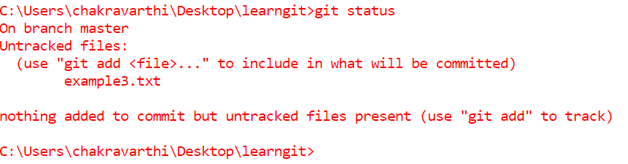

**git add : It is used to add the files in the working directory to staging area.**

**Example :** In the above Example the file is in working directory and it is named as “ example3 ”. By using “ git add ” command we will send that file from working directory to staging area .

***Importance of Staging area*** : suppose if there is are some files like example1,example2 and example3 if we don’t want to add the example 1,example 2 to repository and we want to add only example3 then we will add that file to staging area by using command git add. In simple terms adding only required files among all the files in the working directory to the repository we required staging area. All the files in the staging area will be committed to local repository and then remote repository.

**Syntax for git add : git add filename.extension**

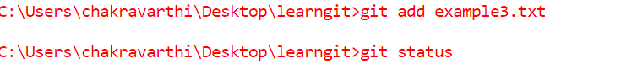

Here example3.txt file is added to staging area.

**Git commit : This command is used to commit the files or add the files in the staging area to local repository.**

**Example :** From the above example the file “ example3 ” is added to staging area.

now if we want to add the file “example3” to local repository then here we use this command git commit.it means all the files in the staging area will be added to the local repository at once. And we can add message to the commitment because since many of the developers work on the same repository and committing various files at a time it is important to write a message for understanding it’s optional.

**Syntax for git commit : git commit -m “committing example3”**

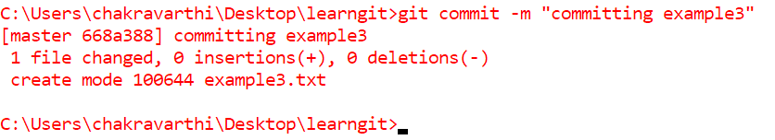

**git remote add origin : This command is used to add the origin that means the remote repository to command prompt . so that we can add the files in the local repository to remote repository.**

**Example :** From the above example the file “example3 ” is added to the local repository by using “ git commit “ command. Now it’s time to add the files in the local repository to remote repository by using command “git push ”. before that we need set the origin to the command prompt. Which is the remote repository that we need to add files of local repository. For that we need to create ad repository or we can add the existing repository in terms it is also called as origin.

**Creating a new repository :** To create a repository we need to visit the <https://github.com> and if you aren’t signed up sign up and then open my repositories. And the click on the new then fill the details of repository.

**Syntax for git remote add origin : git remote add origin link of the origin**

 **Ex:git remote add origin** [**https://github.com/chakravarthi77/learngit.git**](https://github.com/chakravarthi77/learngit.git)

**git push : This command is used to push the files in the local repository to remote repository. This should be done only if after the origin is set.**

**Example :** In the previous example the file “example3” is added to local repository.

Now it’s time to push all the files in the local repository files to remote repository or origin. Actually it consists of branches by default there will be a branch which is named as master/main .all the pushed files from local repository will be added to the remote repository of master/main branch.

At first we need mention the branch name and later it is not necessary or we can mention every time.

Syntax for git push : git push -u origin branch_name

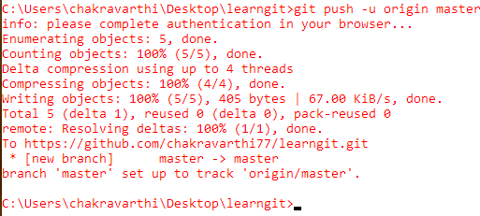Ex : git push -u origin master

**git branch :** **It show the current branch which we are in.**

**Example :**

