PENETRATION TESTING REPORT
FOOTPRINTING & WEB RECONNAISSANCE
W2-PM1 | CYBERSECURITY | NETWORKWALKS
Pentester Name (Cybersecurity Professional) | Chakresh Ram Kudupudi
Program / Batch | B083 - Networkwalks
Date | 16 September 2026
Module | W2-PM1 – Multiple Kali Tools
Target | networkwalks.com
Phase Covered | Phase 1 – Reconnaissance & Footprinting

1. Liability Disclaimer
The activities documented in this report were performed for authorized educational and cybersecurity training purposes within the assigned NetworkWalks exercise scope. Reconnaissance and scanning techniques should only be used against systems where appropriate authorization has been obtained. The observations in this report are information-gathering results and should not be treated as confirmed vulnerabilities without further authorized validation.

2. Introduction
This report documents a web reconnaissance and footprinting exercise against networkwalks.com using multiple Kali Linux tools. The objective was to understand what information can be collected from publicly accessible DNS, HTTP, domain registration, web technology and WAF responses before any deeper security testing.
The tools used were WHOIS, WhatWeb, Nslookup, Curl and Wafw00f, together with DNSRecon for DNS enumeration. Each activity was recorded with the command used, the observed result and a short security interpretation.

3. Tools Used
Tool | Purpose
WHOIS | Collect domain registration details, registrar information and name servers.
WhatWeb | Fingerprint web technologies, CMS, plugins and server information.
nslookup | Resolve the domain name to IP address information through DNS.
curl -I | Inspect HTTP response headers and visible web-service information.
wafw00f | Identify whether a Web Application Firewall is present.
dnsrecon | Enumerate DNS records such as A, AAAA, NS, MX, TXT and SRV records.

4. Activities Performed

4.1 WHOIS Enumeration
WHOIS was used to collect publicly available registration information for networkwalks.com. The result showed GoDaddy.com, LLC as the registrar, HostGator name servers, a creation date of 2019-11-06, and a registry expiry date of 2027-11-06. The WHOIS output also showed DNSSEC as unsigned.
whois networkwalks.com
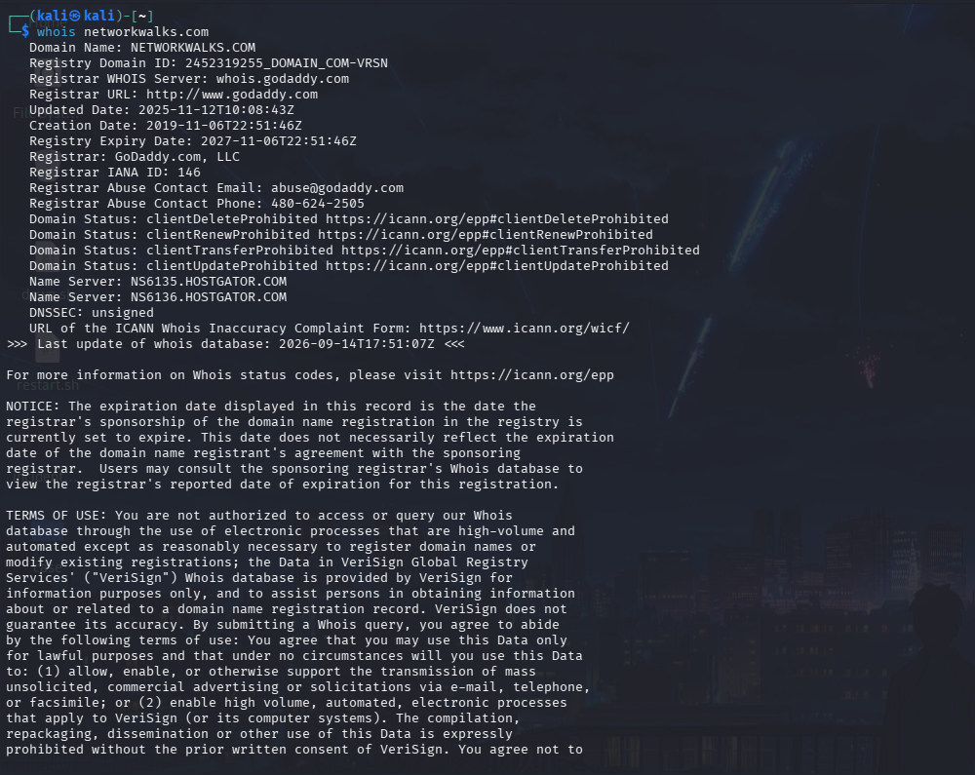
Figure 1 – WHOIS enumeration output

4.2 HTTP Header Inspection with Curl
The HTTP response headers were inspected using curl. The response returned HTTP 200 OK and identified Apache as the web server. The headers also exposed a WordPress REST API reference at /wp-json/ and other application-related header information.
curl -I https://networkwalks.com
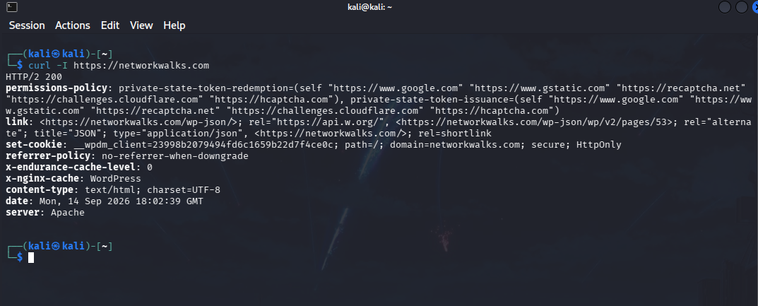
Figure 2 – HTTP response headers

4.3 DNS Enumeration with DNSRecon
DNSRecon was used to enumerate DNS records for the domain. The observed results included the A record 192.232.216.135, an IPv6-mapped AAAA value, HostGator name servers, mail-related MX records, SPF/TXT information and cPanel autodiscover SRV records. The output also reported that DNSSEC queries did not receive an answer.
dnsrecon -d networkwalks.com
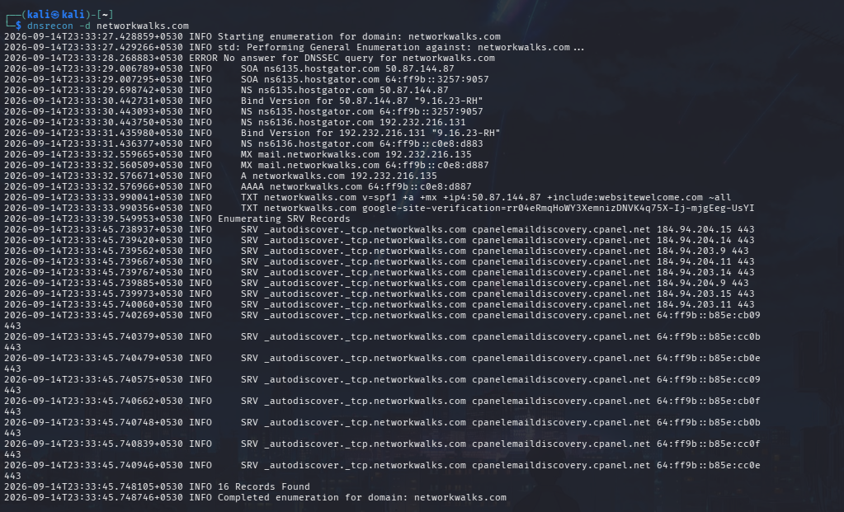
Figure 3 – DNSRecon enumeration output

4.4 DNS Resolution with Nslookup
Nslookup was used to resolve networkwalks.com. The observed non-authoritative answer resolved the domain to 192.232.216.135. The result also displayed the resolver used by the local Kali environment.
nslookup networkwalks.com
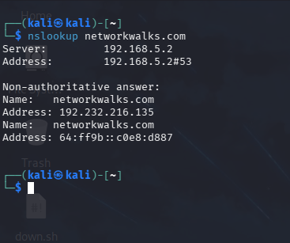
Figure 4 – Nslookup result

4.5 WAF Detection with Wafw00f
Wafw00f was used to fingerprint the presence of a Web Application Firewall. The result identified ModSecurity (SpiderLabs) as the WAF protecting the site. This is useful reconnaissance information because it indicates that subsequent authorized web-security testing may encounter WAF filtering.
wafw00f networkwalks.com
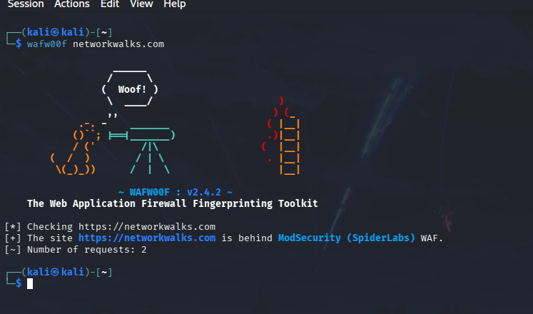
Figure 5 – Wafw00f WAF fingerprinting output

4.6 Web Technology Fingerprinting with WhatWeb
WhatWeb was used to fingerprint the web application. The captured output identified Apache, Bootstrap 7.1, WordPress 7.1 and WP Download Manager 3.3.58, along with jQuery and other web technologies and headers. Technology and version information can help a security tester determine which components should be reviewed during authorized vulnerability assessment.
whatweb networkwalks.com
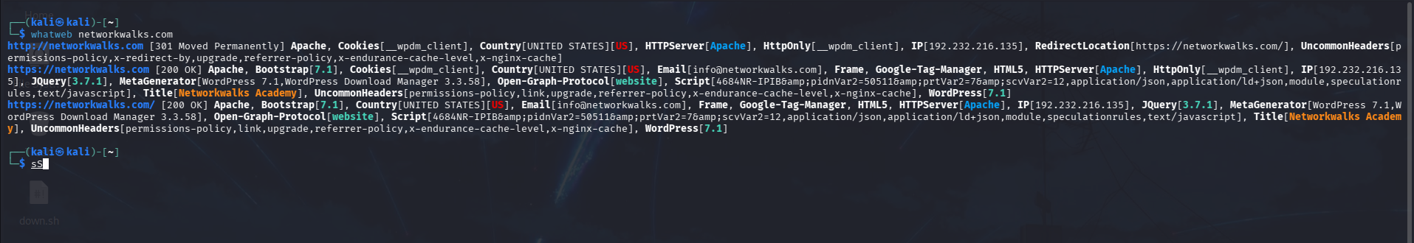
Figure 6 – WhatWeb technology fingerprinting output

5. Findings / Risk Analysis
# | Finding / Observation | Evidence | Potential Security Impact | Level
1 | Web technology information exposed | WhatWeb identified WordPress 7.1 and WP Download Manager 3.3.58. | May help an attacker identify components that require security review. | Medium
2 | Server IP address identifiable | Nslookup/DNSRecon returned 192.232.216.135. | Provides information about the location of the web service. | Low
3 | HTTP technical information exposed | Curl returned Apache headers and a /wp-json/ REST API reference. | Can assist technology fingerprinting and further authorized enumeration. | Low
4 | WAF technology identifiable | Wafw00f identified ModSecurity (SpiderLabs). | Reveals information about the web application's defensive architecture. | Low
5 | DNS infrastructure information exposed | DNSRecon returned NS, MX, TXT/SPF and SRV records. | Can assist broader infrastructure profiling. | Medium
6 | DNSSEC reported as unsigned | WHOIS/DNSRecon output indicated unsigned DNSSEC. | Means DNSSEC-based authenticity protection is not observed for the domain. | Low
Risk levels above are observations for the reconnaissance exercise, not confirmed vulnerabilities. Exposure of a technology version, IP address, DNS record or WAF does not by itself demonstrate that the system is exploitable.

6. Recommendations
1. Review publicly exposed CMS, plugin and server-version information and minimize unnecessary disclosure where practical.
2. Keep WordPress, plugins and supporting web components updated and monitor relevant security advisories.
3. Review HTTP response headers and remove unnecessary technical information where it does not support application functionality.
4. Regularly review DNS records and remove obsolete or unnecessary records and services.
5. Keep the WAF properly configured, monitored and updated; validate that legitimate traffic is not unnecessarily blocked.
6. Review DNS security configuration, including whether DNSSEC is appropriate for the domain and deployment.
7. Perform authorized vulnerability validation after reconnaissance to determine whether any identified technology or configuration actually presents a security weakness.
6.1 Network Scanning with Zenmap
Zenmap was used to perform a Ping Scan against the authorized internal lab subnet 10.10.10.0/24. The scan identified five active hosts and displayed their IP and MAC addresses, providing a basic inventory of active systems in the lab network.
Command used: nmap -sn 10.10.10.0/24
Host | IP Address | MAC Address
Host 1 | 10.10.10.1 | 00:50:56:C0:00:01
Host 2 | 10.10.10.20 | 00:0C:29:A3:FA:0C
Host 3 | 10.10.10.30 | 00:0C:29:CD:D4:04
Host 4 | 10.10.10.40 | 00:0C:29:8F:CA:0A
Host 5 | 10.10.10.50 | 00:0C:29:8F:CA:0A
The scan completed 256 IP-address checks and reported 5 hosts as up. The screenshot below is the evidence collected from Zenmap.
Figure 7 – Zenmap Ping Scan evidence
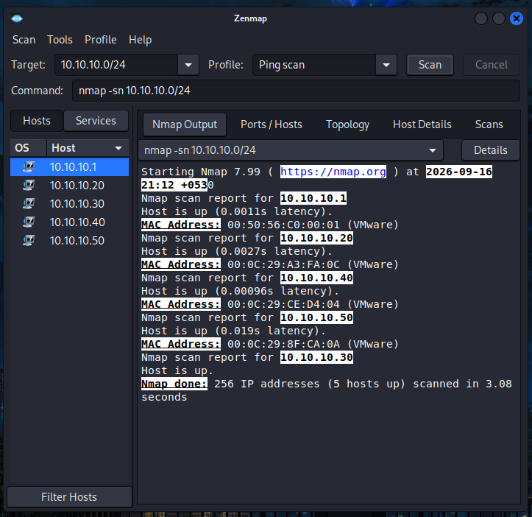

7. Conclusion
This exercise demonstrated how a security professional can build an initial profile of a web domain and discover active hosts within an authorized internal lab network. WHOIS provided registration and name-server information, Nslookup and DNSRecon exposed DNS and infrastructure records, Curl revealed HTTP response information, Wafw00f identified the apparent WAF, WhatWeb fingerprinted the web technology stack, and Zenmap identified five active hosts in the 10.10.10.0/24 lab subnet.
The main lesson from this activity is that reconnaissance creates the foundation for later security testing. However, reconnaissance findings must be distinguished from confirmed vulnerabilities. Any further enumeration, vulnerability assessment or exploitation should remain within the explicitly authorized scope.

8. Evidences Collected
1_whois.png — WHOIS domain registration and name-server information
2_curl.png — HTTP response headers
3_dnsrecon.png — DNS record enumeration
4_nslookup.png — Domain-to-IP resolution
5_wafw00f.png — WAF detection
6_whatweb.png — Web technology fingerprinting

9. Project Information
Program: Cybersecurity Program at NetworkWalks
Week: 02
Module: W2-PM1 – Multiple Kali Tools
Target: networkwalks.com
Author: Chakresh Ram Kudupudi

— End of Report —

