WEEK 1 TASK
Data Science Project Planning and Strategy Design
Project plan for predicting 30-day hospital readmission risk using Python
Intern | V Chakradhar
Internship | Virtual Data Science Explorer Intern - YuvaIntern
Task | Week 1: Data Science Project Planning and Strategy Design
Project | Predicting 30-Day Hospital Readmission Risk (hypothetical)
Submission date | 3 October 2026
Note: this is a planning document for a hypothetical project. All figures labelled "mock-up" or "illustrative" use synthetic numbers created to demonstrate the planned analysis; they are not results from real patient data.

Table of Contents
1. Executive Overview 3
2. Introduction and Background 3
2.1 The problem 3
2.2 Motivation and justification 3
2.3 Stakeholders 4
3. Project Objectives and Scope 4
3.1 SMART objectives 4
3.2 In scope 5
3.3 Out of scope 5
3.4 Assumptions and constraints 5
4. Methodology and Strategy 5
4.1 Solution architecture 6
4.2 Stage 1: Data collection 6
4.3 Stage 2: Data cleaning and validation 7
4.4 Stage 3: Exploratory data analysis (EDA) 7
4.5 Stage 4: Feature engineering 8
4.6 Stage 5: Modelling 8
4.7 Stage 6: Evaluation 9
4.8 Stage 7: Reporting and handover 9
5. Timeline 9
6. Tools and Technologies 10
7. Expected Outcomes 10
7.1 Deliverables 10
7.2 Benefits of the approach 11
8. Anticipated Challenges and Mitigation 11
9. Conclusion 12
10. References 12

1. Executive Overview
This document is the project plan and strategy for a hypothetical data science project: predicting which hospital patients are likely to be readmitted within 30 days of discharge. It defines the problem, the objectives and scope, a stage-by-stage methodology built around the Python data science ecosystem, a 33-hour timeline, the tools to be used, and the expected outcomes, risks and mitigations.
The plan is written so that another analyst could pick it up and execute it. Every stage lists its inputs, the actions to be performed, the Python libraries involved and the output that marks the stage as complete. No dataset is analysed in this phase; the focus is on designing the architecture and approach before any code is written.
Key point: Build a transparent, reproducible Python pipeline that flags high-risk patients at discharge, so that care teams can focus follow-up resources (phone calls, early clinic visits, medication reviews) on the 20% of patients who account for the largest share of readmissions.

2. Introduction and Background

2.1 The problem
A hospital readmission occurs when a patient who has been discharged is admitted again within a short window, conventionally 30 days. Some readmissions are unavoidable, but many are linked to issues that can be addressed: patients going home without a follow-up appointment, confusion about new medications, unmanaged chronic conditions, or a lack of support at home.
In the United States, roughly one in seven to one in six Medicare patients is readmitted within 30 days, and readmissions are among the most expensive events in healthcare. Payers now treat the readmission rate as a quality indicator; the Medicare Hospital Readmissions Reduction Program, for example, reduces payments to hospitals with higher-than-expected readmission rates for conditions such as heart failure, pneumonia and COPD. The same pattern of avoidable return visits is seen in health systems worldwide, including in India, where hospital capacity is limited and out-of-pocket costs fall heavily on families.

2.2 Motivation and justification
Hospitals usually cannot give intensive follow-up to every discharged patient; nurse time and clinic slots are limited. If the hospital could reliably identify the patients most likely to return, it could direct its follow-up programme at them and get a larger reduction in readmissions for the same budget. This makes the problem well suited to data science, for four reasons:
- The data already exists. Electronic health records (EHR) routinely capture admissions, diagnoses, procedures, lab results, medications and discharge details, so no new data collection is needed.
- The outcome is clearly defined and measurable. "Readmitted within 30 days: yes/no" gives a clean binary target for supervised learning.
- There is a decision attached to the prediction. A risk score at discharge leads directly to an action (enrol in the follow-up programme or not), so the model's value can be measured in avoided readmissions and saved cost.
- Current practice leaves room for improvement. Simple checklists such as the LACE index (Length of stay, Acuity, Comorbidities, Emergency visits) are widely used but only moderately accurate (ROC-AUC typically 0.60 to 0.70). Machine learning on richer features has been shown to improve on this.

2.3 Stakeholders
Table 1: Project stakeholders and their needs
Stakeholder | Interest in the project | What they need from us
Hospital leadership | Lower readmission penalties and costs | A clear business case and ROI estimate
Discharge nurses / care coordinators | Knowing whom to call after discharge | A short, ranked daily risk list with reasons
Physicians | Clinical credibility of the score | Transparent drivers; no "black box"
Data / IT team | Maintainable, secure pipeline | Documented, version-controlled Python code
Patients | Fewer complications and return visits | Fair treatment across age, gender and income groups

3. Project Objectives and Scope

3.1 SMART objectives
Table 2: Project objectives and success criteria
# | Objective | Success measure
O1 | Build a clean, documented analytical dataset of inpatient encounters with a 30-day readmission label | Data-quality report with less than 2% unexplained missing values in key fields
O2 | Identify and quantify the main drivers of readmission through exploratory analysis | At least 8 documented, visualised insights
O3 | Train and compare at least four classification models in Python | Best model beats the LACE baseline by 0.05 or more ROC-AUC on the held-out test set
O4 | Make the model usable for care teams | Top-20% risk tier captures at least 50% of actual readmissions
O5 | Check the model for fairness | Recall gap between demographic groups below 10 percentage points
O6 | Communicate results to non-technical stakeholders | Final report and a 10-slide presentation delivered on time

3.2 In scope
- Adult (18+) inpatient encounters from a single hospital system over a 3-year period.
- All-cause, unplanned readmission to any ward within 30 days of discharge.
- Structured data only: demographics, admission details, diagnoses (ICD-10), procedures, labs, vitals, medications and discharge disposition.
- Data cleaning, exploratory analysis, feature engineering, model development, evaluation, interpretation and reporting in Python.
- A prototype scoring script and a static dashboard mock-up.

3.3 Out of scope
- Planned readmissions (for example scheduled chemotherapy or staged surgery). These are excluded from the label.
- Unstructured clinical notes and medical imaging (possible future extension using NLP).
- Paediatric, obstetric and psychiatric admissions, which have different readmission patterns.
- Live integration into the hospital's EHR system. Deployment is planned conceptually only.
- Designing or running the clinical intervention itself; the project ends at producing the risk score.

3.4 Assumptions and constraints
- Data will be provided de-identified and access will follow data-protection rules (HIPAA in the US, the DPDP Act 2023 in India).
- A public dataset with the same structure, such as the UCI Diabetes 130-US Hospitals dataset (about 100,000 encounters), can stand in for development and testing.
- Total effort is limited to about 30-35 hours, on a standard laptop (no GPU required).

4. Methodology and Strategy
The methodology follows the CRISP-DM process (Cross-Industry Standard Process for Data Mining), adapted into eight stages. The stages are sequential, but the process is deliberately iterative: if evaluation shows the model misses its targets, the team returns to feature engineering or cleaning instead of moving on.
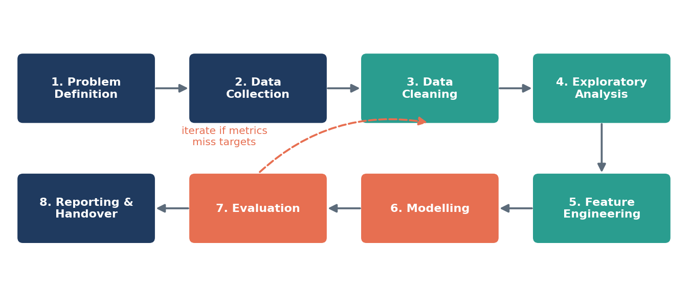
Figure 1: Eight-stage project lifecycle with an iteration loop

4.1 Solution architecture
Figure 2 shows how data will flow through the system. Five source tables are joined at the encounter level, validated, written to a clean analytical table (Parquet format for speed), then used both for exploratory analysis and for model training. The final output is a risk score per patient plus a report.
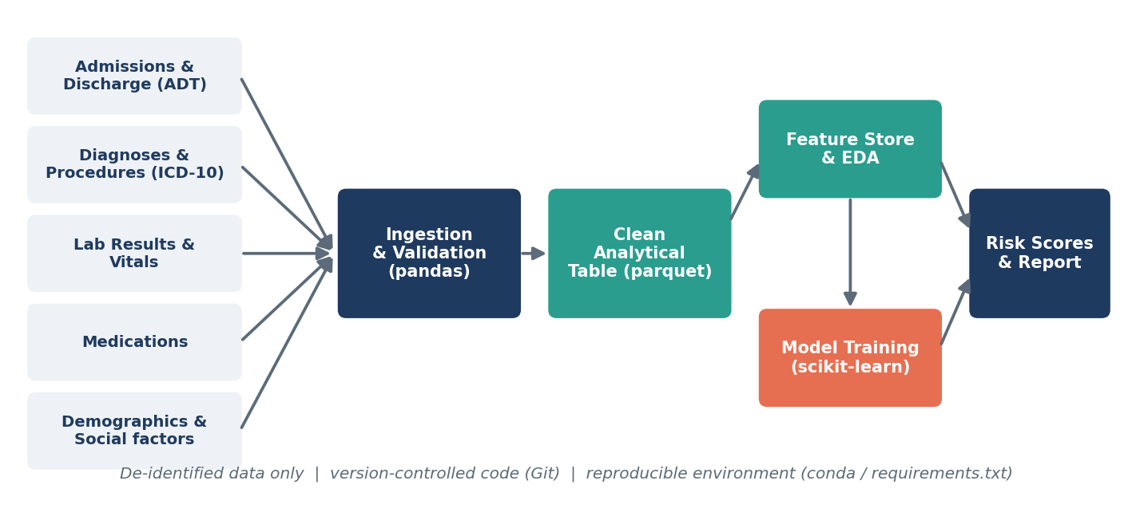
Figure 2: Planned data and solution architecture

4.2 Stage 1: Data collection
Goal: assemble one row per inpatient encounter with every attribute known at the time of discharge, plus the 30-day readmission label.
Table 3: Planned data sources
Source table | Key fields | Join key
Admissions / discharges (ADT) | admit & discharge dates, admission type, ward, discharge disposition | encounter_id, patient_id
Diagnoses & procedures | primary and secondary ICD-10 codes, procedure codes | encounter_id
Labs & vitals | last HbA1c, sodium, haemoglobin, creatinine, BP, heart rate | encounter_id
Medications | number of drugs, high-risk drugs, changes at discharge | encounter_id
Demographics | age, sex, insurance type, postcode-level deprivation index | patient_id

- Load each extract with pandas.read_csv / read_sql, specifying dtypes to save memory.
- Build the target: for each discharge, check whether the same patient_id has an unplanned admission within 1-30 days.
- Write a data dictionary (column name, type, meaning, allowed values, source) before any analysis.
- Leakage guard: keep only information available on or before the discharge timestamp.

4.3 Stage 2: Data cleaning and validation
- Validation rules with pandera: ages 18-110, discharge date after admit date, valid ICD-10 format, lab values in physiological ranges.
- Duplicates: remove exact duplicate encounters; merge transfers between wards into one stay.
- Missing values: profile missingness per column; median/mode imputation for under 5% missing, an is_missing flag plus imputation for informative gaps (such as labs not ordered), and drop columns over 60% missing.
- Outliers: flag with the IQR rule and clinical limits, cap extreme length-of-stay values (winsorise at the 99th percentile), and correct obvious unit errors.
- Standardisation: consistent categorical labels, datetime types, and ICD-10 codes grouped into clinical categories (for example Charlson comorbidity groups).
- Exclusions: in-hospital deaths, transfers to other acute hospitals and planned readmissions.

4.4 Stage 3: Exploratory data analysis (EDA)
- Univariate: distributions of age, length of stay, number of diagnoses and medications; class balance of the target (expected about 15% positive).
- Bivariate: readmission rate by discharge disposition, diagnosis group, age band and insurance; box plots of continuous features split by outcome; chi-square tests and point-biserial correlations.
- Multivariate: correlation heatmap to spot redundant features; interaction views (for example age by number of comorbidities).
- Temporal: monthly readmission trend to check for seasonality and data drift.
- Each insight is logged in a findings table with a chart, observation and implication for modelling.

4.5 Stage 4: Feature engineering
- Utilisation history: number of admissions and ED visits in the past 6 and 12 months (often the strongest predictor).
- Clinical burden: Charlson Comorbidity Index, number of chronic conditions, polypharmacy flag (5 or more drugs).
- Stay characteristics: length of stay, ICU use, weekend discharge, discharge disposition.
- Lab abnormality flags: abnormal values on the last test before discharge.
- Baseline score: compute the LACE index as a benchmark feature.
- Encoding & scaling: one-hot encoding for low-cardinality fields, target encoding (fitted inside cross-validation) for high-cardinality ones, standard scaling for linear models.

4.6 Stage 5: Modelling
Models are trained from simple to complex so that every added layer of complexity has to earn its place:
Table 4: Candidate models
Model | Why it is included | Library
LACE index (rule-based) | Current clinical benchmark to beat | pandas
Logistic regression | Interpretable baseline; coefficients easy to explain | scikit-learn
Decision tree | Shows simple, human-readable rules | scikit-learn
Random forest | Captures non-linear effects, robust to outliers | scikit-learn
Gradient boosting (XGBoost / LightGBM) | Usually the best performer on tabular data | xgboost, lightgbm

- Split: stratified 70% train / 15% validation / 15% test; a time-based split (train on earlier years, test on the latest year) is used as a robustness check.
- Class imbalance: class weights first, then SMOTE applied only inside training folds if needed.
- Tuning: RandomizedSearchCV or Optuna with 5-fold stratified cross-validation.
- Pipelines: every preprocessing step lives inside a scikit-learn Pipeline so no information leaks from validation folds.

4.7 Stage 6: Evaluation
- Primary metric: ROC-AUC, which is threshold-independent and comparable with published studies.
- Secondary metrics: recall and precision at the operating threshold, PR-AUC (more informative with a 15% positive class), and Brier score for calibration.
- Business metric: the share of all readmissions captured in the top 20% of risk scores.
- Explainability: SHAP values for global drivers and per-patient reasons.
- Fairness: compare recall and calibration across age, sex and insurance groups.

4.8 Stage 7: Reporting and handover
Deliverables are a final report, an executive slide deck, a reproducible Git repository (notebooks, src/ package, requirements.txt) and a dashboard mock-up showing the risk list and its drivers.

5. Timeline
The plan allocates 33 hours of focused work plus 2 hours of contingency, for 35 hours in total, spread over four weeks. Four milestones act as quality gates; the next phase does not start until the gate criteria are met.
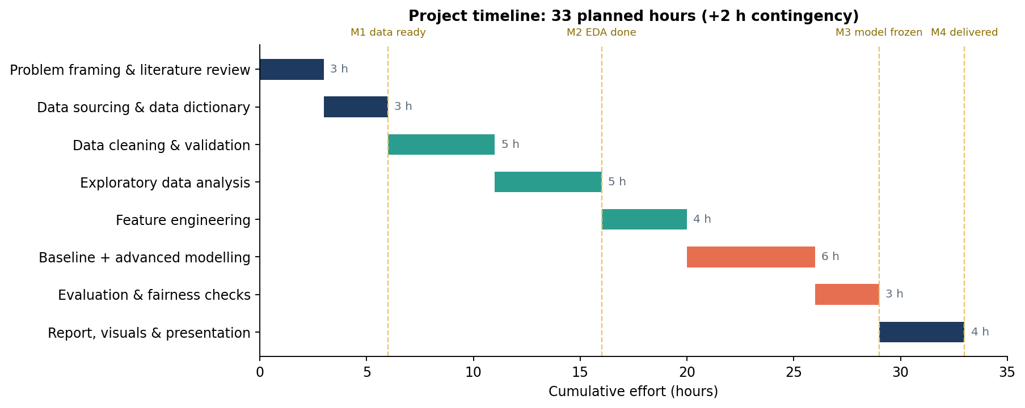
Figure 3: Gantt chart of planned effort with milestones
Table 5: Detailed timeline and effort allocation
Phase | Activities | Hours | Milestone / output
Week 1 | Problem framing, literature review, data sourcing, data dictionary | 6 | M1: data dictionary and raw data loaded
Week 1-2 | Cleaning, validation, EDA | 10 | M2: clean table and EDA findings log
Week 3 | Feature engineering, baseline and advanced models, tuning | 10 | M3: model frozen, test set scored once
Week 3-4 | Evaluation, fairness, explainability | 3 | Evaluation report
Week 4 | Final report, visuals, presentation | 4 | M4: deliverables submitted
Buffer | Contingency for data issues or re-work | 2 | -
Total |  | 35

6. Tools and Technologies
Table 6: Python libraries and tools
Category | Tool / library | Purpose in this project
Language & environment | Python 3.11, Jupyter Lab, VS Code | Analysis, prototyping and scripting
Data handling | pandas, NumPy, pyarrow | Loading, joining, cleaning and reshaping data
Data validation | pandera | Schema and range checks as automated tests
Visualisation | matplotlib, seaborn, plotly | EDA charts, interactive exploration, report figures
Statistics | SciPy, statsmodels | Hypothesis tests, logistic regression with p-values
Machine learning | scikit-learn, XGBoost, LightGBM, imbalanced-learn | Pipelines, models, CV, resampling
Tuning & tracking | Optuna, MLflow | Hyperparameter search, experiment logging
Explainability | SHAP | Global and per-patient feature contributions
Fairness | Fairlearn | Group-wise performance metrics
Reproducibility | Git & GitHub, conda / requirements.txt | Version control, environment pinning
Reporting | Streamlit (prototype), MS Word / PowerPoint | Dashboard mock-up and final deliverables

7. Expected Outcomes

7.1 Deliverables
- A clean, documented, de-identified analytical dataset and data dictionary.
- An EDA report with at least eight visual insights on readmission drivers.
- A tuned classification model with an expected ROC-AUC of about 0.72-0.78, compared with roughly 0.65 for LACE.
- A ranked risk list in which the top 20% of patients is expected to contain over half of all readmissions.
- Explainability outputs (SHAP) and a fairness audit.
- A final report, presentation and GitHub repository.

7.2 Benefits of the approach
- Better targeting: follow-up resources go to the patients who need them most.
- Transparent: starting from interpretable baselines and adding SHAP helps clinicians trust the results.
- Reproducible: pipelines, version control and fixed random seeds mean results can be re-created and audited.
- Extensible: the same pipeline can be retrained for other outcomes, such as ED revisits or length-of-stay prediction.

8. Anticipated Challenges and Mitigation
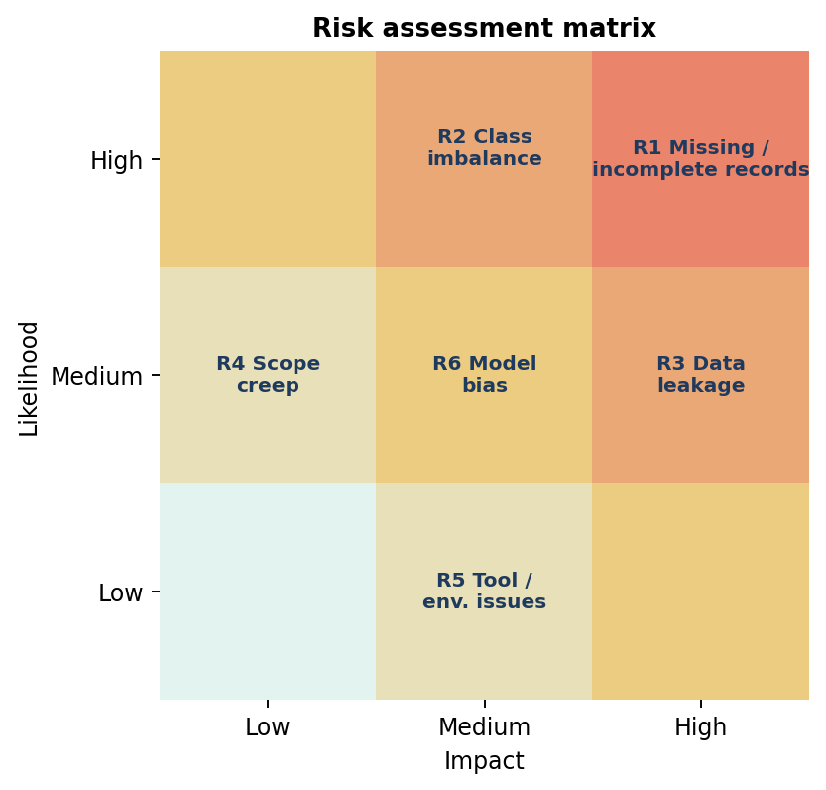
Figure 4: Risk matrix: likelihood versus impact
Table 7: Risk register with mitigation strategies
Risk | Impact on project | Mitigation strategy
R1 Missing / incomplete records | Biased or weak model | Missingness profiling, indicator flags, sensitivity analysis comparing imputation methods
R2 Class imbalance (about 15% positive) | Model predicts "no readmission" for everyone | Class weights, PR-AUC and recall as metrics, threshold tuning
R3 Data leakage | Over-optimistic results that fail in practice | Strict "known at discharge" rule, pipelines inside CV, time-based test split
R4 Scope creep | Missed deadline | Fixed scope list, milestone gates, out-of-scope ideas logged for future work
R5 Tool / environment issues | Lost hours | Pinned requirements.txt, Git commits after each stage, 2-hour buffer
R6 Model bias across groups | Unfair allocation of care | Fairlearn audit, group-wise thresholds if justified, documented limitations
R7 Privacy / compliance | Project cannot proceed | Use de-identified or public data only; no personal identifiers in code or outputs

9. Conclusion
This plan sets out a complete, well-justified approach to predicting 30-day hospital readmissions with Python. It starts from a clear problem with a real decision attached, sets measurable objectives and an explicit scope, and lays out an iterative eight-stage methodology from data collection to reporting. The 35-hour timeline is broken into milestone-gated phases, and the main risks (missing data, class imbalance, leakage and bias) each have a planned mitigation.
The next phases will build on this foundation: a detailed exploratory analysis and visualisation framework, then model development and evaluation, and finally a stakeholder-ready report of insights and recommendations.

10. References
- Chapman, P. et al. (2000). CRISP-DM 1.0: Step-by-step data mining guide. SPSS Inc.
- van Walraven, C. et al. (2010). Derivation and validation of an index to predict early death or unplanned readmission after discharge (LACE). CMAJ, 182(6).
- Strack, B. et al. (2014). Impact of HbA1c measurement on hospital readmission rates. BioMed Research International. (UCI Diabetes 130-US Hospitals dataset.)
- Centers for Medicare & Medicaid Services. Hospital Readmissions Reduction Program (HRRP). cms.gov.
- Lundberg, S. & Lee, S.-I. (2017). A unified approach to interpreting model predictions (SHAP). NeurIPS.

