WEEK 2 TASK
Exploratory Data Analysis and Visualisation Framework Design
A reusable Python framework for exploring any dataset, illustrated with hospital readmission data
Intern | V Chakradhar
Internship | Virtual Data Science Explorer Intern - YuvaIntern
Task | Week 2: EDA and Visualisation Framework Design
Project | Predicting 30-Day Hospital Readmission Risk (hypothetical)
Submission date | 3 October 2026
Note: this is a planning document for a hypothetical project. All figures labelled "mock-up" or "illustrative" use synthetic numbers created to demonstrate the planned analysis; they are not results from real patient data.

Table of Contents
1. Introduction to Exploratory Data Analysis 3
1.1 What EDA is 3
1.2 Why EDA matters 3
1.3 Purpose of this framework 3
2. Understanding Potential Data Types 4
3. Step-by-Step Data Exploration Techniques 5
3.1 Step 1: Load and inspect 5
3.2 Step 2: Data quality audit 5
3.3 Step 3: Handling missing data 5
3.4 Step 4: Detecting and treating outliers 6
3.5 Step 5: Univariate analysis 7
3.6 Step 6: Bivariate analysis 7
3.7 Step 7: Multivariate analysis 8
3.8 Time-based exploration 8
4. Visualisation Strategies 8
4.1 Choosing the right chart 8
4.2 Planned chart catalogue 9
4.3 Visual design standards 10
5. Tools and Libraries 11
6. Reporting and Documentation Plan 11
6.1 Working documentation 11
6.2 Final EDA report structure 12
6.3 Presentation for stakeholders 12
7. Adapting the Framework to Any Dataset 12
8. Conclusion 13
9. References 13

1. Introduction to Exploratory Data Analysis

1.1 What EDA is
Exploratory Data Analysis (EDA) is the stage of a data science project where the analyst gets to know the data before building any model. The term was popularised by the statistician John Tukey in 1977, who described it as "detective work": using summary statistics and, above all, visualisations to discover patterns, spot anomalies, test assumptions and generate hypotheses.
EDA answers three groups of questions:
- Is the data trustworthy? Are there missing values, duplicates, impossible values, inconsistent labels or unit errors?
- What does the data look like? What is the shape of each variable's distribution, what are typical values, and how much variation is there?
- How do variables relate? Which features move together, which differ between groups, and which appear to be linked to the outcome of interest?

1.2 Why EDA matters
- It prevents "garbage in, garbage out". Data errors found after modelling are expensive; EDA catches them early.
- It guides feature engineering and model choice. Skewed variables suggest transformations, non-linear relationships suggest tree-based models, and strongly correlated features suggest removing redundancy.
- It detects leakage. A feature that predicts the target suspiciously well is often a sign that it contains future information.
- It builds domain understanding and produces early insights that stakeholders value even before a model exists.
- It sets realistic expectations about what the data can and cannot answer.

1.3 Purpose of this framework
This document sets out a reusable EDA and visualisation framework that can be applied to any tabular dataset. Each step lists the technique, the Python code pattern and the decision it supports. To make the framework concrete, examples use the running case of a hospital dataset for predicting 30-day patient readmission, where each row is a hospital stay and the target readmitted_30d is 1 if the patient returned within 30 days.
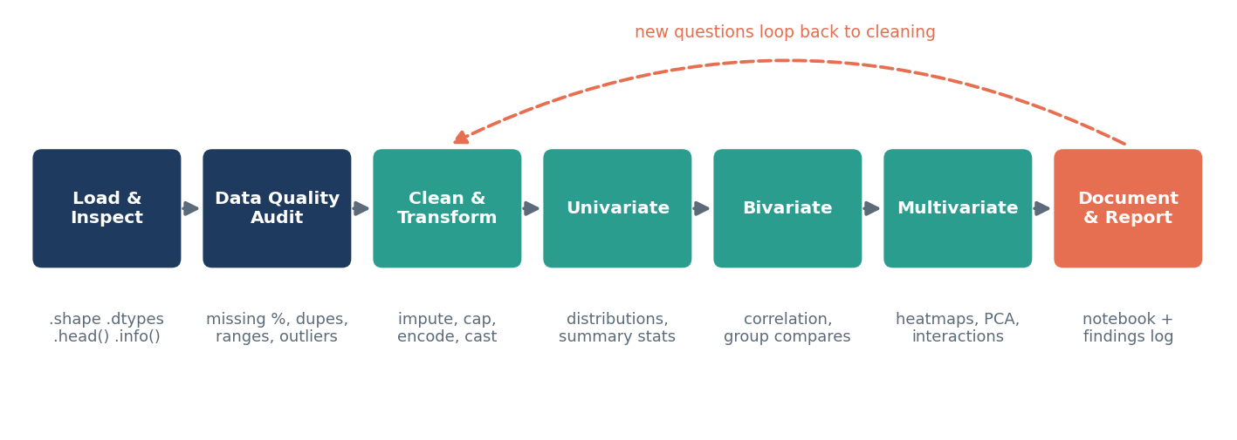
Figure 1: The seven-step EDA workflow used in this framework

2. Understanding Potential Data Types
The right technique depends on the type of each variable, so the first task in any EDA is to classify every column. The table below is the reference used throughout the framework.
Table 1: Data types and how each is explored
Data type | Description | Readmission example | Summary statistics | Typical plots
Continuous numeric | Measured on a scale, any value in a range | age, length_of_stay, HbA1c | mean, median, std, IQR, skewness | histogram, KDE, box, violin
Discrete numeric | Whole-number counts | num_medications, prior_admissions | median, mode, range | bar of counts, histogram
Nominal categorical | Labels with no order | admission_type, discharge_disposition | counts, proportions, mode | bar chart, count plot
Ordinal categorical | Labels with a natural order | age_band, triage_level | median category, counts | ordered bar chart
Binary | Two values | readmitted_30d, sex | proportion / rate | bar, stacked bar
Date / time | Timestamps and dates | admit_date, discharge_date | min, max, frequency by period | line chart, calendar heatmap
Text | Free text | discharge notes | length, top words | word frequency bar
High-cardinality ID / code | Many unique values | ICD-10 diagnosis code, patient_id | number of unique values, top-N | top-N bar chart

Tip: Numbers are not always numeric variables. A postcode or an ICD code stored as a number must be treated as categorical, otherwise averages and correlations become meaningless. Checking df.dtypes and correcting types is therefore step one.

3. Step-by-Step Data Exploration Techniques

3.1 Step 1: Load and inspect
Get a first impression of size, structure and types, and confirm that the data loaded correctly.
import pandas as pd
df = pd.read_csv("encounters.csv", parse_dates=["admit_date", "discharge_date"])
print(df.shape) # rows, columns
df.info() # dtypes and non-null counts
df.head() # first rows
df.describe(include="all").T # summary of every column
df.nunique().sort_values() # cardinality per column

3.2 Step 2: Data quality audit
Table 2: Data quality checklist
Check | How (pandas) | What to look for
Missing values | df.isna().mean().sort_values() | Columns with high % missing; patterns of missingness
Duplicates | df.duplicated(subset=["encounter_id"]).sum() | Repeated records from extraction errors
Impossible values | df.query("age < 0 or age > 110") | Negative ages, discharge before admission
Inconsistent labels | df["sex"].value_counts() | "M", "Male", "male" counted separately
Constant columns | df.columns[df.nunique() == 1] | Columns with no information
Target balance | df["readmitted_30d"].value_counts(normalize=True) | Class imbalance (about 15% positive expected)

3.3 Step 3: Handling missing data
Missing data is handled according to why it is missing, because the mechanism decides whether a simple fix will introduce bias:
- MCAR (Missing Completely At Random): missingness is unrelated to anything, for example a random data-entry failure. Dropping rows is safe if the amount is small.
- MAR (Missing At Random): missingness depends on other observed variables, for example HbA1c tested less often in younger patients. Use imputation conditioned on other variables (KNN or iterative imputation).
- MNAR (Missing Not At Random): missingness depends on the missing value itself or carries meaning, for example a lab not ordered because the doctor judged the patient healthy. Impute and add an is_missing indicator, because the absence is itself informative.
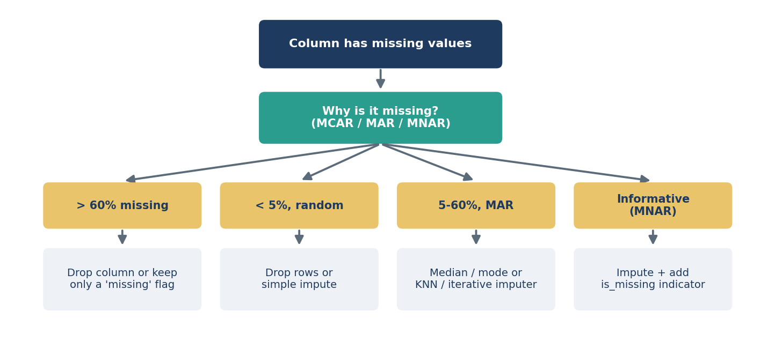
Figure 2: Decision flow for handling missing values
- Visualise missingness with the missingno library (msno.matrix(df), msno.heatmap(df)) to see whether gaps occur together.
- Compare the target rate for rows with and without missing values; a large difference suggests MNAR.
- Fit imputers on the training data only, inside a scikit-learn Pipeline, to avoid leakage.

3.4 Step 4: Detecting and treating outliers
Table 3: Outlier detection methods
Method | Rule | Best for
IQR rule | below Q1 - 1.5 x IQR or above Q3 + 1.5 x IQR | Skewed data; robust default
Z-score | |z| > 3 | Roughly normal data
Domain limits | Clinical or business ranges (e.g. heart rate 20-250) | Catching data-entry errors
Isolation Forest / LOF | Model-based anomaly score | Multivariate outliers

Detected outliers are investigated before being treated. Errors (such as an age of 999) are corrected or set to missing. Genuine but extreme values (such as a 60-day stay) are kept but capped (winsorised) or log-transformed so they do not dominate the analysis. Every treatment is logged in the cleaning notes.
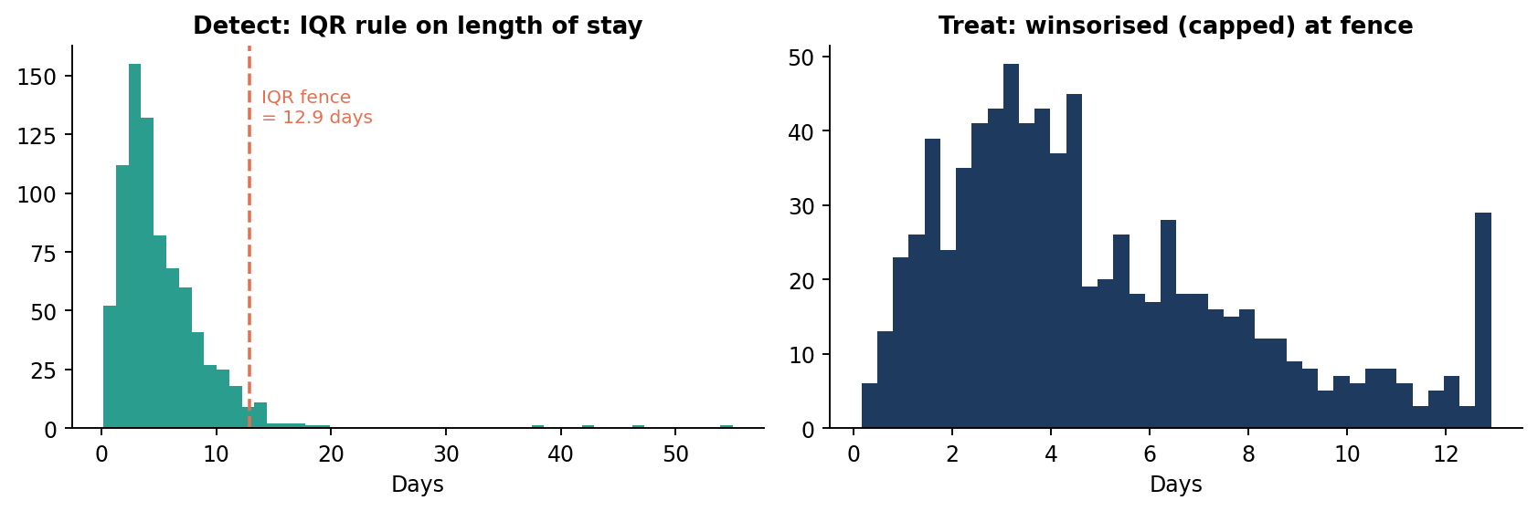
Figure 3: Example of IQR outlier detection and capping on length of stay (synthetic data)

3.5 Step 5: Univariate analysis
Each variable is examined on its own to understand its distribution.
- Numeric: mean, median, standard deviation, min/max, quartiles, skewness and kurtosis; histogram with KDE and a box plot. A large gap between mean and median indicates skew (length of stay is usually right-skewed).
- Categorical: frequency and percentage tables; bar chart sorted by count; rare categories (under 1%) flagged for grouping into "Other".
- Target variable: class proportions, which determine whether resampling or class weights will be needed later.
num_cols = df.select_dtypes("number").columns
df[num_cols].agg(["mean", "median", "std", "skew"]).T
for col in num_cols:
sns.histplot(df[col], kde=True); plt.title(col); plt.show()
df["discharge_disposition"].value_counts(normalize=True).plot.barh()

3.6 Step 6: Bivariate analysis
Pairs of variables are examined, with particular focus on each feature's relationship with the target.
Table 4: Bivariate techniques by variable type
Variable pair | Statistic / test | Visualisation
Numeric vs numeric | Pearson (linear), Spearman (monotonic) correlation | Scatter plot with trend line, hexbin for large data
Numeric vs binary target | Point-biserial correlation, Mann-Whitney U test | Box / violin plot split by target, overlaid KDE
Categorical vs binary target | Chi-square test, Cramer's V, target rate per category | Bar chart of readmission rate per category
Categorical vs categorical | Chi-square, contingency table | Stacked / grouped bar, mosaic plot
Numeric vs time | Rolling mean, trend | Line chart

# Readmission rate by category, with counts for context
(df.groupby("discharge_disposition")["readmitted_30d"]
.agg(rate="mean", n="size").sort_values("rate", ascending=False))

from scipy.stats import chi2_contingency, mannwhitneyu
chi2, p, _, _ = chi2_contingency(pd.crosstab(df["admission_type"], df["readmitted_30d"]))
mannwhitneyu(df.loc[df.readmitted_30d == 1, "length_of_stay"],
df.loc[df.readmitted_30d == 0, "length_of_stay"])

3.7 Step 7: Multivariate analysis
- Correlation heatmap of all numeric features to find redundancy (|r| > 0.8 suggests dropping or combining one feature) and multicollinearity; follow up with Variance Inflation Factor (VIF) for linear models.
- Pair plots (sns.pairplot(df, hue="readmitted_30d")) on a sample of 5-6 key features to view all pairwise relationships at once.
- Grouped / faceted plots to study interactions, for example readmission rate by age band, faceted by number of chronic conditions.
- Dimensionality reduction (PCA, or t-SNE / UMAP for visual exploration) to see whether readmitted patients form distinct clusters.
- Pivot tables for three-way comparisons (e.g. disposition x diagnosis group -> readmission rate).

3.8 Time-based exploration
When data includes dates, the framework adds a temporal check: monthly volumes and readmission rates (to spot seasonality such as winter peaks), day-of-week effects (such as weekend discharges) and data drift between early and late periods. Drift found here affects how data is later split for validation.

4. Visualisation Strategies

4.1 Choosing the right chart
Every chart should answer a specific question. The framework picks the chart from the question being asked, not the other way round:
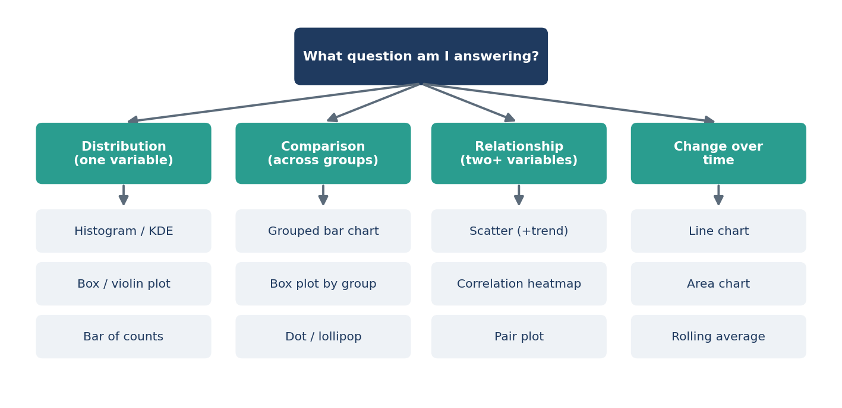
Figure 4: Chart selection guide based on the analytical question

4.2 Planned chart catalogue
Table 5: Visualisation catalogue
Chart | Purpose | Example use in the project | Library
Histogram / KDE | Shape of a numeric distribution | Age and length-of-stay distributions | seaborn
Box / violin plot | Compare spread across groups, show outliers | Length of stay: readmitted vs not | seaborn
Bar / count plot | Compare categories | Readmission rate by discharge disposition | matplotlib, seaborn
Scatter / hexbin | Relationship between two numeric variables | Age vs number of medications | seaborn, plotly
Correlation heatmap | Overview of numeric relationships | Redundancy among clinical features | seaborn
Pair plot | All pairwise relationships | Key features coloured by outcome | seaborn
Line chart | Trends over time | Monthly readmission rate | matplotlib, plotly
Missingness matrix | Pattern of missing data | Which labs are missing together | missingno
Interactive dashboard | Drill-down for stakeholders | Filter by ward, diagnosis, month | plotly, Streamlit

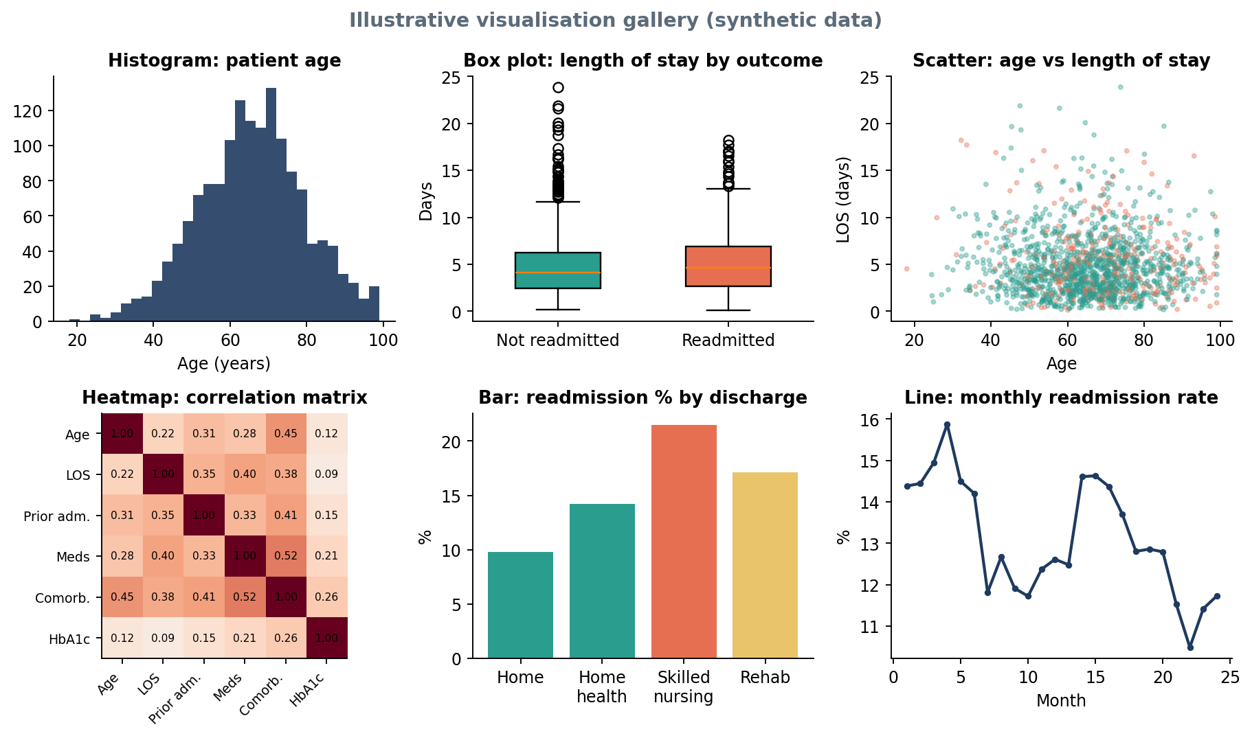
Figure 5: Examples of the six core chart types applied to the readmission case (synthetic data)

4.3 Visual design standards
- One message per chart, stated in the title (e.g. "Patients discharged to nursing facilities are readmitted twice as often"), not just "Bar chart of disposition".
- Consistent colours: one colour for "not readmitted" and one highlight colour for "readmitted" used across every figure; colour-blind-safe palettes (e.g. seaborn colorblind).
- Labelled axes with units, readable fonts (10pt or larger), and data labels where exact values matter.
- Honest scales: bar charts start at zero; avoid 3D and pie charts with many slices.
- Show sample sizes (n) on group comparisons so small groups are not over-interpreted.
- Reusable plotting functions so every chart has the same style and can be regenerated with one command.
def rate_by(df, col, target="readmitted_30d", ax=None):
"""Bar chart of target rate per category, annotated with n."""
s = df.groupby(col)[target].agg(["mean", "size"]).sort_values("mean")
ax = s["mean"].mul(100).plot.barh(ax=ax, color="#2A9D8F")
for i, (r, n) in enumerate(zip(s["mean"], s["size"])):
ax.text(r * 100 + 0.3, i, f"{r:.1%} (n={n:,})", va="center")
ax.set_xlabel("Readmission rate (%)"); ax.set_title(f"Readmission rate by {col}")
return ax

5. Tools and Libraries
Table 6: Python tools and their contribution
Library | Role in the EDA | Key functions
pandas | Core data structure; loading, cleaning, grouping, reshaping | read_csv, info, describe, groupby, pivot_table, crosstab
NumPy | Fast numeric operations and array maths | where, percentile, log1p, clip
matplotlib | Base plotting engine; full control over figure layout | subplots, bar, hist, savefig
seaborn | Statistical plots with less code; attractive defaults | histplot, boxplot, heatmap, pairplot, catplot
plotly | Interactive charts with hover and zoom for stakeholders | px.scatter, px.histogram, px.line
SciPy / statsmodels | Statistical tests and confidence intervals | chi2_contingency, mannwhitneyu, VIF
missingno | Visualising missing-data patterns | matrix, bar, heatmap
ydata-profiling | Automated first-pass profile report (HTML) | ProfileReport(df)
scikit-learn | Imputation, scaling, PCA | SimpleImputer, KNNImputer, PCA
Jupyter Lab | Interactive, documented analysis environment | Notebooks with Markdown narrative
Streamlit | Lightweight dashboard prototype | st.plotly_chart, st.selectbox

Automated profiling (ydata-profiling) is used only as a first pass to flag issues quickly; the targeted analysis in Section 3 is still carried out manually so each finding is understood and explained.

6. Reporting and Documentation Plan

6.1 Working documentation
- Structured notebooks: 01_load_and_audit.ipynb, 02_cleaning.ipynb, 03_univariate.ipynb, 04_bivariate_multivariate.ipynb, each beginning with its purpose and ending with a summary of findings.
- Cleaning log: every transformation (rows dropped, values imputed or capped) with the reason and the number of records affected.
- Findings log: a running table where each insight is recorded as it is found.
- Version control: notebooks and src/plots.py committed to GitHub; figures saved to reports/figures/ at 300 dpi.
Table 7: Example findings log template (illustrative entries)
ID | Finding | Evidence (chart) | Implication for modelling
F1 | Readmission rate roughly doubles for patients with 3+ prior admissions | Bar chart: rate by prior admissions | Include utilisation history as a key feature
F2 | Length of stay is strongly right-skewed | Histogram | Log-transform for linear models
F3 | HbA1c missing for 80% of records, but missingness is linked to outcome | Missingness matrix + rate comparison | Keep an is_missing flag
F4 | Number of medications and comorbidities are correlated (r = 0.52) | Heatmap | Monitor multicollinearity in logistic regression

6.2 Final EDA report structure
- Executive summary: the five to eight most important findings in plain language.
- Data overview: sources, size, time period, data dictionary, inclusion and exclusion criteria.
- Data quality assessment: missingness, duplicates, outliers and how each was handled.
- Univariate profiles: key distributions and the target balance.
- Relationships with the outcome: bivariate and multivariate results with charts and statistical tests.
- Temporal patterns: trends, seasonality and drift.
- Implications for modelling: recommended features, transformations, validation strategy.
- Limitations and open questions.
- Appendix: full tables, code references, profiling report.

6.3 Presentation for stakeholders
A short slide deck (8-10 slides) accompanies the report. It follows a "one slide, one insight" rule: each slide has a headline stating the finding, a single supporting chart, and one line on why it matters. Technical details such as statistical tests are moved to an appendix. For clinical teams, an interactive Plotly/Streamlit view lets users filter by ward or diagnosis group.

7. Adapting the Framework to Any Dataset
Although illustrated with readmission data, the framework is dataset-agnostic. The same sequence applies to sales, finance, marketing or sensor data:
Table 8: Applying the framework across domains
Framework step | Healthcare example | Retail example | Finance example
Target | Readmitted in 30 days | Customer churns | Loan defaults
Key data types | Labs, diagnoses, dates | Transactions, product categories | Income, credit history
Typical missingness | Labs not ordered | Missing demographics | Self-reported income
Typical outliers | Very long stays | Bulk orders | Very high incomes
Key bivariate view | Rate by discharge type | Churn by tenure | Default by credit grade

Summary: The framework is a repeatable checklist: classify types, audit quality, treat missing data and outliers on purpose, explore from one variable to many, visualise with clear rules, and record every finding with its implication. This produces an analysis that is transparent, reproducible and directly useful for the modelling stage.

8. Conclusion
Exploratory Data Analysis turns a raw table into understanding. This framework sets out a clear, step-by-step process covering data type identification, quality auditing, principled handling of missing values and outliers, and univariate, bivariate, multivariate and temporal analysis, supported by a deliberate visualisation strategy and a documented reporting plan. It specifies which Python libraries to use at each step and why.
Applied to the readmission project, the framework will establish which patient and hospital-stay factors are linked to returning within 30 days, produce a clean and well-understood dataset, and give the modelling stage a strong evidence-based starting point.

9. References
- Tukey, J. W. (1977). Exploratory Data Analysis. Addison-Wesley.
- McKinney, W. (2022). Python for Data Analysis, 3rd ed. O'Reilly.
- Waskom, M. (2021). seaborn: statistical data visualization. Journal of Open Source Software, 6(60).
- Little, R. J. A. & Rubin, D. B. (2019). Statistical Analysis with Missing Data, 3rd ed. Wiley.
- Wilke, C. O. (2019). Fundamentals of Data Visualization. O'Reilly.

