WEEK 3 TASK
Machine Learning Model Development and Evaluation Plan
Step-by-step Python plan for a 30-day hospital readmission prediction model
Intern | V Chakradhar
Internship | Virtual Data Science Explorer Intern - YuvaIntern
Task | Week 3: Python-Based ML Model Development and Evaluation Plan
Project | Predicting 30-Day Hospital Readmission Risk (hypothetical)
Submission date | 3 October 2026
Note: this is a planning document for a hypothetical project. All figures labelled "mock-up" or "illustrative" use synthetic numbers created to demonstrate the planned analysis; they are not results from real patient data.

Table of Contents
1. Introduction 3
2. Problem Definition 3
2.1 The problem 3
2.2 Justification 4
2.3 Success criteria 4
3. Data Preprocessing 4
3.1 Data cleaning 4
3.2 Normalisation and encoding 5
3.3 Feature engineering 5
3.4 Feature selection 6
3.5 Preprocessing challenges and solutions 6
4. Model Selection and Training 7
4.1 Candidate models 7
4.2 Choice of model 7
4.3 Data splitting and training process 8
4.4 Hyperparameter tuning strategy 8
5. Evaluation Metrics and Validation 9
5.1 Why accuracy is not enough 9
5.2 Threshold selection 10
5.3 Cross-validation strategy 11
5.4 Model interpretation 11
6. Model Deployment and Maintenance (Conceptual) 12
6.1 Deployment design 12
6.2 Monitoring and updating 12
7. Timeline and Effort 13
8. Conclusion 13
9. References 14

1. Introduction
This document is a detailed plan for developing, evaluating and deploying a machine learning model in Python. It covers every phase of the work: problem definition, data preprocessing, feature engineering and selection, model selection and training, hyperparameter tuning, evaluation and validation, and post-deployment maintenance. No code needs to be run at this stage, but each step is specified precisely enough (including the scikit-learn components to be used) to guide a full implementation.
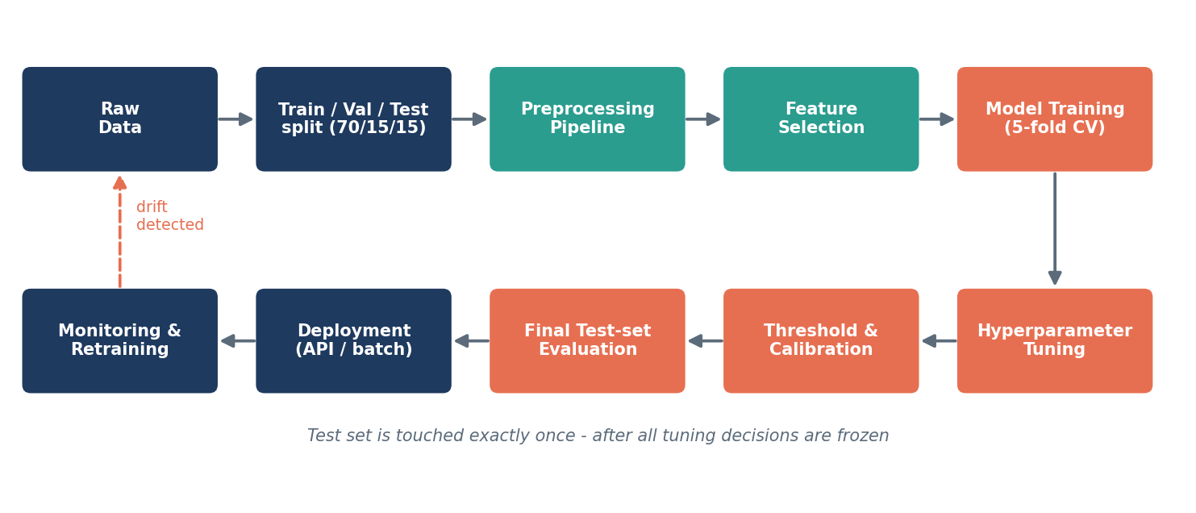
Figure 1: End-to-end machine learning workflow

2. Problem Definition

2.1 The problem
Predict, at the moment of discharge, the probability that an adult inpatient will have an unplanned readmission to hospital within 30 days.
Table 1: Formal problem specification
Element | Definition
ML task type | Supervised binary classification, with probability output
Unit of prediction | One hospital stay (encounter)
Target variable | readmitted_30d = 1 if an unplanned admission occurs 1-30 days after discharge, else 0
Prediction time | At discharge; only information available by then may be used
Expected class balance | About 15% positive (imbalanced)
Data | About 100,000 de-identified encounters: demographics, diagnoses, procedures, labs, medications, utilisation history
Decision supported | Enrol the top-risk patients in a post-discharge follow-up programme

2.2 Justification
- High impact: readmissions are costly, often harmful for patients, and used by payers as a quality measure, with financial penalties for hospitals that perform poorly.
- Actionable: a risk score at discharge triggers a concrete, affordable intervention (a follow-up call within 48 hours, an early clinic appointment, a medication review).
- Suitable for ML: the relationship between risk and its many contributing factors (comorbidities, prior use, social factors, medication complexity) is non-linear and interacting, which suits ensemble methods better than hand-made scoring rules such as LACE.
- Measurable: success can be measured both statistically (ROC-AUC, recall) and operationally (readmissions avoided per 100 patients contacted).

2.3 Success criteria
- ROC-AUC of at least 0.72 on the held-out test set, and at least 0.05 above the LACE baseline.
- Recall of at least 60% at the operating threshold chosen for the follow-up programme's capacity.
- Well-calibrated probabilities (Brier score better than baseline; calibration curve close to the diagonal).
- Recall difference between demographic groups below 10 percentage points.

3. Data Preprocessing

3.1 Data cleaning
Table 2: Data cleaning plan
Issue | Planned treatment | Python tool
Duplicate encounters | Drop exact duplicates; merge ward transfers into one stay | pandas drop_duplicates
Invalid values | Rule-based validation (age 18-110, discharge after admit, lab ranges); invalid values set to NaN | pandera, pandas
Missing numeric values | Median imputation plus missing-indicator column | SimpleImputer(strategy="median", add_indicator=True)
Missing categorical values | Treat as its own category "Unknown" | SimpleImputer(strategy="constant")
Outliers | Cap at 1st/99th percentile (winsorise) for linear models; tree models left as is | custom transformer / np.clip
Inconsistent categories | Standardise labels; group rare levels (under 1%) into "Other" | OneHotEncoder(min_frequency=0.01)
Excluded records | In-hospital deaths, transfers to other hospitals, planned readmissions | pandas filtering

3.2 Normalisation and encoding
- Scaling: StandardScaler for logistic regression and other distance- or gradient-based models; tree-based models do not need scaling.
- Skewed variables (length of stay, number of prior visits): log1p or PowerTransformer (Yeo-Johnson) for linear models.
- Nominal categories: one-hot encoding for low-cardinality fields (admission type, discharge disposition).
- High-cardinality codes (thousands of ICD-10 codes): first grouped into clinically meaningful categories (Charlson / Elixhauser comorbidity groups, CCSR categories), then target-encoded inside cross-validation folds to avoid leakage.

3.3 Feature engineering
Table 3: Planned engineered features
Feature group | Engineered features | Rationale
Utilisation history | admissions, ED visits and outpatient visits in prior 6 / 12 months; days since last discharge | Past use is the strongest known predictor of readmission
Clinical burden | Charlson Comorbidity Index, count of chronic conditions, specific flags (heart failure, COPD, diabetes, CKD) | Sicker patients are more likely to return
Medication complexity | number of drugs, polypharmacy (5 or more), high-risk drugs (anticoagulants, insulin), number of medication changes | Medication errors are a common cause of readmission
Stay characteristics | length of stay, ICU stay, number of procedures, weekend discharge, discharge disposition | Severity and quality of the transition
Lab abnormality | abnormal sodium, haemoglobin, creatinine at discharge; HbA1c tested / result | Unresolved clinical instability
Social / access | age band, insurance type, deprivation index, lives alone (if available) | Support at home affects recovery
Benchmark | LACE score | Provides a clinical baseline and an extra feature

3.4 Feature selection
- Filter: remove constant and near-constant features (VarianceThreshold) and one of each highly correlated pair (|r| > 0.85).
- Statistical screening: mutual information with the target to rank features and drop the weakest.
- Embedded: L1-regularised logistic regression and tree-based feature importance to see which features the models actually use.
- Wrapper (final check): recursive feature elimination with cross-validation (RFECV) to find the smallest set that keeps performance.
- Explainability check: SHAP values on the final model to confirm that the important features make clinical sense.

3.5 Preprocessing challenges and solutions
Table 4: Preprocessing challenges and mitigation
Challenge | Why it matters | Solution
Data leakage | Features recorded after discharge (e.g. follow-up visit outcome) inflate scores but are unavailable in practice | Strict "known at discharge" rule; all preprocessing inside a Pipeline fitted only on training folds
Class imbalance (15%) | Model may ignore the minority class | class_weight="balanced" / scale_pos_weight; SMOTE inside folds only if needed; threshold tuning
Same patient in train and test | Repeated patients leak information across splits | Group-aware splitting (GroupKFold / StratifiedGroupKFold on patient_id)
Temporal drift | Clinical practice changes over time | Time-based hold-out set (latest 6 months) as robustness check
High-cardinality codes | Sparse, noisy features | Clinical grouping plus regularised target encoding

All of these steps are combined in a single scikit-learn Pipeline, so exactly the same transformations are applied in training, validation and production:
from sklearn.compose import ColumnTransformer
from sklearn.pipeline import Pipeline
from sklearn.impute import SimpleImputer
from sklearn.preprocessing import StandardScaler, OneHotEncoder

numeric = Pipeline([("impute", SimpleImputer(strategy="median", add_indicator=True)),
("scale", StandardScaler())])
categorical = Pipeline([("impute", SimpleImputer(strategy="constant", fill_value="Unknown")),
("onehot", OneHotEncoder(handle_unknown="ignore", min_frequency=0.01))])
preprocess = ColumnTransformer([("num", numeric, num_cols), ("cat", categorical, cat_cols)])
model = Pipeline([("prep", preprocess), ("clf", LogisticRegression(class_weight="balanced"))])

4. Model Selection and Training

4.1 Candidate models
Table 5: Model comparison
Model | Strengths | Weaknesses | Role in the project
Logistic regression | Fast, interpretable coefficients and odds ratios, well-calibrated | Assumes linear effects; misses interactions | Interpretable baseline
Decision tree | Human-readable rules, handles non-linearity | Unstable, overfits easily | Explanation aid; weak learner reference
Random forest | Robust, handles interactions, few assumptions | Larger, less interpretable, probabilities may need calibration | Strong ensemble benchmark
Gradient boosting (XGBoost / LightGBM) | Usually the top performer on tabular data; handles missing values natively | More hyperparameters; risk of overfitting without tuning | Primary candidate
Linear regression | Simple | Wrong for a binary target: predictions not bounded between 0 and 1 | Not used (explained for completeness)

4.2 Choice of model
Gradient-boosted trees (LightGBM, with XGBoost as an alternative) are proposed as the final model, with logistic regression kept as the interpretable benchmark. The reasons are:
- Readmission risk depends on interactions (for example, many medications matter more for elderly patients with heart failure). Boosted trees capture these automatically.
- Published readmission studies consistently report boosted trees achieving ROC-AUC around 0.70-0.80, compared with 0.60-0.70 for LACE.
- LightGBM handles missing values and categorical features natively, and trains in seconds on 100,000 rows on a laptop.
- SHAP's TreeExplainer gives exact, fast explanations for each prediction, addressing the "black box" concern for clinicians.
- If the boosted model does not beat logistic regression by a meaningful margin (above 0.02 AUC), the simpler model is preferred because it is easier to explain and maintain.
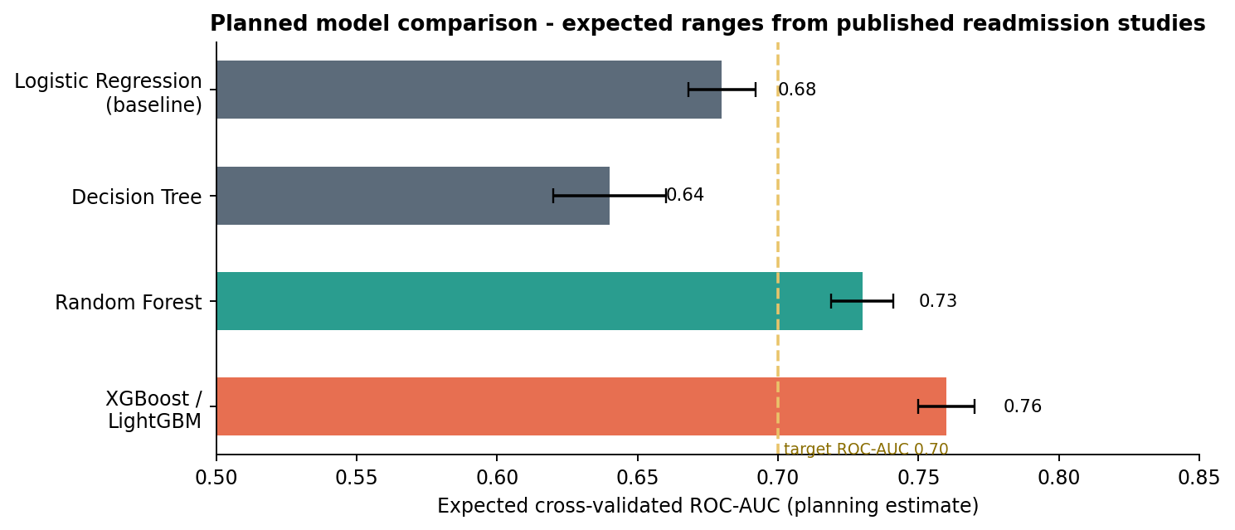
Figure 2: Expected model performance range used for planning (based on published readmission studies)

4.3 Data splitting and training process
- Hold out a test set (15%), stratified by target and grouped by patient_id. It is locked away and used once at the end.
- Development set (85%) used for 5-fold StratifiedGroupKFold cross-validation.
- Train the LACE baseline and logistic regression to set the reference score.
- Train decision tree, random forest and LightGBM with default parameters to compare out-of-the-box performance.
- Tune the top two models (Section 4.4).
- Refit the chosen model on the full development set with the best parameters and calibrate probabilities.
- Choose the decision threshold, then score the test set once and report final results.

4.4 Hyperparameter tuning strategy
Table 6: Hyperparameter search space
Model | Key hyperparameters | Search range
Logistic regression | C (regularisation strength), penalty | C: 0.001-100 (log scale); L1, L2, elastic-net
Random forest | n_estimators, max_depth, min_samples_leaf, max_features | 200-1000; 4-20; 1-50; sqrt, 0.3-0.7
LightGBM | learning_rate, num_leaves, max_depth, min_child_samples, subsample, colsample_bytree, reg_lambda | 0.01-0.2; 15-127; 3-12; 20-200; 0.6-1.0; 0.6-1.0; 0-10

- Method: Bayesian optimisation with Optuna (about 100 trials) for LightGBM; RandomizedSearchCV for the other models. Bayesian search finds good settings with fewer trials than grid search.
- Objective: mean cross-validated ROC-AUC; PR-AUC reported alongside.
- Overfitting control: early stopping on a validation fold, regularisation, and comparing training vs validation scores (a gap above 0.05 is a warning sign).
- Reproducibility: fixed random seeds; every trial logged to MLflow with parameters, metrics and the dataset version.

5. Evaluation Metrics and Validation

5.1 Why accuracy is not enough
With only 15% of patients readmitted, a model that predicts "no readmission" for everyone would be 85% accurate and completely useless. Metrics are therefore chosen to reflect performance on the minority class and the real-world decision.
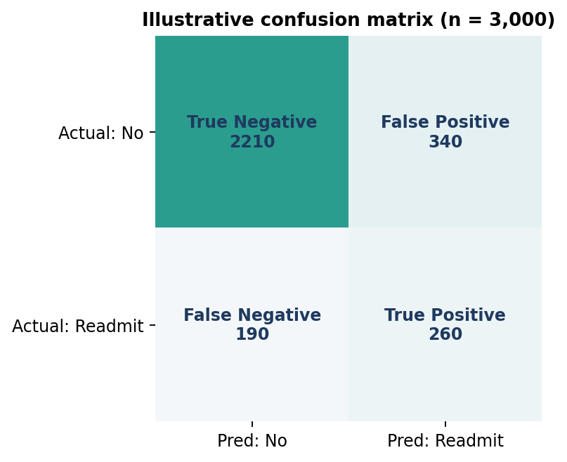
Figure 3: Illustrative confusion matrix at the chosen threshold
Table 7: Evaluation metrics and justification
Metric | Formula / meaning | Role in this project
ROC-AUC | Probability that a random readmitted patient is ranked above a random non-readmitted one | Primary metric: threshold-independent, comparable with literature
PR-AUC (average precision) | Area under precision-recall curve | More informative than ROC-AUC when positives are rare
Recall (sensitivity) | TP / (TP + FN): share of readmissions caught | Key clinical metric: missed patients get no follow-up
Precision (PPV) | TP / (TP + FP): share of flagged patients who are readmitted | Measures wasted follow-up effort
F1-score | Harmonic mean of precision and recall | Single summary when balancing both
Brier score & calibration curve | Accuracy of predicted probabilities | Clinicians need a 30% score to mean about 30% risk
Recall @ top 20% | Share of readmissions in the top 20% of risk scores | Business metric tied to programme capacity
Accuracy | (TP + TN) / total | Reported only for completeness

Using the illustrative confusion matrix above: recall = 260 / (260 + 190) = 58%, precision = 260 / (260 + 340) = 43%, F1 = 0.49, accuracy = 82%. The accuracy figure looks good but hides the fact that 190 readmitted patients were missed, which is why recall and precision drive the decisions.
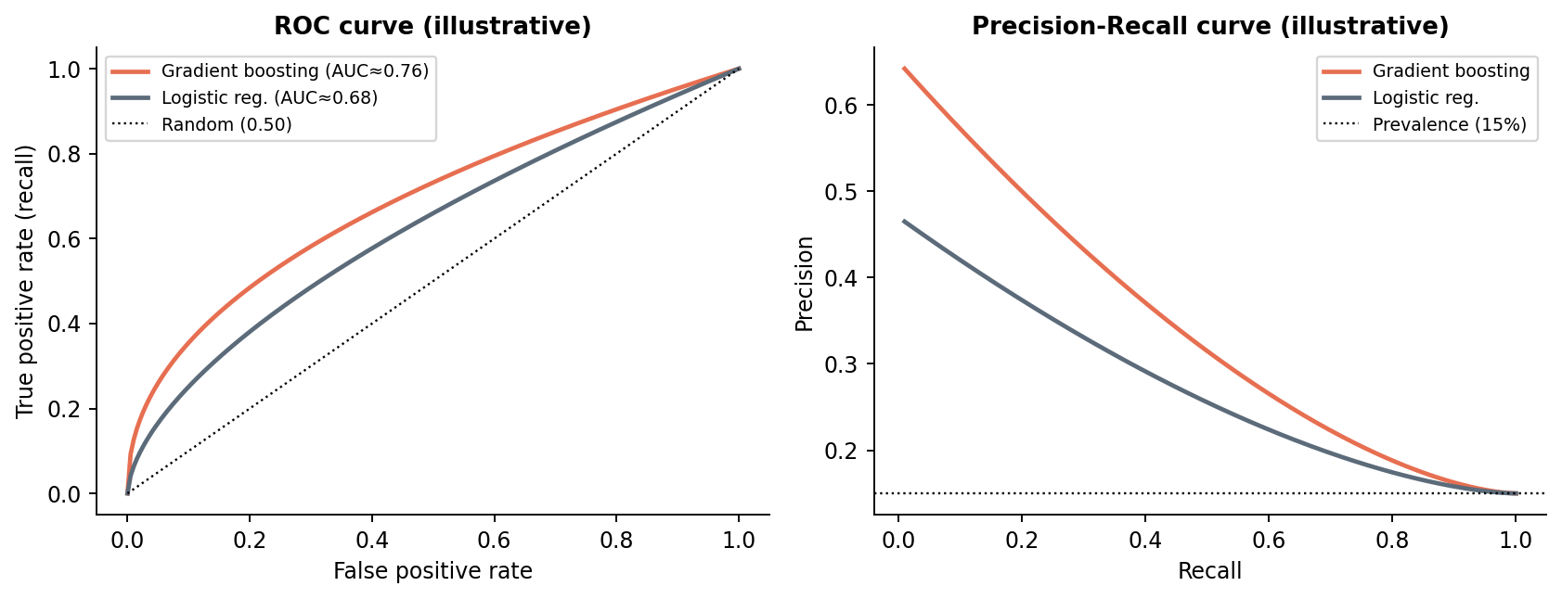
Figure 4: ROC and precision-recall curves used to compare models (illustrative)

5.2 Threshold selection
A model outputs probabilities; the hospital needs a yes/no decision. The threshold is chosen from the business constraint, not fixed at 0.5. If the follow-up team can contact 20% of discharged patients, the threshold is set at the 80th percentile of predicted risk. Alternatively, a cost-based threshold weighs the cost of a missed readmission (high) against the cost of an unnecessary follow-up call (low). The threshold is chosen using cross-validation predictions, never the test set.

5.3 Cross-validation strategy
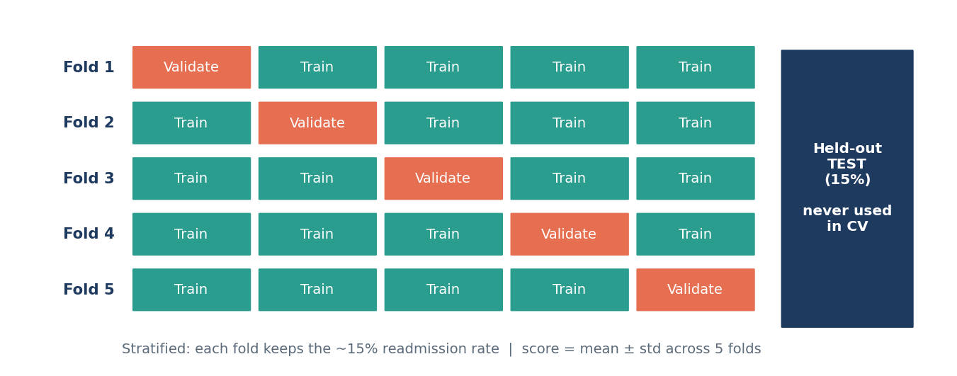
Figure 5: Stratified 5-fold cross-validation with a separate held-out test set
- Stratified so every fold keeps the 15% positive rate; grouped by patient so one patient's stays never appear in both training and validation folds.
- Report the mean and standard deviation across folds; a model with a high mean but large variation is less trustworthy.
- Nested cross-validation (inner loop for tuning, outer loop for scoring) is used for the final comparison so that tuning does not bias the estimate.
- Temporal validation: train on the first 2.5 years, test on the last 6 months, to check the model still works on newer data.
- Statistical comparison: paired comparison of fold scores (or DeLong's test for AUC) to confirm that differences between models are real, not noise.
- Subgroup evaluation: recall, precision and calibration reported separately by age band, sex and insurance type (Fairlearn MetricFrame).

5.4 Model interpretation
- Global: SHAP summary plot ranking features by average impact; partial dependence plots for key features such as prior admissions.
- Local: SHAP waterfall for each patient, giving care teams the top three reasons behind a high score (for example "4 admissions in past year, discharged to nursing facility, 12 medications").
- Sanity checks: clinicians review whether the drivers make medical sense; unexpected drivers are investigated as possible leakage.

6. Model Deployment and Maintenance (Conceptual)

6.1 Deployment design
- Packaging: the full fitted pipeline (preprocessing + model) saved with joblib and registered in the MLflow Model Registry with a version number.
- Serving: a nightly batch job scores all patients discharged that day and writes a ranked risk list to the care coordinators' dashboard. A FastAPI endpoint offers real-time scoring if later integrated with the EHR.
- Containerisation: Docker image with pinned library versions so the model behaves identically everywhere.
- Human in the loop: the score supports, not replaces, clinical judgement; staff can override and record the reason.
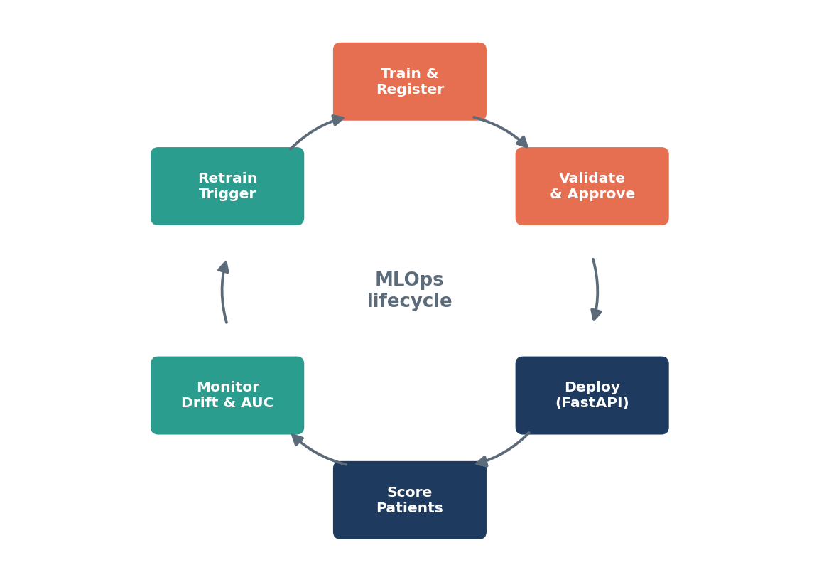
Figure 6: Continuous lifecycle for maintaining the deployed model

6.2 Monitoring and updating
Table 8: Post-deployment monitoring plan
What is monitored | How | Action trigger
Input data drift | Population Stability Index (PSI) per feature, monthly | PSI > 0.2 on a key feature
Prediction drift | Distribution of risk scores over time | Mean score shifts by more than 20%
Performance | ROC-AUC and recall once 30-day outcomes are known (one-month lag) | AUC falls more than 0.03 below validation
Calibration | Observed vs predicted readmission rate per risk decile | Systematic over- or under-prediction
Fairness | Recall by demographic group | Gap above 10 percentage points
Data pipeline health | Row counts, schema checks, missing-value rates | Any failed validation

- Scheduled retraining every 6 months on the most recent 3 years of data, plus triggered retraining when monitoring thresholds are crossed.
- A new model replaces the current one only if it performs at least as well on a recent hold-out set (champion vs challenger), after clinical sign-off.
- Every model version, dataset version and evaluation report is kept, so any past prediction can be traced and audited.

7. Timeline and Effort
Table 9: Effort allocation for the modelling phase
Phase | Activities | Hours
Problem definition | Specify target, success criteria, leakage rules | 3
Preprocessing | Cleaning, encoding, pipelines, validation tests | 7
Feature engineering & selection | Build feature groups, selection experiments | 6
Model training & tuning | Baselines, candidate models, Optuna tuning, MLflow tracking | 8
Evaluation & interpretation | CV, threshold choice, test-set scoring, SHAP, fairness | 5
Deployment design & documentation | Packaging plan, monitoring plan, write-up | 4
Total |  | 33

8. Conclusion
This plan covers every phase of building a machine learning model to predict 30-day hospital readmission. It defines the problem precisely, sets out a leakage-safe preprocessing and feature engineering pipeline, compares candidate models and justifies gradient boosting (with logistic regression as the interpretable benchmark), and specifies a Bayesian tuning strategy. Evaluation focuses on ROC-AUC, recall, precision, PR-AUC and calibration rather than accuracy, using stratified, patient-grouped and temporal cross-validation, with fairness checks across patient groups. Finally, it outlines how the model would be deployed, monitored for drift and retrained. Together these steps form a practical blueprint for implementing a full-scale, trustworthy machine learning system.

9. References
- Pedregosa, F. et al. (2011). Scikit-learn: Machine Learning in Python. JMLR, 12.
- Ke, G. et al. (2017). LightGBM: A highly efficient gradient boosting decision tree. NeurIPS.
- Akiba, T. et al. (2019). Optuna: A next-generation hyperparameter optimization framework. KDD.
- Saito, T. & Rehmsmeier, M. (2015). The precision-recall plot is more informative than the ROC plot when evaluating binary classifiers on imbalanced datasets. PLoS ONE.
- Kansagara, D. et al. (2011). Risk prediction models for hospital readmission: a systematic review. JAMA, 306(15).
- Sculley, D. et al. (2015). Hidden technical debt in machine learning systems. NeurIPS.

