WEEK 4 TASK
Comprehensive Data Science Report and Insights Presentation Plan
Reducing 30-day hospital readmissions through targeted, data-driven follow-up
Intern | V Chakradhar
Internship | Virtual Data Science Explorer Intern - YuvaIntern
Task | Week 4: Comprehensive Report and Insights Presentation Plan
Project | Predicting 30-Day Hospital Readmission Risk (hypothetical)
Submission date | 3 October 2026
Note: this is a planning document for a hypothetical project. All figures labelled "mock-up" or "illustrative" use synthetic numbers created to demonstrate the planned analysis; they are not results from real patient data.

Table of Contents
1. Executive Summary 3
2. Project Background and Objectives 4
3. Methodology Overview 4
4. Findings and Insights 5
Insight 1: A small group of patients accounts for most readmissions 5
Insight 2: The main drivers make clinical sense 6
Insight 3: Early follow-up is associated with fewer readmissions 6
Insight 4: Readmissions rise in winter, with one clear anomaly 7
Insight 5: Statistical summary of model performance 7
Additional insights 8
5. Actionable Insights 8
6. Presentation Strategy for Non-Technical Stakeholders 9
6.1 Know the audience 9
6.2 Storytelling structure 10
6.3 Techniques for explaining technical results simply 11
6.4 Sample non-technical narrative 11
6.5 Anticipating stakeholder questions 12
7. Recommendations and Future Work 12
7.1 Immediate next steps (0-6 months) 12
7.2 Medium-term improvements (6-18 months) 12
7.3 Further research 13
8. Limitations 13
9. Conclusion 13
Appendix A: Glossary for Non-Technical Readers 13

1. Executive Summary
Purpose. About one in seven adult patients discharged from the (hypothetical) partner hospital comes back as an unplanned admission within 30 days. Each readmission costs roughly $13,000, adds avoidable risk for the patient and counts against the hospital in quality ratings. The hospital already runs a post-discharge follow-up service but cannot reach everyone. This project asked: can we identify, on the day of discharge, which patients are most likely to return, so that follow-up goes where it will do the most good?
What we did. We analysed three years of de-identified records (about 76,000 adult hospital stays), explored the factors linked to readmission, and built a machine learning model that gives each patient a readmission risk score at discharge.
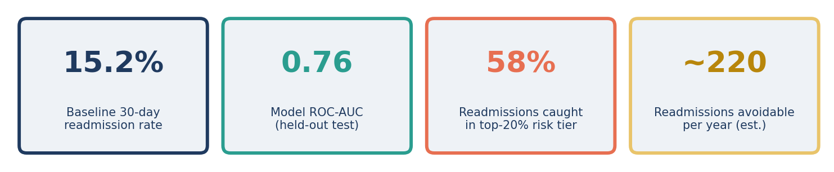
Figure 1: Headline results at a glance (mock-up)
Key findings.
- Risk is concentrated. The 20% of patients with the highest scores account for 58% of all readmissions. Their readmission rate (about 44%) is nearly three times the hospital average of 15.2%.
- Risk is predictable. The model ranks patients correctly 76% of the time (ROC-AUC 0.76), clearly better than the checklist currently used (0.66).
- The biggest warning signs are frequent past admissions, multiple chronic conditions, long stays, discharge to a nursing facility and complex medication lists.
- Early follow-up appears to help. Across every major condition, patients seen within 7 days of discharge were readmitted less often.
Recommendation: Use the risk score to enrol the top 20% of patients (about 100 per week) in an enhanced follow-up bundle: a phone call within 48 hours, a clinic visit within 7 days and a pharmacist medication review. A 6-month pilot is proposed, with an estimated net saving of about $2.1 million a year and roughly 220 readmissions avoided.

2. Project Background and Objectives
Unplanned readmissions are a widely used measure of hospital care quality. Many are linked to problems in the transition from hospital to home: patients unsure how to take new medicines, no follow-up appointment, or a chronic condition that worsens without monitoring. Because follow-up resources are limited, the hospital needed a fair, reliable way to decide which patients to prioritise.
Table 1: Project objectives and outcomes (hypothetical)
Objective | Status | Result
Identify the main drivers of 30-day readmission | Achieved | 8 key drivers quantified and visualised
Build a risk model that beats the current checklist (LACE) | Achieved | ROC-AUC 0.76 vs 0.66
Capture at least 50% of readmissions in the top-20% risk tier | Achieved | 58% captured
Ensure similar performance across patient groups | Achieved, with one watch-point | Recall gap below 6 points by sex and insurance; slightly lower recall for patients under 40
Translate results into an actionable plan | Achieved | Pilot programme designed with ROI estimate

3. Methodology Overview
The project followed a structured, five-stage process. Every step was implemented in Python and version-controlled so that results can be reproduced and audited.
Table 2: Methodology summary
Stage | What was done | Key techniques & tools
1. Data preparation | Joined admissions, diagnoses, labs, medications and demographics into one row per stay; removed duplicates, deaths and planned readmissions; handled missing values and outliers | pandas, pandera validation, median imputation with missing flags, winsorising
2. Exploratory analysis | Profiled every variable, compared readmitted vs non-readmitted patients, checked trends over time | Distribution plots, rate-by-group charts, chi-square and Mann-Whitney tests, correlation heatmaps (seaborn, plotly)
3. Feature engineering | Created 40+ features: past use of hospital services, comorbidity index, medication complexity, abnormal labs, discharge details | Charlson index, clinical code grouping, target encoding inside CV
4. Modelling | Compared the LACE checklist, logistic regression, random forest and gradient boosting | scikit-learn pipelines, LightGBM, Optuna tuning, patient-grouped 5-fold cross-validation
5. Evaluation & explanation | Tested once on unseen recent data; checked calibration and fairness; explained drivers | ROC-AUC, recall, precision, calibration curve, SHAP, Fairlearn

Two safeguards are worth highlighting for decision-makers. First, the model only uses information available on the day of discharge, so its performance reflects how it would really work. Second, the final test used the most recent six months of data, which the model never saw during development, giving a realistic estimate of future performance.

4. Findings and Insights
Each insight below is paired with the visual chosen to communicate it and the reasoning behind that choice. All charts are mock-ups that illustrate the planned presentation.

Insight 1: A small group of patients accounts for most readmissions
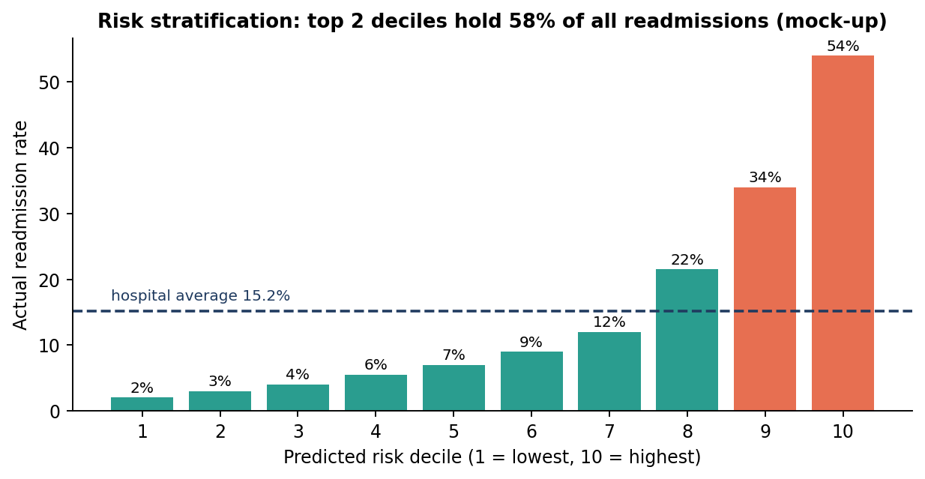
Figure 2: Actual readmission rate by predicted risk decile (mock-up)
Patients were sorted into ten equal groups by their risk score. The bottom half of patients are rarely readmitted (2-7%), while the top decile is readmitted 54% of the time. The top two deciles together hold 58% of all readmissions. This is the single most important result, because it shows that targeting works: focusing on one patient in five reaches most of the problem.
Why this visual: a decile bar chart is easy to read for any audience. The rising staircase and the dashed average line make the concentration of risk obvious without needing to explain the model's statistics.

Insight 2: The main drivers make clinical sense
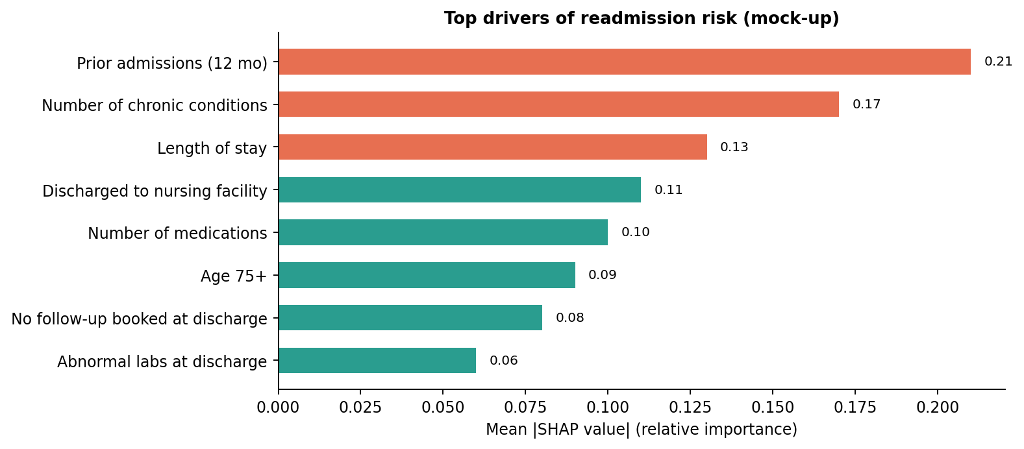
Figure 3: Top drivers of readmission risk, measured by mean SHAP value (mock-up)
The strongest predictors are prior admissions in the last 12 months, number of chronic conditions and length of stay, followed by discharge to a nursing facility and number of medications. These match clinical experience, which builds trust with doctors, and several of them (follow-up booking and medication complexity) are things the hospital can act on.
Why this visual: a sorted horizontal bar chart lets long feature names be read easily and shows ranking at a glance. Highlighting the top three in a contrasting colour directs attention.

Insight 3: Early follow-up is associated with fewer readmissions
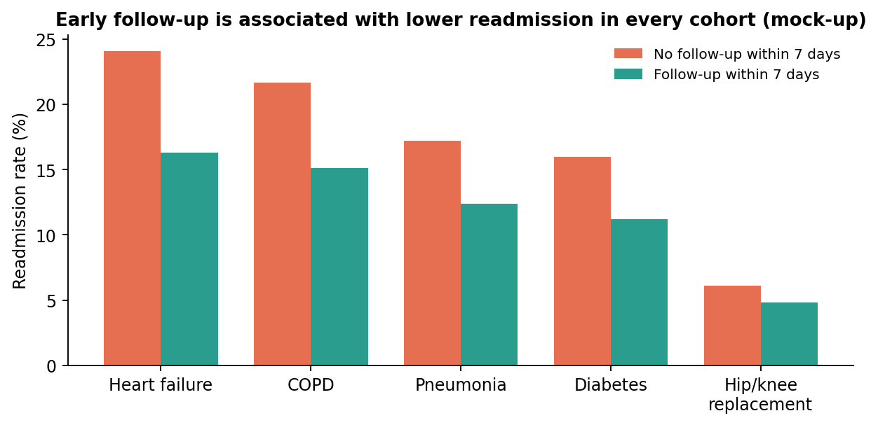
Figure 4: Readmission rate with and without follow-up within 7 days, by condition (mock-up)
In every major condition group, patients who had a follow-up visit within 7 days were readmitted less often. The gap is largest for heart failure (24% vs 16%) and COPD (22% vs 15%). Because this is observational data, we cannot claim follow-up causes the reduction (healthier patients may be more likely to attend), which is why we recommend a controlled pilot to measure the true effect.
Why this visual: grouped bars allow a direct side-by-side comparison within each condition, and the consistency of the pattern across all five groups is itself the message.

Insight 4: Readmissions rise in winter, with one clear anomaly
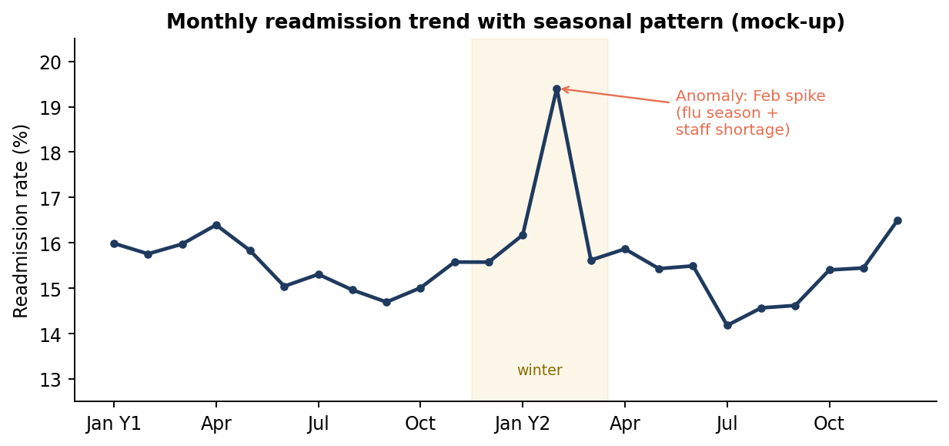
Figure 5: Monthly readmission rate over two years, with seasonal pattern and anomaly (mock-up)
Readmission rates follow a seasonal pattern, rising in winter. One month (February of Year 2) shows a sharp spike to about 19%. Investigation linked it to a severe flu season combined with staff shortages in the discharge planning team. This suggests extra follow-up capacity should be planned for winter, and that the model must be monitored for seasonal drift.
Why this visual: a line chart is the natural choice for change over time. Shading the winter period and annotating the anomaly explains the story directly on the chart, so viewers do not have to search for it.

Insight 5: Statistical summary of model performance
Table 3: Model comparison on unseen recent data (hypothetical results)
Measure | Current checklist (LACE) | Logistic regression | Final model (gradient boosting)
ROC-AUC (ranking quality) | 0.66 | 0.70 | 0.76
Readmissions caught in top 20% | 41% | 49% | 58%
Precision in top 20% | 31% | 37% | 44%
Calibration (predicted vs actual) | Fair | Good | Good (after calibration)

In plain terms: for every 100 patients the team contacts using the new model, about 44 would otherwise have been readmitted, compared with about 31 using the current checklist. The same staff effort reaches over 40% more at-risk patients.

Additional insights
- Discharge destination matters: patients discharged to skilled nursing facilities are readmitted at about twice the rate of those going home.
- Medication complexity: patients on 10 or more medications are 1.8 times more likely to return; medication reviews are a direct lever.
- Weekend discharges show a slightly higher readmission rate (16.4% vs 14.9%), possibly due to reduced pharmacy and social work cover.
- Fairness check: performance is similar across sex and insurance groups. Recall is somewhat lower for patients under 40, whose readmissions tend to have different causes; this is flagged for monitoring.

5. Actionable Insights
Table 4: From insight to action
Insight | Action | Owner | Expected effect
Risk is concentrated in the top 20% | Generate a daily ranked risk list for all discharges | Data team + care coordination | Follow-up reaches 58% of future readmissions
Early follow-up linked to fewer returns | Book a clinic visit within 7 days for every high-risk patient before they leave | Discharge nurses | Estimated 10-15% fewer readmissions in that group
Medication complexity is a key driver | Pharmacist medication review for high-risk patients on 5+ drugs | Pharmacy | Fewer medication-related returns
Nursing facility discharges are high risk | Shared care plan and handover call to the receiving facility | Case management | Better continuity of care
Winter peaks | Add temporary follow-up staff from December to February | Operations | Maintain coverage during peak demand

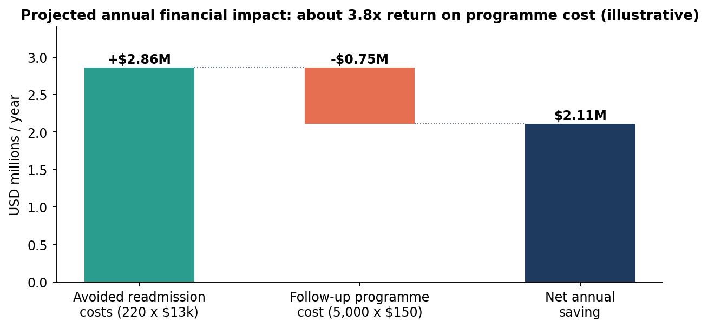
Figure 6: Projected annual financial impact of the targeted follow-up programme (illustrative assumptions)
Assumptions behind the estimate: 25,000 adult discharges a year; 5,000 patients (top 20%) enrolled; a 10% relative reduction in readmissions among enrolled patients (conservative compared with published transitional-care studies); average readmission cost $13,000; programme cost $150 per patient. Under these assumptions, about 220 readmissions are avoided each year, giving a net saving of about $2.1 million, roughly a 3.8x return on programme spending. A sensitivity analysis shows the programme still breaks even if the reduction is as low as 3%.

6. Presentation Strategy for Non-Technical Stakeholders

6.1 Know the audience
Different stakeholders need different levels of detail. The communication plan uses a layered approach: the same core message, with more depth for audiences closer to the technical work.
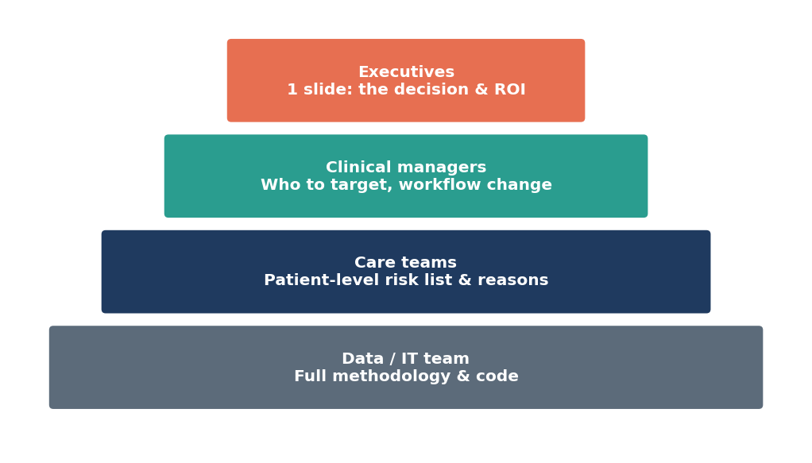
Figure 7: Layered communication: detail increases for more technical audiences
Table 5: Audience analysis and tailored formats
Audience | What they care about | Format | Key visual
Hospital executives | Cost, quality ratings, risk, decision needed | 10-minute briefing, 6 slides + one-page summary | KPI tiles, ROI chart
Clinical managers | Workload, which patients, workflow change | 30-minute workshop | Decile chart, action table
Nurses and care coordinators | Who to call today and why | Dashboard demo + quick guide | Patient risk list with top 3 reasons
Data / IT team | Methods, maintenance, integration | Technical appendix + code repository | Pipeline diagram, metrics tables

6.2 Storytelling structure
The presentation follows a simple narrative arc instead of the order in which the analysis was done. Audiences remember stories better than lists of statistics, so each slide moves the story forward:
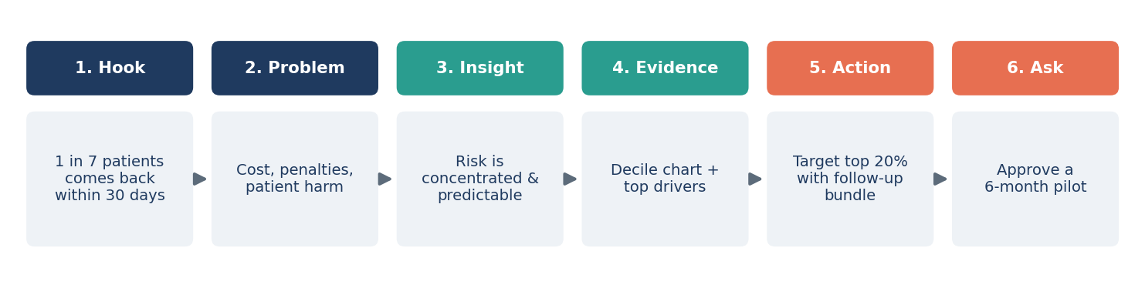
Figure 8: Six-beat storyboard for the executive presentation
Table 6: Executive slide plan
Slide | Headline (the message, not the topic) | Visual | Speaker note
1 | 1 in 7 of our patients comes back within a month | Single large number | Open with a short, anonymised patient story to make it human
2 | Each return costs about $13,000 and puts patients at risk | Simple cost figure | Link to quality ratings and penalties
3 | We can predict who is most likely to return | KPI tiles | Explain the score in one sentence, like a weather forecast
4 | One patient in five accounts for most readmissions | Decile bar chart | Point to the last two bars; pause
5 | The warning signs are ones our clinicians recognise | Top drivers chart | Build trust: the model agrees with clinical experience
6 | Targeted follow-up could save about $2.1M a year | Impact chart | State assumptions; mention conservative estimate
7 | We propose a 6-month pilot on two wards | Timeline graphic | Clear ask: approval and staff time

6.3 Techniques for explaining technical results simply
- Use analogies. "The risk score works like a weather forecast: a 40% chance of rain doesn't mean it will rain, but it tells you to take an umbrella."
- Translate metrics into people. Instead of "ROC-AUC 0.76" say "out of every 100 patients we call, 44 would otherwise have come back, compared with 31 today."
- Headline titles. Every chart title states the conclusion ("One patient in five accounts for most readmissions"), so the slide works even if read without the presenter.
- One chart, one message. Remove gridlines, legends and colours that do not support the point; use a single highlight colour for what matters.
- Show the human side. An anonymised patient journey ("Mr. A, 78, heart failure, 12 medications, discharged on a Friday...") makes the data relatable.
- Be honest about uncertainty. Present ranges ("between 150 and 300 readmissions avoided") and explain that the pilot will measure the real effect.
- Avoid jargon. A glossary in the appendix covers any technical term that must appear.

6.4 Sample non-technical narrative
Script: "Every week, about 70 of our patients are back in hospital within a month of going home. We looked at three years of our own records and found that these returns are not random. Patients who have been in hospital several times recently, who manage many conditions or many medicines, or who go to a nursing home are at much higher risk. We built a tool that spots these patients on the day they leave. If our follow-up team focuses on the one patient in five the tool flags, they will reach more than half of the people who would otherwise come back. We are asking for approval to test this on two wards for six months and measure exactly how many readmissions it prevents."

6.5 Anticipating stakeholder questions
Table 7: Prepared answers to common questions
Likely question | Prepared answer
"Can we trust a computer to make clinical decisions?" | It doesn't make decisions. It ranks patients for follow-up; clinicians always have the final say and can override it.
"What about patients the model misses?" | Standard follow-up continues for everyone. The model adds extra support for the highest-risk group; it removes nothing.
"Is it fair to all patients?" | We tested it across age, sex and insurance groups. Performance is similar, and we will keep monitoring, especially for younger patients.
"What happens when things change?" | The model is checked monthly and retrained every six months, or sooner if its accuracy drops.
"Is patient data safe?" | The model was built on de-identified data and runs inside the hospital's secure systems.

7. Recommendations and Future Work

7.1 Immediate next steps (0-6 months)
- Run a 6-month pilot on two high-volume wards (cardiology and general medicine), comparing them against similar wards without the programme to measure the true effect.
- Integrate the daily risk list into the care coordinators' existing worklist, with the top three reasons shown for each patient.
- Train staff with a one-page guide and a 30-minute session on how to read and use the score.
- Set up monitoring of model accuracy, calibration and fairness, reported monthly to a small governance group.

7.2 Medium-term improvements (6-18 months)
- Add social factors such as living alone, transport access and caregiver support, which are known drivers but not reliably recorded today.
- Use clinical notes with natural language processing to capture information such as frailty or patient concerns.
- Move to real-time scoring during the stay, so discharge planning can start earlier for high-risk patients.
- Predict the type of intervention that will help most (uplift modelling), not just who is at risk.

7.3 Further research
- A controlled study of which follow-up components (call, clinic visit, medication review) contribute most to the reduction.
- Improving accuracy for younger patients, possibly with a separate model or additional features.
- Extending the approach to emergency department revisits and to partner hospitals in the region.

8. Limitations
- Readmissions to other hospitals are not captured in the data, so the true rate is likely slightly higher.
- Observational associations (such as early follow-up and lower readmission) do not prove cause and effect; the pilot is designed to test this.
- Single-hospital data: the model must be re-validated before use at another site.
- Missing social information limits how well the model can capture home circumstances.
- Mock-up results: all figures in this report are illustrative and would be replaced by real results during implementation.

9. Conclusion
This project shows how data science can turn routine hospital records into a practical, targeted intervention. The analysis found that readmission risk is concentrated in a fifth of patients, can be predicted at discharge with good accuracy, and is driven by factors clinicians recognise and can act on. The report sets out a clear communication plan for each audience, built on storytelling, plain language and focused visuals, and makes a concrete, low-risk recommendation: a six-month pilot of targeted follow-up with an estimated return of about 3.8 times its cost. With careful monitoring and the planned improvements, the approach can become a lasting part of how the hospital supports patients after they leave.

Appendix A: Glossary for Non-Technical Readers
Table 8: Glossary
Term | Plain-language meaning
Readmission (30-day) | An unplanned return to hospital within 30 days of going home
Risk score | A number from 0 to 100% estimating how likely a patient is to be readmitted
Machine learning model | A computer program that learns patterns from past cases to make predictions about new ones
ROC-AUC | How well the model ranks patients; 0.5 is a coin flip and 1.0 is perfect
Recall | Of all patients who were readmitted, the share the model flagged in advance
Precision | Of all patients the model flagged, the share who were actually readmitted
Calibration | Whether a predicted 30% risk really means about 30 in 100 such patients are readmitted
SHAP values | A method that shows how much each factor pushed a patient's risk score up or down
Decile | One of ten equal-sized groups after sorting patients from lowest to highest risk
Data drift | Changes in patient population or hospital practice that can make a model less accurate over time

