**Lambda Function To trigger Slack Notification to any one particular channel in Slack**

**Step 1**:

Add Incoming web hooks app to your slack account and configure that plugin.

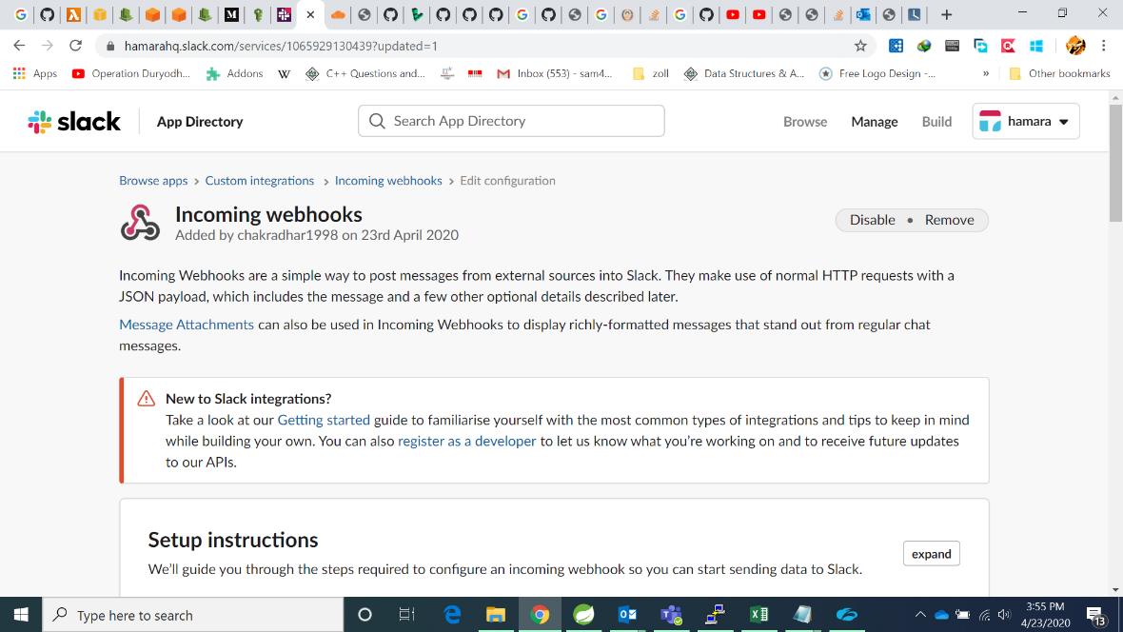

**Step 2**:

open cloud watch alarm in aws console and create an alarm.

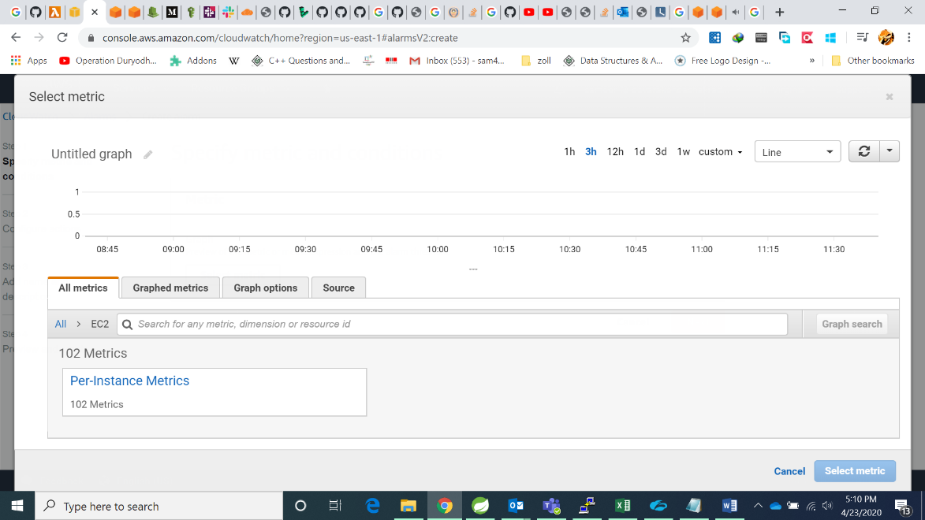

**Step 3**:

Select an SNS topic to that alarm and select the action to perform on ec2.

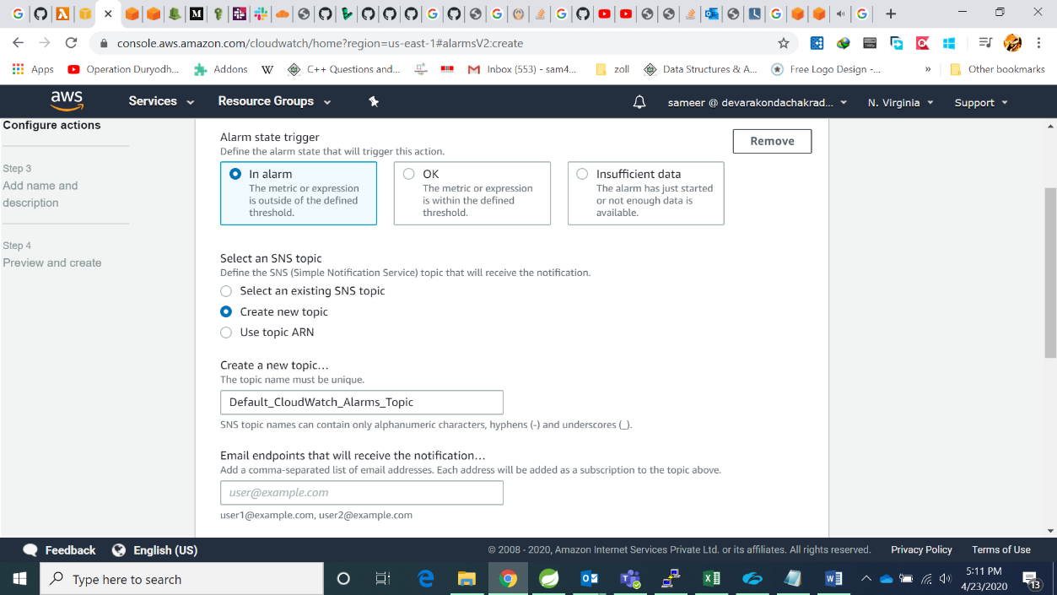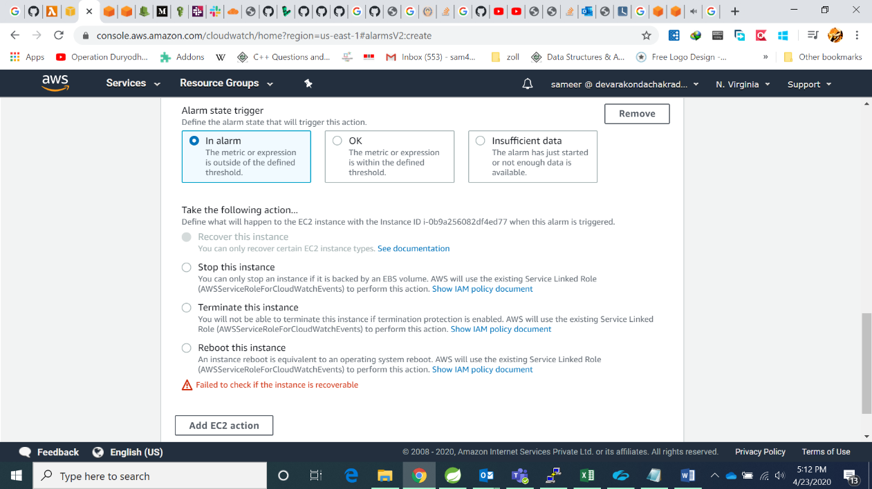

**Step 4**:

give a proper name to the alarm.

**Step 5**:

open aws lambda in the console.

**Step 6**:

create a function to send notification to slack.

**Step 7**:

select runtime in python 3.6.

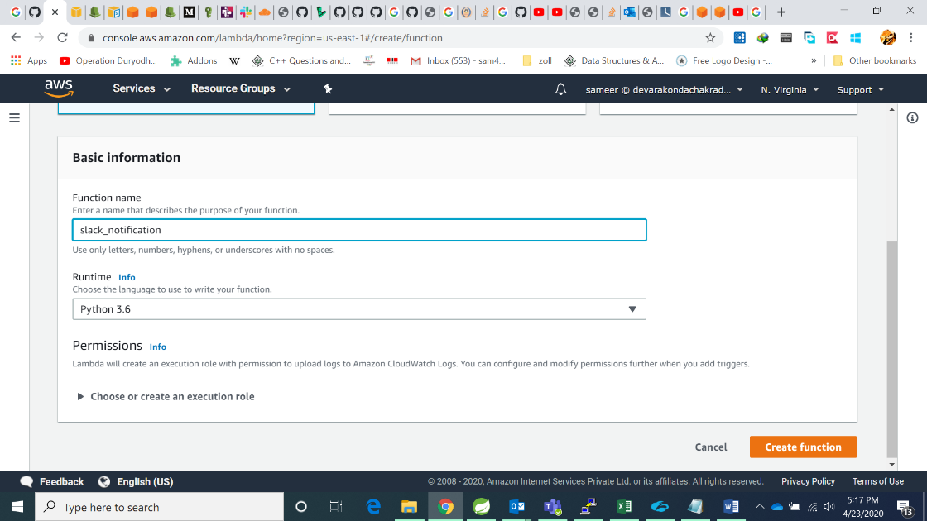

**Step 8**:

add trigger to the function select sns topic which we have configured to cloudwatch alarm.

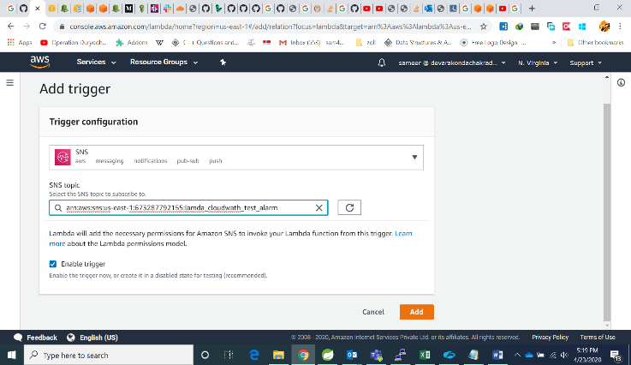 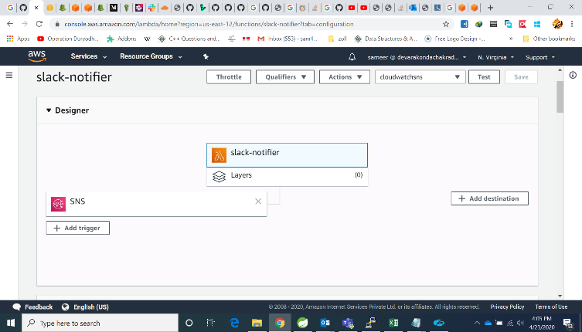

**Step 9**:

Copy and paste this code in edit code inline.

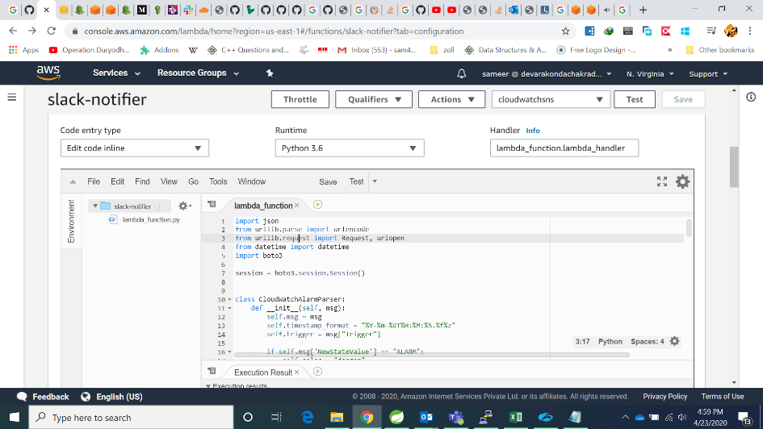

**Code**:

**Note:**  change your webhook url and channel name accordingly.

Please refer to the code I attached in the mail.

**Step 10**:

save and test the function you get a alert in the channel.

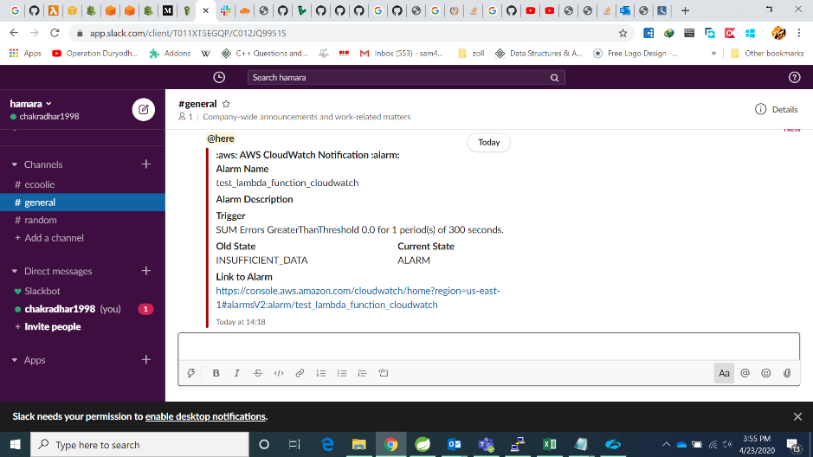

**Date**: 23rd April 2020,

**Facilitator**: Devarakonda Chakradhar