PoultryVision: A Deep Learning-Based Poultry Disease Classifier

# INTRODUCTION

* 1. Project Overview

PoultryVision is a web-based application that uses deep learning (transfer learning with MobileNetV2) to classify common poultry diseases-Salmonella, New Castle Disease, Coccidiosis-or identify healthy birds based on images. It aims to assist veterinary students in understanding disease patterns and supports early diagnosis through AI-driven visual recognition.

* 1. Purpose

To empower veterinary students with a practical tool for learning poultry diagnostics by simulating disease prediction and classification, thereby bridging academic learning with AI technology.

# IDEATION PHASE

* 1. Problem Statement

Manual disease detection in poultry is labor-intensive, subjective, and error-prone. Using deep learning, we can make this process faster, scalable, and educationally engaging.

* 1. Empathy Map Canvas
     + Users: Veterinary students, poultry farmers
     + Needs: Rapid and accurate diagnosis tool
     + Pain Points: Lack of real-time feedback, minimal exposure to AI tools in curriculum
     + Goals: Enhance diagnostics learning using AI-based applications
  2. Brainstorming

Ideas explored included using symptom-based questionnaires, IoT sensor integration, and real-time video analysis. The final solution was a web-based image classifier using MobileNetV2.

# REQUIREMENT ANALYSIS

* 1. Customer Journey

1. User uploads a poultry image
2. Model predicts the disease
3. System displays prediction with confidence
4. User views disease info or suggestions
5. Student logs result or retests
   1. Solution Requirement
      * Input: Poultry image (infected or healthy)
      * Output: Predicted disease label with confidence score
      * Features: Educational descriptions, real-time results
   2. Data Flow Diagram

User -> Upload Image -> Preprocessing -> MobileNetV2 Model -> Prediction -> Display

* 1. Technology Stack
     + Frontend: HTML, CSS, Bootstrap
     + Backend: Flask (Python)
     + Model: TensorFlow/Keras MobileNetV2
     + Dataset: Google Images + Kaggle poultry datasets

# PROJECT DESIGN

* 1. Problem-Solution Fit

The project aligns with the need for modern diagnostic aids in veterinary education. It provides instant feedback and high accuracy predictions with minimal resources.

* 1. Proposed Solution
     + Upload interface for poultry images
     + Real-time prediction display
     + Descriptions for each disease
     + Simple educational interface
  2. Solution Architecture

HTML/CSS (Frontend) -> Flask Server -> TensorFlow Model -> Output to User

# PROJECT PLANNING & SCHEDULING

Week 1: Research poultry diseases, collect datasets Week 2: Model training using transfer learning Week 3: Backend integration using Flask

Week 4: UI design, testing, and final demo preparation

# FUNCTIONAL AND PERFORMANCE TESTING

* [OK] Training Accuracy: 0.935
* [OK] Validation Accuracy: 0.902
* [OK] Test Accuracy: 0.915

The model was tested with images collected independently and performed well on unseen images. Testing included UI usability checks and prediction feedback accuracy.

# RESULTS

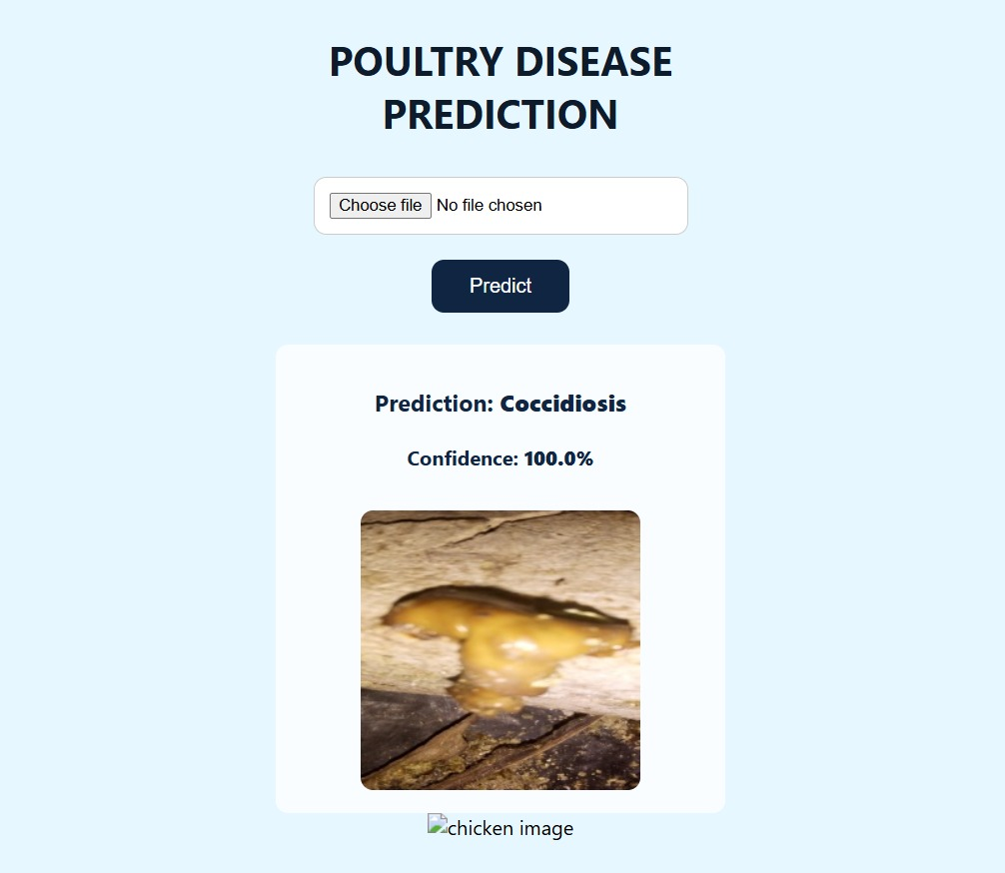

# ADVANTAGES & DISADVANTAGES

[OK] Advantages:

* Provides veterinary students hands-on experience with AI tools
* Fast and easy diagnosis tool for poultry diseases
* Web-based, accessible and platform-independent

[X] Disadvantages:

* Depends on good image quality
* Currently supports only four disease categories

# CONCLUSION

PoultryVision illustrates how AI can aid veterinary training by simulating real diagnostic scenarios. With high accuracy and ease of use, it helps bridge traditional education with emerging technologies.

# FUTURE SCOPE

* Add more poultry diseases (e.g., Avian Influenza)
* Include symptom-based text inputs (NLP)
* Develop mobile app for farmers
* Link predictions to treatment guides or online vet services

# APPENDIX

* Dataset Sources: Google Images, Kaggle Poultry Dataset
* GitHub Repository: https://github.com/chakri71/poultry-disease
* Demo Video Link: https://drive.google.com/file/d/1IxGjKdSFVLEbF8t-__tRqIFyNDBuBEL2/view?usp=sharing