mkdir AOA(Airline online Analysis)

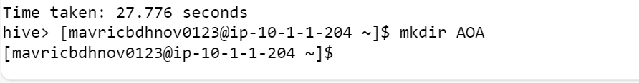

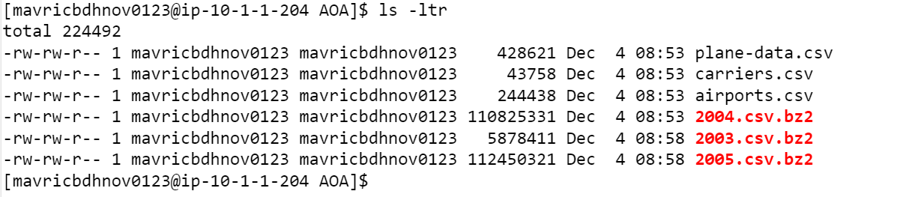

**Step 2:** Unzip the contents for the bz2 files.

**Step 3: Create the directories in hdfs where your data will reside**

**Step 4: copy the respective files to the above created hdfs structure**

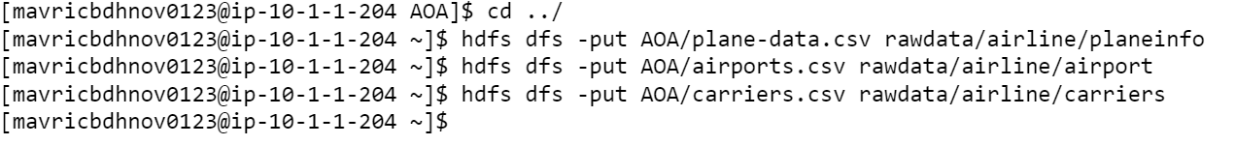

**2. Create tables using Hive**

**Create all the tables in a different database in Hive(airline_db)**

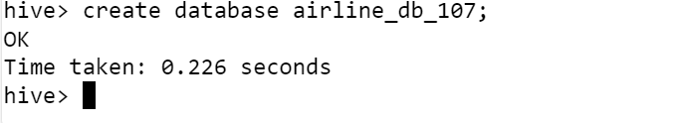

**Create tables for flights , plane_info, carriers and airports in the staging area.**

**Hive QL:**

CREATE EXTERNAL TABLE carriers_stg (Code string,Description string) ROW FORMAT DELIMITED FIELDS TERMINATED BY ',' location '/user/mavricbdhnov0123/rawdata/airline/carriers';

CREATE EXTERNAL TABLE airport_stg (iata string,airport string,city string,state string,country string,lat decimal,long decimal) ROW FORMAT DELIMITED FIELDS TERMINATED BY ',' location '/user/mavricbdhnov0123/rawdata/airline/airport';

CREATE EXTERNAL TABLE plane_info_stg (tailnum string,type string,manufacturer string,issue_date string,model string,status string,aircraft_type string,engine_type string,year int) ROW FORMAT DELIMITED FIELDS TERMINATED BY ',' location '/user/mavricbdhnov0123/rawdata/airline/planeinfo';

CREATE EXTERNAL TABLE flights_stg (Year int,Month int,DayofMonth int,DayOfWeek int,DepTime int,CRSDepTime int,ArrTime int,CRSArrTime int,UniqueCarrier string,FlightNum strin

Hive>ALTER TABLE flights_stg SET TBLPROPERTIES ("skip.header.line.count"="1");

hive> ALTER TABLE plane_info_stg SET TBLPROPERTIES ("skip.header.line.count"="1");

hive> ALTER TABLE airport_stg SET TBLPROPERTIES ("skip.header.line.count"="1");

hive> ALTER TABLE carriers_stg SET TBLPROPERTIES ("skip.header.line.count"="1");

**Check if the tables have data.**

select * from k_airline_db.flights_stg limit 5;

select * from k_airline_db.plane_info_stg limit 5;

select * from k_airline_db.airport_stg limit 5;

select * from k_airline_db.carriers_stg limit 5;

**What is the average arrival delay and average departure delay in each month of the year 2004?**

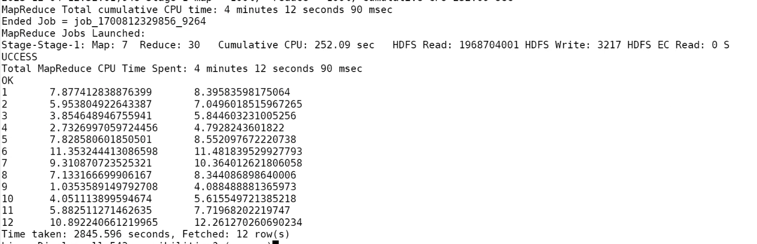



**3. Improving the performance of Hive tables - Parquet format**

CREATE EXTERNAL TABLE flight_pq (Year int,Month int,DayofMonth int,DayOfWeek int,DepTime int,CRSDepTime int,ArrTime

int,CRSArrTime int,UniqueCarrier string,FlightNum string,TailNum string,ActualElapsedTime int,CRSElapsedTime int,AirTime

int,ArrDelay int,DepDelay int,Origin string,Dest string,Distance int,TaxiIn string,TaxiOut string,Cancelled string,Cance

llationCode string,Diverted string,CarrierDelay int,WeatherDelay int,NASDelay int,SecurityDelay int,LateAircraftDelay int

) STORED AS PARQUET location '/user/maverickavitha/output/airline/pq_flights';

insert overwrite table k_airline_db.flight_pq select * from k_airline_db.flights_stg

Select * from flight_pq limit 5;

**Is there a difference between the response times for the queries(2 and 3)**

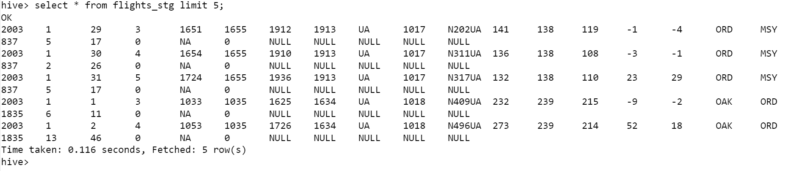

**AVG Calculation in PARQUET format:**

**AVG Calculation in normal STG table:**

