1. Write a C program to simulate a Deterministic Finite Automata (DFA) for the given language representing strings that start with 0 and end with 1

Program:

#include <stdio.h>

int dfa_transition(int current_state, char input) {

switch (current_state) {

case 0:

if (input == '0') return 1;

break;

case 1:

if (input == '1') return 2;

if (input == '0') return 1;

break;

case 2:

if (input == '1') return 2;

if (input == '0') return 1;

break;

}

return -1;

}

int simulate_dfa(const char *input_string) {

int current_state = 0;

for (int i = 0; input_string[i] != '\0'; ++i) {

current_state = dfa_transition(current_state, input_string[i]);

if (current_state == -1) {

return 0;

}

}

return (current_state == 2);

}

int main() {

char input[100];

printf("Enter a string: ");

scanf("%s", input);

if (simulate_dfa(input)) {

printf("String is accepted by the DFA.\n");

} else {

printf("String is not accepted by the DFA.\n");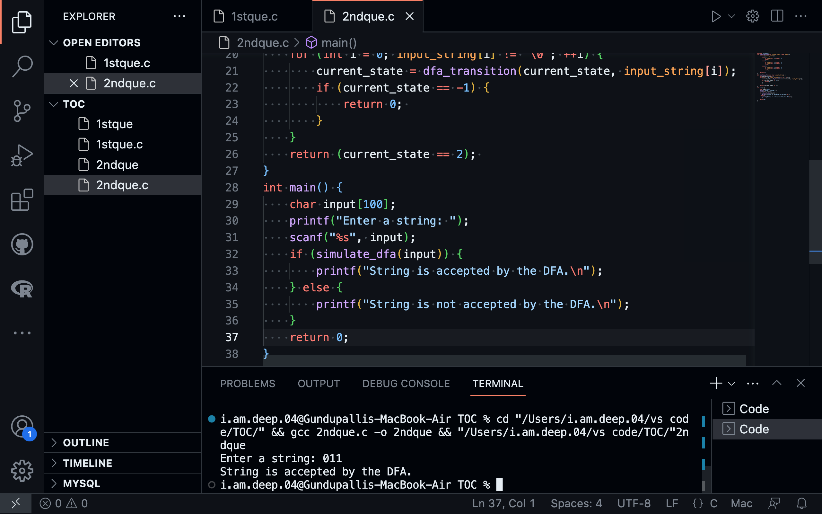

}

return 0;

}