7.Write a C program to check whether a given string belongs to the language defined by a Context Free Grammar (CFG)

S → A101A, A → 0A | 1A | ε

Program:

#include <stdio.h>

#include <string.h>

int belongsToLanguageA(const char \*str, int start, int end) {

if (start > end) {

return 1;

}

if (str[start] == '0' || str[start] == '1') {

int i;

for (i = start + 1; i <= end; ++i) {

if (belongsToLanguageA(str, start + 1, i - 1) && belongsToLanguageA(str, i, end)) {

return 1;

}

}

}

return 0;

}

int belongsToLanguageS(const char \*str, int start, int end) {

if (start > end) {

return 0;

}

if (str[start] == '1' && str[end] == '1' && str[end - 1] == '0') {

return belongsToLanguageA(str, start + 1, end - 2);

}

return 0;

}

int main() {

char input[100];

printf("Enter a string: ");

scanf("%s", input);

int length = strlen(input);

if (belongsToLanguageS(input, 0, length - 1)) {

printf("String belongs to the CFG language.\n");

} else {

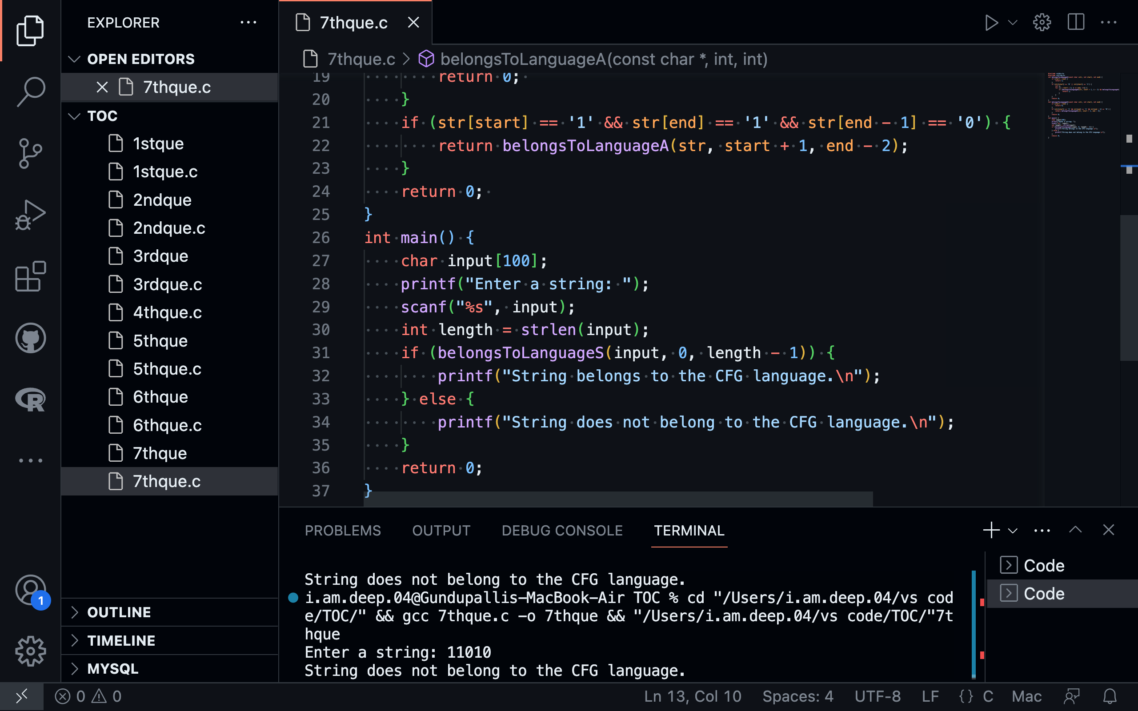

printf("String does not belong to the CFG language.\n");

}

return 0;

}