WEEK 11 PRACTICAL

QUESTION 1
Develop a multithreaded counter application using POSIX threads (pthread_create, pthread_join). Demonstrate race conditions by allowing multiple threads to update a shared variable concurrently.

Aim
To develop a multithreaded counter application using the POSIX thread functions pthread_create() and pthread_join(), and to demonstrate a race condition by allowing several threads to update a shared variable concurrently without synchronization.

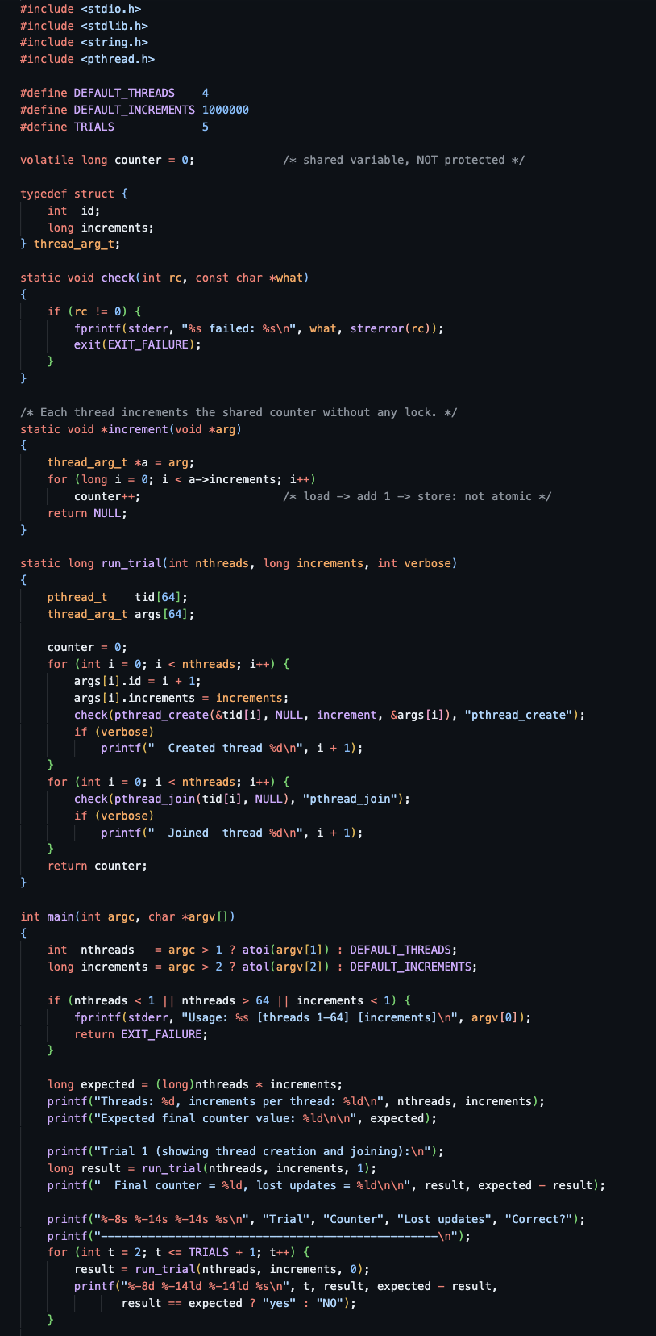
Program:

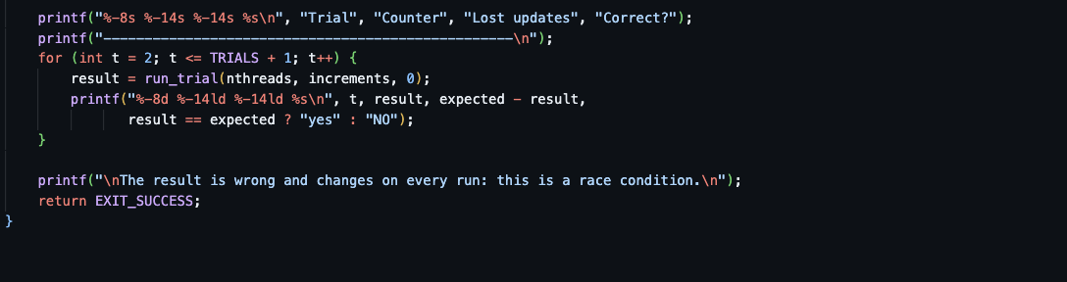

Output
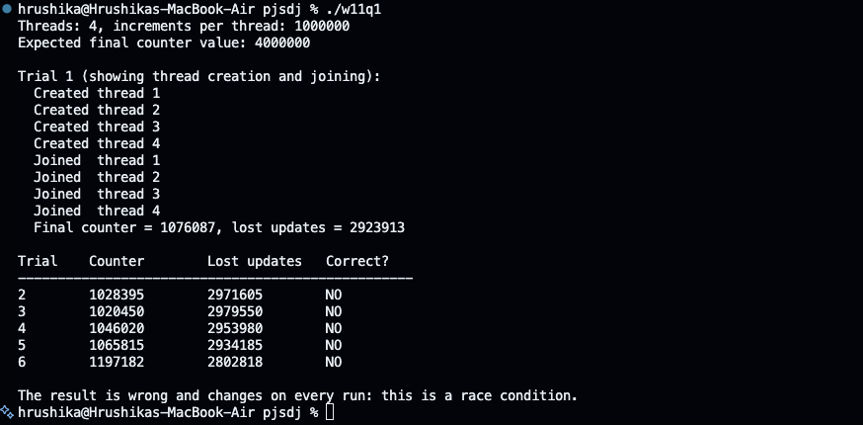
The final counter value is different on every run because the threads are scheduled unpredictably.

Observation
Four threads each incremented the shared counter 1,000,000 times, so the correct result is 4,000,000. Every trial produced a smaller, different value.
The statement counter++ is not a single operation. The CPU performs it in three steps:
Step | Thread A | Thread B | counter in memory
1 | Load counter (100) into a register |  | 100
2 |  | Load counter (100) into a register | 100
3 | Add 1 (register = 101) |  | 100
4 |  | Add 1 (register = 101) | 100
5 | Store 101 |  | 101
6 |  | Store 101 | 101 (one update lost)

pthread_create() started four threads that run concurrently and share the global variable counter. pthread_join() made the main thread wait for all of them before printing the result.

When two threads interleave between the load and the store, one increment overwrites the other. This is a race condition, and the code containing counter++ is a critical section.

The number of lost updates changed on every run because it depends on how the operating system schedules the threads on the CPU cores.

The volatile keyword does not prevent the race. It only stops the compiler from caching the value; it does not make the increment atomic.

Result:

A multithreaded counter was successfully implemented using pthread_create() and pthread_join(). The experiment demonstrated a race condition: concurrent unsynchronized updates to a shared variable lost increments and produced incorrect, unpredictable results.

QUESTION 2

Modify the previous program using mutex locks (pthread_mutex_lock, pthread_mutex_unlock) and compare the outputs with the race-condition version. Analyze the impact of synchronization.

Aim

To modify the multithreaded counter to protect the shared variable with a mutex lock (pthread_mutex_lock() and pthread_mutex_unlock()), to compare its output with the race-condition version, and to analyze the effect of synchronization on correctness and performance.

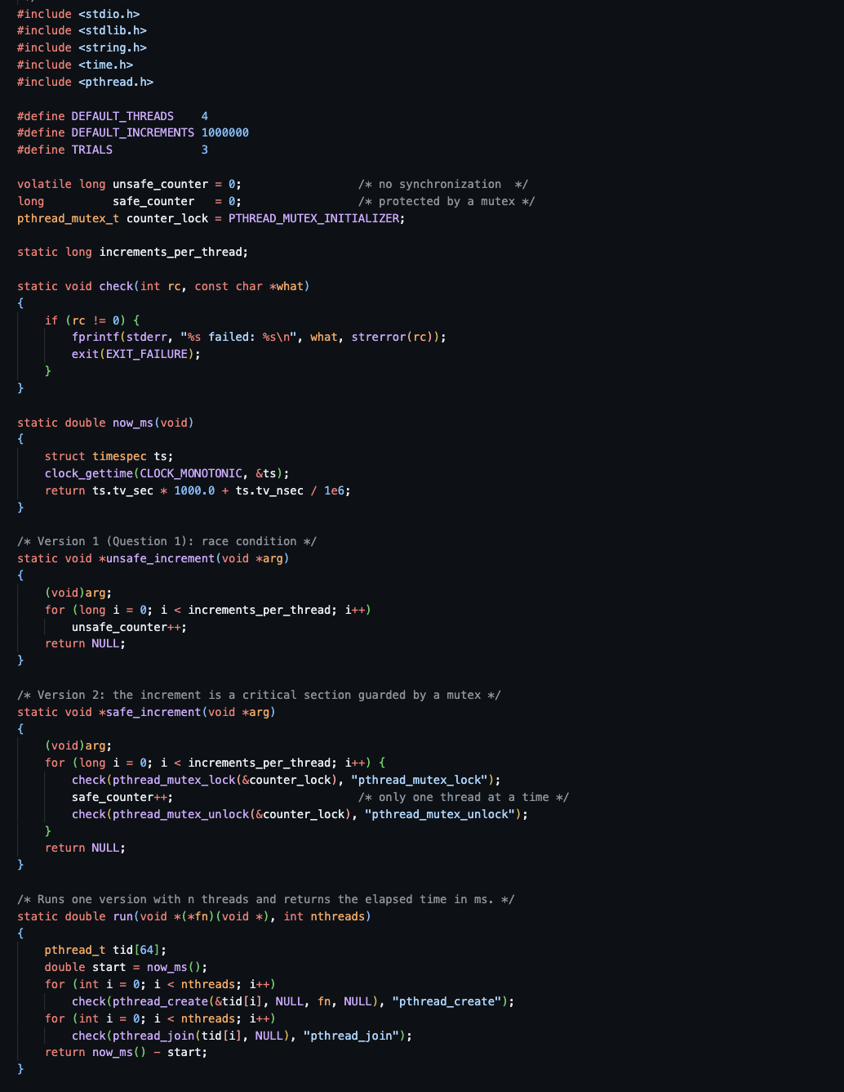
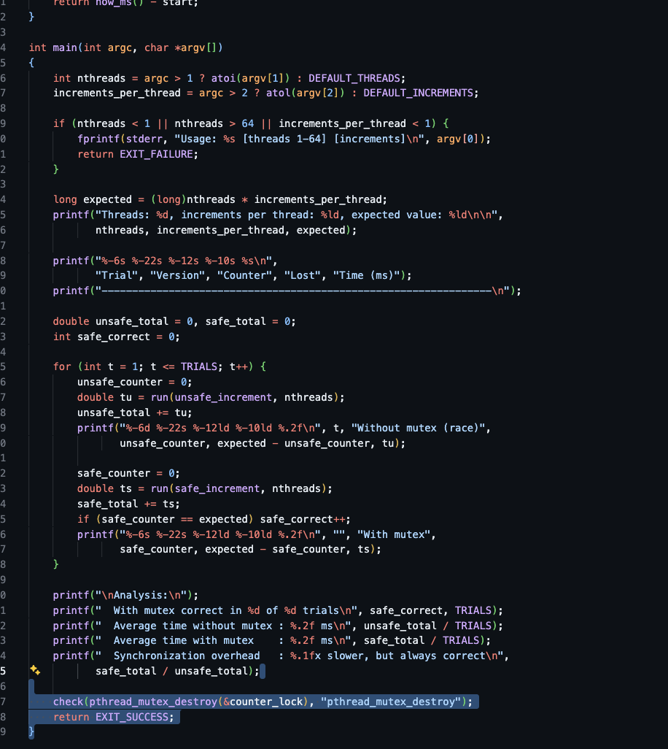
Program

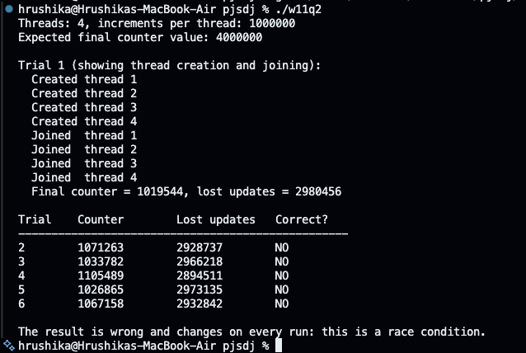
Output:

Observation
Criterion | Without mutex (Question 1) | With mutex (Question 2)
Final value | Always less than 4,000,000 | Always exactly 4,000,000
Consistency | Different on every run | Identical on every run
Lost updates | Between 1.4 and 2.7 million in these runs | None
Execution time | About 10 ms | About 290 ms (about 29 times slower)
Parallelism | Threads run the increment truly in parallel | Only one thread at a time can execute the critical section

pthread_mutex_lock() lets only one thread enter the critical section; any other thread that calls it blocks until the owner calls pthread_mutex_unlock(). This provides mutual exclusion, so each load-add-store sequence completes without interference.

Synchronization made the program correct, but slower. Each increment now requires a lock and an unlock operation, and threads contend for the same lock, so they mostly wait for one another.

The critical section should be kept as short as possible. A better design lets each thread count in a private local variable and add it to the shared counter once, under the lock, at the end.

For a simple counter, atomic operations such as __atomic_fetch_add() give correctness with lower overhead than a mutex.

Result

The counter program was successfully modified to use pthread_mutex_lock() and pthread_mutex_unlock(). The mutex eliminated the race condition and produced the correct result on every run, at the cost of additional execution time caused by locking and contention between threads.

