USABILITY TEST — FINDINGS REPORT
Resolute Count AI
Self-Conducted Usability Review • September 2026

1. Test Overview
Test type | Self-conducted, task-based usability review
Prototype | Resolute Count AI
Screens reviewed | Welcome, Dashboard, New Count, Image Analysis, Count Results, Count History
Tasks evaluated | 5 core user tasks
Focus areas | Navigation, CTA clarity, information hierarchy, task flow, feedback and error/confusion points
Note: This review evaluates the prototype through a structured walkthrough. It does not claim that external users participated in the test.

2. Test Tasks & Findings

Task 1 — Start a new count
Flow: Welcome → Get Started → Dashboard → Start New Count
Finding: The primary CTA is visually prominent and the starting flow is easy to understand.
Result: Successful Severity: Low
Recommendation: Keep the primary CTA prominent and consistent.

Task 2 — Upload an image
Flow: Dashboard → Start New Count → Upload from Gallery
Finding: Camera and Gallery choices are clearly separated, making the next action understandable.
Result: Successful Severity: Low
Recommendation: Maintain the clear separation between capture and gallery actions.

Task 3 — Understand AI analysis
Flow: Upload Image → Analyzing Image
Finding: The analysis screen communicates that the image was uploaded and that detection/counting is in progress. A stronger progress indicator or estimated processing time would reduce uncertainty.
Result: Successful with improvement Severity: Medium
Recommendation: Add a visible progress indicator, step status, or estimated processing time.

Task 4 — Check the count result
Flow: Analyzing Image → Count Results
Finding: Total count, confidence score, category, detected image and next actions are presented clearly.
Result: Successful Severity: Low
Recommendation: Keep the count and confidence score visually prominent.

Task 5 — Find previous results
Flow: Dashboard → History
Finding: Search, category filters and previous results support finding historical counts. The cards contain several details, so hierarchy can be refined for faster scanning.
Result: Successful with minor improvement Severity: Low
Recommendation: Prioritize the most important history information and reduce visual density where possible.

3. Key Findings
ID | Finding | Priority | User Impact | Recommendation
F-01 | AI analysis progress is not as informative as it could be. | Medium | Users may be unsure how long the analysis will take or whether the process is still active. | Add a progress bar/step indicator and, where practical, an estimated processing time.
F-02 | The analysis waiting state could provide stronger feedback. | Medium | More explicit status feedback can reduce uncertainty during processing. | Use concise status labels such as Uploading, Detecting, Counting, and Complete.
F-03 | History cards may be information-dense. | Low | Multiple metadata items can slow visual scanning. | Strengthen hierarchy so count, category and date are immediately scannable.
F-04 | Primary actions are easy to identify. | Positive | The main CTAs stand out and support the intended flow. | Preserve the existing CTA hierarchy and consistency.
F-05 | Result presentation is clear. | Positive | The total count and confidence score are prominent and easy to interpret. | Retain the strong emphasis on the primary result.

4. Priority Summary
High priority: No critical usability blockers were identified in this self-review.
Medium priority: Improve the AI analysis/loading experience with clearer progress and status feedback.
Low priority: Refine History information hierarchy and maintain clear CTA labeling.

5. Overall Usability Assessment
Overall, the Resolute Count AI prototype provides a clear core flow from starting a count, selecting or capturing an image, processing the image, viewing the result, and accessing history. The strongest areas are CTA visibility and result presentation. The main opportunity is to make the AI processing state more transparent and reassuring.

6. Recommended Design Improvements
- Add a visible progress indicator to the AI analysis screen.
- Show clear processing stages such as Uploading → Detecting → Counting → Complete.
- Consider displaying an estimated processing time when technically feasible.
- Improve the information hierarchy of History cards for faster scanning.
- Continue using strong, consistent primary CTAs throughout the app.

7. Prototype Screens Reviewed
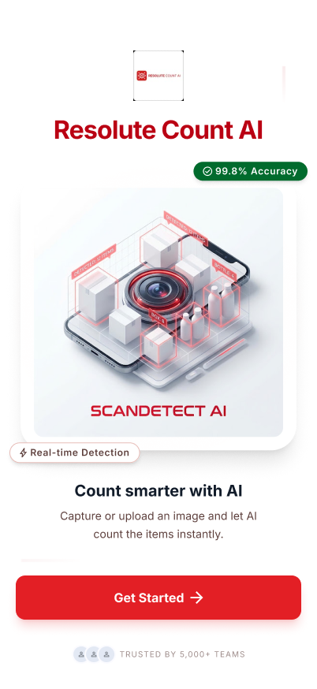
Welcome screen
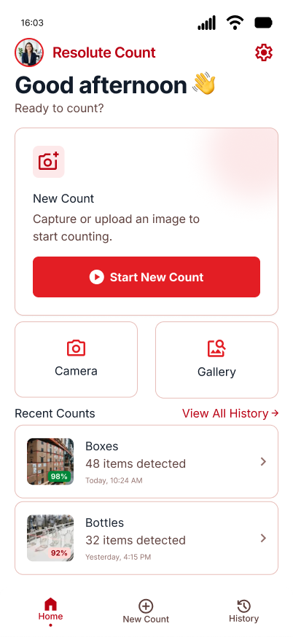
Dashboard
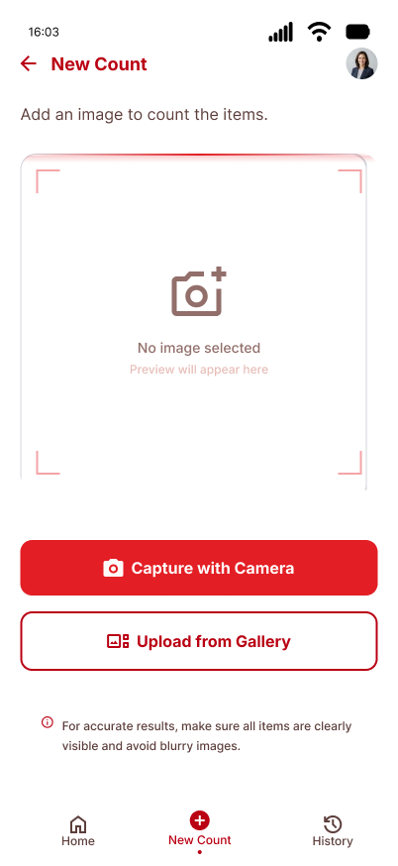
New Count / Capture options
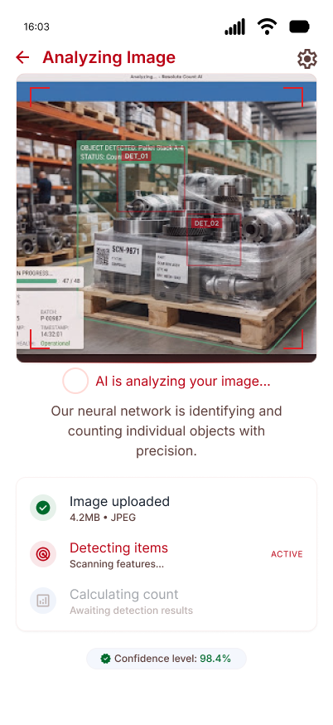
AI image analysis
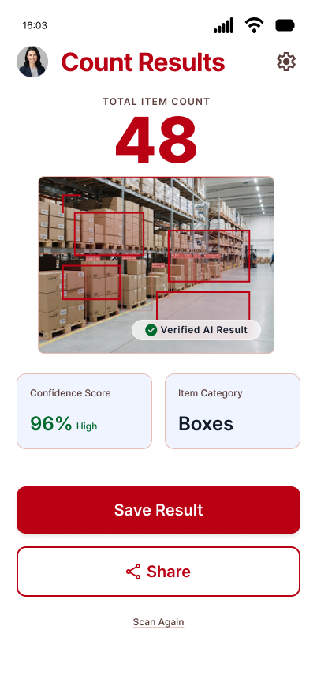
Count results
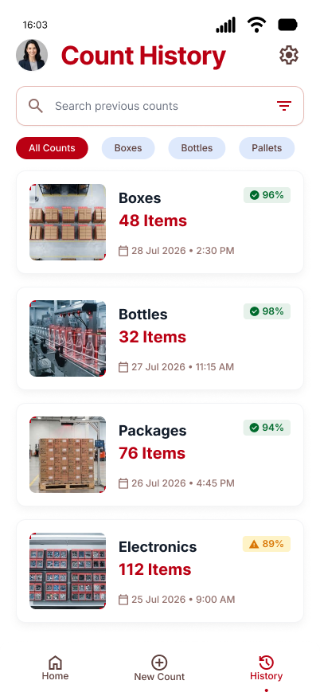
Count history

8. Internship Submission Statement
A self-conducted, task-based usability review was performed on the Resolute Count AI prototype. Five core tasks were evaluated across the primary user flow, focusing on navigation clarity, call-to-action visibility, information hierarchy and system feedback. The review found the core experience to be usable, with the primary improvement opportunity being clearer progress feedback during AI image analysis.

