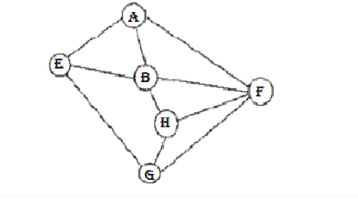

DFS: G E A F B H;

BFS: H B F G A E;

Consider the following graph.

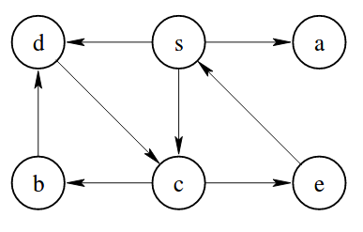

Which of the following is not a valid depth first traversal of the graph?

Select one:

a.   s, c, b, d, e, a

b.   s, d, c, a, b, e

c.   s, a, d, c, b, e

d.   s, c, e, b, d, a;

Consider the following graph.

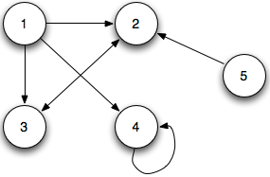

b.   
  
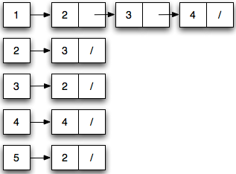

Which one of the following is a correct adjacency matrix representation of the graph?

Select one:

a.   
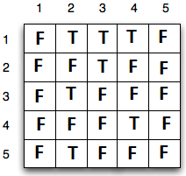

\*\*Which of the following is true about a graph that is a tree? Note: A cycle exists when there is a valid path along *unique*edges that ends at the starting vertex.

🡪Adding an edge between existing nodes always creates a cycle.

\*\*What causes a collision when hashing?

->two hash keys are the same

\*\*A collision occurs when hashing a value. The hash function searchers for the next empty array location. What is this method of collision handling called?

->linear probing

\*\*In which of the following situations is separate chaining inefficient?

* All the values in an array of size n hash to the same address

\*\*which of the following is true about open addressing?

* Hashed value will always be found in the table