Homework 4

Name: Chakrya Ros

Report

1. Picture of input grids

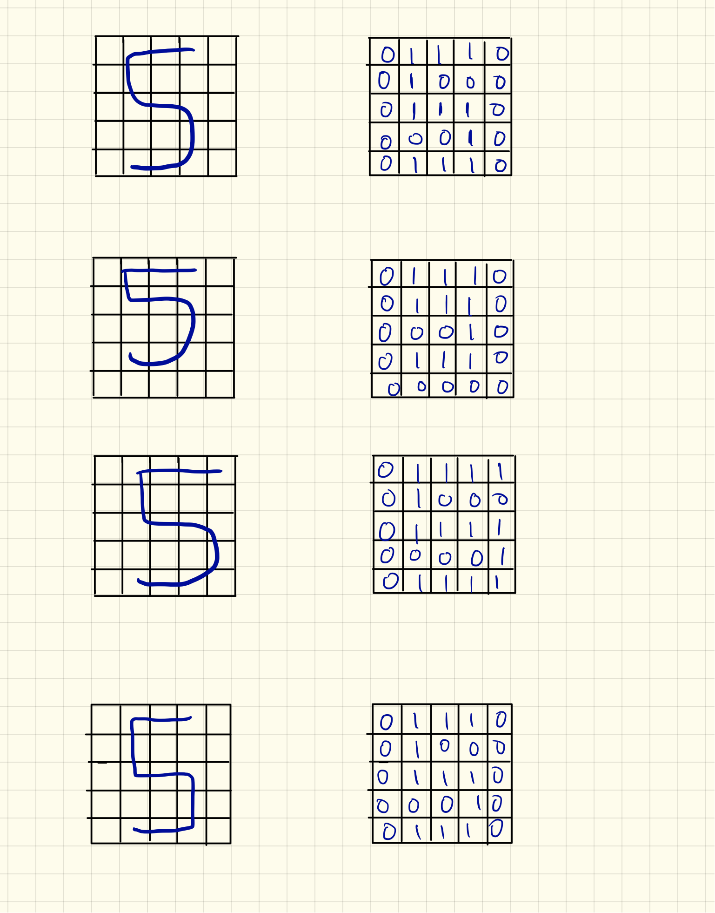

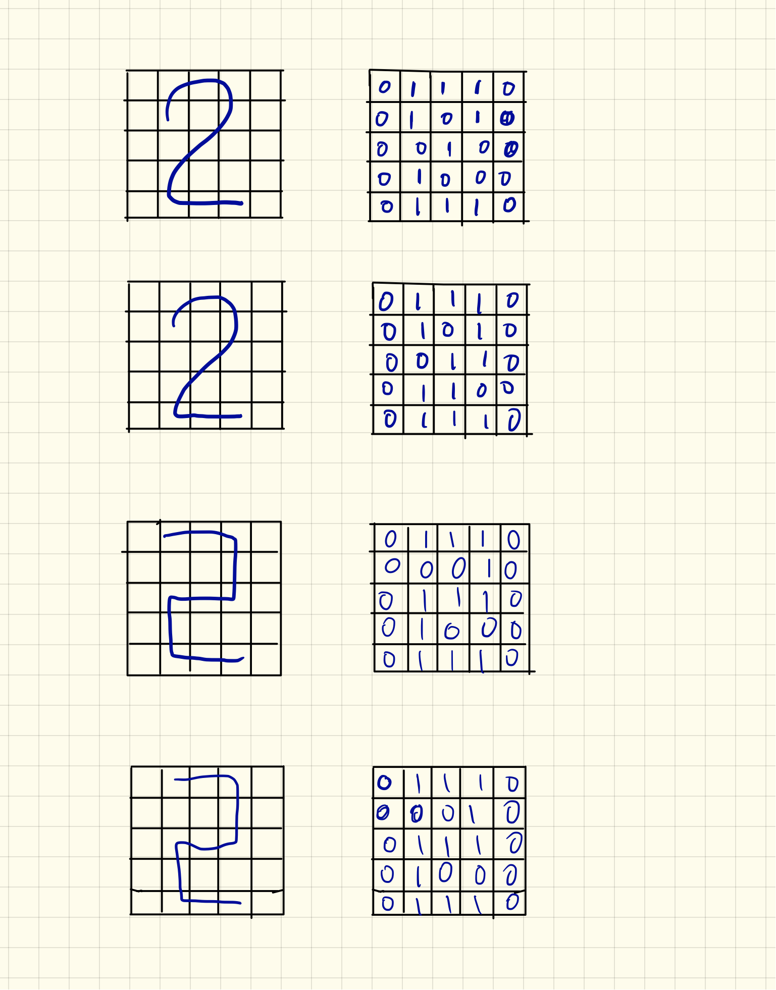

1. Accuracy score using Hopfield network is equal to 87.5%. So It means that we got 12.5% errors. We have high accuracy score because we use the perfectly patterns to train and fit the model using Hopfield network. And then use the data that I generated from drawing digit to classify as five, two or unknown. When we classify each pattern by calling classify function, the true pattern is “five” but the predict is “unknown” or the true pattern is “two” but the predict is “unknown” that is false memory, those cause the accuracy score got error.
2. Accuracy score using MLP Classifier is equal to 100%. MLP is not making errors and it is classifying the data 100% percent correctly because I used the perfectly patterns to train and fit the model, and the predict on the data that I generated. This classifier predicts on my data produce the perfectly patterns as the training data that’s why it’s 100% accuracy score. Another reason, MLP Classifier used default parameter that hidden_layer_sizes equals to 100 that help to reduce the error rate.

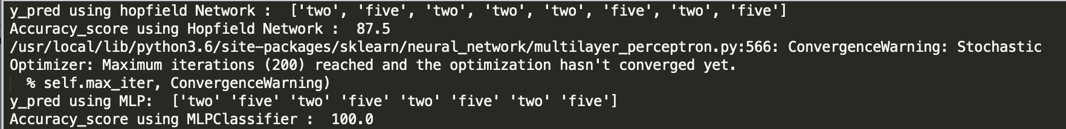

1. Produce a line plot for Hopfield network and MLPClassifier

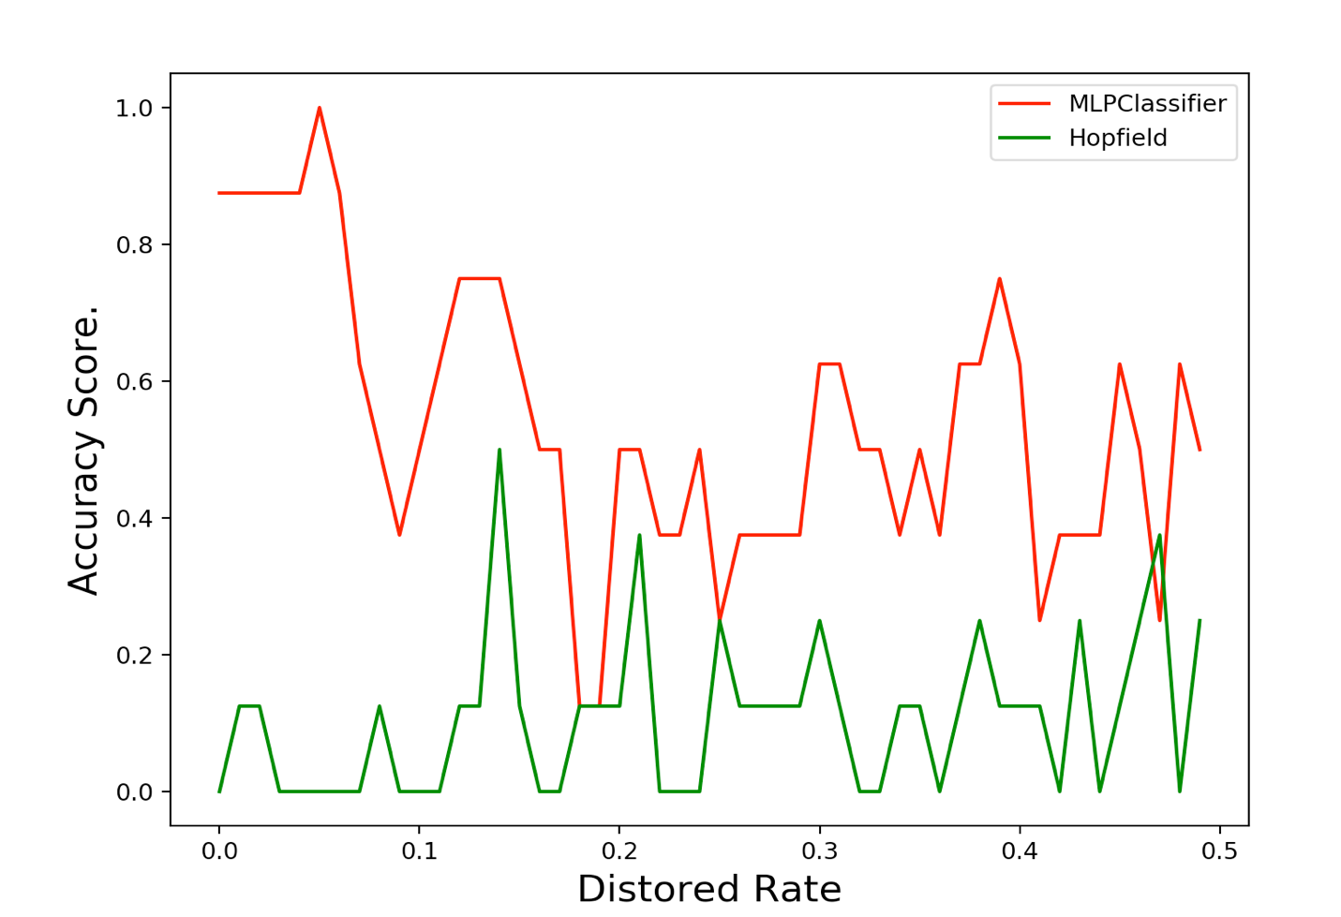

Because of distorted instances, Hopfield network (green line) produce the line that have lower accuracy score than MLP Classifier (red line). The accuracy score of both Hopfield network and MLP classifiers went up and down depending on the distorted rate. Overall, the MLP classifier produce the robustness to distortion. MLP classifier is performed better than Hopfield network.

1. Reproduce the graph with additional line

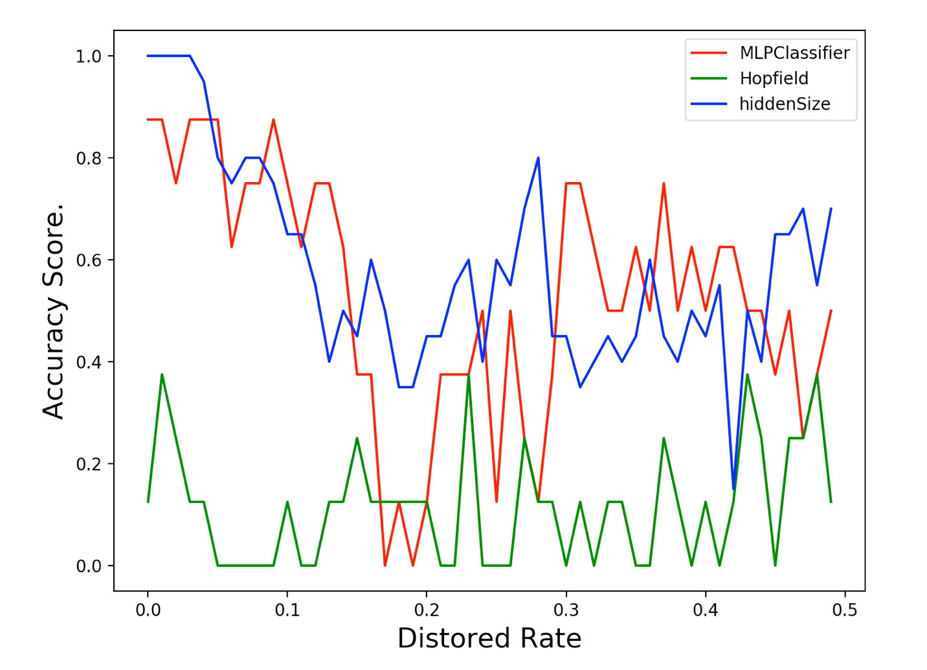In this part, I tried different size of hidden layer like (50, 50), (20, 30 ,50), (10, 20, 30), (50, 100, 150) and (50, 30, 10) for performaning MLP classifier. The hidden_layer_size is equal to (50, 30, 10) that is the most improvement overall. Looking at the graph, the green line is hopfield network, red line is MLP classifier with default hidden layer size parament, and the blue line is MLP classifier with hidden_lay_size = (50, 30, 10). The blue line is performed better than other two. With the distored rate of 0.5, blue line has about 70% accuracy score, and red line has about 50% accuracy score and the green line has about 1% accuracy score. Therefore, the MLP classifier is still performed better than hopfield network.