Name: Chakrya Ros

Homework 4 : Case Study

**Data Modal of Eden Landscape**

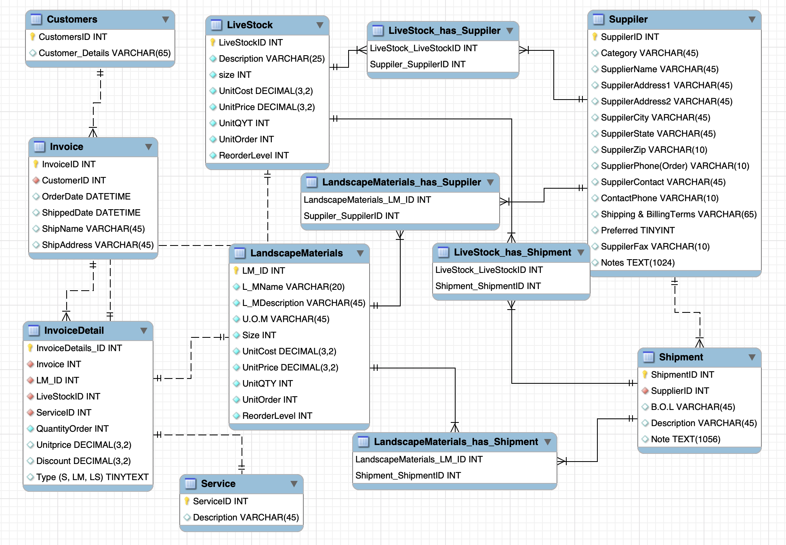

**Physical Data Model**

-- MySQL Workbench Forward Engineering

SET @OLD_UNIQUE_CHECKS=@@UNIQUE_CHECKS, UNIQUE_CHECKS=0;

SET @OLD_FOREIGN_KEY_CHECKS=@@FOREIGN_KEY_CHECKS, FOREIGN_KEY_CHECKS=0;

SET @OLD_SQL_MODE=@@SQL_MODE, SQL_MODE='ONLY_FULL_GROUP_BY,STRICT_TRANS_TABLES,NO_ZERO_IN_DATE,NO_ZERO_DATE,ERROR_FOR_DIVISION_BY_ZERO,NO_ENGINE_SUBSTITUTION';

-- -----------------------------------------------------

-- Schema Eden_landscape

-- -----------------------------------------------------

-- -----------------------------------------------------

-- Schema Eden_landscape

-- -----------------------------------------------------

CREATE SCHEMA IF NOT EXISTS `Eden_landscape` DEFAULT CHARACTER SET utf8 ;

USE `Eden_landscape` ;

-- -----------------------------------------------------

-- Table `Eden_landscape`.`Suppiler`

-- -----------------------------------------------------

CREATE TABLE IF NOT EXISTS `Eden_landscape`.`Suppiler` (

`SuppilerID` INT NOT NULL AUTO_INCREMENT,

`Category` VARCHAR(45) NULL,

`SupplierName` VARCHAR(45) NULL,

`SuppilerAddress1` VARCHAR(45) NULL,

`SuppilerAddress2` VARCHAR(45) NULL,

`SuppilerCity` VARCHAR(45) NULL,

`SuppilerState` VARCHAR(45) NULL,

`SuppilerZip` VARCHAR(10) NULL,

`SupplierPhone(Order)` VARCHAR(10) NULL,

`SuppilerContact` VARCHAR(45) NULL,

`ContactPhone` VARCHAR(10) NULL,

`Shipping & BillingTerms` VARCHAR(65) NULL,

`Preferred` TINYINT NULL,

`SuppilerFax` VARCHAR(10) NULL,

`Notes` TEXT(1024) NULL,

PRIMARY KEY (`SuppilerID`))

ENGINE = InnoDB;

-- -----------------------------------------------------

-- Table `Eden_landscape`.`LandscapeMaterials`

-- -----------------------------------------------------

CREATE TABLE IF NOT EXISTS `Eden_landscape`.`LandscapeMaterials` (

`LM_ID` INT NOT NULL AUTO_INCREMENT,

`L_MName` VARCHAR(20) NOT NULL,

`L_MDescription` VARCHAR(45) NOT NULL,

`U.O.M` VARCHAR(45) NOT NULL,

`Size` INT NOT NULL,

`UnitCost` DECIMAL(3,2) NOT NULL,

`UnitPrice` DECIMAL(3,2) NOT NULL,

`UnitQTY` INT NOT NULL,

`UnitOrder` INT NOT NULL,

`ReorderLevel` INT NOT NULL,

PRIMARY KEY (`LM_ID`))

ENGINE = InnoDB;

-- -----------------------------------------------------

-- Table `Eden_landscape`.`LiveStock`

-- -----------------------------------------------------

CREATE TABLE IF NOT EXISTS `Eden_landscape`.`LiveStock` (

`LiveStockID` INT NOT NULL AUTO_INCREMENT,

`Description` VARCHAR(25) NOT NULL,

`size` INT NOT NULL,

`UnitCost` DECIMAL(3,2) NOT NULL,

`UnitPrice` DECIMAL(3,2) NOT NULL,

`UnitQYT` INT NOT NULL,

`UnitOrder` INT NOT NULL,

`ReorderLevel` INT NOT NULL,

PRIMARY KEY (`LiveStockID`))

ENGINE = InnoDB;

-- -----------------------------------------------------

-- Table `Eden_landscape`.`Customers`

-- -----------------------------------------------------

CREATE TABLE IF NOT EXISTS `Eden_landscape`.`Customers` (

`CustomersID` INT NOT NULL AUTO_INCREMENT,

`Customer_Details` VARCHAR(65) NULL,

PRIMARY KEY (`CustomersID`))

ENGINE = InnoDB;

-- -----------------------------------------------------

-- Table `Eden_landscape`.`Invoice`

-- -----------------------------------------------------

CREATE TABLE IF NOT EXISTS `Eden_landscape`.`Invoice` (

`InvoiceID` INT NOT NULL,

`CustomerID` INT NOT NULL,

`OrderDate` DATETIME NULL,

`ShippedDate` DATETIME NULL,

`ShipName` VARCHAR(45) NULL,

`ShipAddress` VARCHAR(45) NULL,

PRIMARY KEY (`InvoiceID`),

INDEX `customerID_idx` (`CustomerID` ASC) VISIBLE,

CONSTRAINT `customerID`

FOREIGN KEY (`CustomerID`)

REFERENCES `Eden_landscape`.`Customers` (`CustomersID`)

ON DELETE NO ACTION

ON UPDATE NO ACTION)

ENGINE = InnoDB;

-- -----------------------------------------------------

-- Table `Eden_landscape`.`Service`

-- -----------------------------------------------------

CREATE TABLE IF NOT EXISTS `Eden_landscape`.`Service` (

`ServiceID` INT NOT NULL AUTO_INCREMENT,

`Description` VARCHAR(45) NULL,

PRIMARY KEY (`ServiceID`))

ENGINE = InnoDB;

-- -----------------------------------------------------

-- Table `Eden_landscape`.`InvoiceDetail`

-- -----------------------------------------------------

CREATE TABLE IF NOT EXISTS `Eden_landscape`.`InvoiceDetail` (

`InvoiceDetails_ID` INT NOT NULL,

`Invoice` INT NOT NULL,

`LM_ID` INT NOT NULL,

`LiveStockID` INT NOT NULL,

`ServiceID` INT NOT NULL,

`QuantityOrder` INT NOT NULL,

`Unitprice` DECIMAL(3,2) NULL,

`Discount` DECIMAL(3,2) NULL,

`Type (S, LM, LS)` TINYTEXT NULL,

PRIMARY KEY (`InvoiceDetails_ID`),

INDEX `InvoiceID_idx` (`Invoice` ASC) VISIBLE,

INDEX `LiveStockID_idx` (`LiveStockID` ASC) VISIBLE,

INDEX `LM_ID_idx` (`LM_ID` ASC) VISIBLE,

INDEX `ServiceID_idx` (`ServiceID` ASC) VISIBLE,

CONSTRAINT `InvoiceID`

FOREIGN KEY (`Invoice`)

REFERENCES `Eden_landscape`.`Invoice` (`InvoiceID`)

ON DELETE NO ACTION

ON UPDATE NO ACTION,

CONSTRAINT `LiveStockID`

FOREIGN KEY (`LiveStockID`)

REFERENCES `Eden_landscape`.`LiveStock` (`LiveStockID`)

ON DELETE NO ACTION

ON UPDATE NO ACTION,

CONSTRAINT `LM_ID`

FOREIGN KEY (`LM_ID`)

REFERENCES `Eden_landscape`.`LandscapeMaterials` (`LM_ID`)

ON DELETE NO ACTION

ON UPDATE NO ACTION,

CONSTRAINT `ServiceID`

FOREIGN KEY (`ServiceID`)

REFERENCES `Eden_landscape`.`Service` (`ServiceID`)

ON DELETE NO ACTION

ON UPDATE NO ACTION)

ENGINE = InnoDB;

-- -----------------------------------------------------

-- Table `Eden_landscape`.`Shipment`

-- -----------------------------------------------------

CREATE TABLE IF NOT EXISTS `Eden_landscape`.`Shipment` (

`ShipmentID` INT UNSIGNED NOT NULL AUTO_INCREMENT,

`SupplierID` INT NOT NULL,

`B.O.L` VARCHAR(45) NULL,

`Description` VARCHAR(45) NULL,

`Note` TEXT(1056) NULL,

PRIMARY KEY (`ShipmentID`),

INDEX `SupplierID_idx` (`SupplierID` ASC) VISIBLE,

CONSTRAINT `SupplierID`

FOREIGN KEY (`SupplierID`)

REFERENCES `Eden_landscape`.`Suppiler` (`SuppilerID`)

ON DELETE NO ACTION

ON UPDATE NO ACTION)

ENGINE = InnoDB;

-- -----------------------------------------------------

-- Table `Eden_landscape`.`LiveStock_has_Suppiler`

-- -----------------------------------------------------

CREATE TABLE IF NOT EXISTS `Eden_landscape`.`LiveStock_has_Suppiler` (

`LiveStock_LiveStockID` INT NOT NULL,

`Suppiler_SuppilerID` INT NOT NULL,

PRIMARY KEY (`LiveStock_LiveStockID`, `Suppiler_SuppilerID`),

INDEX `fk_LiveStock_has_Suppiler_Suppiler1_idx` (`Suppiler_SuppilerID` ASC) VISIBLE,

INDEX `fk_LiveStock_has_Suppiler_LiveStock1_idx` (`LiveStock_LiveStockID` ASC) VISIBLE,

CONSTRAINT `fk_LiveStock_has_Suppiler_LiveStock1`

FOREIGN KEY (`LiveStock_LiveStockID`)

REFERENCES `Eden_landscape`.`LiveStock` (`LiveStockID`)

ON DELETE NO ACTION

ON UPDATE NO ACTION,

CONSTRAINT `fk_LiveStock_has_Suppiler_Suppiler1`

FOREIGN KEY (`Suppiler_SuppilerID`)

REFERENCES `Eden_landscape`.`Suppiler` (`SuppilerID`)

ON DELETE NO ACTION

ON UPDATE NO ACTION)

ENGINE = InnoDB;

-- -----------------------------------------------------

-- Table `Eden_landscape`.`LiveStock_has_Shipment`

-- -----------------------------------------------------

CREATE TABLE IF NOT EXISTS `Eden_landscape`.`LiveStock_has_Shipment` (

`LiveStock_LiveStockID` INT NOT NULL,

`Shipment_ShipmentID` INT UNSIGNED NOT NULL,

PRIMARY KEY (`LiveStock_LiveStockID`, `Shipment_ShipmentID`),

INDEX `fk_LiveStock_has_Shipment_Shipment1_idx` (`Shipment_ShipmentID` ASC) VISIBLE,

INDEX `fk_LiveStock_has_Shipment_LiveStock1_idx` (`LiveStock_LiveStockID` ASC) VISIBLE,

CONSTRAINT `fk_LiveStock_has_Shipment_LiveStock1`

FOREIGN KEY (`LiveStock_LiveStockID`)

REFERENCES `Eden_landscape`.`LiveStock` (`LiveStockID`)

ON DELETE NO ACTION

ON UPDATE NO ACTION,

CONSTRAINT `fk_LiveStock_has_Shipment_Shipment1`

FOREIGN KEY (`Shipment_ShipmentID`)

REFERENCES `Eden_landscape`.`Shipment` (`ShipmentID`)

ON DELETE NO ACTION

ON UPDATE NO ACTION)

ENGINE = InnoDB;

-- -----------------------------------------------------

-- Table `Eden_landscape`.`LandscapeMaterials_has_Suppiler`

-- -----------------------------------------------------

CREATE TABLE IF NOT EXISTS `Eden_landscape`.`LandscapeMaterials_has_Suppiler` (

`LandscapeMaterials_LM_ID` INT NOT NULL,

`Suppiler_SuppilerID` INT NOT NULL,

PRIMARY KEY (`LandscapeMaterials_LM_ID`, `Suppiler_SuppilerID`),

INDEX `fk_LandscapeMaterials_has_Suppiler_Suppiler1_idx` (`Suppiler_SuppilerID` ASC) VISIBLE,

INDEX `fk_LandscapeMaterials_has_Suppiler_LandscapeMaterials1_idx` (`LandscapeMaterials_LM_ID` ASC) VISIBLE,

CONSTRAINT `fk_LandscapeMaterials_has_Suppiler_LandscapeMaterials1`

FOREIGN KEY (`LandscapeMaterials_LM_ID`)

REFERENCES `Eden_landscape`.`LandscapeMaterials` (`LM_ID`)

ON DELETE NO ACTION

ON UPDATE NO ACTION,

CONSTRAINT `fk_LandscapeMaterials_has_Suppiler_Suppiler1`

FOREIGN KEY (`Suppiler_SuppilerID`)

REFERENCES `Eden_landscape`.`Suppiler` (`SuppilerID`)

ON DELETE NO ACTION

ON UPDATE NO ACTION)

ENGINE = InnoDB;

-- -----------------------------------------------------

-- Table `Eden_landscape`.`LandscapeMaterials_has_Shipment`

-- -----------------------------------------------------

CREATE TABLE IF NOT EXISTS `Eden_landscape`.`LandscapeMaterials_has_Shipment` (

`LandscapeMaterials_LM_ID` INT NOT NULL,

`Shipment_ShipmentID` INT UNSIGNED NOT NULL,

PRIMARY KEY (`LandscapeMaterials_LM_ID`, `Shipment_ShipmentID`),

INDEX `fk_LandscapeMaterials_has_Shipment_Shipment1_idx` (`Shipment_ShipmentID` ASC) VISIBLE,

INDEX `fk_LandscapeMaterials_has_Shipment_LandscapeMaterials1_idx` (`LandscapeMaterials_LM_ID` ASC) VISIBLE,

CONSTRAINT `fk_LandscapeMaterials_has_Shipment_LandscapeMaterials1`

FOREIGN KEY (`LandscapeMaterials_LM_ID`)

REFERENCES `Eden_landscape`.`LandscapeMaterials` (`LM_ID`)

ON DELETE NO ACTION

ON UPDATE NO ACTION,

CONSTRAINT `fk_LandscapeMaterials_has_Shipment_Shipment1`

FOREIGN KEY (`Shipment_ShipmentID`)

REFERENCES `Eden_landscape`.`Shipment` (`ShipmentID`)

ON DELETE NO ACTION

ON UPDATE NO ACTION)

ENGINE = InnoDB;

SET SQL_MODE=@OLD_SQL_MODE;

SET FOREIGN_KEY_CHECKS=@OLD_FOREIGN_KEY_CHECKS;

SET UNIQUE_CHECKS=@OLD_UNIQUE_CHECKS;

**Thought and Process**

I assume that LiveStock, LandscapeMaterial entities have several supplier and shipment so I create the associate entities for those. LandscapeMaterial_has_supplier, LandscapeMaterial_has_shipment, LiveStock_has_supplier and LiveStockl_has_shipment are associate entities from many to one.