Homework 5:

Name: Chakrya Ros

**Question 1.** Which salesperson produced the most total revenue for this organization during 2012? (Total Revenue = SalesPrice * Quantity)

Quary >

SELECT FP.SalesPersonID, ds.SalesPersonName, dd.YEAR,

SUM(FP.SalesPrice * FP.Quantity) as TotalRevenue

FROM Fact_ProductSales FP JOIN Dim_SalesPerson ds

ON ds.SalesPersonID = FP.SalesPersonID

JOIN Dim_Date dd on FP.SalesDatekey = dd.DateKey WHERE dd.YEAR = '2012'

GROUP BY FP.SalesPersonID ORDER BY TotalRevenue DESC LIMIT 1;

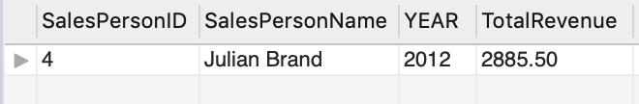

**Question 2.** Which customer’s revenue increased the most from 2012 to 2013? (Total Revenue = SalesPrice * Quantity)

Quary >

SELECT dc.CustomerID, dc.CustomerName, SUM(FP.SalesPrice * FP.Quantity) as Amount

FROM Dim_Customer dc JOIN Fact_ProductSales FP

ON FP.CustomerID = dc.CustomerID

JOIN Dim_date dd ON FP.SalesDateKey = dd.DateKey

WHERE dd.YEAR BETWEEN 2012 AND 2013

GROUP BY FP.CustomerID ORDER BY Amount DESC LIMIT 1;

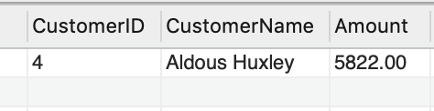

**Question 3.** Rank all stores by their total revenue for each year represented in the data warehouse. In other words, for a given year rank the three stores by revenue for that year.

Quary >

SELECT ds.StoreID, ds.StoreName, dd.YEAR, SUM(FP.SalesPrice * FP.Quantity) AS Amount

FROM Dim_Store ds

JOIN Fact_ProductSales FP ON ds.StoreID = FP.StoreID

JOIN Dim_Date dd ON FP.SalesDatekey = dd.DateKey

GROUP BY FP.StoreID, dd.YEAR ORDER BY dd.YEAR ASC, Amount DESC;

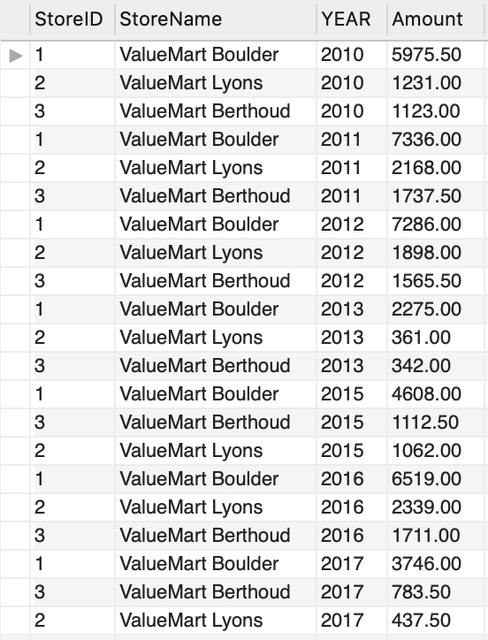

**Question 4.** Which product yielded the highest profit in 2015? (Profit = (sales price – actual cost) * quantity )

Quary >

SELECT p.ProductKey, p.ProductName,

SUM((p.ProductSalesPrice - p.ProductActualCost) * FP.Quantity) AS Profit

FROM Fact_ProductSales FP JOIN Dim_Product p ON FP.ProductID = p.ProductKey

JOIN Dim_Date dd ON dd.Datekey = FP.SalesDateKey WHERE dd.YEAR = '2015'

GROUP BY FP.ProductID ORDER BY Profit DESC LIMIT 1;

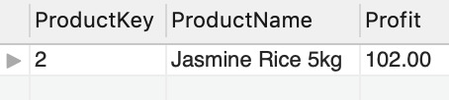

**Question 5.** In which calendar quarter in 2016 did the Boulder store show the highest revenue?

Quary >

SELECT ds.StoreID, ds.StoreName, ds.City, sum(fp.SalesPrice* Quantity) as TotalRevenue, dd.QUARTER

FROM Dim_Store ds JOIN Fact_ProductSales fp ON ds.StoreID = fp.StoreID

JOIN Dim_Date dd ON dd.DateKey = fp.SalesDateKey

WHERE ds.City = 'Boulder' AND dd.Year = '2016'

GROUP BY dd.QUARTER, fp.StoreID ORDER BY TotalRevenue DESC LIMIT 1;

