PRACTICE 4
Determine the validity of the following three statements. Circle either True or False.
1. Group functions work across many rows to produce one result per group.
True/False
ANS:True
2. Group functions include nulls in calculations.
True/False
ANS:False
3. The WHERE clause restricts rows prior to inclusion in a group calculation.
True/False
ANS:True
The HR department needs the following reports:
4. Find the highest, lowest, sum, and average salary of all employees. Label the columns
Maximum, Minimum, Sum, and Average, respectively.
ANS: SELECT MAX(SALARY) “Maximum”, MIN(SALARY) “Minimum”, SUM(SALARY) “Sum”, AVG(SALARY) “Average” FROM EMPLOYEES;
- Modify the query in lab_04 to display the minimum, maximum, sum, and average salary for each jb type.

ANS: SELECT JOB_ID, MAX(SALARY) “Maximum”, MIN(SALARY) “Minimum”, SUM(SALARY) “Sum”, AVG(NVL(SALARY,0)) “Average” FROM EMPLOYEES GROUP BY JOB_ID;

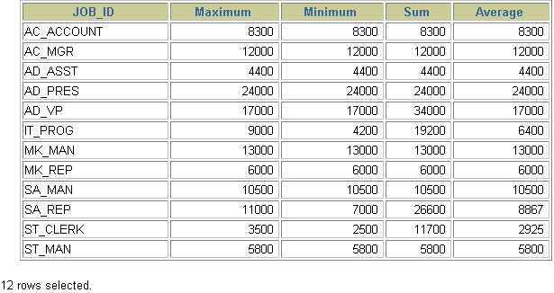
- Write a query to display the number of people with the same job.

ANS: SELECT COUNT(JOB_ID), JOB_ID FROM EMPLOYEES GROUP BY JOB_ID;

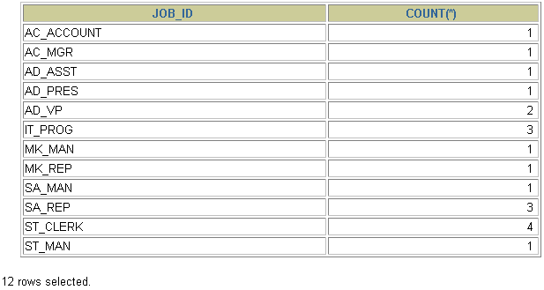
- Determine the number of managers without listing them. Label the column Number of Managers.
ANS:SELECT COUNT(DISTINCT MANAGER_ID) “Number of Managers” FROM EMPLOYEES;
8.Find the difference between the highest and lowest salaries. Label the column DIFFERENCE.
ANS:SELECT MAX(SALARY) - MIN(SALARY) DIFFERENCE FROM EMPLOYEES;

