Exercise 1 – Lambda auto start/stop
IAM Role Creation with admin access
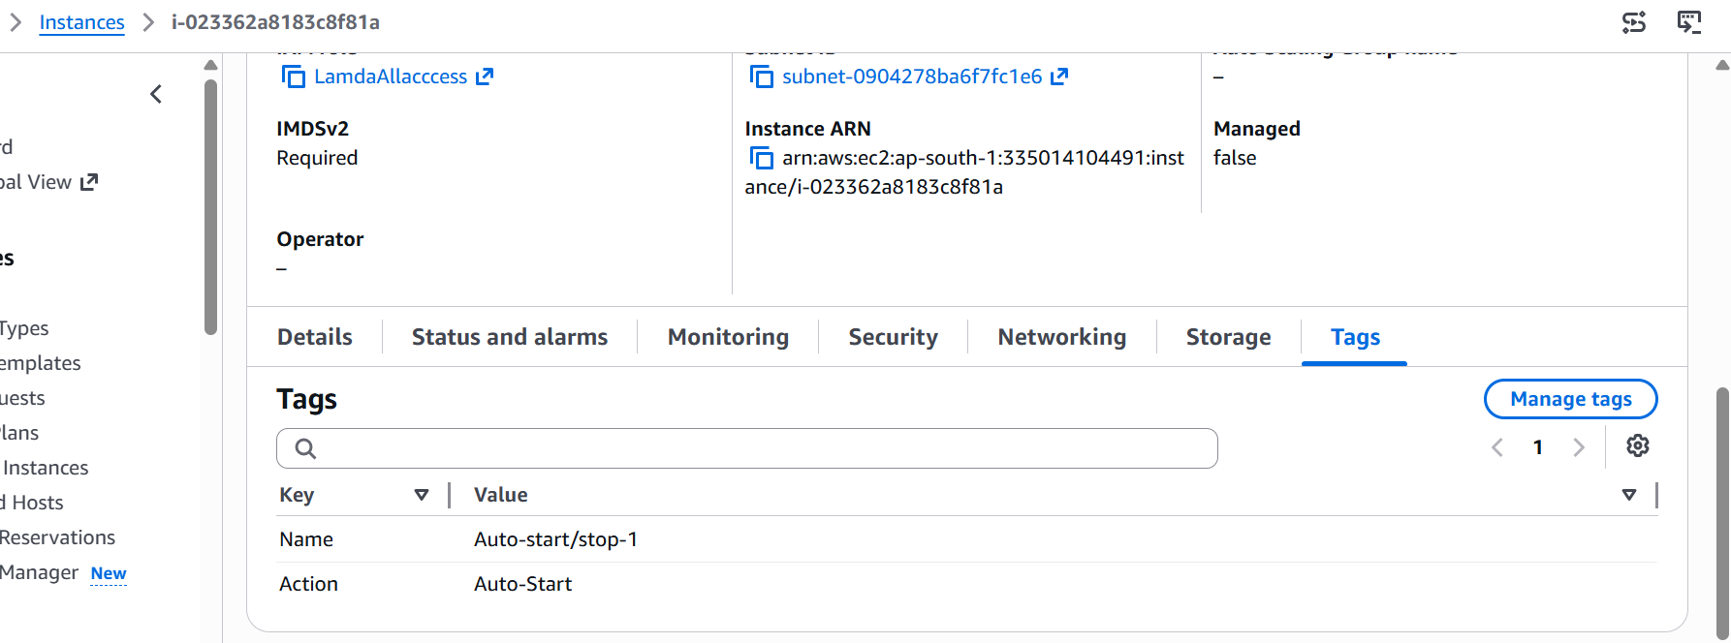

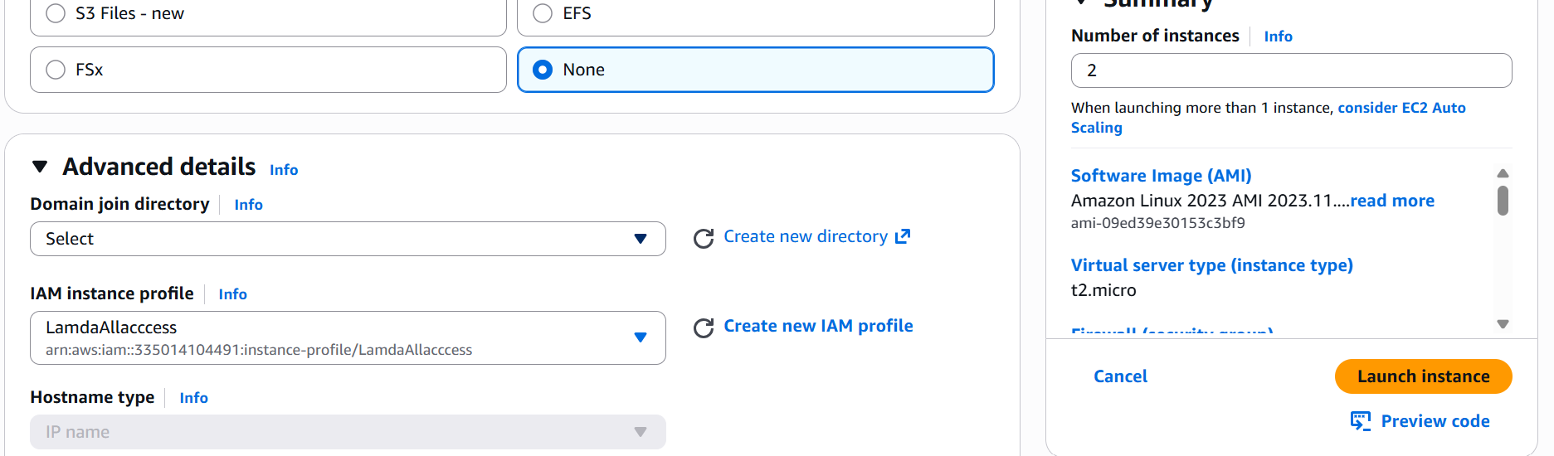

Tag the auto-start/stop behaviour
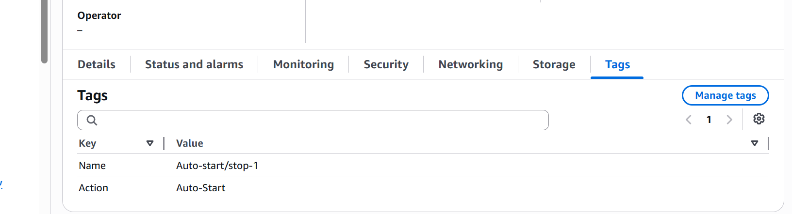
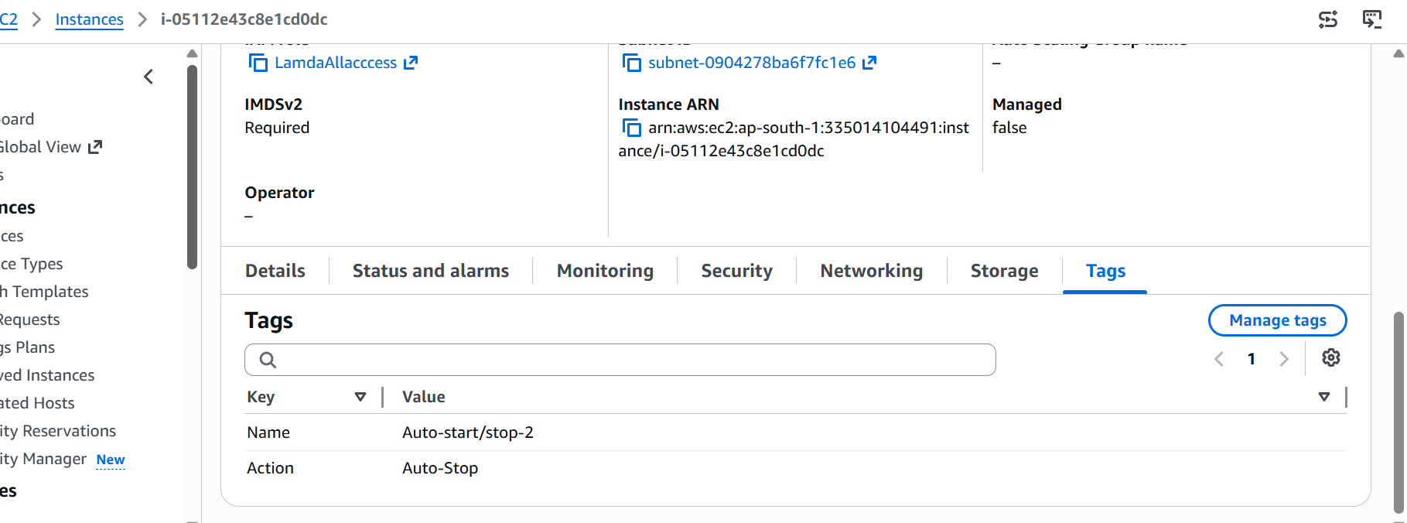

Function Creation – ec2-auto-start-stop
import boto3

# Initialize EC2 client
ec2 = boto3.client('ec2')

def lambda_handler(event, context):
stop_instance_ids = ['i-05112e43c8e1cd0dc']
start_instance_ids = ['i-023362a8183c8f81a']

# Stop instances
if stop_instance_ids:
ec2.stop_instances(InstanceIds=stop_instance_ids)
print(f"Stopped instances: {stop_instance_ids}")
else:
print("No instances found for stopping.")

# Start instances
if start_instance_ids:
ec2.start_instances(InstanceIds=start_instance_ids)
print(f"Started instances: {start_instance_ids}")
else:
print("No instances found for starting.")

return {
'statusCode': 200,
'body': 'EC2 start/stop automation completed.'
}

Deployed the function successfully and run the test event to validate the event.
Test event
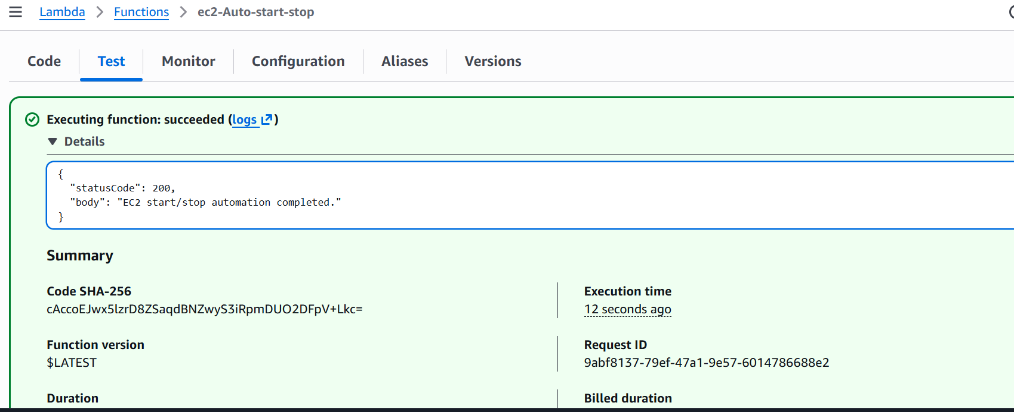
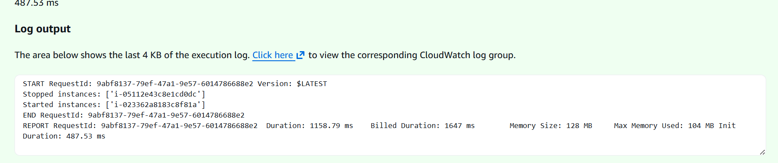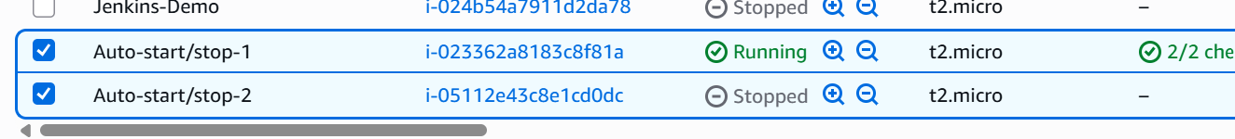
++++++++++++++++++++++++++++++++++++++++++++++++++++++++++++++++++++++
Exercise 2 Automated S3 Bucket Cleanup Using AWS Lambda and Boto3
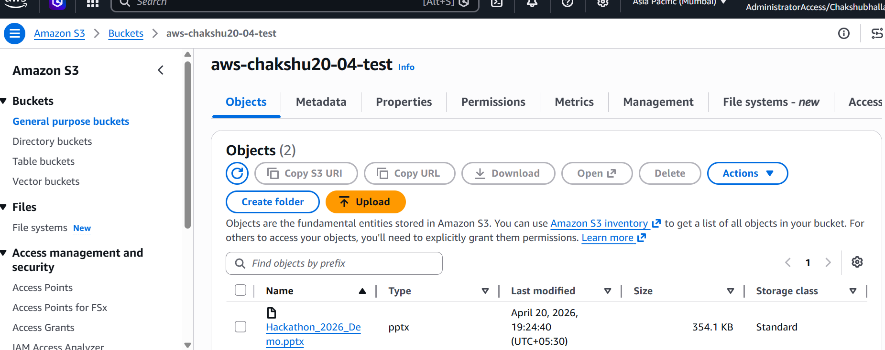
using old bucket created on practice named as aws-chakshu20-04-test
Already having 2 files also …. Added one more as an additional file .
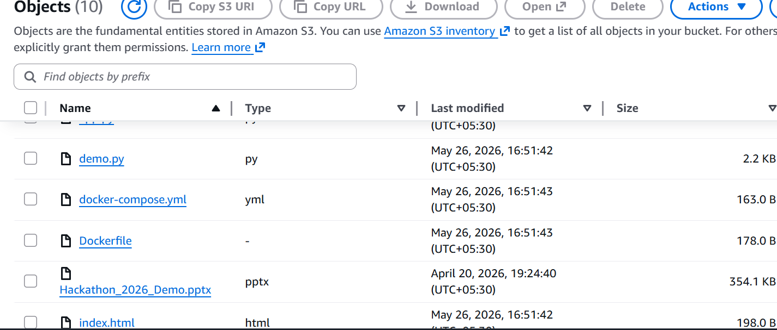

Attached AmazonS3FullAccess to the role.
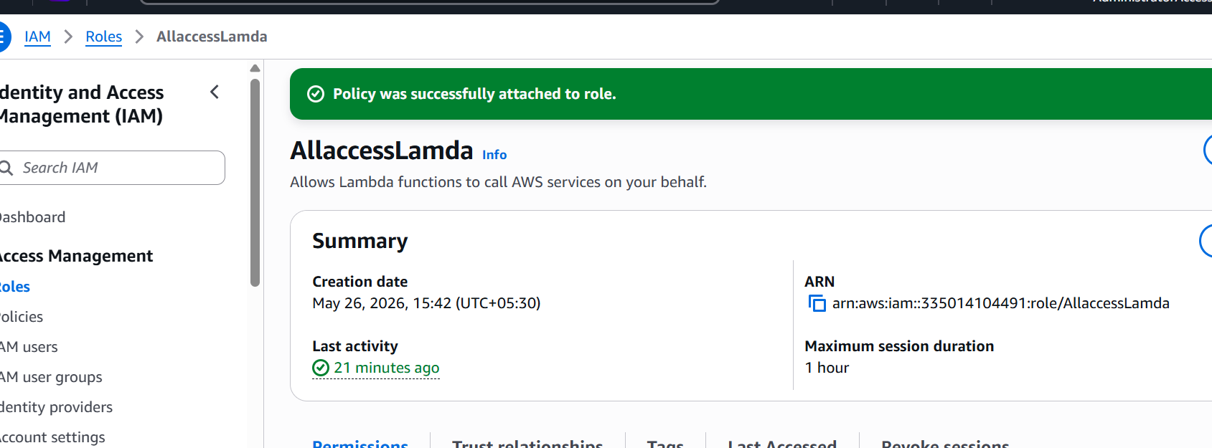

Boto3 code for file deletion and s3 trigger attachment // deployed successfully
import boto3
from datetime import datetime, timezone, timedelta

# Create S3 client
s3 = boto3.client('s3')

# Your bucket name
bucket_name = 'aws-chakshu20-04-test'

def lambda_handler(event, context):

old_date = datetime.now(timezone.utc) - timedelta(days=3)

objects = s3.list_objects_v2(Bucket=bucket_name)

if 'Contents' in objects:

for file in objects['Contents']:

file_name = file['Key']
file_date = file['LastModified']

# Check old files
if file_date < old_date:

# Delete file
s3.delete_object(
Bucket=bucket_name,
Key=file_name
)

print(f"Deleted: {file_name}")

return {
'statusCode': 200,
'body': 'Old files deleted successfully'
}

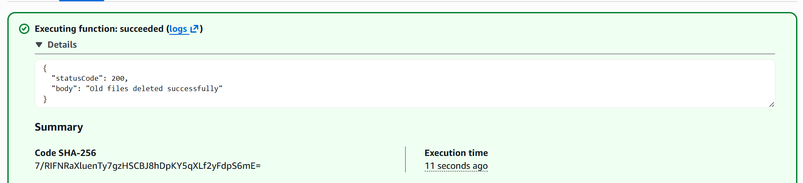
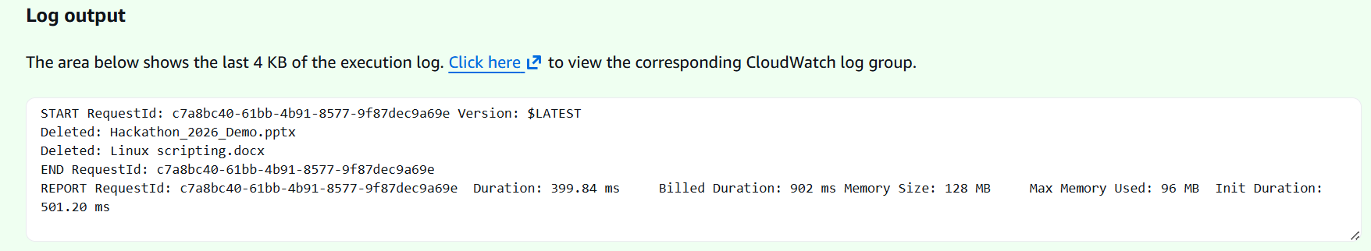
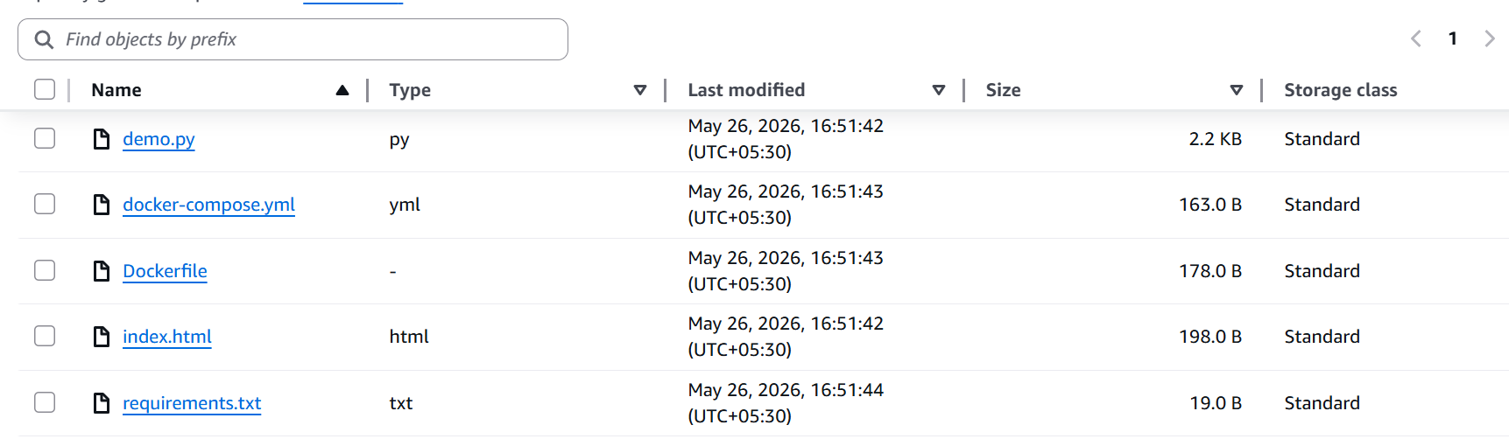
Files deleted successfully
+++++++++++++++++++++++++++++++++++++++++++++++++++++++++++++++++++++++++
Assignment 4: Automatic EBS Snapshot and Cleanup Using AWS Lambda and Boto3

Copied the existing volume id by going to EC2 ---- ebs – volumes
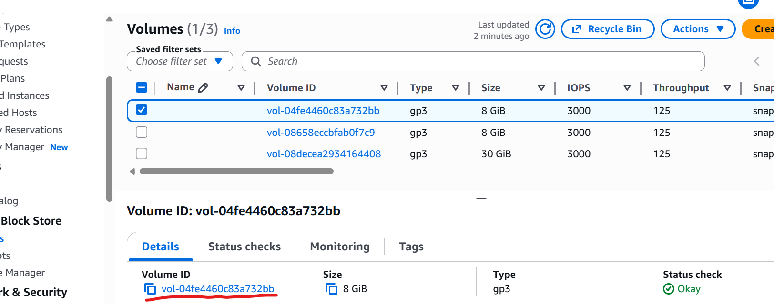

Created new lambda function with IAM role with AmazonEC2FullAccess.
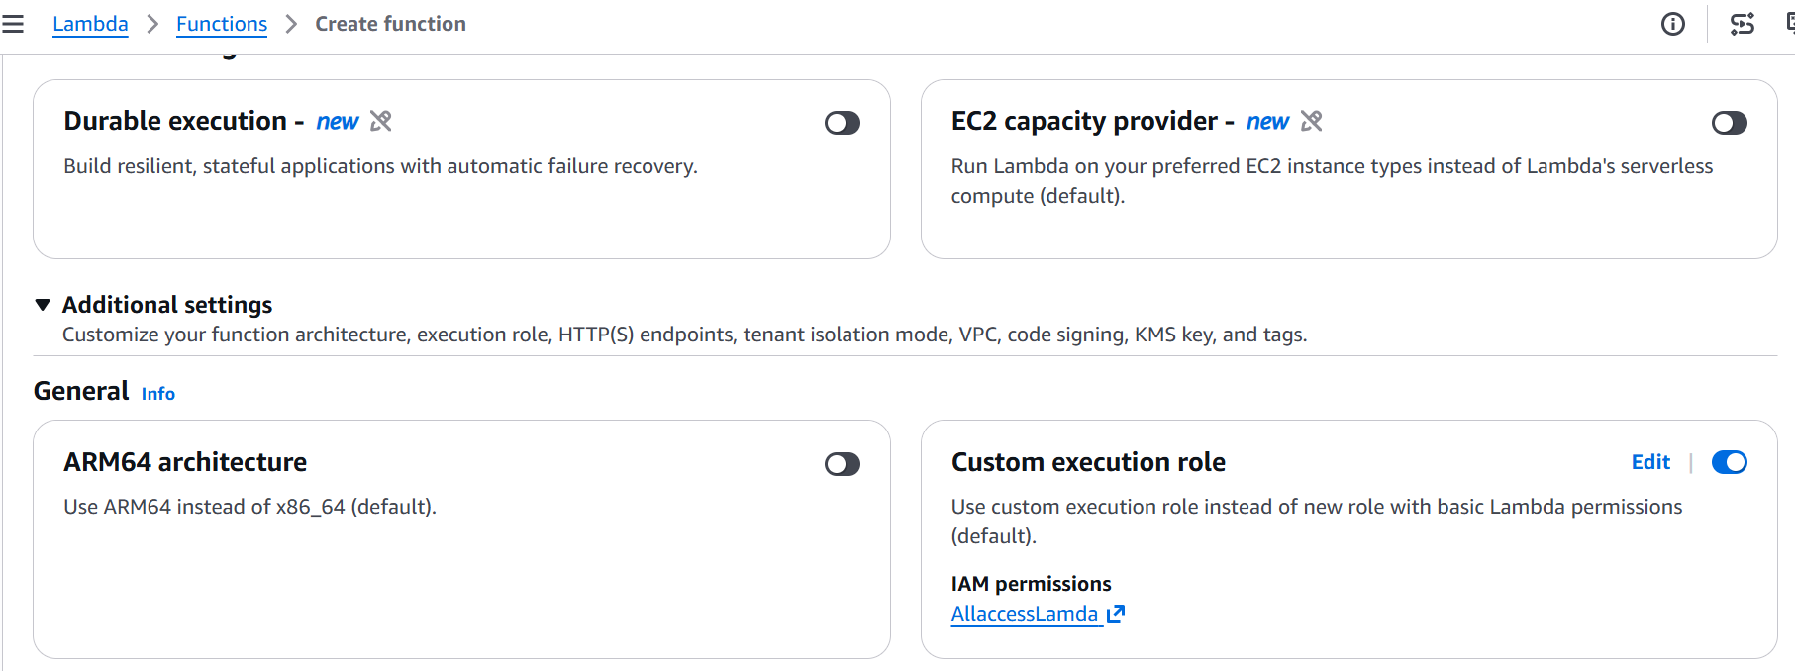
Lambda code
import json
import logging
from datetime import datetime, timedelta, timezone
import boto3

logger = logging.getLogger()
logger.setLevel(logging.INFO)

VOLUME_ID = "YOUR_VOLUME_ID"
RETENTION_DAYS = 30

def lambda_handler(event, context):
ec2 = boto3.client('ec2')
current_time = datetime.now(timezone.utc)

# 1. CREATE SNAPSHOT WITH TAG IN ONE SINGLE CALL
try:
snapshot = ec2.create_snapshot(
VolumeId=VOLUME_ID,
Description=f"Automated backup for {VOLUME_ID} on {current_time.strftime('%Y-%m-%d')}",
TagSpecifications=[{
'ResourceType': 'snapshot',
'Tags': [{'Key': 'AutomatedBackup', 'Value': 'True'}]
}]
)
logger.info(f"CREATED_SNAPSHOT: {snapshot['SnapshotId']} for volume {VOLUME_ID}")
except Exception as e:
logger.error(f"Failed to create snapshot: {str(e)}")
raise e

# 2. LIST AND PURGE SNAPSHOTS OLDER THAN RETENTION WINDOW
try:
filters = [{'Name': 'tag:AutomatedBackup', 'Values': ['True']}]
snapshots = ec2.describe_snapshots(OwnerIds=['self'], Filters=filters)['Snapshots']

for snap in snapshots:
snap_id = snap['SnapshotId']
age_days = (current_time - snap['StartTime']).days

if age_days > RETENTION_DAYS:
ec2.delete_snapshot(SnapshotId=snap_id)
logger.info(f"DELETED_SNAPSHOT: {snap_id} (Age: {age_days} days old)")

except Exception as e:
logger.error(f"Failed during cleanup cycle: {str(e)}")
raise e

return {
'statusCode': 200,
'body': json.dumps('EBS backup and cleanup cycle complete.')
}

Change configuration to 1 min timeout
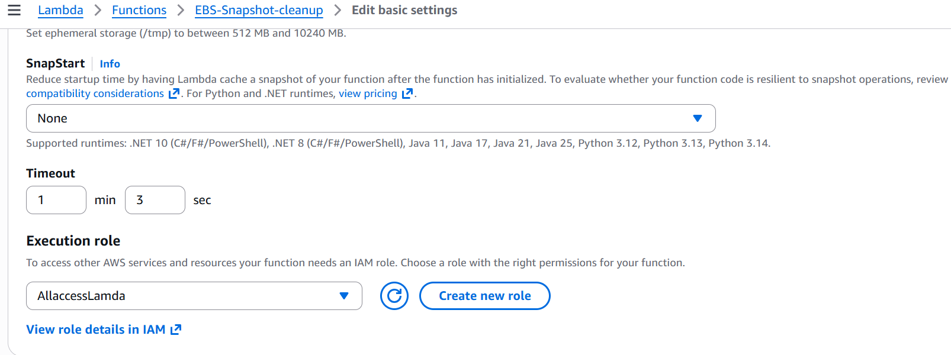
Schedule automation via amazon event bridge everyday at 5:30
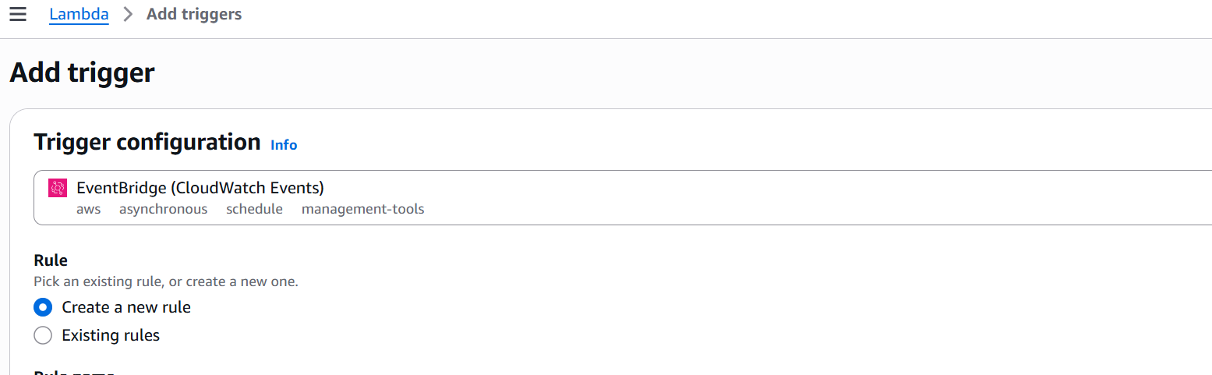

Cron job --cron(35 17 * * ? *) daily at 5:30 pm utc
Do the test event generation testing and verification
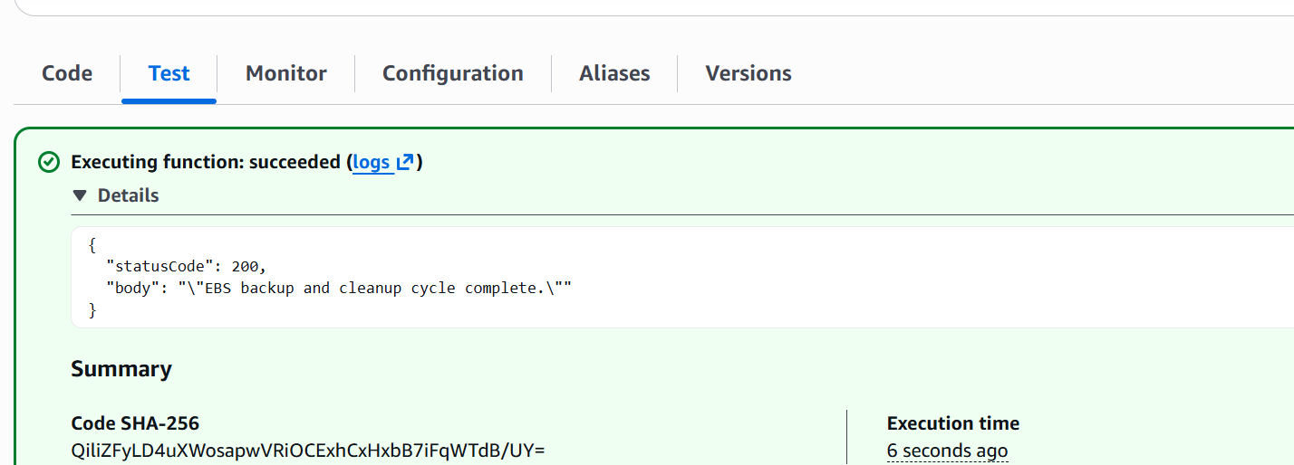

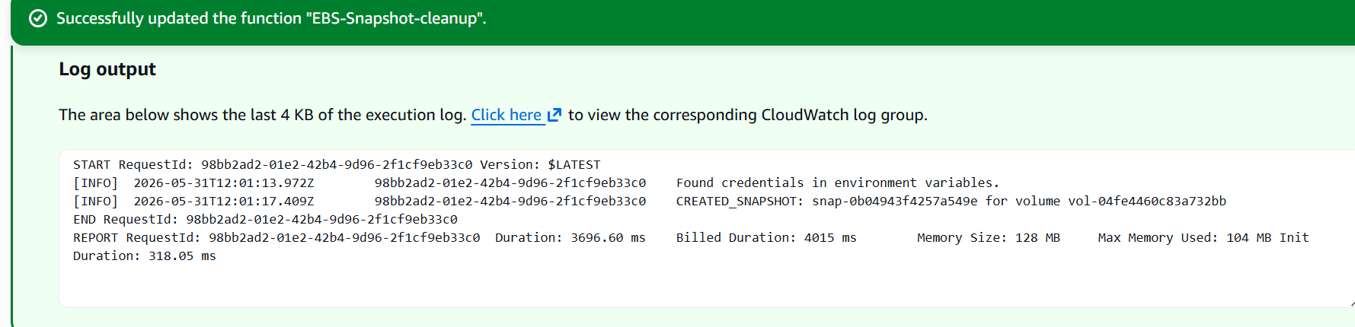

Verified the snapshot competition status
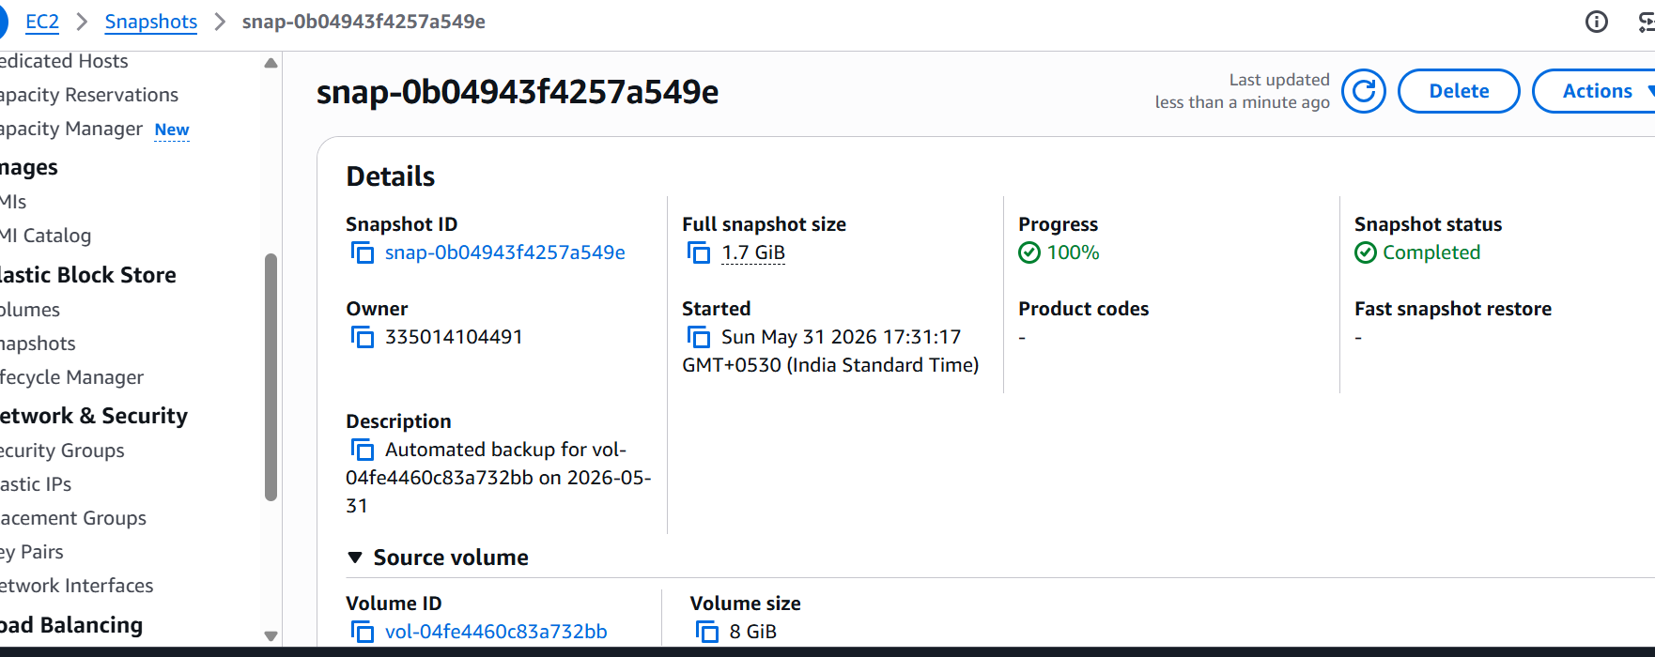

++++++++++++++++++++++++++++++++++++++++++++++++++++++++++++++++++++++++++++++
Exercise 5 :
Auto-Tagging EC2 Instances on Launch Using AWS Lambda and Boto3

Existing roles : allaccesslamda

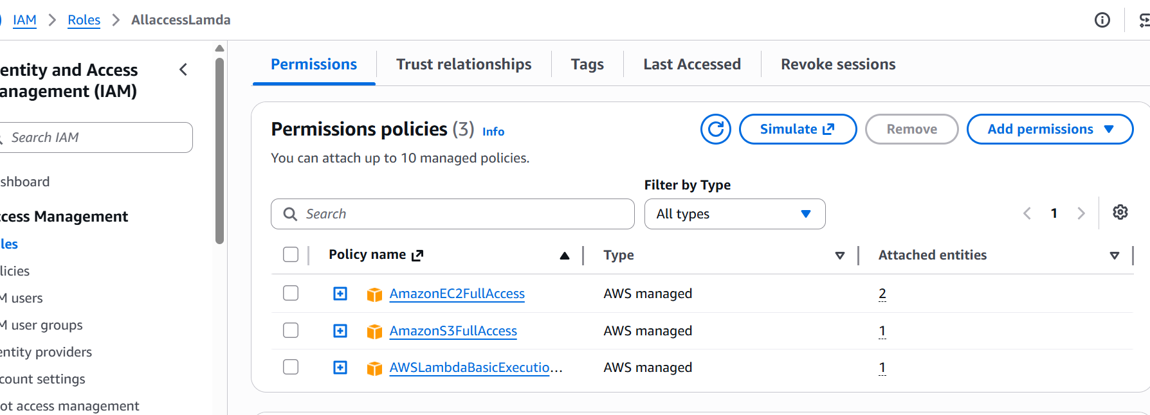
Create Function
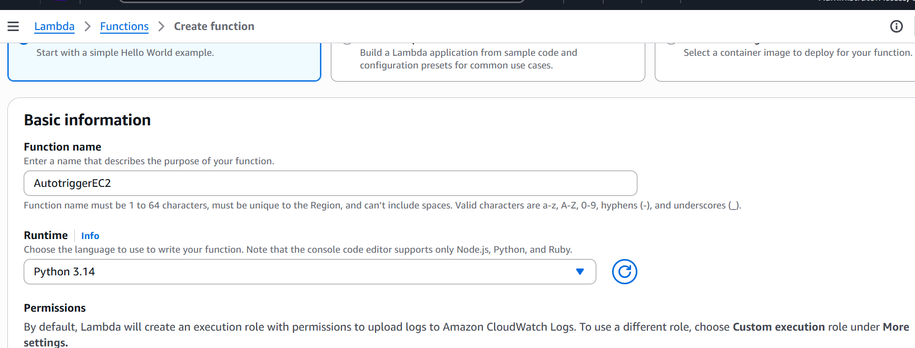

Created a rule and tagged it with the lambda function
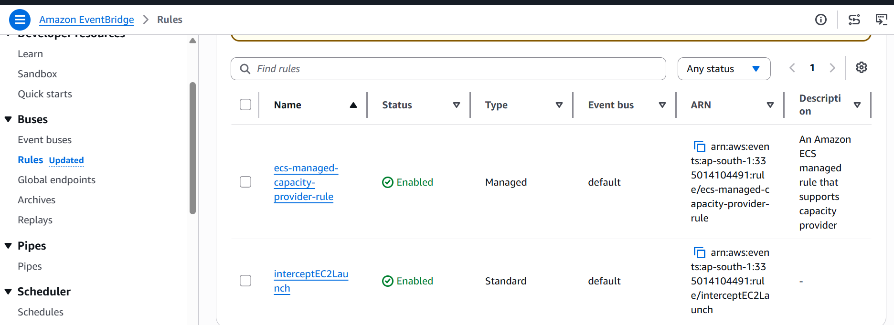

Aws instance creation
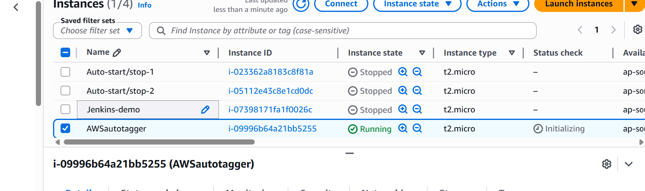

Check the tag section to verify the tagging of EC2 after few seconds .

Cloud watch logs says --- no new events detected
Test event says – no new events
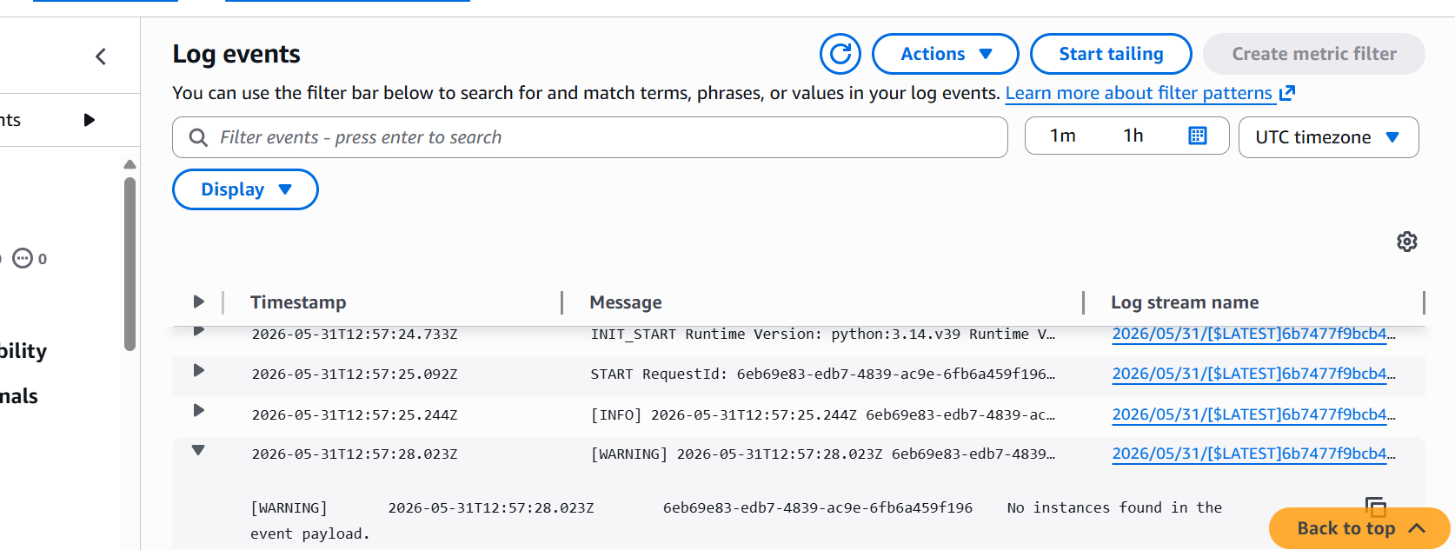

++++++++++++++++++++++++++++++++++++++++++++++++++++++++++++++++++++++
3. Monitor Unencrypted S3 Buckets Using AWS Lambda and Boto3
Note : AWS no longer allows you to disable S3 default encryption entirely.

Created 2 buckets one is with sse-kms and default.
- Encryptedbucket0106 -- default settings sse -s3
- Bucketsse-kms-0106 --- aws sse-kms
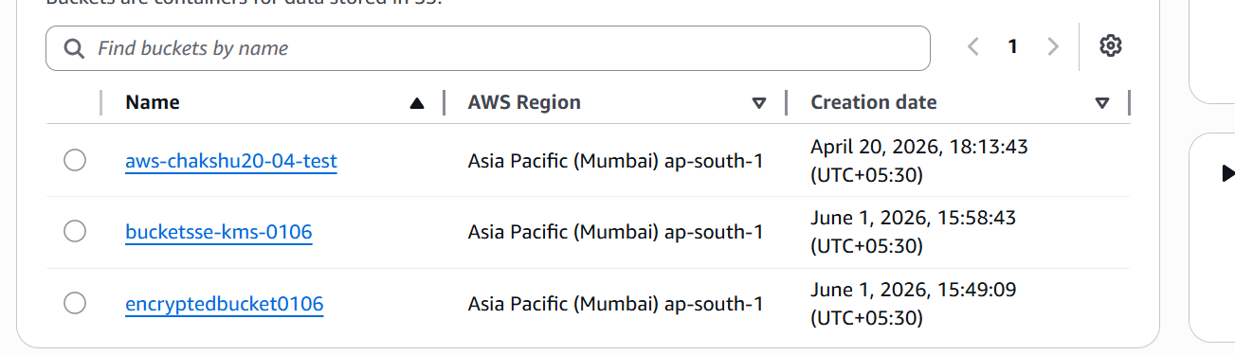

Configure the sse-kms key …for the bucket…
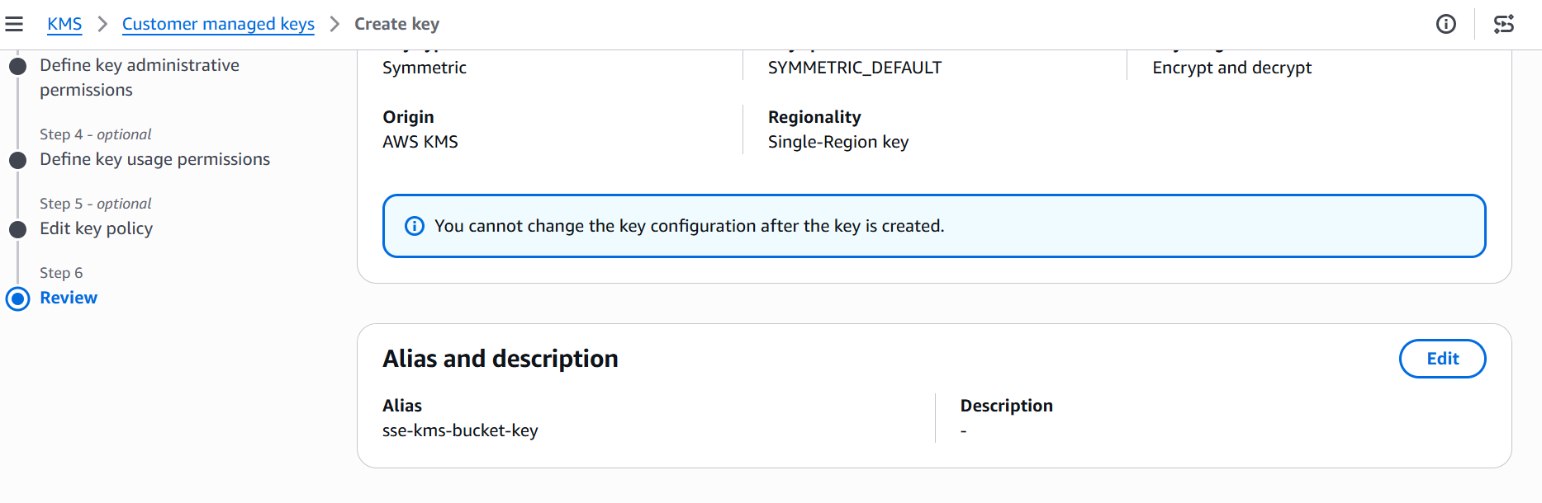
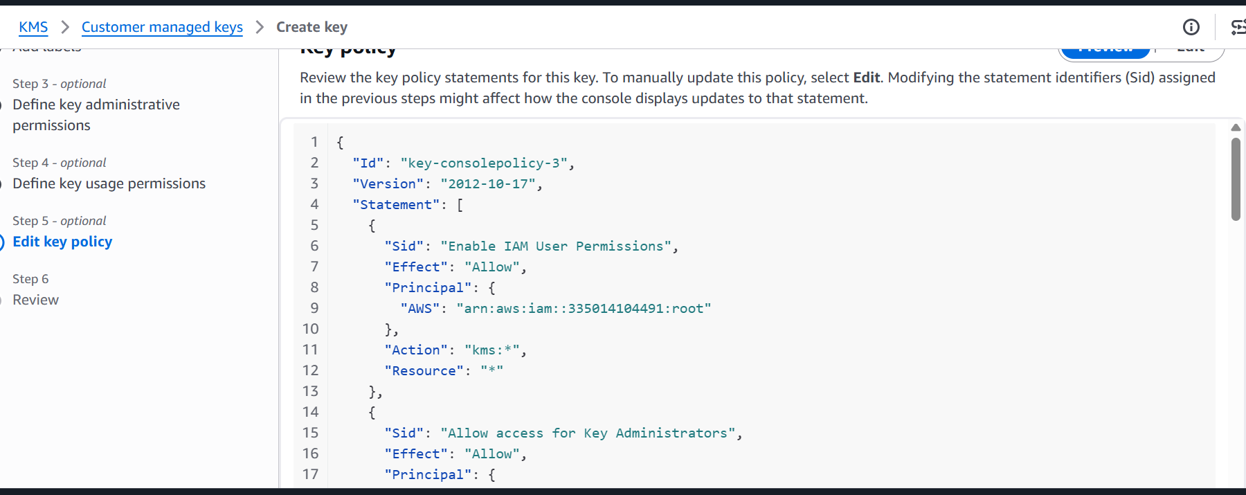

Created a lambda fuction and assign access as all access to the function.
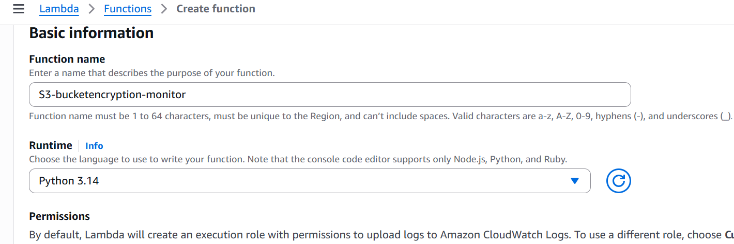

Organizations often require SSE-KMS (customer-managed keys) and flag SSE-S3 (Amazon's default keys) as non-compliant.

Bucket – sse-s3 as unencrypted
Bucket – sse-kms as encrypted
Boto3 script

import boto3
from botocore.exceptions import ClientError

def lambda_handler(event, context):
s3_client = boto3.client('s3')

try:
response = s3_client.list_buckets()
buckets = response.get('Buckets', [])

print(f"Found {len(buckets)} total buckets. Checking compliance...\n")
non_compliant_buckets = []

for bucket in buckets:
bucket_name = bucket['Name']

try:
# Fetch encryption configuration
enc_resp = s3_client.get_bucket_encryption(Bucket=bucket_name)
rules = enc_resp['ServerSideEncryptionConfiguration']['Rules']

# Check the exact encryption algorithm used
for rule in rules:
algo = rule['ApplyServerSideEncryptionByDefault']['SSEAlgorithm']

# Flag buckets using basic SSE-S3 (AES256) instead of custom KMS keys
if algo == 'AES256':
non_compliant_buckets.append(bucket_name)

except ClientError as e:
error_code = e.response['Error']['Code']
print(f"Could not read encryption for {bucket_name}: {error_code}")

# Log results
if non_compliant_buckets:
print("⚠️ WARNING: The following buckets use basic SSE-S3 instead of corporate KMS encryption:")
for bucket in non_compliant_buckets:
print(f" - {bucket}")
else:
print("✅ Success: All S3 buckets comply with KMS encryption standards.")

return {
'statusCode': 200,
'body': f"Checked {len(buckets)} buckets. Found {len(non_compliant_buckets)} basic-encrypted buckets."
}

except Exception as e:
print(f"An unexpected error occurred: {e}")
return {'statusCode': 500, 'body': "Error processing S3 check."}

change connection timeout to 2 min.
deploy the code and do the test event check
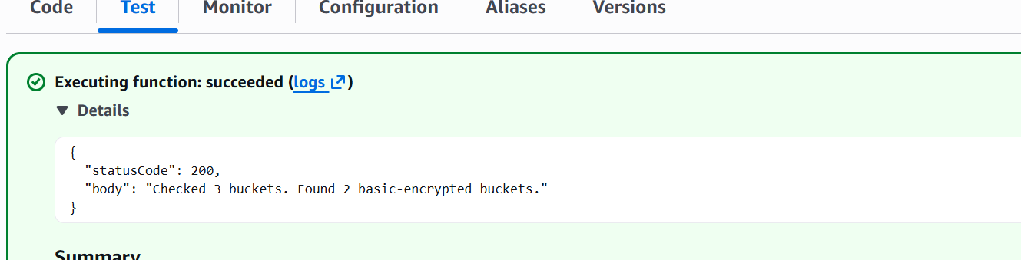

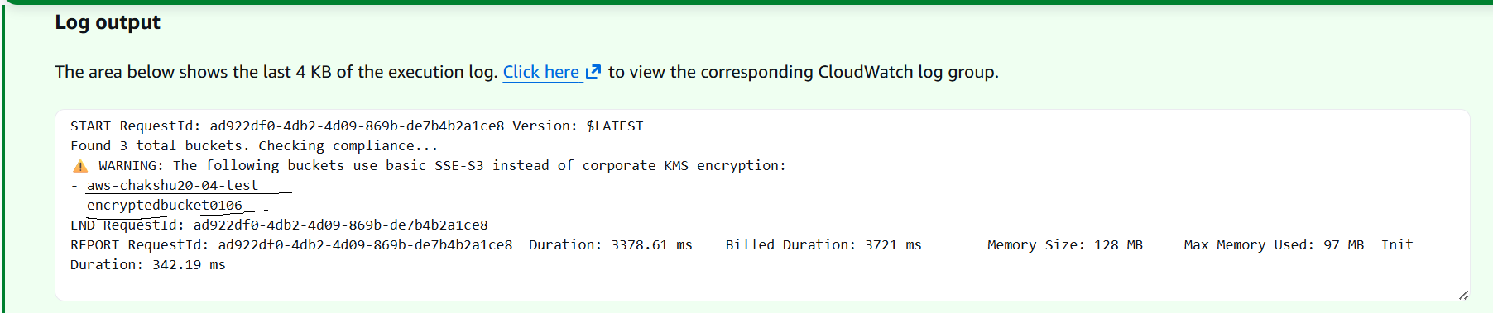

Detected 2 buckets using by default encryption sse-s3

