Git pull https://github.com/chakshubhalla100-spec/Microservices-Task16B.git
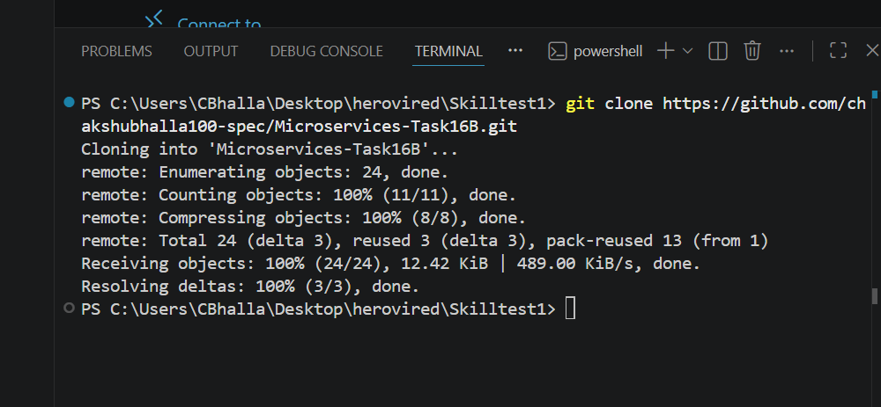

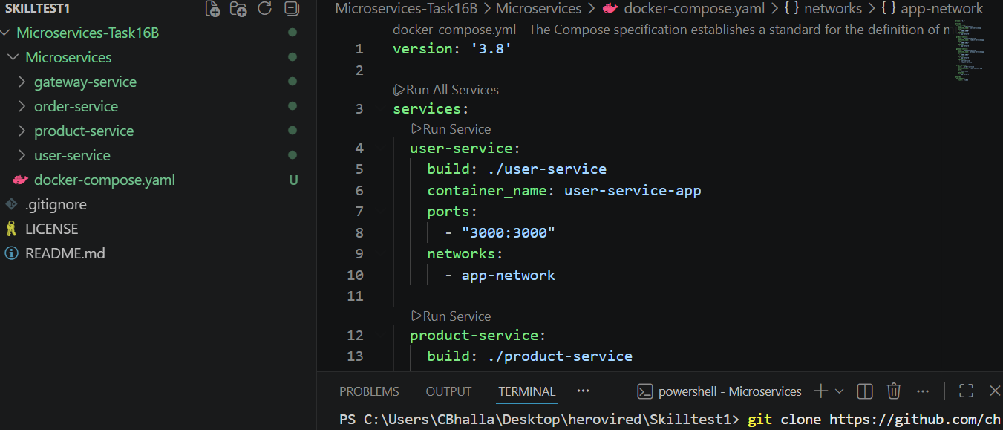
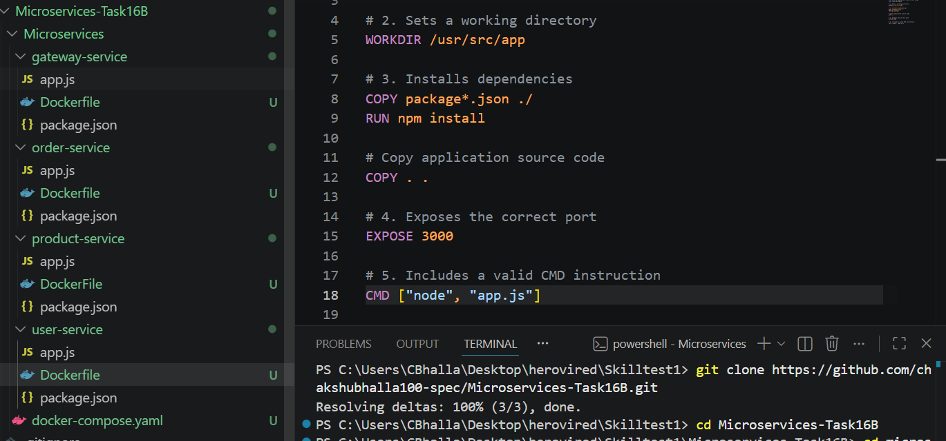
User service
# 1. Uses an appropriate Node.js base image
FROM node:20-alpine

# 2. Sets a working directory
WORKDIR /usr/src/app

# 3. Installs dependencies
COPY package*.json ./
RUN npm install

# Copy application source code
COPY . .

# 4. Exposes the correct port
EXPOSE 3000

# 5. Includes a valid CMD instruction
CMD ["node", "app.js"]

Product service
# 1. Uses an appropriate Node.js base image
FROM node:20-alpine

# 2. Sets a working directory
WORKDIR /usr/src/app

# 3. Installs dependencies
COPY package*.json ./
RUN npm install

# Copy application source code
COPY . .

# 4. Exposes the correct port
EXPOSE 3001

# 5. Includes a valid CMD instruction
CMD ["node", "app.js"]

Order service
# 1. Uses an appropriate Node.js base image
FROM node:20-alpine

# 2. Sets a working directory
WORKDIR /usr/src/app

# 3. Installs dependencies
COPY package*.json ./
RUN npm install

# Copy application source code
COPY . .

# 4. Exposes the correct port
EXPOSE 3002

# 5. Includes a valid CMD instruction
CMD ["node", "app.js"]

Gateway service
# 1. Uses an appropriate Node.js base image
FROM node:20-alpine

# 2. Sets a working directory
WORKDIR /usr/src/app

# 3. Installs dependencies
COPY package*.json ./
RUN npm install

# Copy application source code
COPY . .

# 4. Exposes the correct port
EXPOSE 3003

# 5. Includes a valid CMD instruction
CMD ["node", "app.js"]
+++++++++++++++++++++++++++++++++++++++++++++++++++++++++++++

Docker compose file
version: '3.8'

services:
user-service:
build: ./user-service
container_name: user-service-app
ports:
- "3000:3000"
networks:
- app-network

product-service:
build: ./product-service
container_name: product-service-app
ports:
- "3001:3001"
networks:
- app-network

gateway-service:
build: ./gateway-service
container_name: gateway-service-app
ports:
- "3003:3003"
networks:
- app-network
depends_on:
- user-service
- product-service

order-service:
build: ./order-service
container_name: order-service-app
ports:
- "3002:3002"
networks:
- app-network

networks:
app-network:
driver: bridge

++++++++++++++++++++++++++++++++++++++++++++++++++++++++++++++

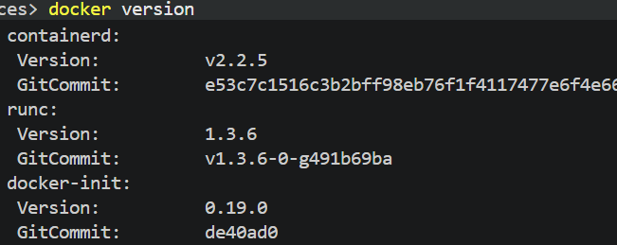
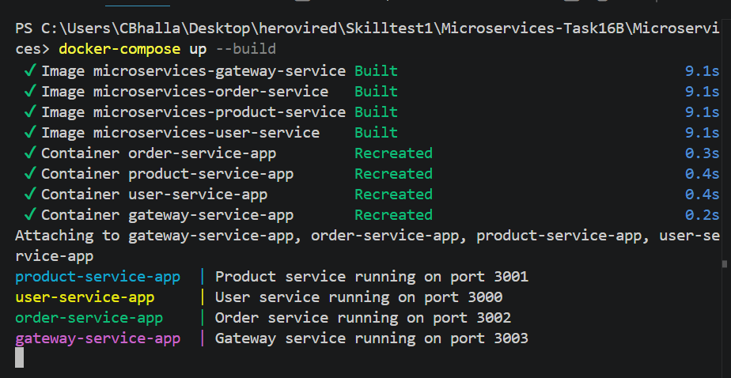
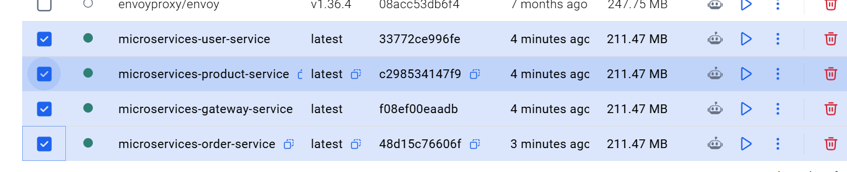

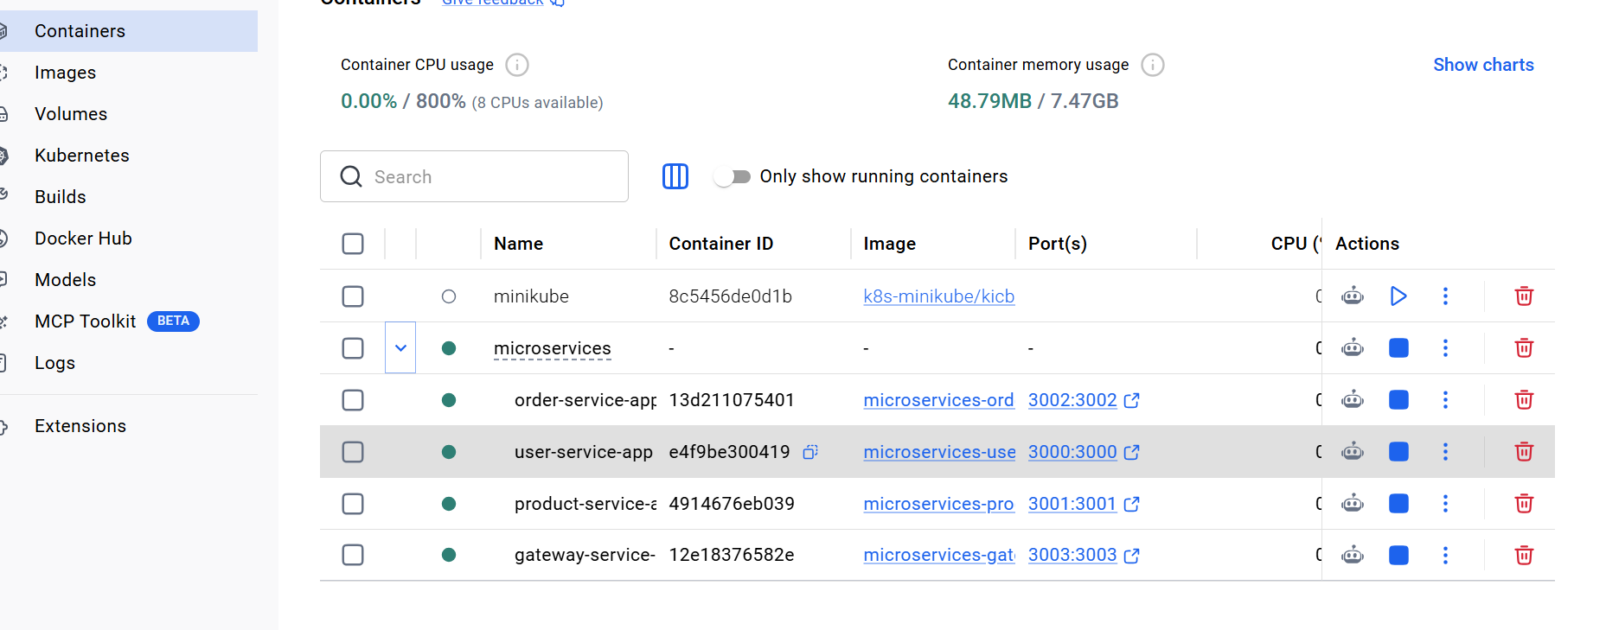
Troubleshooting tips
check port occupancy -- netstat -ano | findstr :3000 --- for all port
Dependency refresh issue -- docker-compose build --no-cache
docker-compose up

