AE097_SG Performance review

July 2014

Disclaimer

Please **refer to the Compliance Officer in your area for content** for this section, which **may be compulsory for legal and regulatory reasons** depending on the subject of the document and its target audience.

Table of Contents

1. Overview 4

2. the Performance test scenario & workaround: 5

2.1. The baseline : 5

2.2. the results : 5

2.2.1 On the scheduling side 5

2.2.2 On oracle side 5

2.3. the AE097_SG WORKAROUND: 6

2.3.1 AE097_SG SQL reviews: 6

2.3.1.1. Oracle Objects CREATION: 6

2.3.1.2. Existing SQL modification 7

2.3.1.3. Existing SQL hints modification 12

2.3.2 AE097_SG Program review 12

2.3.2.1. AE Steps modification 12

2.3.2.2. Poluate the GTT table 12

2.3.2.3. AE Peoplecode modification 13

2.3.2.4. AE parameter review 14

2.3.3 Other improvement areas: 16

# Overview

The aim of this document is to give a quick overview of the suggestions made by the performance team to improve time execution of RFI’s extractions (AE097_SG).

This is not specification document and does not intend to be a migration template. Development team should handle AE097_SG performance suggestions and follow the whole migration process, based on SGCIB development rules and standards, before it’s effective on COE production environment.

# the Performance test scenario & workaround:

## The baseline :

In order to reproduce performance issue on AE097_SG, Production snapshot was applied on Performance environment (OPARCOEP53) in order to run RFI Extraction for D+1, D+2 closure period.

As an example, here are time executions for RFI Extraction for June 2014 closure

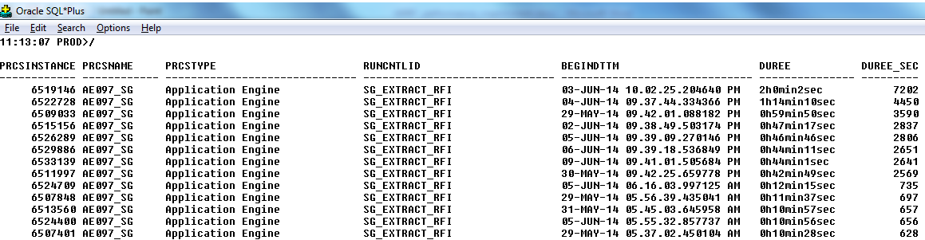

## the results :

### On the scheduling side

The extraction below shows different AE097_SG launches on OPACOEP53, along with improvement modifications :

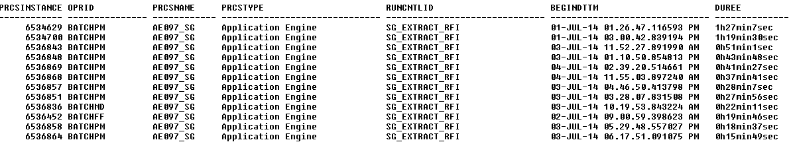

### On oracle side

As you can see below, the time spent by RFI Extraction on the Oracle side is on the step AE097_SG.FILE_JRN.BUILD_JR (see below) :

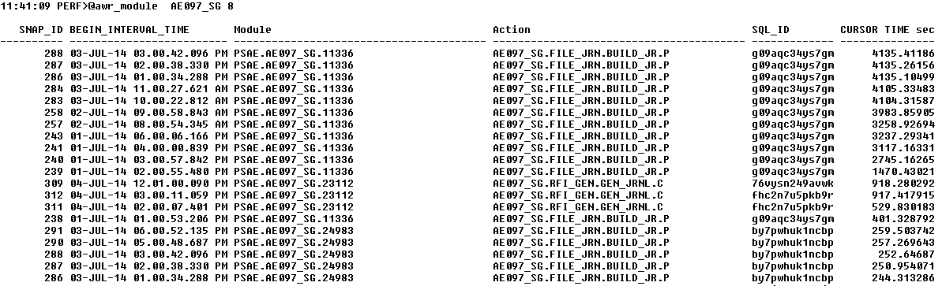

The SQL is encapsulated in a SQLEXEC statement inside a Peoplecode (example Below) :

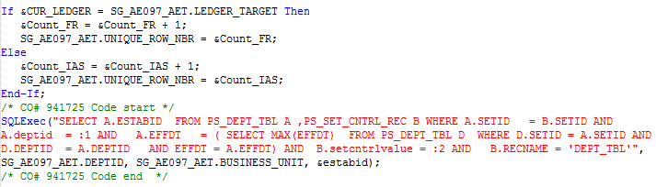

## the AE097_SG WORKAROUND:

For each process execution, AE097_SG is looping on the SQL_EXEC inside a ‘Do Select’ statement in order to retrieve ESTABID information, which is harmful in terms of performance.

The global rework done is to remove this SQLEXEC call and retrieve the ESTABID information earlier in the program.

In order to make this modification effective, the steps below were necessary:

* SQL review :
  + New oracle objects Creation : table , index
  + Existing SQL modification
  + Existing SQL hint’s modification
* AE Program review :
  + AE Steps modification
  + AE Peoplecode modification
  + AE parameter review

### AE097_SG SQL reviews:

### Oracle Objects CREATION:

In order to make the ESTABID columns information available to the AE097_SG program, this information is retrieved and stored in an Oracle Global Temporary Table. Storing this information in a GTT table will make the table and data maintenance easier: data in the table is local to the session and Oracle creates as many GTT instances in it’s memory as AE097_SG occurrences running.

Also, an index is necessary to fasten access to this GTT.

Below is the script to create GTT Table and it’s index:

CREATE GLOBAL TEMPORARY TABLE "COEPRD00"."PS_AE097_DEPT_TMP_SG"

( "SETCNTRLVALUE" VARCHAR2(20) NOT NULL ENABLE,

"DEPTID" VARCHAR2(10) NOT NULL ENABLE,

"ESTABID" VARCHAR2(12) NOT NULL ENABLE

) ON COMMIT DELETE ROWS

CREATE INDEX "COEPRD00"."PS_AE097_DEPT_TMP_SG" ON "COEPRD00"."PS_AE097_DEPT_TMP_SG" ("DEPTID", "SETCNTRLVALUE")

### Existing SQL modification

As mentioned previousely, the SQLEXEC to remove is encapsulated inside a Peopesoft ‘Do Select’ statement.

The SQLEXEC will be removed and the ESATBID information will be captured in the ‘Do select’ (see example below)

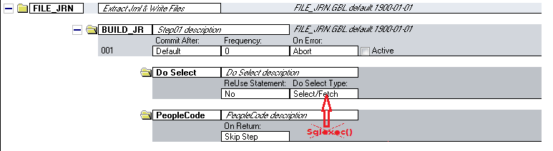

PS:

The same logic is used on several step of the application Engine to retrieve the ESTABID information, so the same logic will be applied to remove the Sqlexec calls. Below is the list of the steps that need to be changed:

**AE097_SG.FILE_JRN.BUILD_JR.D**

**AE097_SG.FILE_TRA.JRNL_TRA.D**

**AE097_SG.FILE_TRA.BAL_TRA.D**

**AE097_SG.FILE_OTH.BLD_OTH.D**

AE097_SG.FILE_JRN.BUILD_JR.D (After) :

%Select(JOURNAL_LINE , DEPTID , OBJECT_CODE , PRODUCT , FOREIGN_AMOUNT , FOREIGN_CURRENCY , ALTACCT , VALUE_DT_SG , BO_ID_SG , FO_ID_SG , OPERATION_CD_SG , PROD_TYPE_BO_SG , CRE_LOGIC_ID_SG , RDJ_DT_SG , SIGN, LEDGER,**ESTABID**)

SELECT **/*+ ORDERED */** N.JOURNAL_LINE

, N.DEPTID

, N.OBJECT_CODE

, N.PRODUCT

, DECODE(SIGN(N.FOREIGN_AMOUNT)

, -1

, N.FOREIGN_AMOUNT*-1000

, N.FOREIGN_AMOUNT*1000)

, N.FOREIGN_CURRENCY

, DECODE(n.BUSINESS_UNIT

,'G0001'

, N.ALTACCT

, N.ACCOUNT)

, %DateOut(N.VALUE_DT_SG)

, N.BO_ID_SG

, N.FO_ID_SG

, N.OPERATION_CD_SG

, N.PROD_TYPE_BO_SG

, N.CRE_LOGIC_ID_SG

, %DateOut(nvl(N.RDJ_DT_SG, N.JOURNAL_DATE))

, DECODE(SIGN(N.FOREIGN_AMOUNT)

, -1

, 1

, 0)

, N.LEDGER

**, TRIM(d.estabid)**

FROM **/* PS_JRNL_HEADER a JOIN */** PS_JRNL_LN N **/* ON ( N.BUSINESS_UNIT = a.BUSINESS_UNIT AND N.JOURNAL_ID = a.JOURNAL_ID AND N.JOURNAL_DATE = a.JOURNAL_DATE AND N.UNPOST_SEQ = a.UNPOST_SEQ AND a.JRNL_HDR_STATUS IN ('P' , 'U') ) */** JOIN PS_RFI_ACCOUNTS_SG ACCT ON ( N.LEDGER = ACCT.LEDGER %Bind(ACCT_ALT_CLAUS_SG, NOQUOTES)

AND ACCT.OPRID = %OperatorId

AND ACCT.RUN_CNTL_ID = %runcontrol )

**LEFT OUTER JOIN PS_AE097_DEPT_TMP_SG d**

**ON ( d.deptid = n.deptid AND d.setcntrlvalue = n.business_unit )**

WHERE **n**.BUSINESS_UNIT = %Bind(BUSINESS_UNIT)

AND **n**.JOURNAL_ID = %Bind(JOURNAL_ID)

AND N.JOURNAL_DATE = %Bind(JOURNAL_DATE)

AND N.UNPOST_SEQ = %Bind(UNPOST_SEQ)

AND N.LEDGER %Bind(LEDGER_LIST_SG, NOQUOTES)

AND N.FOREIGN_AMOUNT <> 0 %Bind(DEPT_EXC_CLAUS_SG, NOQUOTES)

ORDER BY N.JOURNAL_LINE

AE097_SG.FILE_TRA.JRNL_TRA.D (After) :

%Select (ALTACCT, FOREIGN_CURRENCY , RDJ_DT_SG, VALUE_DT_SG, FOREIGN_AMOUNT, SIGN, **ESTABID**)

SELECT **/*+ ORDERED */** DECODE(N.BUSINESS_UNIT

,'G0001'

,DECODE( N.ALTACCT

, ' '

, N.ACCOUNT

, N.ALTACCT )

,N.ACCOUNT)

, N.FOREIGN_CURRENCY

, %DateOut(N.RDJ_DT_SG)

, %DateOut(N.VALUE_DT_SG )

, SUM(N.FOREIGN_AMOUNT)*-1000

, DECODE(SIGN(FOREIGN_AMOUNT)

, -1

, 1

, 0)

, **TRIM(d.estabid)**

FROM PS_JRNL_LN N

, PS_RFI_EXTRACT_SG A

, PS_RFI_ACC_TRF_SG ACCT

**, PS_AE097_DEPT_TMP_SG D**

WHERE N.BUSINESS_UNIT = %Bind (BUSINESS_UNIT)

AND N.BUSINESS_UNIT = A.BUSINESS_UNIT

AND N.BUSINESS_UNIT = ACCT.BUSINESS_UNIT

AND N.LEDGER %Bind(LEDGER_LIST_SG, NOQUOTES)

AND ACCT.OPRID = %OperatorId

AND ACCT.RUN_CNTL_ID = %runcontrol

AND N.JOURNAL_ID = A.JOURNAL_ID

AND N.JOURNAL_DATE = A.JOURNAL_DATE

AND N.UNPOST_SEQ = A.UNPOST_SEQ %Bind(FROM_DT_CLAUSE_SG, NOQUOTES)

AND (A.PROCESS_DATE BETWEEN TO_DATE('0101' || To_Char(%Bind(AS_OF_DATE),'yyyy'),'DDMMYYYY') AND TRUNC(%Bind(DATE_PROCESSED)))

AND A.PROCESS_INSTANCE > 0 %Bind(ACCT_ALT_CLAUS_SG, NOQUOTES)

AND N.DEPTID = %Bind(DEPTID)

AND N.FOREIGN_AMOUNT <> 0

AND N.JOURNAL_DATE >= %Bind(JOURNAL_DATE_FROM)

**AND N.BUSINESS_UNIT = D.setcntrlvalue(+)**

**AND N.DEPTID = D.DEPTID(+)**

GROUP BY DECODE(N.BUSINESS_UNIT ,'G0001',DECODE( N.ALTACCT , ' ' , N.ACCOUNT , N.ALTACCT ),N.ACCOUNT), N.FOREIGN_CURRENCY, N.RDJ_DT_SG, N.VALUE_DT_SG, DECODE(SIGN(FOREIGN_AMOUNT) , -1 , 1 , 0) **, TRIM(d.estabid)**

AE097_SG.FILE_TRA.BAL_TRA.D (After):

%Select (CURRENCY_CD , FISCAL_YEAR, FOREIGN_AMOUNT, DATE_EXTRACT_SG, ALTACCT, SIGN,**ESTABID**)

SELECT N.CURRENCY_CD

, N.FISCAL_YEAR

, SUM (YTD_TRAN_AMT) * 1000

, %DateOut( To_Date('3112' || To_Char(To_Number(To_Char(To_Date(%Bind(AS_OF_DATE) ,'YYYY-MM-DD') ,'yyyy'))-1) ,'DDMMYYYY'))

, DECODE(N.BUSINESS_UNIT

,'G0001'

,N.ALTACCT

,N.ACCOUNT)

, DECODE(SIGN(SUM (YTD_TRAN_AMT) * 1000)

, -1

, 1

, 0)

**, TRIM(d.estabid)**

FROM PS_%Bind(RECNAME, NOQUOTES) N

, PS_RFI_ACC_TRF_SG ACCT

**, PS_AE097_DEPT_TMP_SG D**

WHERE N.BUSINESS_UNIT = %Bind(BUSINESS_UNIT)

AND N.BUSINESS_UNIT = ACCT.BUSINESS_UNIT

AND ACCT.OPRID = %OperatorId

AND ACCT.RUN_CNTL_ID = %runcontrol

AND N.LEDGER %Bind(LEDGER_LIST_SG, NOQUOTES) %Bind(ACCT_ALT_CLAUS_SG, NOQUOTES)

AND N.DEPTID = %Bind(DEPTID)

AND N.FISCAL_YEAR = To_Number(To_Char(%Bind(AS_OF_DATE),'yyyy'))-1

AND N.ACCOUNTING_PERIOD = 12

**AND N.BUSINESS_UNIT = D.setcntrlvalue(+)**

**AND N.DEPTID = D.DEPTID(+)**

GROUP BY N.CURRENCY_CD, N.FISCAL_YEAR ,DECODE(N.BUSINESS_UNIT ,'G0001',N.ALTACCT,N.ACCOUNT), **TRIM(d.estabid)**

AE097_SG.FILE_OTH.BLD_OTH.D (After) :

%Select(BUSINESS_UNIT, ALTACCT, CURRENCY_CD, DEPTID, YTD_TRAN_AMT, SIGN, LEDGER, **ESTABID**)

SELECT N.BUSINESS_UNIT

, N.ACCOUNT

, N.CURRENCY_CD

, N.DEPTID

, DECODE(SIGN(SUM(N.YTD_TRAN_AMT))

, -1

, SUM(N.YTD_TRAN_AMT)*-1000

, SUM(N.YTD_TRAN_AMT)*1000)

, DECODE(SIGN(SUM(N.YTD_TRAN_AMT))

, -1

, 1

, 0)

, N.LEDGER

**, TRIM(d.estabid)**

FROM PS_%Bind(RECNAME, NOQUOTES) N

, PS_RFI_ACCOUNTS_SG ACCT

**, PS_AE097_DEPT_TMP_SG D**

WHERE N.BUSINESS_UNIT = %Bind(BUSINESS_UNIT)

AND N.ACCOUNTING_PERIOD = %Bind(ACCOUNTING_PERIOD)

AND N.FISCAL_YEAR= %Bind(FISCAL_YEAR)

AND N.LEDGER %Bind(LEDGER_LIST_SG, NOQUOTES)

AND N.LEDGER = ACCT.LEDGER

AND ACCT.OPRID = %OperatorId

AND ACCT.RUN_CNTL_ID = %runcontrol

AND N.ACCOUNT = ACCT.ALTACCT %Bind(DEPT_EXC_CLAUS_SG, NOQUOTES)

AND NOT (N.CURRENCY_CD = BASE_CURRENCY

AND N.YTD_TRAN_CR = 0

AND N.YTD_TRAN_DR = 0

AND N.YTD_BASE_AMT = 0 )

**AND N.BUSINESS_UNIT = D.setcntrlvalue(+)**

**AND N.DEPTID = D.DEPTID(+)**

GROUP BY N.BUSINESS_UNIT, N.ACCOUNT, N.CURRENCY_CD, N.DEPTID , N.LEDGER , **TRIM(d.estabid)**

ORDER BY N.BUSINESS_UNIT, N.ACCOUNT, N.CURRENCY_CD, N.DEPTID, N.LEDGER

### Existing SQL hints modification

For the Step **AE097_SG.FILE_JRN.BUILD_JR.D,** existing hint :

/*+ PARALLEL(N 8) use_hash(N a)*/

Has been changed to

/*+ ORDERED */

PS: please respect the order of the tables as written in the Step.

### AE097_SG Program review

### AE Steps modification

For readability purpose and fast switching between old / new code, AE steps that were modified were duplicated, and old steps where flagged as ‘inactive’. Also the new step are called SG_...

below is an example:

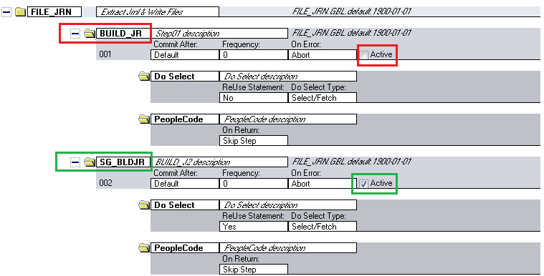

### Poluate the GTT table

As mentioned at the beginning of the document, all the needed ESTABID values needed by the program are poplated in a GTT table. An AE step is added in order to populate this table? The step name is RFI_GEN.SG_STG1. It has been added just after step RFI_GEN.JRNL.P ( see screenshot below)

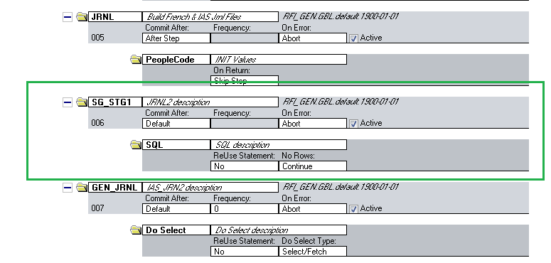

### AE Peoplecode modification

As mentioned below the SQLExec inside the Peoplecode that retrieves ESTABID value is removed as the ESTABID is retrieved earlier in the ‘Do Select’ statement.

The modification is done on 4 Peoplecode steps :

**AE097_SG.FILE_JRN.BUILD_JR.P**

**AE097_SG.FILE_TRA.JRNL_TRA.P**

**AE097_SG.FILE_TRA.BAL_TRA.P**

**AE097_SG.FILE_OTH.BLD_OTH.P**

Example on the step **AE097_SG.FILE_JRN.BUILD_JR.P**

**Before :**



**After** :



Also some operations done in the peoplecode on the value of the ESTBID, were done directly in the ‘Do select’ statement.

As an example the operation to retrieve left and right space in ESTABID, done in Peoplecode ( using syntax LTrim(RTrim(&estabid, " "), " "); ) are now done in during SQL selection .

Before:

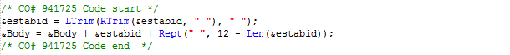

After:

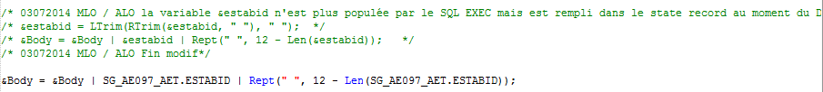

### AE parameter review

During performance test the step AE097_SG.FILE_JRN/BUILD_JR.D is Called as many time as Journals to Extract. This step is containing litterals, so Oracle is generating as many exection plan as occurrence, causing overhead on Execution plan parsing and also, sometime, generating a bad execution plan.

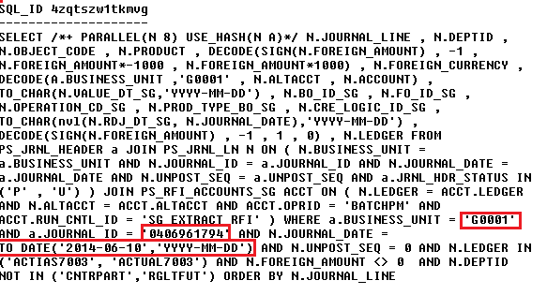

The solution is to bind the SQL STATEMENT through the tools by setting ‘reuse statement’ to ‘Yes’ on the Step level ( see screenshots below )

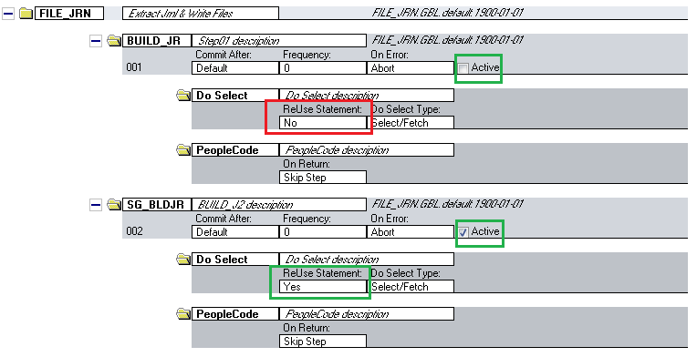

This make Peoplesoft generate SQL with Bind variable instead of hardcoded values. Below is the step as executed after on the database side :

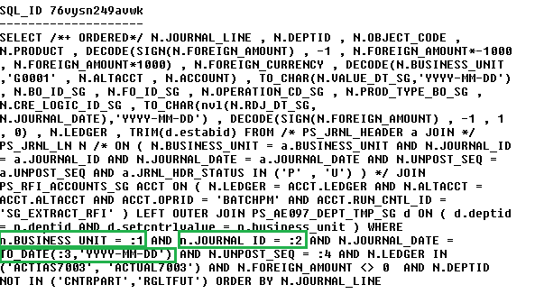

### Other improvement areas:

During the performance tests, a significant AE097_SG processing time is spent on on-SQL

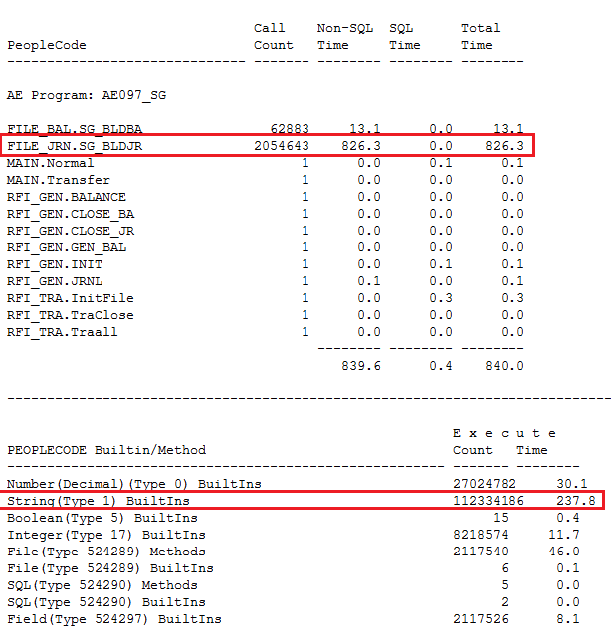

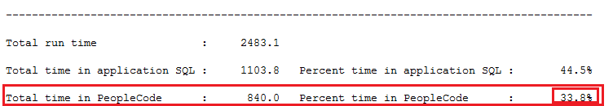

On large files processing/extraction, Application Engine programs are not very efficient, also linear call of Peoplecode is time consuming. There are still some Peoplecode manipulating functions that can be removed and call earlier in the SQL statements. As an example, all the peoplecode Ltrim(Rtrim(… operation can be done during SQL extractions using the Oracle TRIM function

Below some extraction from the AE097_SG Peoplecode :

&Body = LTrim(RTrim(&unique_row_nbr, " "), " ");

&foriegn_cur = LTrim(RTrim(SG_AE097_AET.FOREIGN_CURRENCY, " "), " ");

&Body = &Body | LTrim(RTrim(&sign, " "), " ");

&deptid = LTrim(RTrim(SG_AE097_AET.DEPTID, " "), " ");

&altacct = LTrim(RTrim(SG_AE097_AET.ALTACCT, " "), " ");

&estabid = LTrim(RTrim(&estabid, " "), " ");

Etc…